
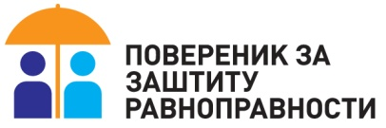

REGULAR ANNUAL REPORT
OF THE COMMISSIONER FOR THE PROTECTION OF EQUALITY FOR 2025

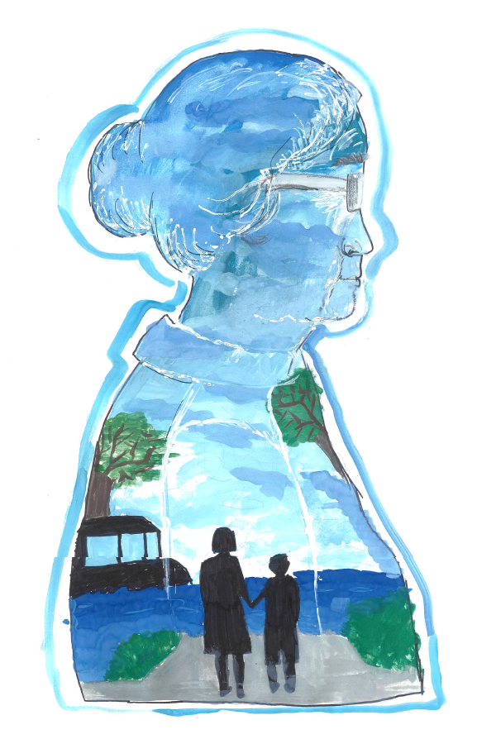

Belgrade, March 2026

All terms used in the masculine grammatical gender denote both the masculine and the
feminine genders of the respective persons

*** The illustration on the cover page is an artwork by Anđelka Bogić, VII/2, “Milisav Nikolić” Primary School, Cŕljenac Satellite Unit (Malo Crniće), winner of the 1st prize in the Commissioner for the Protection of Equality’s 2025 prize competition “Bridge of Understanding – Intergenerational Solidarity”.

Table of Contents
FOREWORD 6
SUMMARY 8
Recommendations to Advance Equality and Eliminate Discrimination 26
ABOUT THE COMMISSIONER FOR THE PROTECTION OF EQUALITY 31
Professional Service of the Commissioner 32
Comissioner‘s work in 2025 in numbers 34
COMMISSIONER’S ACTIONS RELATED TO PROTECTION AGAINST DISCRIMINATION IN 2024 35
Citizens’ Complaints 37
Recommended Measures 41
Opinions on Draft Laws and Other Legal Documents and Initiatives Submitted 44
Other Outcomes of Proceedings 46
Court Proceedings 46
Civil Proceedings 46
Misdemeanour proceedings 50
Criminal proceedings 50
Situational testing 51
Proposals for the Review of Constitutionality and Legality 52
COMMISSIONER’S ACTIONS IN 2025 CONCERNING THE PROMOTION OF EQUALITY 57
Reports, Surveys and Other Publications of the Commissioner 57
Trainings 64
Professional Meetings, Conferences, and Other Activities 68
Professional Meetings Organised by the Commissioner 68
Professional meetings organised by other actors 75
Implemented Projects 80
International Cooperation 83
Cooperation with the European Network of Equality Bodies (EQUINET) 89
OVERVIEW OF THE SITUATION AND KEY ISSUES IN THE FIELD OF EQUALITY PROTECTION 91
Reports and other acts of the EU, international organisations, and treaty bodies 92
The case law of the European Court of Human Rights in the field of protection against discrimination 96
Reports and Research of Domestic Institutions and Organisations 98
Actions of State Authorities on the Recommendations of the Commissioner 104
KEY ISSUES IN EQUALITY PROTECTION 115
Discrimination on the Grounds of Age 124
Discrimination on the Grounds of Health Status 138
Discrimination on the Grounds of Income Level 146
Discrimination on the Grounds of Disability 148
Discrimination on the Grounds of Sex and Marital and Family Status 156
Discrimination on the Grounds of National Affiliation or Ethnic Origin 172
Discrimination on the Grounds of Membership in Political, Trade Union and Other Organisations and on the Grounds of Religious and Political Beliefs 181
Discrimination on the Grounds of Sexual Orientation and Gender Identity 186
Discrimination against Refugees, Internally Displaced Persons, Migrants and Asylum-seekers 190
Discrimination on Other Grounds 194
Multiple and Intersectional Discrimination 201
Discrimination and Artificial Intelligence – Equality in the Digital Sphere 203
MEDIA REPORTING 205
REPORT ON EXECUTION OF THE FINANCIAL PLAN 209
COMPILIANCE WITH DUTIES UNDER LAW ON FREE ACCESS TO INFORMATION OF PUBLIC IMPORTANCE 211
ANNEX 1: STATISTICAL OVERVIEW OF COMMISSIONER’S CASES IN 2025 213
ANNEX 2: BUDGET EXECUTION FOR 2025 222
ANNEX 3: REFERENCES 225

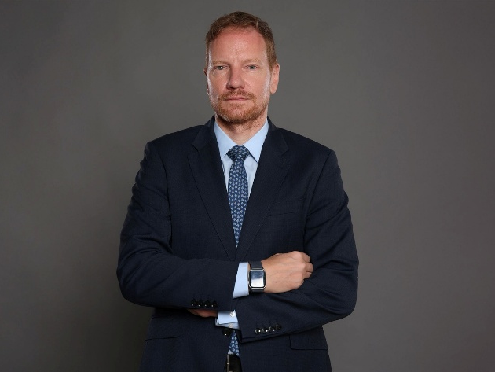
FOREWORD

Respected members of the parliament,
Esteemed readers,

Before you is the Regular Annual Report of the Commissioner for the Protection of Equality for 2025, that reflects another year of continuous work in accordance with the competences entrusted to us, as an independent institution, under the Law on the Prohibition of Discrimination. This is the sixteenth such report of the institution, which, since its establishment, has provided protection to citizens against discrimination and has worked intensively to improve the implementation of the principle of equality for all social groups and in all areas of social life. The Report provides an overview of the situation in the field of equality protection in the Republic of Serbia during the year, points to the problems identified and sets out recommendations for their elimination..
I assumed the office of Commissioner for the Protection of Equality in early December 2025, following my election by the National Assembly of the Republic of Serbia. I took up this duty with a sense of responsibility and determination to continue leading the institution in the same spirit as my predecessors, with the firm conviction that human rights are not merely a legal category, but above all the foundation of every democratic society oriented towards development and the well-being of every individual.
The fight for equality cannot be waged through the language of dehumanisation, by encouraging prejudice and deepening intolerance. The greatest advances in the field of human rights have come through dialogue, not through witch-hunts. Equal treatment ensures the rule of law, while any form of unequal treatment creates a sense of injustice and increases tensions, mistrust and divisions. I therefore believe that we can agree that Serbia's national interest is the equality and dignity of all citizens, without exception, which we can achieve only through joint work and cooperation among state institutions, local self-governments, the academic community, civil society, the business community and other socially responsible actors willing to take both small and large steps towards building a more equal and inclusive society. After all, this is a commitment we have undertaken as a member of the Council of Europe and as a candidate country for full membership of the EU.
Although human rights are the foundation of a life in dignity, it is not uncommon for them to be under threat, especially among certain social groups such as older persons, children and young people, the sick, the poor, minorities, persons with disabilities, women, etc., which is also characteristic at the global level. The Commissioner’s practice during 2025 also showed that, according to the complaints submitted, discrimination was most frequent on the grounds of age, health status, income level, disability, sex, marital and family status and national affiliation, as well as on the grounds of political beliefs or membership in political and trade union organisations.
The year behind us was marked by numerous social developments, including citizens’ protests, suspensions of teaching in education, as well as individual cases of attacks on journalists, activists, human rights defenders and citizens with different actual or presumed political beliefs. We know from previous periods that such circumstances and divisions in society may affect the exercise of human rights and equality, particularly with regard to the position of vulnerable social groups.
When it comes to protection against discrimination, the Commissioner acted in 4,151 cases, including 939 complaints; 837 recommended measures for achieving equality were issued to public authorities and other persons, 16 initiatives for amending regulations were submitted, 20 opinions were issued on draft laws and other regulations, three proposals were submitted to the Constitutional Court for the review of constitutionality and legality, two strategic litigations were initiated, and seven criminal charges and one misdemeanour charge were filed.
Work on improving equality in 2025 was guided by the current situation, submissions to the institution, and cooperation and joint action with other authorities and civil society organisations. Thus, during the year, several dozen training sessions were conducted, attended by more than 2,000 participants, primarily young people, students and pupils, teachers, non-teaching staff and representatives of student parliaments in primary and secondary schools. A total of eight publications were issued, including two special reports submitted to the National Assembly - the Special Report on Discrimination against Persons with Disabilities and the Special Report on Discrimination against Women.
When it comes to the media, as well as social networks, an increase was observed in the intensity and frequency of discriminatory and offensive posts, including hate speech, primarily in the context of confronting political opponents. As public rhetoric became more aggressive, several warnings and press releases were issued, with particular concern expressed that such impermissible speech was being resorted to more than before by certain public office holders and other public figures.
What is always encouraging when it comes to protection against discrimination is compliance with recommendations - recommended measures for improving equality addressed to public authorities and other persons were complied with in 89.2% of cases, which, together with compliance with the recommendations issued with opinions, gives an average of 85.1%. This long-standing trend also shows a willingness to improve the existing situation and to resolve certain problems.
Nevertheless, in this reporting year as well, some previously identified problems have not been fully resolved, such as the adoption of certain regulations, strategic documents and action plans, the improvement of the scope and types of social protection services, the accessibility of health care and palliative care, the capacities of inclusive education, and accessibility. Some of the laws that were adopted or worked on in previous years, but did not appear on the agenda, were labelled as controversial in the public and political environment. However, there must be no retreat from respect for human rights, regardless of misunderstanding and pressure. The standards of equality already achieved must be preserved. I will therefore reiterate the importance of dialogue, first and foremost with those who oppose the advancement of human rights because they do not understand the needs of, nor respect, the other.
May the words of Martin Luther King serve as inspiration in pursuing this goal: “The time is always right to do what is right. No man can ride your back unless it is bent.”
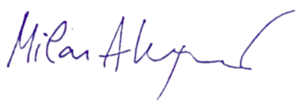
Along with intensified efforts to reach all those who need us and to ensure that protection against discrimination is as effective and accessible as possible, I am convinced that, by joining forces, we can achieve lasting improvements in the field of human rights and equality and contribute to a better quality of life for all citizens in our country.
Lead by example,
Milan Antonijević
Comissioner for the Protection of Equality

SUMMARY
The situation in the field of equality protection in the Republic of Serbia in 2025 is presented in this Report, as in previous regular annual reports of the Commissioner for the Protection of Equality (hereinafter: the Commissioner), primarily on the basis of action taken on complaints and other submissions from citizens and civil society organisations addressed to the institution as the specialised body for protection against discrimination and the advancement of equality, but also on the basis of other activities regularly carried out by the Commissioner. Bearing in mind that submissions to the Commissioner and the institution’s activities are not, and cannot be, an absolute indicator of the situation in this field, other available sources have also been considered in order to provide a more comprehensive overview. These include reports and acts of the EU, international organisations and treaty bodies, reports and surveys by national institutions and organisations, relevant judgments of the European Court of Human Rights, as well as conclusions of expert meetings and other events addressing issues related to improving the position of social groups at greater risk of discrimination. This approach to reporting arises from the Commissioner’s statutory obligation to submit an annual report to the National Assembly on the situation in the field of equality protection.
During 2025, the Commissioner continued to work on protecting citizens against discrimination and on advancing equality in accordance with the law. At the end of the year, Commissioner Brankica Janković completed her second term of office at the head of the institution, and the National Assembly elected Milan Antonijević as the new Commissioner for a five-year term; he assumed office on 3 December.
The reporting year in Serbia was marked by numerous social events, including citizens’ protests, suspensions of classes in education, as well as individual cases of attacks on journalists, activists, human rights defenders and citizens with different actual or presumed political beliefs. Such circumstances and divisions in society may affect the exercise of human rights and equality, particularly with regard to the position of vulnerable social groups. The United Nations specifically emphasises that human rights violations pose a challenge to the stability and democratic development of society, especially when vulnerable groups such as the poor, children, minorities, persons with disabilities and women are affected.
Immediately after assuming office, Commissioner Antonijević stated in a press release that human rights are not only a legal category, but the foundation of equality and democracy, and of a society oriented towards the development and well-being of every individual, and that a society in which divisions are growing and public dialogue is weakening is facing serious challenges. Precisely for this reason, human rights must not become collateral damage of global crises and political tensions. Starting from his mandate, the Commissioner therefore emphasises the importance of protecting human rights and the need for the continuous improvement of public dialogue and institutional cooperation. The protection of human rights requires close cooperation with the National Assembly of the Republic of Serbia, through monitoring laws and oversight mechanisms, as well as cooperation with other institutions, the Constitutional Court, courts, public prosecutors’ offices, administrative authorities, local self-government units, independent bodies, civil society organisations and other stakeholders, together with the effective application of laws and a joint struggle for full equality, because issues concerning equality, dignity and fairness cannot be postponed.
As regards protection against discrimination, in 2025 the Commissioner acted in 4,151 cases. Compared with the previous reporting year, a larger number of complaints were filed and a larger number of recommended measures were issued, and a larger number of certificates of non-discriminatory conduct were issued to persons applying for positions or employed in the education system. The Commissioner acted on 939 complaints; 837 recommended measures to achieve equality were issued to public authorities and other persons; 16 initiatives to amend regulations were submitted; 20 opinions were given on draft laws and other general acts; three proposals were submitted to the Constitutional Court for the review of constitutionality and legality; two civil proceedings for protection against discrimination were initiated, bringing the total number of ongoing proceedings to six; one misdemeanour proceeding was initiated; seven criminal complaints were filed; six warnings to the public were issued; and 35 press releases were published.
In complaint procedures, 36 opinions were issued. In proceedings concerning 30 complaints, an opinion was issued establishing a violation of rights under the Law on Prohibition of Discrimination and recommending measures. In the remaining six complaints, an opinion was issued establishing no violation of rights, while in four of those cases a recommendation of measures to achieve equality and protect against discrimination was issued in accordance with Article 33, paragraph 1, item 9 of the Law on Prohibition of Discrimination, even though no violation of rights had been established.
In 83 cases, the procedure was discontinued because the consequences of discriminatory conduct had been remedied after the initiation of proceedings before the Commissioner, or because the person withdrew from further pursuing the procedure for these reasons. A number of procedures were also discontinued for other reasons prescribed by law, such as an incomplete complaint that was not supplemented even after the Commissioner’s repeated request, where it was obvious that no violation of rights had occurred, where the Commissioner was not competent to conduct proceedings in the specific case or had already acted in the same matter and no new evidence had been offered, where court proceedings had been initiated or concluded, where the person withdrew the complaint, and the like.
The Commissioner’s recommendations given in opinions were complied with in 81% of cases, while in 19% of cases they were not complied with.
The largest number of complaints submitted to the Commissioner in 2025 concerned discrimination on the grounds of age, health status, income level, disability, sex, national affiliation or ethnic origin, political beliefs, membership of political, trade union and other organisations, another personal characteristic, marital and family status, property status, citizenship, language, sexual orientation and gender identity, while other personal characteristics cited by citizens were represented in a smaller number of cases. Complaints on the grounds of another personal characteristic include personal characteristics that are not explicitly listed in the law. This group includes complaints relating to place of residence, temporary residence, membership of groups such as internally displaced persons, different treatment of educational institutions depending on whether they were founded by the state or by a private individual, and the like.
It should be noted that sex and marital and family status, as well as political belief and membership of political and trade union organisations as grounds of discrimination, most often appear together, as multiple and/or intersectional discrimination, which is why these personal characteristics are addressed jointly in this report.
With regard to the areas of social relations in 2025, the largest number of complaints were submitted in relation to employment procedures or work, most often on the grounds of disability and health status, as well as on the grounds of political belief and membership of political and trade union organisations. These were followed by complaints submitted in proceedings before public authorities, then in the areas of education and professional training, the provision of public services or the use of facilities and public areas, the public sphere/general public, followed by healthcare, public information and the media, and other areas in smaller percentages. Certain events led to a larger number of complaints on the same grounds. For example, the Commissioner received more than one hundred complaints from employees and trade unions indicating the less favourable position in which certain workers from social welfare centres found themselves as a result of the adoption of the Regulation Amending the Regulation on Coefficients for the Calculation and Payment of Salaries of Employees in Public Services. This resulted, for the first time since the personal characteristic of income level was introduced into the Law on the Prohibition of Discrimination by the 2021 amendments, in this characteristic being among the leading grounds on which complaints were filed. In this regard, the Commissioner issued a recommendation of measures to the Ministry of Public Administration and Local Self-Government and the Ministry of Labour, Employment, Veteran and Social Affairs to submit a proposal for amending the disputed provisions of the said regulation, in order to equalise the coefficient for employed professional workers, that is, to ensure compliance with the legal guarantee of equal pay for the same work or work of equal value. In addition, a number of complaints were also filed concerning the provisions of the Special Collective Agreement for Employees in Primary and Secondary Schools and Student Dormitories, alleging discrimination on the grounds of trade union membership, as well as the Rulebook on Work Discipline and Rules of Conduct of Employees of the National Theatre in Belgrade, alleging discrimination on the grounds of political beliefs. This, in part, contributed to the fact that the number of complaints filed in 2025 on the above grounds was twice as high as in the previous year. Also, towards the end of the year, the Commissioner received several complaints, most often from employees in education whose contracts were not extended, that is, whose fixed-term contracts were not renewed after many years of work in an educational institution, due to the employees’ political beliefs or trade union membership. In view of the increase in communications from citizens and complaints filed on these grounds, in addition to several opinions issued during the year in which discrimination was found, two civil proceedings for protection against discrimination were also initiated. Through these civil proceedings, the Commissioner primarily sought to point to the importance of respecting anti-discrimination regulations and the prohibition of such conduct. In contrast to these grounds of discrimination, the number of complaints decreased on some other grounds. Thus, for example, in 2025, fewer complaints were filed on the grounds of sex than in the previous year, 2024, while compared with 2023 the number was approximately the same. This was due to the large number of complaints filed last year which pointed to the treatment of women during and after childbirth in gynaecology and obstetrics clinics, as a result of which, in 2024, the Commissioner issued recommended measures to these health care institutions, as well as to the Ministry of Health. Compliance with these recommendations resulted in there being no communications on this matter this year. During 2025, the Commissioner also considered complaints filed by parents of eighth-grade pupils concerning the scheduling of different dates for taking the trial final examination, because there was concern that this could lead to an unequal position of pupils, given that trial examinations in Serbian/mother tongue and the third test are held at different times determined by schools. There was also an increase in the number of communications concerning problems in exercising social welfare rights and services due to insufficient capacities of service providers and the lack of funds allocated by local self-governments for these purposes (e.g. several complaints were filed due to the failure to exercise the right to organised transport for children with developmental disabilities and disabilities, as well as due to the failure to provide the service of a personal companion to children with disabilities, which was also reflected in the increased number of complaints on these grounds).

As in previous years, the largest number of complaints was filed against public authorities, followed by legal persons (most often employers), natural persons, while the smallest number was filed against groups of persons and organisations. Except for the region of Kosovo and Metohija, the number of complaints by region was relatively even, with the exception of the Belgrade region, where the largest number of complaints continues to be filed.
This year, as in previous years, the Commissioner monitored the situation in the field of equality protection and, through recommended measures and initiatives addressed to the Government and line ministries, pointed to various problems faced by citizens and proposed solutions for overcoming them in practice. During the year, 837 recommended measures for achieving equality and protection against discrimination were issued, as well as 16 initiatives.
Thus, on the occasion of the formation of the new Government, a recommendation was addressed to the Prime Minister-designate concerning the balanced representation of women and men in the future Government, while a recommendation of measures was addressed to television broadcasters with national coverage, print media and internet portals to take all necessary measures to prevent the publication, as well as to remove already published content and comments that incite discrimination, hatred or violence. All local self-government units were recommended to establish or improve the system of free legal aid and, when issuing calls for programmes and projects financed from budgetary funds, to also take into account civil society organisations established in accordance with the Law on Endowments and Foundations.
In order to advance equality of persons with disabilities, all banks were recommended to improve access to banking products and services.
recommended measures were also addressed to various ministries with a view to undertaking measures within the competence of these authorities to advance equality of certain social groups. Thus, the Ministry of Labour, Employment, Veteran and Social Affairs received a recommendation of measures concerning the problems that arose due to the abolition of the right to financial social assistance for certain persons, caused by an error made by employees in several social welfare centres. The Ministry of Education received a recommendation concerning the issuing of diplomas on acquired education and other public documents to persons who, after completing their education, underwent gender reassignment (change of sex marker).
The Institute for Health Protection of Workers of the Ministry of Interior received a recommendation to review and correct the List of Morbid Conditions by assessing whether all diseases and conditions included in the List have an essential impact and objectively constitute an obstacle, that is, an excluding condition for obtaining a positive assessment of health fitness for work in the police. The National Employment Service was recommended, when preparing individual employment plans, to pay particular attention to persons who provide direct care to a close family member, with a view to their more effective inclusion in active labour market policy measures. The Belgrade Emergency Medical Institute received a recommendation to include the category of older persons in the Code of Business Conduct of the City Institute for Emergency Medical Care – Belgrade, which prescribes the duty of employees to treat persons with disabilities with special care and to ensure that they have priority in the provision of health care.
recommended measures were also issued to local self-government units. Thus, the City of Pančevo was recommended, in accordance with the Law on Refugees and the Government Conclusion, and with the aim of completing the process of integration of refugees who are beneficiaries of the SIRP Programme, to enable the purchase of housing units acquired through construction for the purpose of refugee integration. The City of Požarevac was recommended to take all necessary measures and activities within its competence with a view to equalising the position of children attending a preschool institution founded by the City and children referred to attend a private preschool institution because of insufficient capacities of the institutions founded by Požarevac. The Commissioner recommended to the City of Prokuplje that it take urgent measures to ensure electricity supply to households and humane living conditions in the village of Miljkovica. The City of Niš was recommended to apply the Decision on Granting Assistance to Pupils in the Territory of the City of Niš also to children attending the “Škola plus” Primary School for Children with Developmental Disabilities in Niš.
Regarding compliance with the recommended measures to advance equality which the Commissioner addressed to public authorities and other persons, compliance was achieved in 89.2% of cases, which, together with compliance with the recommendations given in opinions, amounts on average to 85.1%, thus continuing the trend of compliance with the Commissioner’s recommendations.
In cases in which the recommendations issued were not complied with, these primarily concerned discriminatory speech in the public sphere, discrimination on the grounds of membership in political, trade union and other organisations, as well as discrimination against law graduates who completed a private law faculty.
Compliance with the Commissioner’s recommendations has facilitated the exercise of rights or removed obstacles to their exercise, that is, it has improved the position of the social groups and individuals concerned. Thus, for example, accessibility of certain public facilities was ensured; the treatment of women in gynaecology and obstetrics clinics was improved; the list of medicinal products covered by the National Health Insurance Fund was expanded; free legal aid services were established in certain local self-government units; co-financing calls for proposals were announced placing associations and foundations in an equal position; missing traffic signs written in the languages of national minorities in official use in the local self-government unit were changed and installed; the provision of notarial and banking services to persons with disabilities, as well as to refugees, asylum seekers and persons with approved subsidiary protection, was improved; the procedure for reactivation of mobile banking applications was facilitated for deaf persons and persons with hearing impairment; more than 2,000 participants were trained (pupils and students, teachers, non-teaching staff, representatives of students’ parliaments in primary and secondary schools, police officers, representatives of the Ministry of Defence and the Serbian Armed Forces, employees of social work centres, representatives of national councils of national minorities, employers, employees of local self-government units, civil servants, residents of informal settlements, media representatives, etc.); in specific cases in which the Commissioner conducted proceedings: discriminatory graffiti and comments on social networks were removed; the consequences of discriminatory conduct by employers were rectified in individual cases of discrimination in the employment procedure or at work; the personal aide service was ensured; awards for pupils in the territory of a local self-government unit were ensured under equal conditions for all children regardless of their place of residence; support was provided to socially vulnerable families; an examination and access to an adequate health care service were enabled for a person living with HIV; parents who do not exercise parental rights were enabled to have insight into their child’s grades and achievements at school; registration was carried out for persons without registered residence; the screening of the film “Next to Us” at the Jagodina Cultural Centre was enabled, etc.
Several initiatives were also submitted during the year. Thus, an initiative was addressed to the Chamber of Public Notaries with a view to ensuring uniform and least restrictive application of the provisions of Articles 34 and 34a of the Law on Prevention of Discrimination against Persons with Disabilities in proceedings before public notaries when using a facsimile, that is, a stamp with an engraved signature in legal transactions. Although the latest amendments to the Law on Financial Support to Families with Children improved the position of women entrepreneurs and women engaged under various contracts during maternity leave and leave from work for childcare, they are still not fully equalised with women in employment, which is why initiatives were addressed to the ministries competent for proposing certain regulations, for amendments to and harmonisation of the Labour Law, the Law on Financial Support to Families with Children, the Law on Contributions for Compulsory Social Insurance, the Law on Personal Income Tax, the Law on Health Insurance, the Company Law and the Law on Pension and Disability Insurance. Initiatives were also submitted to amend the Company Law, the Law on Public Enterprises and the Law on Management of Companies Owned by the Republic of Serbia, with a view to introducing quotas for the underrepresented sex in management bodies, as well as an initiative to the Ministry of Labour, Employment, Veteran and Social Affairs to include, when adopting the new Action Plan for the implementation of the Employment Strategy, within the category of persons facing greater difficulties in finding employment, persons who provide direct care to an immediate family member. In addition, an initiative was submitted to the National Health Insurance Fund to enable persons living with multiple sclerosis to obtain their therapies in local health centres, and not only in tertiary health care institutions, while an initiative was addressed to the Ministry of Internal and Foreign Trade to amend the Law on Real Estate Brokerage and Leasing in connection with the absolute prohibition on entry in the Register of Intermediaries on the grounds of prior conviction, regardless of the penalty imposed and the offence for which the person had been convicted. An initiative was also submitted to the Ministry of Health to clearly prescribe, when adopting a new bylaw regulating the manner and procedure for exercising rights under compulsory health insurance, the actions of health care institutions in a situation where a person is staying in a place outside his or her place of residence and needs health care in the place of temporary stay. The initiative to the Ministry of Finance to exempt products used for women’s hygiene from VAT was repeated.
It is important to note that an initiative has also been repeatedly submitted to the Ministry of Justice to amend the Criminal Code, the Law on Misdemeanours and the Law on Execution of Criminal Sanctions, as well as to adopt a bylaw in accordance with Articles 40a and 40b of the Law on Prohibition of Discrimination, which concern records on protection against discrimination, that is, the submission of final court judgments and decisions relating to discrimination and violation of the principle of equality. The Commissioner also again addressed the Ministry of Health regarding amendments to laws relating to organ and tissue transplantation.
Namely, in the previous period the Commissioner submitted several reasoned initiatives to the competent ministry concerning amendments and/or supplements to several provisions of the Criminal Code, as well as the Law on the Execution of Criminal Sanctions, and recalled the need to harmonise the Criminal Code with Directive (2012)29/EU with regard to the concept of victim, and with the Directive of the European Parliament and of the European Council on combating violence against women and domestic violence (2022/0066(COD) PE-CONS 33/24).
Bearing in mind that the Commissioner’s previous initiatives were not adopted, i.e. that the Criminal Code was not amended, the need was once again pointed out to amend the articles prescribing the criminal offences of Unlawful Termination of Pregnancy (Article 120), Rape (Article 178), Sexual Intercourse with a Helpless Person (Article 179), and Transmission of HIV Infection under Article 250, as well as to amend Chapter 14 of the Criminal Code by prescribing a new offence that would criminalise the misuse and publication of sexually explicit recordings, by specifically sanctioning the misuse of genuine or false sexually explicit recordings. It is especially necessary to sanction making such content available to a third person or to a larger number of persons, as well as cases in which the content is published or made available through information or communication technologies or in another manner. In addition to the fact that the consequences of this offence affect victims, most often women and children, although men may also be victims, the fact should not be overlooked that they also affect the victim’s family members and immediate environment, and that the victim finds it difficult to recover because the content may remain available even after many years and may cause retraumatisation over and over again. Bearing in mind the consequences of this offence, it is necessary to improve protection, which in a large number of cases is impossible without the assistance of the public prosecutor’s office and the police. Such changes require the provision of additional human and technical resources; however, this cannot be a reason not to sanction this form of violence and not to protect the victim. As an aggravated form of this criminal offence, the situation in which the victim is a child should certainly be envisaged.
Given the number of femicides over the years, we pointed out that consideration should be given to whether the introduction of femicide as a separate criminal offence would contribute to a better response to this form of violence, since there are certain characteristics and specific features that distinguish this offence from the criminal offences of murder. Introducing the offence of femicide would send a clear message about the importance of addressing this pressing social problem, while at the same time enabling adequate and centralised data collection which would contribute, among other things, to better planning of preventive activities and other appropriate measures.
The Commissioner also reiterated the initiative to amend Article 181 of the Law on the Enforcement of Criminal Sanctions, in order to consider introducing an obligation for the competent authorities, acting ex officio, in cases of gender-based and domestic violence, as well as in cases of trafficking in human beings, to inform the victim of the convicted person’s release or escape from prison, regardless of the risk assessment carried out by the institution in the specific case.
It was also proposed that, if the initiative concerning the mandatory notification of victims is not adopted, an obligation should be prescribed for the competent authorities to inform the victim, at every stage of the proceedings, how and in what manner they may obtain, or request to obtain, the notification referred to in Article 181, paragraph 1 of the Law.
In the procedure for adopting laws and other regulations, the Commissioner issued a total of 20 opinions on draft laws and other acts. Certain ministries, contrary to the law, do not submit draft laws and other regulations for an opinion. Another problem is the absence, contrary to the legal obligation, of an assessment of the impact of regulations on the exercise of the rights of socio-economically disadvantaged persons, which is mandatory pursuant to Article 14 of the Law on Prohibition of Discrimination. This practice results in the adoption of regulations whose implementation causes consequences that were not considered at the time of their adoption, negatively affects certain social groups or places citizens in an unequal position. It has happened on several occasions that, following the adoption of regulations in whose adoption the procedure prescribed by law was not observed, proceedings for the review of constitutionality and legality were initiated before the Constitutional Court. This year, the Commissioner filed a Proposal for the Review of Constitutionality and Legality of Article 27 paragraphs 2 and 3 and Article 31 paragraphs 4 and 5 of the Special Collective Agreement for Employees in Primary and Secondary Schools and Student Dormitories (“Official Gazette of the RS”, Nos. 21/15, 92/20, 123/22 and 13/25), since this provision places employees who are not members of any trade union or who are members of a non-representative trade union in an unjustifiably less favourable position. A Proposal for the Review of Constitutionality and Legality of Article 3 paragraph 1 item 7) of the Rulebook on Work Discipline and Rules of Conduct of Employees and Compensation for Damage at the National Theatre in Belgrade, No. 7299 of 25 September 2025, was also filed, due to unjustified differentiation on the basis of political belief. A Proposal for the Review of Constitutionality and Legality of Article 114 of the Law on Health Insurance (“Official Gazette of the RS”, Nos. 25/19 and 92/23) was also filed, due to differentiation on the basis of health status as a personal characteristic.
In addition, for years we have been pointing out that certain regulations, strategic documents and/or action plans have not been adopted over a longer period of time, such as the regulation on same-sex partnerships and the regulation on the ratification of Convention No. 190 of the International Labour Organization, or have not been amended, such as the Family Law, the Law on Non-Contentious Procedure, the Labour Law, the Law on Work Practice, the Law on Transplantation of Human Organs, the Law on Human Cells and Tissues, the Law on Certification of Signatures, Manuscripts and Transcripts, the Law on Misdemeanours, the Law on the Execution of Criminal Sanctions, the Law on Social Protection, and others. Also, documents relating to the development of adult education, the development of social protection services, corporate social responsibility, the improvement of the position of national minorities and others have not been adopted. The adoption of strategic documents and the development of action plans are necessary in order to establish a framework for action or ensure continuity in the implementation of measures and activities, and it is also important for strategic documents to be adopted on the basis of an analysis of the situation, on realistic grounds and the needs of citizens, and for funds to be envisaged for achieving the objectives that lead to an improved quality of life of citizens.
The Regular Annual Report of the Commissioner for the Protection of Equality for 2024 was submitted to the National Assembly in March 2025, and was considered at the session of the Committee on Human and Minority Rights and Gender Equality, together with the Commissioner’s previous reports for 2023 and 2022, and at the plenary session of the National Assembly held on 16 June 2025, when the conclusions concerning the consideration of all three reports were adopted.
During 2025, the Commissioner also submitted two special reports to the National Assembly, namely: in May 2025, the Special Report on Discrimination against Persons with Disabilities and, in November 2025, the Special Report on Discrimination against Women. In addition, the following publications were prepared during the reporting year: Collection of Opinions, Initiatives, Warnings and Court Proceedings on Discrimination on the Grounds of Sexual Orientation and Gender Identity; Peer Education Programme on Recognising and Responding to Discrimination; Easy-Read Guide on the Commissioner for the Protection of Equality; Guidelines for Undertaking Activities Related to Reasonable Accommodation of the Workplace/Jobs; Manual for Teaching on the Topics of Protection against Discrimination and Improving Equality; and Collection of Selected Opinions, Recommendations, Initiatives, Warnings and Court Proceedings on Discrimination on the Grounds of National Affiliation or Ethnic Origin.
In addition, a number of trainings and workshops were held on recognising and responding to discrimination, as well as on the application of anti-discrimination regulations. These trainings covered more than 2,000 participants, primarily young people, students and pupils, teachers, non-teaching staff and representatives of student parliaments in primary and secondary schools, police officers, representatives of the Ministry of Defence and the Serbian Armed Forces, employees of centres for social work, representatives of national councils of national minorities, employers, employees in local self-government units, civil servants, residents of informal settlements, media representatives, and others.
During the year, we organised a number of conferences and expert meetings. To mark the International Day for Tolerance, this year too we organised our regular annual conference dedicated to advancing equality and promoting tolerance, entitled The Position of Women – Great Steps, Small Advances: How Education Can Help Us. At the conference, the annual media awards for tolerance were presented for the tenth time, with the support of the OSCE Mission in Serbia and the Delegation of the European Union to Serbia. In the TV/radio category, the awards went to: Višnja Višnjić Milić (RTS), Vladimir Malešić (TV Forum), Maja Simić (TV N1) and Jasna Đurović (TV Una). In the online media/portals category, the awards went to: Dina Đorđević (CINS), Milica Mihajlović (danas.rs) and Zoran Strika (021.rs), while in the print media category the awards went to: Vuk Vučković (Lice ulice), Miroslava Pudar (Novi magazin) and Teodora Škobo (NIN). The conference was attended by numerous representatives of the diplomatic corps, European equality institutions, civil society organisations, the media and other relevant actors.
In addition to this conference, we also organised the conference Partnership for Equality: Building a Better Work Environment Together, dedicated to marking 15 years of the Commissioner’s work and to achieving equality in the workplace, bearing in mind that work and employment is the area in which the largest number of complaints have been submitted to the Commissioner for years.
In cooperation with the Austrian Ministry of Labour, Social Affairs, Health and Consumer Protection, a meeting was organised to mark World Elder Abuse Awareness Day, at which it was concluded that it is necessary to speak more often about this topic and to change the narrative and the way old age is perceived, with the indispensable change of awareness and the building of a culture that respects older persons as equal members of society and enables them to exercise all human rights. This year, the conference My Future – Whose Care? Inclusive Society for All – Part Two was also organised, bringing together decision-makers, representatives of civil society and experts from Serbia and Austria as a platform for discussing innovative approaches to active and healthy ageing, digital inclusion, the silver economy and intergenerational cooperation, which are key priorities for ensuring that older persons live a dignified, active and fulfilled life. The final part of this conference was marked by the official presentation of awards in the Commissioner’s competition in the categories of literary work, visual art and photography, A Bridge of Understanding – Intergenerational Solidarity. This competition for pupils in senior grades of primary schools in Serbia was held for the eighth time, and the awards in the Literary Work category went to Petar Soleša, VII/2, Dragomir Marković Primary School, Kruševac, Lea Aleksić, 6/1, Vuk Karadžić Primary School, Ćuprija, and Maša Radović, VII/5, Nikola Tesla Primary School, Belgrade. In the Visual Art category, the awards went to Anđelka Bogić, VII/2, Milisav Nikolić Primary School, Crnjenac Branch School (Malo Crniće), Aleksandra Maksimović, VII/2, Živomir Savković Primary School, Kovačevac (Mladenovac), and Nikola Cmiljanić, VII/3, 20 October Primary School, Sivac (Kula). In the Photography category, the awards went to Anđela Jakovljević, VII/2, Mićo Matović Primary School, Močioci Branch School (Ivanjica), Nađa Ličina, VIII/1, Slobodan Bajić Baja Primary School, Novi Karlovci, and Luka Lukić, VIII/5, Nikolaj Velimirović Primary School, Dobrić (Šabac). The special award was presented to Nadezhda Ashastova, VII/3, Vuk Karadžić Primary School, Crvenka.
During the year, a gathering was also organised for previous winners of the Annual Media Award for Tolerance, which the Commissioner, together with the OSCE Mission in Serbia, has traditionally presented for 10 years, bearing in mind that the media are one of the institution’s most important allies in promoting tolerance and advancing equality in society.
Bearing in mind that part of the population of the Republic of Serbia consists of members of different national minorities, and that the issue of their position ranks high among the priorities, the Commissioner brought together representatives of all national councils, which are a unique mechanism for the inclusion, participation and empowerment of members of minority communities and natural partners of the institution, at the Forum of National Councils of National Minorities. The topics addressed included the role of women in national councils, cultural identity, partnership with institutions and the role of young people in preserving minority identity.
At the end of September, an expert meeting entitled Presentation of the Special Report of the Commissioner for the Protection of Equality on Discrimination against Persons with Disabilities was organised, at which the main findings of this report were presented and it was pointed out that persons with disabilities remain one of the most vulnerable social groups, often exposed to various forms of discrimination.
Under the symbolic slogan Tomorrow May Be Too Late, in the run-up to the 16 Days of Activism against Gender-Based Violence campaign, the Special Report on Discrimination against Women was presented. It was noted that this was the second special report on discrimination against women, developed as a result of continuous, multi-year institutional monitoring of the position of women and the application of anti-discrimination regulations in Serbia.
This year, for the twelfth time, we implemented the programme Moot Court in the Field of Protection against Discrimination for future lawyers, students of law faculties, with the aim of raising their capacities, knowledge and skills in the field of advancing equality and protection against discrimination. This year’s case concerned discrimination on the grounds of national affiliation and age in the digital sphere. First place in the oral part of the competition was won by the team “Marcus Aurelius” from the Faculty of Law of the University of Niš, while second place went to the team “Sappho”, also from the Faculty of Law of the University of Niš. First place in the public speaking category was won by Mila Jovanović and Kristina Stojanović, students of the Faculty of Law of the University of Niš.
During the year, the Commissioner and the Sports Association of Persons with Disabilities of Belgrade also held the traditional campaign Equal to the Finish Line as part of the 38th Belgrade Marathon. As in previous years, a stand was set up in Nikola Pašić Square, where citizens and marathon participants were provided with information material on the concept and forms of discrimination, as well as ways to recognise and prevent it.
The Youth Panel – advisers to the Commissioner, was extremely active during 2025, particularly bearing in mind the institution's commitment to focusing on young people in general, as well as the protests in a number of educational institutions. Members of the Youth Panel were involved in training on gender equality, discrimination and equal opportunities within the Erasmus+ programme. In order to empower young people to continue transferring knowledge, an event was held in late April at which the Peer Education Programme on Recognising and Responding to Discrimination was presented. The topics covered included mechanisms of protection against discrimination, the role of young people in promoting human rights, and peer education methods. The panellists took the stage as the main actors during five peer education sessions held in Belgrade, Novi Pazar and Smederevska Palanka, aimed at empowering their peers to recognise various forms of discrimination and respond appropriately in everyday situations.
In parallel with these activities, work continued on implementing the national #bodyright campaign, in cooperation with the United Nations Population Fund. Through seven workshops in different secondary schools in Serbia, young panellists brought closer to their peers the topics of stereotypes, prejudices, discrimination and mutual support, as well as the terminology of technology-facilitated gender-based violence. The aim of these workshops was to encourage critical thinking and solidarity among peers through interactive discussions, case studies and creative activities. With the support of the Austrian Embassy in Serbia, a training course on digital safety and discrimination in the online environment was organised, in order to further strengthen members of the Youth Panel and enable them to use the internet and the digital ecosystem safely. The year ended with a visit to Priboj and Prijepolje, where members of the Youth Panel held peer education workshops in four secondary schools, with the support of the OSCE Mission to Serbia.
Successful cooperation with the European Network of Equality Bodies, EQUINET, also continued, through regular participation in and presentation of the institution's work within all working groups and clusters of this network. In 2025, representatives of the institution participated in the work of the working groups on communication strategies and practices; policy formation; gender equality; anti-discrimination law; artificial intelligence; and research and data collection (the representative of the Commissioner continued in 2025 to act as moderator of the Working Group on Research and Data Collection). The Commissioner also participated in the work of the clusters on age, disability issues, and the cluster on the implementation of pay transparency, i.e. the implementation of the European Union Directive on strengthening the application of the principle of equal pay for men and women for equal work or work of equal value through pay transparency. With its anniversary conference 25 Years of Equality: Milestones, Challenges and Horizons, EQUINET marked a quarter of a century since the adoption of key European documents for combating discrimination – Directives 2000/43 and 2000/78 and the EU Charter of Fundamental Rights.
In the previous period, the Commissioner pointed to the institution's limited staff capacities and the fact that the number of employees had not changed for years. The Rulebook on Internal Organisation and Job Classification in the Expert Service of the Commissioner systematises a total of 60 civil servants and state employees (excluding the person elected by the National Assembly – the Commissioner). As of 31 December 2025, the Expert Service employed 43 civil servants and state employees for an indefinite period and 2 fixed-term employees. In 2025, the occupancy rate of systematised posts was 71.66%. The need to increase the institution's capacity is also indicated in the ECRI Report on Serbia, in which one of the recommendations concerns the need to ensure a sufficient budget for the institution of the Commissioner in order to fill all planned positions and enable it to perform all its functions.
In order to respond to citizens' needs in a timely and adequate manner, in addition to the capacities of the Commissioner, it is also necessary to improve the quantitative and qualitative capacities of other institutions, primarily the social, health and child protection authorities, education authorities, free legal aid services, inspection authorities, the police and others, which we have been continuously pointing out for years. Based on citizens' submissions, it may be concluded that the exercise of rights and access to services are often prevented or made more difficult due to the lack of capacity of individual services. It also happens that appropriate bodies are not established, adequate measures and activities are not created, or that, at the local level, the problems of certain social groups are not addressed systematically, nor is their position improved. Adequate capacities, equal treatment and continuous training of officials would contribute to a better response to citizens' needs.
Although intensive work has been carried out in recent years on the e-government system and its modernisation and digitalisation, citizens still often point to the complexity of procedures for exercising certain rights, the length of proceedings, the excessive number of required documents, waiting times, unclear ways of exercising rights, errors in the implementation of regulations, etc., which leads to the conclusion that further work on these issues is necessary. Thus, a recommendation of measures was issued to the Ministry of Labour, Employment, Veteran and Social Affairs concerning the problems that arose due to the abolition of the right to financial social assistance for certain persons as a result of an error made by employees in several centres for social work, because, due to the incorrect classification of income relevant to the exercise of the right to financial social assistance, the right to social assistance was reduced or revoked for some persons.
It is also necessary to take into account that not all citizens, particularly among the older population, are familiar with the use of modern ICT tools and the possibility of using services in this way, while the issues of network coverage and possession of appropriate devices (a smartphone or computer), etc. should also be considered. For this reason, appropriate attention should be devoted to these issues and the unhindered exercise of rights should be enabled for all citizens.
In addition, there is an evident lack of various services, primarily social welfare services, both in terms of scope and type, their availability and continuity. Although the Strategy for Deinstitutionalisation and Development of Community-based Social Welfare Services for the period 2022–2026 has been adopted, the action plan and funding for the implementation of this strategy and the development of community-based social welfare services have been delayed. Examples from the Commissioner’s practice show that persons are unable to exercise certain social welfare services at all or are unable to exercise them continuously, which prevents them from integrating into society, i.e. from attending school, gaining employment, etc., leading to their unequal position or discrimination on the grounds of various personal characteristics, most commonly disability, age and health status.
We have been pointing to certain problems concerning the availability of social and health care for years, through various opinions and recommendations, as well as through regular annual reports. Integrated social welfare and health care services (Article 60 of the Law on Social Protection) are also lacking, as is cross-sectoral action by these systems, as well as cooperation with institutions in the fields of education, employment, the police, judicial and other state authorities, authorities of local self-government units and civil society organisations, in order to achieve more optimal results in terms of exercising rights and, consequently, in terms of improving the position of citizens. In this respect, it is necessary to work more intensively on ensuring all social welfare services in accordance with the needs of the population, reviewing existing standards, standardising new services and developing innovative services, in particular those adapted to persons with mental disabilities, as well as to persons with rare diseases, while encouraging cooperation between local communities and cross-sectoral cooperation among different systems, which is also a statutory obligation of local self-governments.
Certain problems become particularly pronounced in view of the demographic situation in the country, which, according to the data of the Statistical Office of the Republic of Serbia, is characterised by a declining population, a low share of young people and a high and continuously growing share of older persons in the total population. The challenges of depopulation and population ageing are numerous, ranging from the need to ensure material security for all generations, to ensuring the provision of and coverage by services, etc., which particularly applies to children, older citizens, persons with disabilities, chronically ill persons, persons with rare diseases, Roma women and men, persons living in remote or rural areas, etc. The problem of depopulation is also manifested in the inability to exercise the right to certain social welfare and health care services because such services are not organised in less populated areas, there is no adequate staff or possibility of employing professionals, transport to larger centres is not organised, and the like. The decreasing number of pupils in certain settlements causes classes or schools to close, while preschool institutions are lacking. In almost all larger cities, there is an evident shortage of places for children in public kindergartens, which is compensated for by private kindergartens, although the conditions and prices are most often not the same.
Property status certainly has a major impact on people’s quality of life and their position in society, while poverty is one of the main causes of inequality and social exclusion. More effective financial support to individuals and families aimed at overcoming social and life difficulties, well-targeted social policy measures, access to the labour market, availability of education, support measures for families with children, provision of a universal child allowance, advancement of gender equality, reconciliation of work and parenthood, etc., would contribute to reducing poverty and achieving more equal social inclusion of poor citizens.
The area of labour and employment was again this year among the highest-ranking areas in terms of the number of complaints filed with the Commissioner, and complaints are filed on the grounds of all personal characteristics. The legal framework in this area is still not fully completed: the regulations for the implementation of the Law on Social Entrepreneurship have still not been adopted, the Law on Work Placement has not been adopted, flexible forms of work have not been regulated, and International Labour Organization Convention No. 190, concerning the prohibition of violence and harassment at work, has not been ratified. The Commissioner has also pointed this out in previous reports, as well as the need to adjust labour regulations with regard to more precise regulation of the rights of workers engaged outside an employment relationship and platform workers, and to strengthen inspection controls and inspection authorities themselves in relation to various violations of workers’ rights. On the other hand, there are also difficulties in the process of young people becoming independent, as their access to the labour market is hindered. Discrimination in the area of labour and employment of young people entails a high rate of participation in fixed-term contracts or contracts for work outside an employment relationship, while “older” workers face employment, professional development or dismissal problems because of their age. Labour shortages, accelerated digitalisation and the green transition are changing the way work is performed and the types of available jobs, which is transforming the labour market. At the same time, demographic ageing is changing the composition of the labour force, with older workers becoming an increasingly vital part of human capital. These trends raise urgent questions about the sustainability and quality of working life, as well as about how inclusive current and future labour market strategies are. When designing and implementing active labour market policy measures, especially in the local labour market, due attention should be paid to the actual effects of these measures, with particular regard to all categories of hard-to-employ persons. During the year, we devoted a significant part of our activities to this topic; thus, the project “Advancing Equality in the Area of Labour and Employment – Joint Initiative for Equality in the Workplace” was implemented, during which several workshops were held with employers, and the Partnership for Equality Charter was signed with the Commissioner by more than 50 different companies and business associations.
Numerous cases of violence, including gender-based, domestic and digital violence, particularly when women are concerned, as well as peer violence when children and young people are concerned, marked 2025. The root of violence lies in unequal position, patriarchal patterns of behaviour, sexism, misogyny, prejudices and stereotypes against certain social groups, i.e. discrimination as a negative social phenomenon. According to available reports and media information, at least 14 to 17 cases of femicide were recorded in Serbia during 2025, with nearly half of the victims having previously reported violence. Several years ago, the Commissioner supported the initiative to establish a national control mechanism for monitoring femicide cases; however, this mechanism has still not been established, although it is envisaged by the Strategy for Combating Violence against Women. Gender-based violence requires continuous assessment of the situation and urgent response through appropriate measures in the protection and prevention system.
Discriminatory speech in the public space remains present, as does the incitement of an atmosphere of intolerance, fear and a hostile environment, to which numerous inappropriate, degrading and insulting statements and comments have also contributed, most often directed at political opponents, women, the LGBT population and Roma. The media are an important means for receiving and exchanging information and ideas. Their role may support the development, exercise and protection of human rights, or it may lead to the deepening of prejudice. A particular danger is posed by discriminatory attitudes and harassing and degrading conduct by public figures, whose public appearances have a greater impact on public opinion, encourage stereotypes, prejudice and violence, and have more far-reaching consequences.
In addition to these general problems, considered through the practice of the institution and other relevant sources, the following text presents the problems affecting specific social groups, taking into account the frequency of citizens’ communications to the Commissioner.
Discrimination on the grounds of age, as the most frequent ground in terms of complaints filed during the reporting year, covers all age groups, in accordance with the law. Where children are concerned, such complaints are most often filed in the fields of education, social protection and health care. During the year, challenges in the education system were particularly visible, as its functioning was disrupted due to the suspension and reduction of the scope of work in a number of schools and higher education institutions in Serbia, as well as due to the hardening of public discourse towards some young people who took part in protest activities and blockades. In response to certain events, the institution of the Commissioner strongly condemned violence and the use of force, especially against minors, journalists and women, warning of the need to prosecute the perpetrators and launch an urgent social dialogue.
In Serbia, every fifth person is already over the age of 65, and it is expected that by 2041 every fourth person will be over 65, which requires strategic commitment to policies and measures that protect dignity and ensure the continuous and active contribution of older persons to society and the economy, from promoting digital inclusion to encouraging the “silver economy”. In the strategic litigation initiated by the Commissioner in the previous year due to discrimination on the grounds of age in the field of work and employment, at the beginning of 2026 the Higher Court delivered a judgment upholding the Commissioner’s claim and establishing that the respondent Bar Association had discriminated against a person aged 65 by rejecting his request for entry in the Register of trainee lawyers–volunteers of the Bar Association, stating: “the legal profession must be rejuvenated and such growth can have a positive effect only if the legal profession is performed and expanded by young people... while AA, who has already given everything he had and could give in his professional activity through his intellectual and physical strength...”. The Bar Association was prohibited from repeating acts of discrimination and was ordered to publish the operative part of this judgment, at its own expense, in a daily newspaper with national circulation.
A particular problem when discussing the position of older persons in society is violence, which may be physical, emotional, mental, financial, legal, social or health-related, as well as abuse and neglect. The perpetrators of violence against older persons are often members of their families, but this topic is insufficiently discussed, due to fear of the abuser, distrust in institutions, and also feelings of shame and guilt experienced by the victims themselves. What can be observed from communications received from older citizens is also the need for support and care services, as well as the risk of poverty, loneliness and social isolation. Given the position of older persons around the world and the various forms of human rights violations, including, among others, discrimination, violence, abuse and neglect, the UN Human Rights Council established an intergovernmental working group tasked with preparing a Draft UN Convention on the Human Rights of Older Persons. This is an important step towards the adoption of a legally binding international treaty that strengthens and protects the rights of older persons worldwide. In addition, the Parliamentary Assembly of the Council of Europe adopted Resolution 2592, calling on member states to take concrete measures to combat discrimination on the grounds of age, emphasising that human rights should not diminish with age and calling for a “human rights-based approach to ageing”. The Resolution underlined that many legal frameworks do not provide the same level of protection against discrimination on the grounds of age as they do for other forms of discrimination, calling for urgent reforms.
The second most frequent ground of discrimination in the reporting year, in terms of the number of complaints filed, was health status. This ground has for years been among the most common grounds in citizens’ communications and is often cited in combination with another personal characteristic, most frequently disability, age, sex, etc. The largest number of complaints was filed in the procedure of employment or at work, as well as in the field of education and vocational training, while a number of complaints also concerned the provision of social protection and health care services. Thus, during the year, citizens addressed the institution pointing to the problem of being unable to exercise the right to health insurance in emergency cases when insured persons find themselves abroad. The Law on Health Insurance makes the right to health care abroad at the expense of compulsory health insurance conditional by limiting this right only to those insured persons who, in the previous 12 months, had not suffered from acute or chronic diseases in the acute phase requiring long-term or permanent treatment. This provision undoubtedly excludes a large number of people with chronic, developmental, rare or long-term diseases, such as diabetes, arthritis or lupus, among others, from the possibility of exercising the right to emergency medical assistance abroad, even when there is an immediate threat to their life that is not related to the underlying illness, although all citizens pay health insurance in the same way. In this regard, the Commissioner addressed the Constitutional Court. In addition, the institution was informed of different treatment by the Institute for Health Protection of Employees of the Ministry of the Interior when assessing the health fitness of candidates for training and employees, which led to the issuance of a recommendation of measures to review and revise the List of Morbid Conditions.
This year, as in previous years, the problem of ensuring the service of a personal aide and personal assistant to all those who need it and whose need has been established remained current. The same problem continues to exist in certain local self-government units where sufficient funds have not been secured for the provision of transport services to children with health problems and disabilities. The status of parent-caregiver has also still not been regulated.
During the reporting year, a number of complaints concerned access to newer-generation medicines and therapies covered by the Fund, as well as the availability of these therapies in an equal and accessible manner throughout the country. The practice of the institution has shown that there is still a need to better inform families of children with rare diseases about the rights to which they are entitled, and that it is also necessary to adapt, that is, standardise new social protection services that would better meet their needs. It is necessary to ensure a multidisciplinary approach in order to provide health and social support to persons with rare diseases, encourage their employment and enable flexible forms of work, ensure efficient data collection, etc.
When speaking of discrimination on the grounds of health status, a significant problem that continuously arises is access to health care, as well as discrimination against and stigmatisation of persons living with HIV/AIDS. Although a significant improvement is noticeable, practice still shows that these persons encounter various obstacles in accessing health care services if they disclose their status. Fear of discrimination often leads to delayed testing, late inclusion in treatment and avoidance of health and social services, which directly affects health outcomes and quality of life. For years, citizens have also been pointing to problems arising from long waiting lists for organ transplantation. The current lack of legal regulation seriously jeopardises the right to life and health care, especially for those on transplantation waiting lists.
The number of problems faced daily by persons with disabilities in the exercise of fundamental rights and services, coupled with the simultaneous failure to recognise their capacities and abilities, places them at greater risk of discrimination. It should be borne in mind that persons with disabilities are a heterogeneous group comprised of persons of different age, sex, health status, marital and family status, and economic and social position, which affects the diversity of their needs, but also the fact that they are more exposed to multiple and intersectional discrimination, that is, discrimination on the grounds of several personal characteristics, which further aggravates their position. Having regard to the position of this social group in 2025, the Commissioner undertook a number of activities aimed at improving their position. Thus, the Special Report on Discrimination against Persons with Disabilities was submitted to the National Assembly, presenting the situation, problems and progress, as well as recommendations. A number of publications and a survey were prepared, various trainings and workshops were held, and the Instruction on Reasonable Accommodation of the Workplace/Job was prepared. In addition to integration into the labour market, one of the basic problems is the exercise of support services from the social and health care systems, as well as the problem of architectural, information and communication accessibility, which the Commissioner has been pointing out for many years. During the year, one misdemeanour proceeding was also initiated against a bus transport company because a bus driver refused to lower the ramp for a person with disabilities who uses a wheelchair for mobility.
As in previous years, trends continued in 2025 regarding the frequency of complaints and communications from citizens in which sex was cited as a personal characteristic, often in combination with marital and family status. As in previous years, women approached the institution pointing to being placed in a less favourable position in connection with employment, advancement, professional development, as well as after returning from maternity leave and leave from work for child care, reconciliation of work and parenthood, and equal rights related to the birth of a child regardless of whether a woman is self-employed or employed by an employer, while men pointed to difficulties in exercising parental rights because, by court decision, the exercise of parental rights had been entrusted to the mother. Gender-based physical and digital violence remains a major problem, which is why, during the year, the Commissioner filed criminal complaints and addressed the competent public prosecutor’s offices. Having regard to the observed situation, the number and complexity of problems, challenges and systemic shortcomings in the exercise of gender equality in the Republic of Serbia, in the reporting year we also submitted to the National Assembly the Commissioner’s Special Report on Discrimination against Women 2015–2025. In this report, as in the previous one, recommended measures were given to improve this situation.
When considering the Commissioner’s practice regarding discrimination on the grounds of national affiliation or ethnic origin, this year again the largest number of complaints were filed by members of the Roma national minority (59%), while complaints were also filed, in a small number of cases, by members of the Albanian national minority, the Montenegrin, Bosniak, Slovak, Bulgarian and Jewish national minorities, as well as other national minorities. A comparative overview of data from previous years shows that there have been no substantial changes in the structure of complaints on the grounds of national affiliation or ethnic origin, with complaints still mostly relating to the actions of public authorities, as well as to the areas of labour and employment and the public sphere.
The largest number of complaints on this ground was filed due to discrimination against members of the Roma national minority. Discrimination and anti-Gypsyism as one of its forms, poverty and social exclusion remain among the greatest problems faced by the Roma national minority. A number of members of the Roma national minority still live in extreme poverty and in conditions that do not ensure a dignified life, especially in terms of housing and access to basic infrastructure. These long-standing unfavourable living conditions and discrimination together affect education, health care, employment opportunities, full participation in social life and political participation. Negative attitudes and prejudices against Roma, but also against other national minorities, create social distance and are often manifested through social networks, while complaints also relate to insults, disparagement, etc. The risk of forming segregated classes, especially when schools are located near settlements predominantly inhabited by Roma, is also a problem. Communications from citizens also concerned numerous problems faced by residents of substandard settlements. More persistent work is needed to empower and strengthen the capacities of the Roma community, deconstruct stereotypes and prejudices about Roma, build the capacities of local self-governments and provide education for employees in all systems, as well as to undertake other activities in specific areas.
During the reporting year, the institution received more frequent communications concerning discrimination on the grounds of membership in political, trade union and other organisations, most often in the area of labour and employment, as already discussed in the previous section. At the same time, practice shows that discrimination on this ground is not confined exclusively to labour relations, but also occurs in the broader social context, through public speech, media narratives and various forms of unlawful conduct. In this regard, through public warnings and other activities, the Commissioner constantly pointed to the inadmissibility of linking a person’s origin, place of birth or ancestry with political or other forms of public and professional activity. In this context, it was particularly emphasised that the escalation of insulting and threatening speech in the public space may have serious consequences, including incitement to violence and the further deepening of social divisions. Such patterns of public speech and social polarisation create an environment in which pressures are normalised and transferred to labour relations, as confirmed by the Commissioner’s practice.
In the previous year, the trend of a lower number of complaints on the grounds of sexual orientation and gender identity as personal characteristics continued, while some of the complaints concerned discrimination on both of these grounds. The complaints pointed to discriminatory speech, violence, and problems in the field of health care relating to the availability of hormone therapy and health professionals of the relevant specialties. Fear of victimisation is still present, which certainly means that a number of cases of discrimination remain unreported. Members of the LGBT+ community face numerous prejudices and stereotypes, inappropriate speech in the public sphere, which the media often encourage through their reporting, discriminatory treatment, homophobia, transphobia, and even violence.
The trend of a lower number of complaints on the grounds of criminal conviction as a personal characteristic also continued. In order to review and improve the position of this social group, the Commissioner cooperates with institutions and non-governmental organisations dealing with the protection of the rights of persons who have been convicted, and who face numerous obstacles in the process of inclusion in social life, most often encountering prejudices and stereotypes in the field of labour and employment. Practice shows that former convicted persons find it difficult to reintegrate into the community and that the recidivism rate is very high. The purpose of serving a prison sentence is the reintegration of formerly convicted persons into society, and for reintegration to be successful, the type of support and programmes available after release is very important. Employment also contributes to reducing the recidivism rate, which is why support should be provided and incentives envisaged for their employment. A particularly vulnerable category consists of family members - spouses, children and parents of convicted persons. They have not committed a criminal offence, but often suffer social condemnation, economic hardship and psychological pressure, while the problem of peer violence against children is also present. Children of convicted parents or household members may face stigmatisation at school and in the community, which affects their emotional development.
During the year, we also received a number of complaints on the grounds of other personal characteristics, such as property status, appearance, citizenship, race and skin colour. In addition, there were also several complaints on the grounds of another personal characteristic, i.e. personal characteristics not explicitly listed in the Law on Prohibition of Discrimination, such as place of residence, temporary residence, internally displaced person status and others.
Complaints often cited several personal characteristics as the grounds of discrimination. These cases involve multiple or intersectional discrimination, which is one of the severe forms of discrimination because its negative consequences for the victim are more serious. In practice, it often happens that complainants cite several personal characteristics in situations where they are not certain which personal characteristic was the ground of discrimination.
This year, as well as the last, due to the fact that we live in an era of rapid technical and technological progress, characterised also by the development of artificial intelligence (AI), we addressed discrimination in this area separately, emphasising that the development of AI has great potential to improve various aspects of human life, but at the same time entails numerous challenges and risks concerning ethical, legal, social and political issues. The Commissioner organised and supported a number of activities that contribute to building the capacities of employees and the wider public regarding protection against discrimination in the development and application of AI, as well as in the digital sphere in general, in order to ensure that AI is developed and used in a manner that respects human rights, dignity and democracy.
In 2025, unlike in previous years, the Commissioner was not informed that any situation testing had been carried out. As a reminder, in previous years, situation testing was most often carried out by civil society organisations, for example to check the accessibility of centres for social work for persons with disabilities; the availability of health care services to persons living with HIV; the availability of apartment rental services or employment for members of the Roma national minority, and the like. Based on the results of situation testing carried out and complaints submitted by civil society organisations and other persons, the Commissioner conducted proceedings and established discriminatory treatment. In previous years, a number of situation testing activities covered a large number of social welfare institutions, health care institutions, apartment lessors and employers, which was very important for verifying the application of the rules prohibiting discrimination. Given that situation testing very often requires human resources, time and certain financial resources, and that in 2025 there were fewer civil society organisation projects, this unfortunately also resulted in the absence of activities aimed at implementing this important method for detecting potential discrimination.
The recommendations were given on the basis of the observed situation regarding the exercise of equality of different social groups, on all grounds and in all areas of discrimination. First, general recommendations were given (common to all personal characteristics and social groups), followed by recommendations concerning particular personal characteristics on the grounds of which a larger number of complaints were submitted, while recommendations concerning personal characteristics on the grounds of which a smaller number of complaints were submitted were given collectively. As stated in earlier reports, some recommendations can be fulfilled during the year, while the implementation of a number of recommendations requires continuous activities or activities over a longer period, which is why certain recommendations from previous years are repeated.

Recommendations to Advance Equality and Eliminate Discrimination

General recommendation to advance equality
- When adopting regulations and public policies, assess their impact on socio-economically vulnerable persons or groups and their compliance with the principle of equality (public authorities at all levels);
- submit draft laws and proposals for other acts to the Commissioner for opinion (all ministries);
- amend and/or supplement or adopt specific regulations aligned with international standards in the relevant fields (such as regulations on social protection, regulations relating to legal capacity, etc.), with a view to improving the position of all social groups and achieving their equality (competent ministries);
- draft strategic documents and action plans whose validity has expired or is about to expire, including the strategy for the development of adult education, corporate social responsibility, the action plan for improving the status of national minorities, the action plan for the implementation of the deinstitutionalisation strategy, etc. (competent ministries);
- review the existing staffing norms and establish criteria based on the actual needs of services; strengthen, in quantitative and qualitative terms, the capacities of social, health and child protection services and free legal aid services; strengthen inspection authorities and increase the number of inspections. Through programmes and projects, particularly at the level of local communities, provide support to civil society organisations engaged in the protection of human rights, or the rights of a specific group of persons (Ministry of Finance and line ministries, local self-government units);
- increase the scope, type and availability of social protection services and integrated services, primarily social and health care services (Ministry of Labour, Employment, Veteran and Social Affairs, local self-government units and territorial autonomy units);
- continuously work on simplifying procedures for the exercise of various rights (by establishing one-stop shops, reducing the number of required documents, accelerating procedures, providing more efficient information, training, etc.) (ministries, local self-government units and territorial autonomy units, Office for Information Technologies and eGovernment);
- adopt a bylaw regulating the manner in which courts keep records of final judgments and decisions issued in misdemeanour, criminal and civil proceedings for violations of provisions prohibiting discrimination, as well as the manner of submitting such records to the Commissioner (Ministry of Justice);
- strengthen the Commissioner’s capacities in terms of the number of employees and financial resources needed to establish records in accordance with the law (Ministry of Finance, National Assembly);
- regulate in greater detail work from home, flexible working hours, work outside employment relationship, seasonal work, work practice, regulations for the implementation of the Law on Social Entrepreneurship, etc., in order to improve the position of workers. Proceed with the ratification of International Labour Organization Convention No. 190 (Ministry of Labour, Employment, Veteran and Social Affairs);
- continuously implement educational programmes for recognising and responding to all forms of discrimination and for raising awareness of protection mechanisms (National Academy of Public Administration, Judicial Academy, line ministries, public prosecutor’s offices, courts, etc.);
- increase the number of information campaigns, events and content in the public and media space; implement programmes and encourage topics that promote a culture of mutual respect, non-discrimination, tolerance, understanding and appreciation of diversity, gender equality and intergenerational solidarity. Work on recognising and preventing hate speech, harassment and humiliating treatment, sexism, homophobia, transphobia, misogyny, etc., as well as on their adequate and timely sanctioning (Ministry of Information and Telecommunications, Ministry of Culture, REM, public service broadcasters and other media, local self-government units, etc.).

Recommendations to advance equality by specific personal characteristics:
Age:
- Continuously improve the legal and strategic framework by adopting regulations on youth, the protection of children’s rights, a strategy on the prevention and protection of children from violence, and protocols for action in cases of child marriage (Ministry of Family Welfare and Demography, Ministry of Tourism and Youth);
- improve the coordinated and efficient action of all institutions of the system in protection against violence, with further development of support services for victims and child witnesses of violence, provision of free legal aid, raising public awareness of recognising and reporting violence, and educating children on safety, prevention and response in cases of violence (Ministry of Interior, Ministry of Health, Ministry of Labour, Employment, Veteran and Social Affairs, Ministry of Justice, Ministry of Education, local self-government units);
- through affirmative measures, improve the availability of all levels of education and provide quality and continuous support to young people and children with disabilities and developmental difficulties, Roma, children in street situations and others in need of support, through the improvement of inclusive education (Ministry of Education, Ministry of Labour, Employment, Veteran and Social Affairs, Ministry of Tourism and Youth);
- create and implement public policies for the participation of young people in decision-making in order to improve their position and facilitate their access to the labour market (ministries and local self-government units and territorial autonomy units);
- implement activities that ensure equal and planned inclusion of older persons in various areas of social life, and encourage intergenerational solidarity and volunteering (Ministry of Labour, Employment, Veteran and Social Affairs, Ministry of Family Welfare and Demography, social protection institutions, local self-government units);
- continuously improve the position and strengthen the capacities of informal carers, including through working hours, work from home, paid leave, respite care, mutual support groups, training, etc. (Ministry of Labour, Employment, Veteran and Social Affairs, Ministry of Family Welfare and Demography, local self-government units).

Health status:
- Improve the availability and accessibility of health care to all citizens by providing adequate premises, equipment and the necessary number of health care workers, and enable/facilitate the exercise of rights by insured persons when they stay in a place other than their place of residence (Ministry of Health, National Health Insurance Fund, local self-government units and territorial autonomy units);
- provide missing health care services, increase the number of palliative care services, simplify procedures for the exercise of rights, and reduce waiting lists for medical interventions and examinations (Ministry of Health, National Health Insurance Fund, local self-government units and territorial autonomy units);
- re-establish a complete legal framework to enable transplantation of organs and tissues from deceased persons and increase the number of transplantations (Ministry of Health);
- continue work on ensuring more efficient therapies, medicines, materials and newer-generation assistive devices at the expense of the National Health Insurance Fund (Ministry of Finance, Ministry of Health, National Health Insurance Fund);
- continue work on improving the premises and staffing capacities of gynaecology and obstetrics clinics, while ensuring respect for rights and adequate and humane treatment (Ministry of Health, gynaecology and obstetrics clinics);
- intensify the education of employers regarding the assignment of employees to appropriate jobs in line with their health status, while strengthening inspection supervision in this regard and in the field of occupational safety and health (Ministry of Labour, Employment, Veteran and Social Affairs, Labour Inspectorate).
Disability:
- Develop a systemic long-term plan at the national level for removing architectural barriers and improving accessibility in all buildings in public use and public areas (Ministry of Construction, Transport and Infrastructure and other ministries within their respective competences);
- intensify work on applying universal design in all areas (public transport, information, communications, media content, polling stations and election material, SOS helplines, etc.) (competent ministries, Republic Electoral Commission, city electoral commissions, local self-government units and territorial autonomy units);
- change the medical approach in assessing the capacities of persons with disabilities, and ensure the prerequisites for independent decision-making and the promotion of their abilities, in accordance with the Convention on the Rights of Persons with Disabilities (Ministry of Labour, Employment, Veteran and Social Affairs, Ministry of Family Welfare and Demography, Pension and Disability Insurance Fund);
- continue the deinstitutionalisation process while ensuring the availability and continuity of community-based services in accordance with the needs of persons with disabilities and persons with rare diseases (Ministry of Labour, Employment, Veteran and Social Affairs, local self-government units and territorial autonomy units);
- increase the employment of persons with disabilities, particularly in the public sector, and continue implementing effective measures of professional rehabilitation and active employment policy (National Employment Service, public authorities).
Sex nd marital and family status:
- Improve the synchronised and coordinated action of all actors in the prevention of violence against women and domestic violence, while establishing a national control mechanism for monitoring cases of femicide (competent ministries);
- amend the Criminal Code with regard to the definition of sexual violence based on the concept of absence of consent, prescribe femicide as a separate offence, and criminalise the misuse and publication of sexually explicit images and recordings; amend the Law on Enforcement of Criminal Sanctions by prescribing the obligation of competent authorities to inform the victim, ex officio, in cases of gender-based and domestic violence, as well as human trafficking, of the release of the convicted person or escape from prison; amend the Law on Public Order and Peace with regard to the misdemeanour sanctioning sex workers, so as to prescribe punishment only for the user of the service, while developing support for women who have left and/or wish to leave prostitution, as well as for victims of human trafficking (Ministry of Justice, Ministry of Interior, Ministry of Labour, Employment, Veteran and Social Affairs, local self-government units, Centre for Human Trafficking Victims’ Protection);
- improve information on rights and the consequences of renouncing inheritance, particularly the legal consequences for the exercise of social protection rights (Ministry of Labour, Employment, Veteran and Social Affairs, Chamber of Public Notaries, public notaries);
- abolish or reduce VAT on products used for women’s hygiene and provide a larger number of contraceptives at the expense of the National Health Insurance Fund (Ministry of Finance and National Health Insurance Fund);
- ensure gender equality by including and encouraging balanced representation of women and men, particularly in decision-making and the performance of public functions at all levels (ministries, local self-government units and territorial autonomy units);
- equalise the rights of women who are self-employed, women farmers or women working under contracts outside employment relationship with the position of women employed by an employer with regard to the payment of contributions during leave for child care and special child care (Ministry of Labour, Employment, Veteran and Social Affairs, Ministry of Family Welfare and Demography, Ministry of Economy, Ministry of Finance, etc.);
- encourage greater employment of women, the development of women’s entrepreneurship, and equality in access to jobs, equal pay, conditions for promotion, etc. (Ministry of Labour, Employment, Veteran and Social Affairs, Ministry of Economy, Ministry of Agriculture, Forestry and Water Management, Ministry of Rural Welfare, National Employment Service, local self-government units and territorial autonomy units, employers).
Naational affiliation and ethnic origin:
- Take the necessary measures to ensure that the composition of public authorities reflects the national composition of the population (Ministry of Human and Minority Rights and Social Dialogue, Ministry of Public Administration and Local Self-Government, etc.);
- through the action plan relating to the improvement of the status of national minorities, provide for appropriate activities aimed at preventing discrimination, hate speech, harassment and humiliating treatment (Ministry of Human and Minority Rights and Social Dialogue);
- work on improving the status of Roma, especially Roma women and Roma children, by strengthening capacities primarily at the local level, ensuring intersectoral cooperation among various actors and establishing integrated services in relation to the provision of personal documents, access to adequate housing, health, education and social protection services, as well as employment (competent ministries and local self-government units);
- ensure the employment and labour-law status and increase the number of health mediators and pedagogical assistants (Ministry of Health, Ministry of Education);
- increase the coverage of Roma children through incentive measures, while reducing dropout and preventing segregation in the educational system (Ministry of Education, local self-government units);
- continuously work on solving housing problems in substandard settlements, with adequate access to water and electricity (local self-government units).
Other personal characteristics:
- Increase control and ensure consistent implementation of labour regulations concerning the prohibition of discrimination against jobseekers and employees, particularly on the grounds of political, religious or other belief, and membership in political, trade union or other organisations (Labour Inspectorate, employers, ministries, local self-governments);
- adopt regulations enabling registration of same-sex partnerships and regulating their effects, legal consequences and modes of termination (competent ministries);
- ensure continuous availability of hormone therapy medicines in the gender transition process, as well as the amendment of personal data in public documents to align sex and gender identity (competent ministries and National Health Insurance Fund);
- review the property census and relax the conditions for exercising the right to material support for families (Ministry of Labour, Employment, Veteran and Social Affairs, Ministry of Finance);
- enable persons experiencing homelessness to exercise the right to personal documents and access health, social and other services, while ensuring increased shelter capacities and other services (Ministry of Human and Minority Rights, Ministry of Labour, Employment, Veteran and Social Affairs, Ministry of Health, local self-government units);
- enable equal treatment of law graduates when enrolling in the directory of trainee lawyers and trainee lawyer volunteers, regardless of whether they obtained their degree at a state or private faculty that meets the requirements in accordance with the accreditation and licence for the law study programme (bar associations);
- take measures to improve the position of convicted persons and their full social inclusion, without stigmatisation, particularly in the employment procedure (local self-government units, centres for social work, National Employment Service);
- enable refugees and asylum-seekers to access all banking services without discrimination, such as credit cards, overdrafts, credit and savings products, and the use of payment accounts for residents (Association of Serbian Banks);
- improve software for the issuance of biometric documents to asylees (Ministry of Interior).

Note: The recommendations indicate the authorities whose remit predominantly covers the area addressed by the recommendation, bearing in mind their role as proponents of acts and policy-makers, since these authorities initiate the change processes that need to be carried out. It is understood that the Government, within its domain, is the final adopter of certain acts, and that the National Assembly is the supreme legislative authority. In implementing the given recommendations, the Commissioner will continue to undertake measures and activities within its competence, as well as to cooperate with all social actors with a view to advancing equality and protecting citizens against discrimination, which is why the Commissioner is not specifically listed in the recommendations alongside other state authorities responsible for implementing specific recommendations.

ABOUT THE COMMISSIONER FOR THE PROTECTION OF EQUALITY
The Commissioner is an autonomous and independent single-member state authority, established by the Law on the Prohibition of Discrimination, with a broad range of statutory powers that make it the central national body specialised in protecting citizens against discrimination and advancing equality. The Law on the Prohibition of Discrimination provides that the Commissioner is elected by the National Assembly for a term of five years, with the same person eligible for election no more than twice. At the end of the year, Commissioner Brankica Janković’s second term at the head of the institution expired, and the National Assembly elected Milan Antonijević as the new Commissioner for a five-year term; he took office on 3 December. The election of the Commissioner was preceded by a series of offensive and discriminatory posts, to which the then Commissioner, Brankica Janković, responded in view of the institution’s mandate. She warned that offensive and discriminatory comments, which were becoming increasingly brutal by the day and turning into hate speech on social media, targeting candidates for the new Commissioner for the Protection of Equality as well as members of the new REM Council, were entirely inappropriate and deserving of condemnation. The Commissioner pointed out that such language, which humiliates and insults individuals on the basis of an actual or presumed personal characteristic, must stop, because it is unacceptable and prohibited by law to label someone a foreign mercenary or to link a person’s work and public engagement with their origin, sex, sexual orientation, national affiliation, political or other beliefs.

Professional Service of the Commissioner
The Law on the Prohibition of Discrimination provides that the Commissioner shall have a Professional Service to assist in the exercise of the Commissioner’s competences.
The Rulebook on Internal Organisation and Job Classification in the Commissioner’s Professional Service provides for a total of 60 civil servants and employees (excluding the person elected by the National Assembly, i.e. the Commissioner). As at 31 December 2025, the Commissioner’s Professional Service employed 43 civil servants and employees for an indefinite period and two employees for a fixed term. In 2025, 71.66% of the systematised posts were filled.
At the end of 2024, the Commissioner received the consent of the National Assembly’s Committee on Administrative, Budgetary, Mandate and Immunity Issues to establish employment for an indefinite period with two new staff members. A public competition was subsequently announced, on the basis of which one civil servant was employed for an indefinite period in the rank of senior adviser. In 2025, one employee was also hired for an indefinite period. Notwithstanding these recruitments, the staffing capacity of the Professional Service remains insufficient. For this reason, the Commissioner has repeatedly drawn attention over the years to the urgent need to increase staffing capacities, a need also supported by the conclusions of the National Assembly, the Action Plan for Chapter 23, and other relevant documents. It should be particularly emphasised that the 2021 Law amending the Law on the Prohibition of Discrimination introduced an entirely new competence for the institution, relating to the establishment and maintenance of records on protection against discrimination, which requires an increase in the staffing capacity of the Professional Service. In order to further strengthen staffing capacities, it is necessary to fill vacant posts more quickly and on a continuous basis.
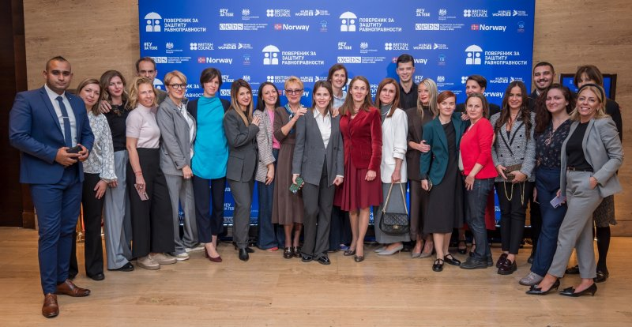
Part of the Professional Service of the Comissioner, 2025.
During 2025, employees of the Professional Service attended training courses organised by the National Academy for Public Administration on various topics: Public Speaking and Presentation Skills; Anti-Stress Workshop; Mental Well-being; Improving the Prevention and Suppression of Trafficking in Human Beings at the National Level; Protection of Human Rights; EIPA – EU Administrative Law; Working in the Central Information System for Payroll Calculation (ISKRA) – HR Module; Agile Internet Searching; and Master the Document Before It Masters You. In addition, employees completed the Ethics and Integrity training organised by the Agency for the Prevention of Corruption, as part of the second cycle of distance learning.
Thanks to full membership in the European Network of Equality Bodies (EQUINET), employees are actively involved in the work of all working groups of this network, which enables the exchange of experience and familiarisation with the anti-discrimination practice and working standards of other equality bodies in Europe.
The level of knowledge, expertise and experience achieved by a number of employees in the Professional Service has provided the institution with the full capacity to deliver training and workshops on anti-discrimination law and on recognising and responding to discrimination, for various professional groups and the general public.
The Commissioner also participated in the “Student Professional Practice in Public Administration 2025/2026” Fair, organised by the Ministry of Public Administration and Local Self-Government, in accordance with the Programme of Cooperation in Providing Public Administration Support to Higher Education Institutions in the Educational Process for the 2024/2025 academic year, with the support of the EU project Communication and Visibility of Public Administration Reform (Communication and Visibility PAR). As part of the implementation of this programme in the 2024/2025 educational process, one student completed professional practice at the institution. In addition, four other students completed professional practice: one in cooperation with the OSCE Mission to Serbia, two in cooperation with Civic Initiatives and one in cooperation with the Roma Education Fund.

Comissioner‘s work in 2025 in numbers

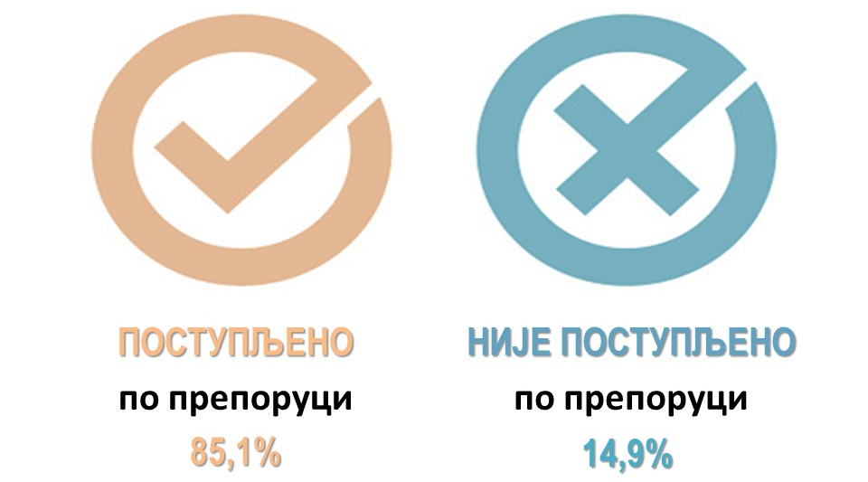
Foto: Acted upon the recommendation 85,1%, Not acted upon recommendation 14,9%

COMMISSIONER’S ACTIONS RELATED TO PROTECTION AGAINST DISCRIMINATION IN 2024
During the reporting year, several thousand citizens contacted the Commissioner, pointing to specific violations of rights or seeking assistance and information regarding the exercise of various rights and services. All citizens who contacted us were provided with detailed information on the possibility of initiating proceedings before the Commissioner, as well as on the possibility of initiating court or other proceedings before the competent authority. By telephone alone, and through conversations at the Commissioner’s reception office, citizens received several dozen pieces of information on average each day. In addition to the information provided in this manner, and in order to make it easier to contact the institution, the Commissioner’s website, which is available in Cyrillic and Latin script as well as in English, contains a complaint form prepared in the languages of national minorities and in a child-accessible format.
During 2025, the Commissioner acted in 4,151 cases. Compared with the previous reporting year, a higher number of complaints was submitted and a higher number of recommended measures was issued, while a higher number of certificates of non-discriminatory conduct was issued to persons applying for positions in the education system or employed in that system.
The total number of cases before the Commissioner and the number of complaints received annually are influenced by a range of factors, such as the adoption or amendment of individual regulations directly affecting the position of individuals; conduct that has affected the position of a particular group sharing the same personal characteristic; situation testing carried out and activities undertaken by civil society organisations, trade unions and other organisations engaged in the protection of human rights; media reporting on certain current issues; and similar factors.
During 2025, the Commissioner received 939 complaints. A total of 837 recommended measures for achieving equality and protection against discrimination were addressed to public authorities and other persons; 16 initiatives for amending regulations were submitted; 20 opinions were issued on draft laws and other general acts; and three proposals were filed for the assessment of constitutionality and legality. Six strategic litigation cases are ongoing, two of which were initiated in 2025, with the Commissioner acting as an intervener in one of them. Seven criminal complaints were filed, six public warnings were issued and 35 press releases were published.
In proceedings upon complaints, 36 opinions were issued. In proceedings upon 30 complaints, an opinion was issued establishing a violation of rights under the Law on the Prohibition of Discrimination, together with a recommendation of measures. In the remaining six complaints, an opinion was issued finding no violation of rights; in four of these cases, however, a recommendation of measures for achieving equality and protection against discrimination was issued in accordance with Article 33, paragraph 1, item 9 of the Law on the Prohibition of Discrimination, although no violation of rights was established.

Commissioner‘s Acting in 2025
*Cases relating to complaints
Prevod slike: 4.151 cases, 6 warnings, 35 announcements, 2316 certificates that no discrimination ws found, 16 initiatives to amend regulations, 6 ongoing proceedings, 7 criminal charges, 1 request for misdeamenor procceding, 20 opinions on legl documents drafts, 837 recommended mesures, 939 complaints received, 3 proposals to review constitutionality

In 83 cases, proceedings were discontinued because the consequences of discriminatory conduct had been remedied after proceedings before the Commissioner had been initiated, and it is not uncommon for a person to withdraw a complaint for these reasons. A number of proceedings were also discontinued for other reasons prescribed by law, such as an incomplete complaint that was not supplemented even after a repeated request from the Commissioner; where it was evident that there had been no violation of rights; where the Commissioner lacked competence to conduct proceedings in the specific case or had already acted in the matter and no new evidence had been offered; where court proceedings had been initiated or completed; where the person withdrew the complaint; and similar reasons.
The Commissioner’s recommendations issued in opinions were complied with in 81% of cases, while 19% were not complied with, and in nine cases the deadline for compliance with the recommendation had not yet expired.
With regard to compliance with the recommended measures for improving equality addressed by the Commissioner to public authorities and other persons, the compliance rate was 89.2%, which, together with compliance with recommendations issued with opinions, gives an average compliance rate of 85.1%. The trend of compliance with the Commissioner’s recommendations has thus continued.

Citizens’ Complaints
In accordance with the Law on the Prohibition of Discrimination, proceedings for protection against discrimination are initiated by a complaint submitted by citizens, civil society organisations, inspection bodies and other persons. However, in addition to acting on complaints, the Commissioner is contacted each year by a considerably larger number of citizens who often do not wish to formally initiate proceedings for protection against discrimination, but rather want to draw attention to a particular problem or request assistance or support in exercising a specific right.
As regards complaints for protection against discrimination, the Commissioner received 939 complaints, the majority of which were submitted by natural persons (795). Women addressed the Commissioner more often than men. In 2025, civil society organisations submitted 74 complaints, almost the same number as in the previous year, while the remaining complaints were submitted by legal entities, inspection bodies and other authorities.

With regard to the areas of social relations in 2025, the largest number of complaints were submitted in the field of employment or at work. These were followed by complaints concerning proceedings before public authorities, education and vocational training, the provision of public services or the use of facilities and public areas, the public sphere/general public, health care, public information and the media, and other areas represented to a lesser extent. Certain events led to a larger number of complaints on the same grounds.
For example, the Commissioner received more than one hundred complaints from employees and trade unions pointing to the less favourable position of certain employees in social welfare centres following the adoption of the Regulation Amending the Regulation on Coefficients for the Calculation and Payment of Salaries of Employees in Public Services. As a result, for the first time since income level was introduced as a personal characteristic into the Law on the Prohibition of Discrimination by the 2021 amendments, this personal characteristic was among the most frequent grounds on which complaints were submitted to the Commissioner. In this regard, the Commissioner issued a recommendation of measures to the Ministry of Public Administration and Local Self-Government and the Ministry of Labour, Employment, Veteran and Social Affairs, which will be discussed in more detail in the section of this Report dealing with discrimination on the basis of specific personal characteristics. Several complaints were also submitted concerning provisions of the Special Collective Agreement for Employees in Primary and Secondary Schools and Student Dormitories, which were disputed from the standpoint of anti-discrimination regulations on the grounds of the personal characteristic of trade union membership, as well as provisions of the Rulebook on Work Discipline and Rules of Conduct for Employees of the National Theatre in Belgrade, which were disputed on the grounds of the personal characteristic of political belief. This partly contributed to the number of complaints submitted in 2025 on these grounds being twice as high as in the previous year. In addition, towards the end of the year, the Commissioner received several complaints, most often from education employees whose contracts were not extended, or whose fixed-term contracts were not renewed after many years of work in an educational institution, on account of their political beliefs or trade union membership.
In view of the increase in citizens’ submissions and complaints filed on these grounds, in addition to several opinions finding discrimination, two civil proceedings for protection against discrimination against employees were also initiated during the year. Through these proceedings, the Commissioner’s primary intention was to emphasise the importance of complying with anti-discrimination regulations and the prohibition of such conduct.
Unlike these grounds of discrimination, for which the number of submissions increased, there was a decrease in the number of complaints on certain other grounds. For instance, fewer complaints on the grounds of sex were filed in 2025 than in the previous year, 2024, while the number was approximately the same as in 2023. This was due to the large number of complaints filed the previous year concerning the treatment of women during and after childbirth in gynaecology and obstetrics clinics, following which the Commissioner issued recommended measures in 2024 to these health care institutions, as well as to the Ministry of Health. Action taken on these recommendations contributed to the absence of submissions on this issue during the current year. In 2025, the Commissioner also considered complaints submitted by parents of eighth-grade pupils concerning the scheduling of different dates for taking the mock final examination. The concern was that this could lead to the unequal treatment of pupils, given that the mock Serbian/mother tongue examination and the third test are held at different times determined by schools.
There was also an increase in the number of submissions concerning problems in exercising rights and accessing social protection services due to insufficient capacities of service providers and insufficient funds allocated for these purposes by local self-governments. For example, several complaints were filed due to the failure to provide organised transport for children with developmental disabilities and disabilities, as well as due to the failure to provide the personal child companion service to children with disabilities, which also resulted in an increase in the number of complaints on these grounds.

In the field of labour and employment, the largest number of complaints this year were submitted on the grounds of membership of trade union organisations and political beliefs, followed by complaints on the grounds of sex and marital and family status, health status and disability. In a number of cases, these involved multiple or intersectional discrimination.

As in previous years, the largest number of complaints were filed against public authorities, followed by complaints against legal entities (most often employers), natural persons, organisations and groups of persons.
Number of complaints by region
Регион Војводине
14,6%
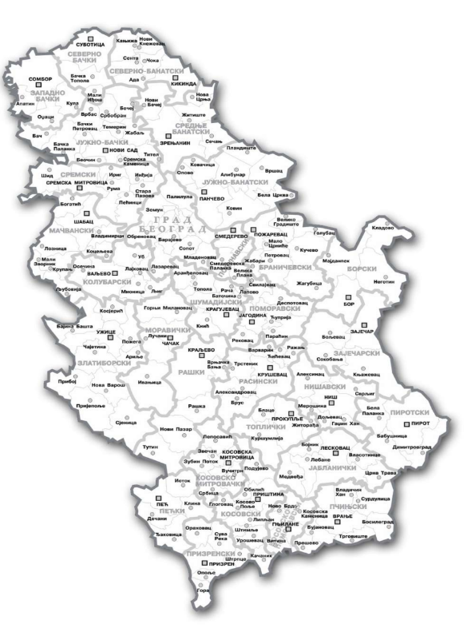
Београдски регион
25,7%
Регион Шумадије и Западне Србије
13,2%
Регион Косова и Метохије
0,7%
Регион Јужне и Источне Србије 16,4%
Непознати регион*
29,3%
Prevod slike: Vojvodina region 14,6%; Belgrade region 25,7%; Šumadij and Western Serbia region 13,2%, Southern and Eastern Serbi region 16,4%; Kosovo and Metohija region 0,7%; Unknown region 29,3%
*The region is unknown where a complaint was submitted by email and the complainant did not indicate the municipality of residence.
As can be seen from the chart, the number of complaints is relatively evenly distributed across regions, with the exception of the Kosovo and Metohija region.

Recommended Measures
In 2025, the Commissioner issued a total of 837 recommended measures for the achievement of equality and protection against discrimination. Although recommended measures are discussed in greater detail in the section of this Report dealing with discrimination on specific grounds, particular recommendations covering a larger number of persons and contributing to improving the position of certain social groups are highlighted here.
Following the formation of the new Government, the Prime Minister-designate was issued a recommendation concerning the balanced representation of women and men in the future Government. The recommendation emphasised that balanced participation of women and men in decision-making and public policy development is one of the prerequisites for the development of society, a fairer distribution of influence, the use of the potential of all its members and the achievement of sustainable development.
A recommendation was issued to television broadcasters with national coverage, print media and online portals (hereinafter: the media) registered in the Media Register maintained by the Serbian Business Registers Agency:
- to take all necessary measures to prevent the publication, and to remove content and comments already published, where they incite discrimination, hatred or violence against a person or group of persons on the basis of their personal characteristic, or constitute harassment, degrading treatment, or sexual and gender-based harassment aimed at violating the dignity of a person or group of persons on the basis of their personal characteristic, in particular where such conduct creates fear or an intimidating, hostile, degrading, humiliating or offensive environment.
A recommendation was also issued to all local self-government units to establish or improve the free legal aid system and to fully inform citizens, through multiple appropriate channels of communication, about this constitutionally guaranteed right. In particular, it was recommended that local self-government units which had not organised the provision of free legal aid in their territory should establish a service providing free legal aid to citizens, and that those which had already established such a service should take measures to ensure that potential beneficiaries are fully informed about their rights, as well as about the ways in which those rights may be exercised and the service provided.
Another recommendation of measures was issued to all local self-government units, recommending that, when announcing public calls for programmes and projects financed from the budget of the Republic of Serbia and from local self-government budgets, they place civil society organisations established in accordance with the Law on Endowments and Foundations on an equal footing with other associations.
In order to advance the equality of persons with disabilities who have permanent consequences of a physical or sensory impairment and are therefore unable to sign by hand, but instead use a facsimile signature (a stamp containing personal identity data / a stamp with an engraved signature), all banks were recommended to improve access to banking products and services (opening accounts, withdrawing funds from accounts, etc.) without discrimination and without imposing additional conditions, such as signing through a proxy, in accordance with the law.
The Commissioner issued a recommendation of measures for the advancement of equality to the Ministry of Labour, Employment, Veteran and Social Affairs in connection with problems that arose when certain persons lost the right to financial social assistance due to errors committed by employees in several social welfare centres. In order to act preventively and improve the equality of beneficiaries of social protection rights and services, the Ministry was recommended to review the existing staffing standards and establish criteria based on the actual needs of social welfare centres; to strengthen their capacities in both quantitative and qualitative terms; to strengthen inspection authorities and increase the number of inspections; and, by analysing the most frequent errors in the work of social welfare centres through second-instance proceedings, to provide training or issue appropriate instructions on how to address problems that arise in practice.
A recommendation was issued to the Ministry of Education concerning measures to enable, at the request of persons who underwent sex reassignment (change of sex marker) after completing their education, the issuance of diplomas on acquired education and other public documents issued by educational institutions, so that the personal data in documents on acquired education (name and surname, personal identification number, sex marker) correspond to the data in identity documents and other public documents.
The Ministry was also recommended to set one and the same date for the mock final examination for all eighth-grade pupils, and to allow pupils, after the mock test and following an assessment of its results, to change their decision regarding the choice of subject for the third test.
In order to ensure the equality of all candidates and employees of the Ministry of Interior and to prevent possible discrimination on the basis of personal characteristics - appearance and health status - a recommendation was issued to the Institute for Health Care of Workers of the Ministry of Interior to:
- review and revise the List of Morbid Conditions, starting from anti-discrimination regulations, by assessing whether all diseases and conditions included in the List are of essential relevance and objectively constitute an obstacle, or an exclusionary condition, for obtaining a positive assessment of medical fitness for police work; that is, whether the exclusionary criteria and standards set are appropriate and necessary, i.e. objectively justified by a legitimate aim with regard to the standards of medical fitness for performing the duties of a police officer.
The National Employment Service was recommended that employment counsellors, in accordance with the Instruction on the Conditions for Including Unemployed Persons in Active Labour Market Policy Measures, should pay particular attention, when preparing individual employment plans, to persons who provide direct care to a close family member; in other words, they should consider these persons’ socio-demographic characteristics, opportunities and difficulties, with a view to their more effective inclusion in active labour market policy measures.
It was recommended that the Belgrade Institute for Emergency Medical Care amend its Code of Conduct, which requires employees to treat persons with disabilities with particular care and to give them priority in the provision of health care, provided that this does not jeopardise the interests of other patients and that such priority is not contrary to the law or the bylaws adopted for its implementation, by also including older persons in this category, and that it comply with this obligation in practice. It was also recommended that the Institute organise sensitivity training for employees on working with older persons, in order to obtain the necessary information on their health condition and need for emergency medical assistance in an appropriate manner.
It was recommended that the City of Pančevo, in accordance with the Law on Refugees and the Conclusion of the Government, and with a view to completing the process of integration of refugees who are beneficiaries of the SIRP Programme, enable the purchase of housing units acquired through construction for the purposes of their integration, and apply to the sale and lease of these housing units the provisions of the Law on Refugees governing the housing needs of refugees.
It was recommended that the City of Požarevac take all necessary measures and activities within its competence to equalise the position of children attending a preschool institution founded by the City of Požarevac and children referred to private preschool institutions because of insufficient capacity in the institutions founded by the city, particularly with regard to the disproportionate shifting of the economic burden for periods of absence between children attending public preschool institutions and those referred to private preschool institutions owing to insufficient capacity in public institutions founded by the city.
It was recommended that the City of Prokuplje take urgent measures to provide households in the village of Miljkovica with electricity and humane living conditions, so that the residents of this village can meet their basic needs and minimum conditions for a normal life, without discrimination.
It was recommended that the City of Niš apply the Decision on granting assistance to pupils in the territory of the City of Niš, concerning the payment of financial assistance in the amount of RSD 20,000 to parents of primary school pupils in the city, also to children attending the School Plus Primary School for Children with Developmental Disabilities in Niš.
It was also recommended that the City of Niš and the City Administration for Social and Family Protection, Education, Culture and Sports of the City of Niš take measures within their competence and issue instructions to the city municipalities of Niš to harmonise the regulations governing the criteria for awarding prizes to primary and secondary school pupils and students who achieve the best results, so that the award criteria are formulated in a way that ensures equal access for all pupils and students, without discrimination on any personal characteristic, including place of residence.
It was recommended that the municipalities of Senta, Ada, Mali Iđoš, Kanjiža, Bačka Topola and Novi Kneževac, as well as the City of Subotica, replace the traffic signs for which local self-government is responsible, where, contrary to the regulations, they are not also written in the language of a national minority that is in official use in their territory.
Since all elected members of the Municipal Council in Vladimirci are men, it was recommended that this local self-government unit take measures to ensure balanced representation of women and men in the bodies of the local self-government unit.
It was recommended that the Ćurija cultural institution immediately suspend the implementation of the published competition for the creation of a mural of General Nebojša Pavković and the display of that mural in a place accessible to the public.
It was recommended that the Organisation of Music Authors of Serbia (SOKOJ) develop ethical guidelines for the assessment of music content, with particular focus on prohibiting the dissemination of racist and sexist narratives, as well as content that incites discrimination, hatred or violence against persons or groups of persons on the basis of their personal characteristics, or constitutes harassing or degrading treatment, or sexual and gender-based harassment aimed at violating the dignity of a person or group of persons on the basis of their personal characteristics, particularly where it creates fear or an intimidating, hostile, degrading, humiliating or offensive environment. It was also recommended that the guidelines be made available to all SOKOJ members and published on its website.
It was recommended that the Museum of Vojvodina remove the word “Unijati” from the text on the panel in the part of the permanent exhibition of this cultural institution that contains basic information about Greek Catholics, bearing in mind that members of this religious community consider the term outdated and as having a negative connotation for their community.
The company Srbijavoz AD was recommended not to charge the additional RSD 500 fee for issuing a ticket on board the train to passengers departing from stations equipped only with ticket machines.
These and other recommendations are presented in more detail in the section of the Report dealing with discrimination on the basis of specific personal characteristics. recommended measures are available on the Commissioner’s website: https://ravnopravnost.gov.rs/misljenja-i-preporuke/preporuke-mere-organima-javne-vlasti/https://ravnopravnost.gov.rs/misljenja-i-preporuke/preporuke-mere-organima-javne-vlasti/

Opinions on Draft Laws and Other Legal Documents and Initiatives Submitted
In 2025, the Commissioner issued 20 opinions on draft laws and other regulations and submitted 16 initiatives for the adoption or amendment of regulations. In line with the mandate entrusted to the institution, the Commissioner used these opinions to point to the need for specific changes to the proposed provisions, or to propose the necessary amendments to these acts in order to bring them into line with anti-discrimination regulations. In 2025, certain authorities failed to comply with their legal obligation to submit draft laws and other acts to the Commissioner for opinion. In addition, no assessment was made of the impact of regulations on socio-economically disadvantaged persons, nor was there an assessment of the risks to the rights, obligations and legally protected interests of persons and groups at greater risk of discrimination.
Opinions were issued on the following: Draft Law on Amendments to the Law on the Foundations of the Education System; Draft Law on Amendments to the Law on Secondary Education; Draft Law on Amendments to the Law on Primary Education; Draft Law on Amendments to the Law on Preschool Education; Draft Law on Amendments to the Law on Textbooks; Draft Law on Information Security; Draft Law on Amendments to the Law on Salaries of Civil Servants and State Employees; Draft Law on Amendments to the Law on Civil Servants; Draft Law on Health Care and Health Insurance of Military Insured Persons; Draft Law on the Register of Births, Marriages and Deaths; Draft Law on Military Education; Proposal for a Decision amending the Strategy for Preventing and Combating Gender-Based Violence against Women and Domestic Violence for the period 2021-2025; Report on activities implemented in 2024 for the implementation of the Strategy for Creating an Enabling Environment for the Development of Civil Society in the Republic of Serbia; Draft General Comment No. 27 (2024) of the UN Committee on the Rights of the Child on access to justice and effective remedy; Proposal for an Environmental Protection Strategy with an Action Plan in the Republic of Serbia for the period 2025-2033 - Serbia's Green Agenda; revised proposal of the National Action Plan for the implementation of United Nations Security Council Resolution 1325; Final Report on the implementation of the Strategy for Improving the Position of Persons with Disabilities in the Republic of Serbia for the period 2020-2024; Proposal for an Action Plan for the implementation of the Strategy for the Development of the Public Information System in the Republic of Serbia for the period 2020-2025, in 2025; Proposal for an Action Plan for the Exercise of the Rights of National Minorities for the period 2026-2029; and Proposal for the Action Plan for 2026 and 2027 for the implementation of the Strategy for Social Inclusion of Roma Men and Women in the Republic of Serbia for the period 2022-2030.
Initiatives were submitted to the Ministry of Finance, the Ministry of Economy, the Ministry of Health, the Ministry of Family Welfare and Demography, and the Ministry of Labour, Employment, Veteran and Social Affairs for the amendment and mutual harmonisation of regulations concerning equalisation of the position of women during pregnancy, maternity leave and leave from work for childcare, regardless of the basis of their work engagement, that is, for equalising the position of women entrepreneurs and women engaged under contracts outside employment with the position of women employed by an employer in terms of exercising rights arising from the same life event - pregnancy and childbirth. An initiative was also submitted for the adoption of a by-law that would clearly regulate the conduct of health-care institutions in situations where a person is staying in a place other than their place of residence and needs health care in the place of temporary stay, when the case is not an emergency. An initiative was submitted to the National Health Insurance Fund to enable persons living with multiple sclerosis to receive therapy in local health centres, rather than only in tertiary health-care institutions. An initiative was submitted to the Ministry of Internal and Foreign Trade to amend the provision of the Law on Real Estate Brokerage and Leasing concerning the absolute prohibition of registration in the Register of Brokers on the grounds of a previous conviction, irrespective of the sentence imposed or the offence for which the person was convicted. An initiative was submitted to the Ministry of Public Administration and Local Self-Government to amend the Regulation on Coefficients for the Calculation and Payment of Salaries of Employees in Public Services. An initiative was also submitted to the Chamber of Public Notaries concerning the issue of the use of facsimile signatures by persons with disabilities, with a view to ensuring uniform and least restrictive application in proceedings before public notaries. Amendments were also initiated to the Action Plan for the period 2024-2026 for the implementation of the Employment Strategy in the Republic of Serbia for the period 2021-2026, and an initiative was submitted to amend the Companies Law, the Law on Public Enterprises and the Law on the Management of Companies Owned by the Republic of Serbia, with the aim of introducing quotas for the underrepresented sex in management bodies. The initiative to the Ministry of Finance to exempt products used for feminine hygiene from VAT was repeated. Initiatives were also resubmitted to the Ministry of Justice to amend the Criminal Code, the Law on Misdemeanours and the Law on the Enforcement of Criminal Sanctions, as well as to adopt a by-law pursuant to Articles 40a and 40b of the Law on the Prohibition of Discrimination, which concern records on protection against discrimination, that is, the submission of final judgments and court decisions concerning discrimination and violations of the principle of equality. The Commissioner again addressed the Ministry of Health regarding amendments to laws concerning the transplantation of organs and tissues.
Certain opinions and initiatives will be discussed in more detail in the sections of the Report dealing with discrimination on the basis of specific personal characteristics. Opinions and initiatives are available on the Commissioner's website: https://ravnopravnost.gov.rs/misljenja-i-preporuke/zakonodavne-inicijative-i-misljenje-o-propisima/

Other Outcomes of Proceedings
In accordance with the Law on the Prohibition of Discrimination, the Commissioner does not act on a complaint where it establishes that it does not have jurisdiction; where the complainant failed to remedy the deficiencies in the complaint within the prescribed time limit;; where proceedings in the same matter have been initiated before a court or have been finally concluded before a court; in the event of the death of the complainant or the deletion of a legal entity from the register; where it is obvious that there has been no violation of the right to which the complainant refers; where the Commissioner has already acted in the same matter in accordance with its powers and no new evidence has been submitted; where, due to the passage of time since the violation occurred, the purpose of the proceedings can no longer be achieved; where the procedure for reaching an agreement has been successfully completed; where the complainant has withdrawn the complaint or agrees that the consequences have been remedied; and in other cases prescribed by law. A statistical overview of the Commissioner’s work is provided in Annex 1 to this Report.

Court Proceedings

Civil Proceedings
In 2025, two civil proceedings for protection against discrimination were initiated: the Commissioner initiated one strategic litigation case and submitted one motion to intervene in proceedings brought by another person before the Higher Court in Kragujevac. In those proceedings, the court issued a decision allowing the Commissioner to join the case as an intervener on the side of the plaintiff. During the year, three judgments and two decisions were also issued in civil proceedings initiated by the Commissioner in previous years. A total of six civil proceedings are currently pending.
Strategic litigation against the Pančevo Health Centre

In 2025, the Commissioner filed a lawsuit for protection against discrimination against an employer for placing an employee in an unjustifiably less favourable position on the grounds of her political beliefs and trade union membership. The Commissioner was contacted by a nurse who, because of her political beliefs and trade union membership, had been transferred from the position of head nurse and head of department at the Pančevo Health Centre to a lower-ranking post of senior nurse at the outpatient clinic in Dolovo, the clinic located furthest from her place of residence. The transfer took place immediately after she had supported the protests in Pančevo following the death of 16 people caused by the collapse of the canopy at the Novi Sad Railway Station, and after her trade union activities, in which she, as an elected union official, sent union letters to employees expressing the union’s support for the protests.
The Commissioner filed this lawsuit in view of the increased number of communications from citizens alleging discrimination on the grounds of political beliefs and membership of a political or trade union organisation, most often in the field of work and employment. The complaints pointed to various forms of less favourable treatment, including transfer to a lower-ranking post, dismissal or threats of dismissal, termination or non-renewal of contracts, or other forms of adverse treatment. The significance of this litigation goes beyond the individual case, and its purpose is to send a clear message that such conduct is discriminatory and prohibited by law. The proceedings are ongoing.

Strategic litigation against the City of Kragujevac – City Administration for Human Resources, General and Joint Affairs

In 2025, at the Commissioner’s request, the Higher Court in Kragujevac issued a decision allowing the Commissioner to join proceedings as an intervener on the side of the plaintiff against the City Administration of the City of Kragujevac, in a case concerning discrimination against an employee of the City Administration on the grounds of political belief and trade union membership. The employee had refused to support the ruling party and to provide a “sure vote”, after which he was immediately transferred to a workplace in a remote local community office in premises unsuitable for work, as confirmed by an inspection report. Because of his transfer to these remote premises, which lacked even the most basic working conditions, he was also prevented from engaging in trade union activities.
This is the second case in which the Commissioner is participating as an intervener. The plaintiff’s claim is in line with the types of claims that may also be brought by the Commissioner. Like the previous case, this litigation goes beyond the importance of the individual case and is of strategic significance, with the aim of contributing to protection against discrimination for persons who find themselves in a similar situation. As with all strategic litigation conducted by the Commissioner, one of its aims is to improve judicial practice in proceedings for protection against discrimination and to raise public awareness of the prohibition of discriminatory conduct. The proceedings are ongoing, and four hearings have been held to date.
Another case is also ongoing in which the Commissioner submitted a motion to participate as an intervener. The proceedings were initiated by the mother of a boy against a private preschool institution, on the grounds of discrimination against her minor son, who has autism. Since the proceedings before the Higher Court in Belgrade had already been initiated, and bearing in mind the frequency of communications from parents of children with health-related difficulties concerning both enrolment in and attendance at preschool institutions, as well as the fact that the case meets all the criteria for strategic litigation, the Commissioner submitted a motion to the court to participate as an intervener on the side of the plaintiff.
In the motion, the Commissioner stated that there was a legal interest in the plaintiff’s success in the proceedings, particularly in view of the importance of inclusion and the equal participation of children with health-related difficulties in the educational process, as well as the importance of their attendance at preschool institutions without discrimination. The proceedings are ongoing.
Judgment of the Higher Court in Belgrade upholding the Commissioner’s claim in full in strategic litigation against the Niš Bar Association

In the strategic litigation initiated by the Commissioner in 2024, two decisions were issued: first, by the Higher Court in Belgrade, staying the proceedings until the final conclusion of proceedings before the Administrative Court in Belgrade; and second, by the Court of Appeal in Belgrade, setting aside the decision of the Higher Court and remitting the case to that court for retrial.
By way of reminder, the Commissioner was contacted by A.A., who alleged that he had been discriminated against on the grounds of age as a personal characteristic. The complaint stated that, because he was over 65 years of age, he had been prevented from practising law.
The Higher Court in Belgrade, taking the view that the administrative dispute constituted a preliminary issue for deciding on the Commissioner’s claim, issued a decision staying the proceedings until the final conclusion of the proceedings before the Administrative Court in Belgrade.
The Commissioner appealed against the decision, pointing out that the lawsuit sought protection against discrimination on the grounds of age and that the matter was not the same as the one before the Administrative Court.
The Court of Appeal in Belgrade issued a decision setting aside the decision of the Higher Court in Belgrade and remitting the case for retrial. The Court stated that the decision in the administrative dispute was not a preliminary issue for deciding on the claim for establishing discrimination, because the decision on the claim did not depend on the outcome of the administrative dispute, given that the subject matter and legal basis of the two proceedings were different.
At the beginning of 2026, the Higher Court issued a judgment upholding the Commissioner’s claim and establishing that the respondent, the Niš Bar Association, had discriminated against A.A. on the grounds of age as a personal characteristic by rejecting his application for entry in the Register of Volunteer Trainee Lawyers of the Niš Bar Association, stating that “the legal profession must be rejuvenated and such growth can have a positive effect only if the practice of law is carried out and expanded by young people... while A.A. has already given everything he had and could give in his professional work with his intellectual and physical capacities....”, thereby violating the principle of equal rights and obligations. The Bar Association was prohibited from repeating the discriminatory acts and ordered, at its own expense, to publish the operative part of the judgment in a daily newspaper with nationwide circulation.

During 2025, two judgments were delivered in the proceedings previously initiated by the Commissioner against a municipality and a social welfare centre. By way of reminder, the Commissioner was addressed by a mother alleging discrimination against her minor child on the grounds of disability and health status. In 2021, the Commissioner filed a lawsuit against the municipality and the social welfare centre, as the defendants had denied the minor child the right to the service of a personal aide, which the child needed due to his health status and disability, thereby hindering the exercise of his right to education and full inclusion in the education system.
The Higher Court in Belgrade delivered a judgment dismissing the Commissioner’s claim as unfounded. Acting on the Commissioner’s appeal, the Court of Appeal in Belgrade stated that the actions of the defendants did not constitute discrimination, although the court established as an undisputed fact that the minor child had not been provided with the personal aide service during the 2020/2021 calendar year, because during the same period no child from the territory of the Municipality of Novi Kneževac had been provided with that service. The court also took the view that, although the service had not been provided on a regular basis, there had been no violation of the right to equality, since such conduct had not been motivated by the child’s personal characteristics (disability), and since the defendants had provided the service within their available capacities.
Considering that this position of the Court of Appeal was not in line either with domestic case-law or with the case-law of the European Court of Human Rights, the Commissioner filed a revision appeal with the Supreme Court of Cassation. In the revision appeal, the Commissioner pointed out, among other things, that when examining whether direct discrimination has occurred, it is necessary to use a “comparator”, namely a person who is in the same or a similar situation as the victim of discrimination, but differs from that person in that they do not have the personal characteristic of the victim. The Commissioner indicated that, in this particular case, the “comparator” could be children without disabilities who attended school, and by no means children with the same or a similar degree of disability. The Commissioner also pointed out that motive or intent are not constitutive elements of an act of discrimination, and that the position that this service is to be provided “within available capacities” is unacceptable, given that this is a human right belonging to the beneficiary from the moment the right is established in accordance with the law. The revision proceedings are ongoing.
Strategic litigation against a doctor for discrimination against a group of persons on the grounds of sexual orientation as a personal characteristic is also ongoing. During a television appearance on the announced holding of EuroPride, at a time of heightened social tension when marches and protests against the event were taking place in the streets of Belgrade, the defendant doctor stated that “homosexuality was and remains a disease and can be treated”. The defendant expressed disagreement with the official position of science, despite being a doctor, which gives particular weight to his statement. The defendant filed a counterclaim against the Commissioner in these proceedings for exercising the powers prescribed by law, which constitutes an abuse of rights and a form of pressure on the work of the court aimed at prolonging the proceedings.
The Higher Court in Belgrade delivered a judgment dismissing in its entirety both the claim of the plaintiff-counter-defendant, the Commissioner, and the counterclaim of the defendant-counterclaimant. In its judgment, the Higher Court stated that in the specific case the defendant-counterclaimant had publicly expressed his personal opinion on homosexual orientation and the announced EuroPride event and that, in the court’s assessment, this statement did not violate the provisions of the Law on the Prohibition of Discrimination. In deciding on the merits of the counterclaim, the court found that the claim was unfounded, as the Commissioner had acted in accordance with his powers under Article 46 of the Law on the Prohibition of Discrimination.
Considering that this position of the Court of Appeal was not in line with the case-law of the Supreme Court, nor with the case-law of the European Court of Human Rights, the Commissioner filed an appeal contesting the part of the judgment dismissing the Commissioner’s claim. In the appeal, it was pointed out, among other things, that it is deeply concerning that such speech, which targets an entire population on the basis of a personal characteristic by portraying it as diseased, is legitimised as an ideological and political position. The Commissioner indicated that the first-instance court recognised the defendant’s speech as offensive, but failed to explain why such speech did not constitute speech that violates the dignity and reputation of an entire group of persons on the basis of a specific personal characteristic. The court also failed to explain why it considered that the conditions had not been met for restricting freedom of expression in order to protect the reputation and rights of others, as provided for in Article 46 paragraph 2 of the Constitution of the Republic of Serbia and Article 10 paragraph 2 of the European Convention for the Protection of Human Rights and Fundamental Freedoms. The appeal proceedings are ongoing.

Misdemeanour proceedings
In 2025, the Commissioner submitted a request to the Misdemeanour Court in Belgrade to institute misdemeanour proceedings against a company providing urban public transport services in the territory of the City of Belgrade, on the grounds of reasonable suspicion that it had committed the misdemeanour referred to in Article 52 paragraph 1 of the Law on the Prohibition of Discrimination. Namely, a bus driver refused to lower the ramp to enable a person with a disability who uses a wheelchair to board the bus, thereby refusing to provide the transport service.

Criminal proceedings
In 2025, the Commissioner filed seven criminal complaints with the competent public prosecutors’ offices.
In the first case, we addressed the Higher Public Prosecutor’s Office in Belgrade regarding a discriminatory message published on a social media profile. A citizen contacted the Commissioner and indicated that a discriminatory message had been posted on the profile, stating: “DEAR PRESIDENT OF SERBIA, I ASK THE COMPETENT STATE INSTITUTIONS TO REACT URGENTLY TO THIS MONSTROUS WRITING BY THIS LADY! THE ABOVE-MENTIONED LADY CALLED THE SURVIVORS OF THE KOČANI ACCIDENT ‘12 PIECES OF ROAST MEAT FROM MACEDONIA THAT ARRIVED IN BELGRADE’.” The citizen further indicated that the unknown author’s profile stated: “The roast meat has arrived in Belgrade. 12 pieces”; “So you did make a deal with Kurti and gave them to us. We’ll throw them into the Zoo! Perfect!” Below this text, an image was posted showing the flag of the European Union, the flag of the KLA, the rainbow flag and the NATO flag, with a silhouette of the President in black in front of them, over which the word “TRAITOR” was written. Beneath the image, the following text appeared: “While you were thinking this up, you were hanging on … This is your flag. Sit down, you get a one.” In the criminal complaint, the Commissioner referred to Article 54a of the Criminal Code, which provides that if a criminal offence is committed out of hatred on the grounds of another person’s race or religion, national or ethnic affiliation, sex, sexual orientation or gender identity, the court shall consider this circumstance as aggravating, unless it is prescribed as an element of the criminal offence.
We addressed the Higher Public Prosecutor's Office in Belgrade, Special Prosecutor's Office for High-Tech Crime, concerning the publication of an antisemitic video on the social media platform Instagram. The text accompanying the video stated: "..... member of the Bravo movement. Jewish woman. Wife of ....... owner of the portal .... together with his wife is destroying the state ... is, moreover, a proven anti-Serb." The text of the video was accompanied by discriminatory photographs.
We also addressed the said public prosecutor’s offices in relation to hate speech directed at the organisation Haver Serbia and its members.
A criminal report was also filed with the Higher Public Prosecutor's Office in Sremska Mitrovica concerning a disturbing video of violence against a minor from Slankamenacki Vinogradi, in the municipality of Indjija, which was published in certain media outlets and on social media. According to the reports, the attacks on the minor were connected with the fact that he belongs to the Slovak national minority. We addressed the Higher Public Prosecutor's Office in Belgrade regarding attacks on members of the Union of Christian Baptist Churches in Serbia on social media (from the profile zemlja.predaka), which were directed at the pastor of the Baptist Church in Vrnjacka Banja and members of his family.
In addition, we addressed the public prosecutor's office in Novi Sad following submissions from citizens who stated that, in the settlement of "Bangladesh" in Novi Sad, police officers of the Novi Sad Police Administration had acted unprofessionally and unlawfully towards several persons of Roma nationality. The submission received by the Commissioner stated that, during the actions taken by police officers, ethnic profiling of residents of the "Bangladesh" settlement had occurred, as well as the indiscriminate excessive use of force against members of the Roma national minority. The Basic Public Prosecutor's Office in Novi Sad informed the Commissioner that it had opened a case and sent a request for the collection of information to the Internal Control Sector - Novi Sad Department.
We filed a criminal report with the Basic Public Prosecutor's Office in Novi Sad following allegations by a foreign worker that he was a victim of exploitation and that his money and passport had been taken from him. In this connection, the Commissioner also immediately contacted the Labour Inspectorate, so that this authority could take measures falling within its competence.
Furthermore, regarding a criminal report filed by this body in 2024, the Third Basic Public Prosecutor's Office in Belgrade informed the Commissioner that it had referred the report to the Higher Public Prosecutor's Office in Belgrade - Special Department for High-Tech Crime, as the manner in which the offence was committed brought it within that department's jurisdiction. By way of reminder, the criminal report was filed on the grounds of suspicion that a person had committed the criminal offence of sexual harassment under Article 182a, paragraph 2, of the Criminal Code, and the criminal offence of showing, obtaining and possessing pornographic material and exploiting a minor for pornography under Article 185, paragraph 1, of the Criminal Code. Namely, the Commissioner received a complaint stating that a karate coach had, continuously over a period of two years, via the social network Facebook and other electronic communication programmes and networks (Instagram, Viber, etc.), sent explicit text, audio and visual messages (images of his sexual organ, and inappropriate and disturbing messages with sexual connotations) to the complainant, who was a minor at the time. The complaint stated that she had been afraid to file a report because of the consequences that had been indirectly threatened, namely exclusion from the national team.

Situational testing
In court and other proceedings, proving discrimination by standard means of evidence often does not produce satisfactory results. For this reason, the Law on the Prohibition of Discrimination introduced a special method of voluntary examination of discrimination (situational testing), which facilitates the proof of discrimination. Situational testing is used to establish discrimination "on the spot", in order to prove unequal or less favourable treatment of a person or group of persons based on a personal characteristic, or to make discriminatory practices visible. This method or mechanism makes it possible to detect discrimination that is often hidden and justified by various pretexts. Situational testing is a specific mechanism that entails creating a particular situation in which a person (the potential discriminator) is placed in a position where they may behave or act in a discriminatory manner without fear of being observed, while the testers are those who expose themselves to the conduct of the potential discriminator and verify whether that person behaves in a discriminatory manner in the given situation. Situational testing has considerable potential to strengthen evidence of discriminatory conduct in individual cases, and is also used to raise public awareness and develop public policies. In accordance with the Law on the Prohibition of Discrimination, a person who has knowingly exposed themselves to discriminatory conduct with the intention of directly verifying the application of the rules prohibiting discrimination in a specific case is required to inform the Commissioner of the intended action, unless the circumstances do not allow this.
In 2025, unlike in previous years, the Commissioner was not informed that any situational testing had been carried out. By way of reminder, in previous years situational testing was most often conducted by civil society organisations, for example to check the accessibility of social welfare centres for persons with disabilities; the availability of health care services to persons living with HIV; the availability of rental housing or employment to members of the Roma national minority, and similar matters. On the basis of the results of situational testing conducted, and complaints submitted by civil society organisations and other persons, the Commissioner conducted proceedings and, in most cases, established discriminatory conduct. In previous years, a number of situational tests covered a large number of social welfare institutions, health care institutions, landlords and employers, which was very important for verifying the application of the rules prohibiting discrimination. Since situational testing very often requires human resources, time and certain financial resources, and since there were fewer civil society organisation projects in 2025, this unfortunately resulted in the absence of activities aimed at implementing this important method for detecting potential discrimination.

Proposals for the Review of Constitutionality and Legality
During 2025, the Commissioner addressed the Constitutional Court on several occasions concerning the review of the constitutionality and legality of certain regulations.
Following submissions from school employees, trade unions and associations, and after conducting an analysis, the Commissioner submitted to the Constitutional Court a Proposal for the review of the constitutionality and legality of Article 27, paragraphs 2 and 3, and Article 31, paragraphs 4 and 5, of the Special Collective Agreement for Employees in Primary and Secondary Schools and Student Dormitories (hereinafter: the SCA), requesting that the Court act urgently and examine the disputed provisions of the Collective Agreement.
The Proposal states that the disputed provisions place members of the representative trade unions that are signatories to the SCA in a privileged position. Under these provisions, compared with other employees, they are entitled to severance pay upon termination of employment for the purpose of retirement in the amount of three times the employee’s last paid salary, whereas employees who are not members of these trade unions are entitled to severance pay in the amount of two average salaries. In addition, under the amended provisions, members of the representative trade unions that are signatories to the Agreement are entitled to a jubilee award that is 50% higher than that paid to employees who are not members of these trade unions.
The Commissioner emphasised that this violates freedom of association and the principle of equality, because granting the prospect of greater rights solely on the basis of membership in a particular trade union influences trade union association and gives employers greater influence over trade unions, which is prohibited under ratified conventions and domestic regulations. The Proposal also notes that representative trade unions do have the right, in the course of collective bargaining, to secure the most favourable working conditions and broader rights for employees. However, their bargaining power is limited by mandatory rules and cannot extend to negotiating basic rights in a manner that differentiates between employees. Bearing in mind the purpose of bargaining on behalf of all employees, as well as the nature and substance of the rights to severance pay and jubilee awards, and the fact that these payments are made from the budget of the local self-government unit rather than from trade union funds, the amounts that employees are to receive on these grounds should not, under any circumstances, be in any causal relationship with any personal characteristic of the employee, including membership in a political, trade union or other organisation. The Proposal points out that the prohibition of discrimination, that is, the prohibition of unequal treatment of employees on the basis of membership in political, trade union or other organisations, is prescribed by the Constitution and the law, and that an analysis of all relevant regulations shows that there is no rational reason for the scope of the exercise of rights to differ on the basis of trade union affiliation.
The disputed provisions may lead an employee to join a representative trade union that is a signatory to the Agreement shortly before the determination of the right to a jubilee award or severance pay, in order to receive a higher amount. This indicates that these economic benefits directly influence the motive and reason for joining a particular trade union, thereby making all other trade unions less competitive.
The Proposal further states that this differential treatment has the effect that, solely because an employee is a member of a representative trade union that is a signatory to the SCA, that employee’s years of service with the employer are now valued more highly, although there is no rational or legally grounded justification for this.
More at: https://ravnopravnost.gov.rs/rs/173-25-predlog-za-ocenu-ustavnosti-i-zakonitosti-posebnog-kolektivnog-ugovora-za-zaposlene-u-osnovnim-i-srednjim-skolama-i-domovima-ucenika/

The Commissioner also submitted to the Constitutional Court a Proposal for the review of the constitutionality and legality of Article 114 of the Law on Health Insurance. The provisions of this Article stipulate that an insured person is entitled to use health care abroad at the expense of compulsory health insurance funds if, prior to travelling abroad, it has been established that their health condition is such that they do not suffer, or have not suffered in the previous 12 months, from acute or chronic diseases in an acute phase requiring longer-term or permanent treatment, and that the insured person is not in a condition which would, shortly after arrival abroad, require treatment or admission to an inpatient health care institution, including other health services. Citizens addressed the Commissioner pointing to the unfavourable position of insured persons with chronic diseases, citing as examples persons with diabetes, arthritis, psoriasis and similar chronic diseases, who, by application of this provision, would in practice never be able to exercise the right to health care abroad in the event of an urgent medical need because the disputed Article excludes them. They also noted that situations requiring emergency medical assistance are generally not caused by a chronic disease, but by an accident, such as injuries resulting from a fall, poisoning and similar incidents, which cannot be foreseen and may happen both to a person who has no illness and to a person who recovered several months earlier or to a person with a chronic disease who is receiving regular therapy.
In the Proposal, the Commissioner stated that the decision to limit health care abroad to emergency cases aimed at eliminating an immediate threat to the life of the insured person may be considered justified and proportionate, given that it applies to all insured persons and that it is evident that the Fund’s resources are not unlimited and must be carefully planned and used in accordance with the principles of health care. However, the question arises as to the justification and proportionality of restricting the right to health care at the expense of compulsory insurance in emergency cases abroad only for a particular group of insured persons, namely those who have or have had an acute disease or a chronic disease in an acute phase in the previous 12 months, requiring longer-term or permanent treatment. The provision does not make clear the justification for such a condition, because the health condition of a person who had an acute disease or a chronic disease in an acute phase in the previous 12 months may be stable and under control. The Commissioner also pointed out that the Republic of Serbia still does not have a single health record in which all examinations and interventions undergone by an insured person, whether in a “public” or a “private” health care institution, are entered. This may lead to a situation in which a person who had an acute or chronic disease in the previous 12 months exercises the right to health care abroad simply because this fact was not recorded, even though they do not meet the statutory requirements because the information was not entered in their medical file. Insured persons who consult a doctor less frequently, or not at all although they have a need to do so, are in the same position and will also receive medical care abroad from the Fund’s resources regardless of their health condition in the previous period, which may have been such that, under the disputed provision, they should not have been entitled to it. In particular, the rationale of the norm cannot be discerned with regard to the prescribed period of 12 months prior to travel abroad, nor is it clear what guided the legislator in prescribing precisely this period. This is especially so if a person had an acute illness, for example, 11 months earlier and recovered from it, and then in the twelfth month wishes to travel abroad; the question arises as to why that person should be excluded from health insurance coverage at the Fund’s expense in the event of emergency medical assistance. Conversely, an insured person who did not suffer from any illness in the 12 months prior to travelling abroad is not exempt from the risk that, immediately after travelling abroad, they may need emergency health care, in which case the costs will be covered by the Fund from resources secured through contributions paid by all insured persons, both those who have an acute or chronic disease and those who do not.
The Commissioner is of the opinion that the exclusionary condition formulated in this manner is neither adequate nor proportionate to the aim pursued, and that the same aim could have been achieved by less restrictive means, especially bearing in mind that the Fund covers only emergency health care aimed at eliminating an immediate threat to the life of the insured person, and not medical treatment abroad.
More at: https://ravnopravnost.gov.rs/453-24-predlog-za-ocenu-ustavnosti-i-zakonitosti-zakona-o-zdravstvenom-osiguranju/

The Commissioner was approached by the Trade Union of Musical Artists Belgrade, the Trade Union of Ballet Dancers Belgrade and Singplus of the National Theatre in Belgrade, which indicated that the provision of Article 3, paragraph 1, item 7) of the Rulebook on Work Discipline and Rules of Conduct for Employees and Compensation for Damage at the National Theatre in Belgrade, No. 7299 of 25 September 2025, was discriminatory. Following an analysis of the Rulebook, the Commissioner submitted a motion for the assessment of its constitutionality and legality.
The contested provision of the Rulebook stipulates that an employee is deemed to have failed to comply with work discipline, or the rules of conduct, if, “in performing the activities of the Theatre, they publicly express, verbally, through symbols or gestures, their political or other affiliation that is not related to the performance of the Theatre’s activities; publicly communicate political or other content; call for activities of a political nature or activities not related to the performance of the Theatre’s activities; or display symbols or insignia whose display is prohibited by law”. Article 6 of the Rulebook further provides that “for failure to comply with work discipline and rules of conduct, the employer may terminate the employee’s employment contract”, which also means for a breach of Article 3, paragraph 1, item 7) of the Rulebook.
An analysis of the above provisions clearly shows that the provision in question restricts freedom of thought and expression on the basis of political belief as a personal characteristic. It is also important to point out that this prohibition also applies to time spent outside the National Theatre, that is, outside working hours, meaning that a sanction is envisaged if the prohibition is breached anywhere and at any place.
The motion pointed out that restrictions on human rights cannot be prescribed by a rulebook, and that the Commissioner considers that the issuer of the contested Rulebook exceeded its statutory powers and, by means of a by-law, restricted freedom of thought and expression, proclaimed under Article 46 of the Constitution, on the basis of political belief as a personal characteristic that constitutes a ground of discrimination and a right protected under Article 21 of the Constitution, as well as Articles 10 and 14 of the European Convention for the Protection of Human Rights and Fundamental Freedoms. These provisions expressly establish the principles on the basis of which human and minority rights and freedoms may be restricted. Bearing in mind that restrictions on human and minority rights and freedoms may be prescribed only by law, where such restriction is permitted by the Constitution, the Commissioner emphasised that by-laws may not regulate materia legis, let alone materia constitutionis. Article 183 of the Labour Law expressly provides that membership of a political organisation or trade union, political or other belief, or another personal characteristic of an employee does not constitute a justified reason for termination of employment.
The Commissioner also pointed out that Article 179, paragraph 3 and Article 163, paragraph 5 of the Labour Law do not constitute a valid legal basis for adopting this Rulebook. Namely, the said articles concern the grounds for termination of an employee’s employment contract and the employee’s liability for damage, and not the legal basis for adopting a rulebook, which only indicates that the purpose of the Rulebook is not to regulate rules of conduct, but primarily to regulate liability and termination of employment.
The motion also referred to the positions previously taken by the Constitutional Court and the Supreme Court in similar cases. It also referred to the case-law of the European Court of Human Rights on this issue. In addition, with regard to the exercise of the principle of equality, the contested provision of the Rulebook is also imprecise and open to different interpretations, depending on who interprets the norm and in what manner, and who assesses which gestures or actions constitute a violation of rights punishable by dismissal. The contested provision stipulates that, in addition to political views, the expression of “other affiliations” also constitutes a breach of the rules. Such a vague determination of rules of conduct carrying certain sanctions is particularly dangerous from the perspective of the exercise of the principles of equality and equal treatment, given the potential for differential treatment of employees on the basis of their actual or presumed political belief or another personal characteristic prescribed by law.
Finally, it was pointed out that this is an act of a cultural institution of special importance and that, unless the Constitutional Court declares this act unconstitutional within a short period of time, it may encourage other theatres to act in the same manner. Since the application of the contested Rulebook may lead to irreparable harmful consequences, the Commissioner proposed that the Constitutional Court act urgently and suspend, until a final decision is adopted, the enforcement of individual acts, or actions, undertaken on the basis of the contested article.
More at: https://ravnopravnost.gov.rs/1190-25-predlog-za-ocenu-ustavnosti-pravilnika-narodnog-pozorista/
This was also confirmed by subsequent submissions from citizens, who indicated that a rulebook with the same content had also been adopted by the National Theatre in Užice. Pending the decision of the Constitutional Court on the submitted motion for the assessment of the constitutionality and legality of the same provision in the Rulebook of the National Theatre in Belgrade, the Commissioner submitted an initiative for amending the Rulebook of the National Theatre in Užice.
More at: https://ravnopravnost.gov.rs/1224-25-inicijativa-za-izmenu-clana-3-stav-1-tacka-9-pravilnika-o-radnoj-disciplini-pravilima-ponasanja-zaposlenih-i-naknade-stete-u-narodnom-pozoristu-u-uzicu/

During 2025, it was brought to the Commissioner’s attention that the provisions of a by-law of a preschool institution, which prohibit employees from wearing visible religious symbols in the workplace, have a disproportionately negative impact on women who wear the hijab. In this regard, the Commissioner examined the rules of conduct of this preschool institution and found that Article 10, paragraph 1, item 19 of these rules prohibits the wearing of all religious symbols on visible parts of the body, without distinction as to religion, meaning that the provision applies equally to members of all denominations.
Having regard to this provision, the relevant case-law of the European Court of Human Rights concerning the wearing of religious symbols on visible parts of the body in the workplace, as well as the competence of the Constitutional Court, which is the only authority empowered to determine the constitutionality and legality of a general act, and the fact that the said restriction was prescribed by a by-law of a preschool institution, the Commissioner addressed the Constitutional Court so that the Court could consider taking measures within its competence under Article 42a, paragraph 1, item 3 of the Law on the Constitutional Court.
The Constitutional Court informed the Commissioner that, in this regard, it had formed a case on the basis of the submitted initiative for reviewing the provision of Article 10, paragraph 1, item 19 of the Rules of Conduct, to which the Commissioner had also referred in his submission, and that, on the basis of the submitted initiative, the Court would conduct a normative review procedure of the said act.

COMMISSIONER’S ACTIONS IN 2025 CONCERNING THE PROMOTION OF EQUALITY
In addition to tasks which, in the broadest sense, concern protection against discrimination, the Commissioner’s competences, regulated by the Law on the Prohibition of Discrimination, also include activities aimed at advancing the right to equality, particularly for social groups at greater risk of discrimination in various areas of social life. Thus, the Commissioner submits annual and special reports to the National Assembly on the situation in the field of equality protection; establishes and maintains cooperation with public authorities and organisations in the territory of the Republic of Serbia, as well as with regional, international and other bodies, authorities and organisations competent for the exercise of equality and protection against discrimination; cooperates with associations that have an interest in participating in the fight against discrimination; organises or conducts independent surveys in the field of advancing equality and protection against discrimination; publishes professional publications, notices and information in the field of advancing equality and protection against discrimination; and performs other tasks in accordance with the law. The following section of this Report provides a brief overview of these activities during 2025.

Reports, Surveys and Other Publications of the Commissioner
In accordance with the Law on the Prohibition of Discrimination, each year the Commissioner submits to the National Assembly a report on the situation in the field of equality protection, which contains an overview of the work of public authorities, service providers and other persons, identified shortcomings and recommendations for their elimination. In addition, the Commissioner’s regular reports contain the practice of this independent institution in all its actions, both with regard to citizens’ complaints in procedures for protection against discrimination and with regard to the promotion of equality. They also take into account reports and surveys by national and international bodies, authorities and organisations, as well as the case-law of the European Court of Human Rights, on the basis of which key problems in equality protection are identified and recommendations for improving the situation are formulated.
Accordingly, in March 2025, the Regular Annual Report of the Commissioner for the Protection of Equality for 2024 was submitted to the National Assembly. It was considered at a session of the Committee on Human and Minority Rights and Gender Equality together with the Commissioner’s previous reports for 2023 and 2022, as well as at the plenary session of the National Assembly held on 16 June 2025, when conclusions were adopted following consideration of the Commissioner’s reports for 2022, 2023 and 2024.


IMPORTANT! At its Fifth Extraordinary Session in the Fourteenth Legislature, the National Assembly of the Republic of Serbia adopted Conclusion No. 25 of 16 June 2025, which assessed that, in this report, the Commissioner for the Protection of Equality had provided a comprehensive account of activities in the field of protection against discrimination and pointed to the need to take into account, when adopting regulations and public policies, their impact on socio-economically disadvantaged persons or groups and their compliance with the principle of equality.
The National Assembly called on the Government to adopt strategic documents and action plans whose validity had expired or would soon expire, such as the Strategy for the Prevention and Protection of Children against Violence, the Adult Education Strategy and the Action Plan for Improving the Position of National Minorities.
With a view to preventing violence against women, the need for further amendments to criminal legislation and for the establishment of a national control mechanism for monitoring cases of violence against women was emphasised.
The importance of promoting a culture of mutual respect, non-discrimination, tolerance, respect for diversity, gender equality and intergenerational solidarity was highlighted through the organisation of information campaigns, events and content in the public and media sphere.
In order to ensure the exercise of the right to personal documents and access to health, social and other services for persons experiencing homelessness, the National Assembly recommended that the Government take appropriate measures, while ensuring greater shelter capacity and other services.
The Conclusion of the National Assembly is available at: https://ravnopravnost.gov.rs/wp-content/uploads/2025/06/Zakljucak-NS-2024.pdf


Where particularly important reasons exist, the Commissioner may, in accordance with the law and on his own initiative or at the request of the National Assembly, submit a special report to the National Assembly. Thus, during 2025, the Commissioner also submitted two special reports to the National Assembly: in May 2025, the Special Report on Discrimination against Persons with Disabilities, and in November 2025, the Special Report on Discrimination against Women. In addition, during the reporting year the Commissioner prepared several publications, namely: “Collection of Opinions, Initiatives, Warnings and Court Proceedings Concerning Discrimination on the Grounds of Sexual Orientation and Gender Identity”; “Peer Education Programme on Recognising and Responding to Discrimination”; Easy-to-Read Guide to the Commissioner for the Protection of Equality; “Manual for Teaching on Protection against Discrimination and the Promotion of Equality”; and “Collection of Selected Opinions, Recommendations, Initiatives, Warnings and Court Proceedings Concerning Discrimination on the Grounds of National Affiliation or Ethnic Origin”.
A summary of the published publications is provided below, together with links and a QR code for accessing the publications available on the Commissioner’s official website.

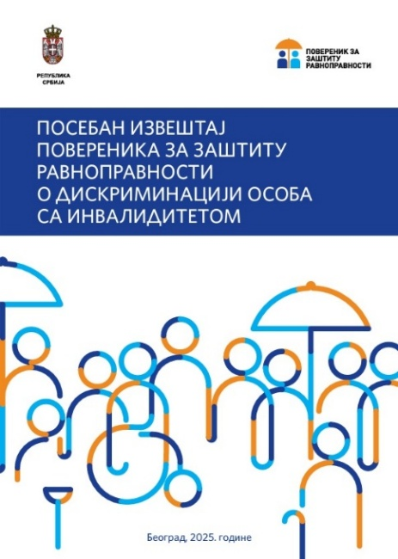
Special Report on Discrimination against Persons with Disabilities
An analysis of the handling of citizens’ complaints in the period from 2015 to 2024 showed that discrimination on the grounds of disability was the most frequently cited ground of discrimination. Therefore, in order to gain a comprehensive insight into the situation and the specific problems faced by persons with disabilities, as well as their interconnected and overlapping nature, the Commissioner, on her own initiative and with the support of the United Nations Population Fund (UNFPA) in Serbia, proceeded to prepare the Special Report on Discrimination against Persons with Disabilities .
According to the frequency of complaints submitted to the Commissioner in specific areas of social life, this report examines in greater detail discrimination in the area of accessibility, that is, in the use of facilities and public areas, as well as in the areas of work and employment, healthcare and social protection, and education, with particular emphasis on children with developmental difficulties and disabilities. In this way, existing problems can be systematically reviewed by area, and relevant conclusions and recommendations can be drawn for further action aimed at improving the position of this social group.
The report highlights the relevant provisions of the Convention on the Rights of Persons with Disabilities and the Concluding Observations of the UN Committee on the Rights of Persons with Disabilities, in order to facilitate monitoring of the implementation of these observations since their issuance. These are cross-referenced with certain relevant provisions of regulations in various fields and with illustrative examples from practice, primarily the practice of the institution itself in protecting the rights of this social group.
For the purposes of preparing this report and assessing the situation in the labour market, guided by the principle “nothing about us without us”, the Commissioner conducted the survey The Position of Persons with Disabilities in the Labour Market. The survey involved representatives of organisations of persons with disabilities, enterprises for professional rehabilitation and employment of persons with disabilities, and employees of these enterprises. Focus groups were also held with employers from the “open economy”, as well as with representatives of the expert assessment bodies of the National Health Insurance Fund. The findings of the survey pointed to significant challenges in the field of education, namely preparation for inclusion in the labour market and the use of assistive technologies, as well as the need for greater support from the state and employers in the employment and retention of employment of persons with disabilities. The most significant barriers to the inclusion of persons with disabilities in the labour market identified in the survey were employers’ prejudices regarding the capacities of persons with disabilities (92%), insufficient accessibility of workplaces (46%) and the lack of appropriate qualifications among persons with disabilities (46%).
In addition, the Commissioner prepared a concise Guide for Undertaking Activities Related to Reasonable Accommodation of the Workplace/Jobs, which contains numerous examples that can be used effectively by employers in practice. This guide, together with a brief overview of the Guidelines for the Development of a Code of Anti-Discrimination Policy for Employers in Serbia – the Equality Code, and examples of socially responsible business, particularly in relation to persons with disabilities, is provided in the annex to this report, in the section Support for an Inclusive Business Policy in the Workplace.
Based on the overall assessment of the situation and the research findings, the Special Report identifies key problems and recommendations for improving the situation, which are presented instead of a conclusion at the end of the report.
IMPORTANT! The recommendations from the Special Report on Discrimination against Persons with Disabilities concern:
- Improving the system for collecting and ensuring the availability of data on the position of persons with disabilities – including the integration of disability-related issues into official statistical surveys and the provision of data disaggregated by relevant criteria, with a view to developing evidence-based policies;
- Ensuring accessibility and universal design – through the systematic removal of architectural, information, communication and digital barriers, improving the accessibility of public services, public transport, media content and the electoral process, as well as harmonising the legislative framework;
- Work and employment – improving measures to encourage employment and professional rehabilitation, strengthening the capacities of the work ability assessment system, educating employers, preventing discriminatory practices and improving reasonable accommodation in the workplace;
- Education – improving access to the mainstream education system, strengthening intersectoral cooperation between education, healthcare and social protection, ensuring support services, accessibility of educational institutions and affirmative measures for children and young people with disabilities;
- The social protection system – reforming the legislative and strategic framework, developing community-based services, advancing the process of deinstitutionalisation, strengthening staffing and inspection capacities, and supporting informal caregivers;
- Healthcare and emergency response – improving the availability and accessibility of healthcare services, respecting human rights in the healthcare system, strengthening intersectoral cooperation and ensuring an adequate response in crisis situations.

Special Report on Discrimination against Women
In 2015, the Commissioner submitted to the National Assembly the first Special Report on Discrimination against Women in Serbia, which analysed the state of equality, highlighted positive developments and identified the areas in which women were exposed to inequality and marginalisation. A decade later, the Commissioner’s data show that these problems persist: sex remains among the most frequently cited grounds of discrimination, while the most vulnerable groups continue to be Roma women, single mothers, women with disabilities, women living in poverty and women from rural areas. In addition, the emergence of new forms of discrimination in the digital, cultural and media spheres, insufficient implementation of laws and declining trust in institutional protection clearly point to the need for a comprehensive assessment of the barriers, consequences and institutional responses. For this reason, a new Special Report on Discrimination against Women was prepared in 2025 and submitted to the National Assembly.
The aim of the Report is to provide a comprehensive overview of the state of gender equality and to point to institutional responsibility for the implementation of the Constitution and laws, as well as international standards, including CEDAW and the Istanbul Convention. The Report presents the different areas in which challenges and unequal treatment occur, including labour relations and economic independence, women’s participation in decision-making and public life, education, health care, the media and culture, as well as gender-based violence and other forms of discrimination. The voices of women and men who support equality are integrated into the Report in order to illu
On the basis of the overall situation assessed, the Report sets out recommendations aimed at improving the situation by ensuring the implementation of laws and policies that promote equality, prevent violence and discrimination, recognise the value of unpaid work and care, and enable women’s full and equal participation in decision-making processes.
IMPORTANT! Recommendations from the Special Report on Discrimination against Women concern:

- Improving data and analysis systems - by strengthening gender-sensitive data collection and availability, integrating a gender perspective into official statistical surveys and ensuring data disaggregated by relevant grounds;
- Work and employment - preventing discrimination and gender-based harassment, improving equal opportunities for employment and career advancement, encouraging a better work-life balance, and reducing the gender pay and pension gaps;
- Education - combating gender stereotypes in the education system, encouraging equal educational and career choices for girls and women, improving a safe and supportive learning environment, and strengthening the role of education in preventing discrimination and violence;
- Health care - ensuring the availability and quality of health services for women, respect for reproductive and other rights, a gender-sensitive approach in the health system and an adequate institutional response in emergency and crisis situations;
- The social protection system - by improving the normative and strategic framework, developing and ensuring the availability of support services, particularly for women exposed to multiple discrimination, and recognising and valuing unpaid work and care, etc.;
- Preventing and combating violence against women - including preventive measures, effective protection and support for victims, strengthening inter-sectoral cooperation and institutional accountability, and consistently applying national and international standards, etc.;
- The media, culture and public information - by encouraging gender-responsive reporting, combating stereotypes and sexism, increasing the visibility of women and their contributions, and creating an environment that promotes equality and respect for women’s dignity, etc.


Collection of Opinions, Initiatives, Warnings and Court Proceedings Concerning Discrimination on the Grounds of Sexual Orientation and Gender Identity
This publication is a thematic collection of opinions, recommendations and warnings issued by the Commissioner in the period from 1 January 2018 to 31 December 2024, in proceedings based on complaints and in the application of anti-discrimination regulations in the field of protection against discrimination on the grounds of sexual orientation and gender identity. The collection provides a systematised overview of the Commissioner’s practice in this area and enables both professional and wider audiences to gain insight into typical forms of discrimination, institutional responses and the challenges faced by individuals and communities in practice.
The collection contains summaries of opinions and recommendations issued in response to complaints, presented according to the frequency with which they appeared in certain areas of social life, as well as recommended measures addressed to public authorities and other entities with a view to achieving equality. In addition, it includes opinions on draft laws, examples of strategic litigation, criminal complaints filed, and warnings issued to the public regarding the most common, typical and severe cases of discrimination.
Although the number of complaints based on this personal characteristic is not among the highest, and complaints are often submitted by civil society organisations, the practice presented clearly indicates the existence of structural problems and the need for a continuous institutional response.
The publication aims to contribute to a better understanding of the phenomenon of discrimination on the grounds of sexual orientation and gender identity, to strengthen trust in institutions, and to encourage further activities aimed at preventing discrimination and improving equality.

Peer Education Programme on Recognising and Responding to Discrimination
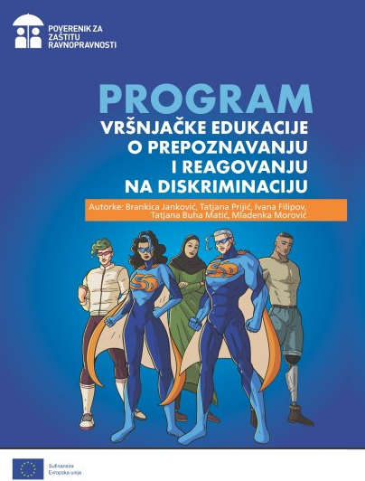
The publication is intended for children and young people aged 12 to 18, with the aim of acquiring basic knowledge about the concept and forms of discrimination, its consequences, and protection mechanisms. The programme is based on a peer education approach and proceeds from the fact that knowledge and attitudes are more easily and effectively transmitted within peer groups. It covers several thematic units relating to the basics of peer education, discrimination and its forms in educational institutions, the consequences of discrimination, the legal framework and institutional mechanisms for protection against discrimination. An integral part of the publication consists of detailed workshop plans, adapted to different implementation conditions, as well as accompanying educational content, including recommended literature, video materials and an overview of relevant campaigns.
The publication was developed within the project “Youth Panel of the Commissioner for the Protection of Equality – Youth for Equality”, implemented with the support of the European Union’s Erasmus+ programme, in partnership with the Gender Equality Ombudsperson of the Republic of Croatia. The project focused on improving equality of children and young people in Serbia and Croatia by empowering young people, raising awareness of discrimination, improving communication with equality institutions and developing a network of peer educators.

Easy-to-Read Guide to the Commissioner for the Protection of Equality
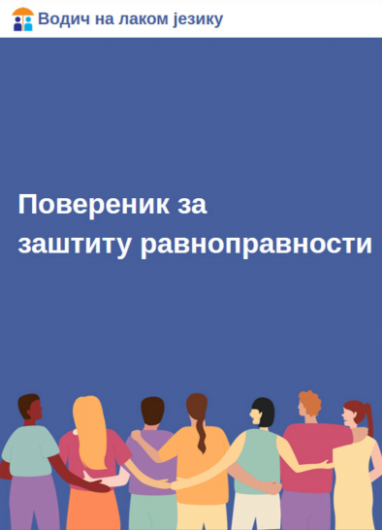
This publication is an easy-to-read guide on the role, competences and procedures of the institution, intended for all those who need a clear, understandable and accessible overview of the system of protection against discrimination. Through simple language and numerous examples, the publication explains what discrimination is, the personal characteristics on the basis of which it may occur, who may be discriminated against, and the areas in which discrimination most commonly occurs.
A separate section is devoted to the Commissioner’s role in acting on complaints, from the submission of a complaint, the establishment of facts and the issuing of an opinion, to making recommendations, issuing warnings and informing the public, as well as the possibility of initiating court proceedings. At the same time, it also points out the difference between discrimination and other forms of unlawful conduct, such as violence, which should be reported to other competent authorities.
The guide explains in detail what a complaint looks like, what it should contain, who may submit it, the time limit within which the Commissioner acts, and the rights of persons who address the institution. Special attention is given to practical instructions for completing the complaint form and indicating evidence, in order to make the procedure as accessible and understandable as possible.
Through this publication, the institution seeks to bring the mechanisms of protection against discrimination closer to the wider public, particularly to persons for whom complex legal texts are difficult to understand, and to encourage the exercise of the right to equality through information, empowerment and strengthening trust in institutional protection.

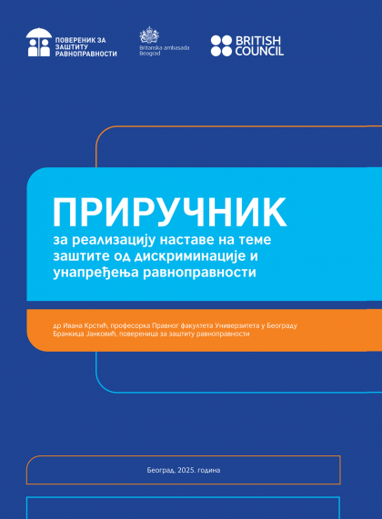
Manual for Teaching Topics Related to Protection against Discrimination and the Promotion of Equality
The publication provides practical support to teachers and other education professionals in teaching about equality, tolerance and non-discrimination. The manual explains in detail the legal and institutional framework for protection against discrimination, as well as the role of teachers and school teams in creating an environment that enables the safe and equal participation of children and young people.
A section of the manual is devoted to field experience and contains an analysis of interactive workshops conducted in schools across Serbia, where students discussed the forms and causes of discrimination, expressed their views and proposed prevention programmes.
The publication also contains concrete methodological tools for work, including proposed workshops, activities and examples of good practice that can be adapted to the needs of students and the curriculum, as well as additional resources, including a glossary of basic terms and recommendations for further reading. The aim of the manual is to enable teachers and all those who wish to improve the quality of education to work effectively on affirming human rights, equality and respect for diversity, while giving young people the opportunity to develop their potential in an environment free from discrimination.
The manual was developed with the support of the British Embassy in Serbia and in partnership with the British Council, within the project “Education for Equality”.

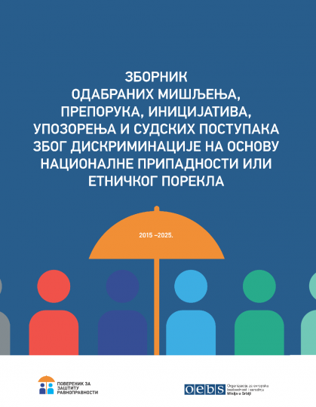
Collection of Selected Opinions, Recommendations, Initiatives, Warnings, and Court Proceedings Concerning Discrimination Based on Nationality or Ethnic Origin
The Publication represents a compilation of selected opinions, recommendations, initiatives, warnings, and other acts issued by the Commissioner for the period 2015 – 2025, adopted in proceedings for protection against discrimination upon complaints and other submissions by citizens, associations, and civil society organisations on the grounds of nationality or ethnic origin.
This ground of discrimination ranks among the top five in terms of the frequency of complaints submitted by citizens and organisations. The largest number of complaints were filed by members of the Roma national minority, particularly in proceedings before public authorities, in the areas of labour and employment, education, vocational training, and public information.
The Collection illustrates the complexity and diversity of cases involving discriminatory conduct, as well as progress in the implementation of the institution’s recommendations. Special attention is given to the Commissioner’s preventive role and to raising awareness of human rights, equality, and non-discrimination. The publication also includes recommendations of the OSCE High Commissioner on National Minorities, which assist participating States in ensuring and protecting the rights of national minorities.
This Collection is intended for experts, representatives of public authorities, the media, and all interested individuals, serving as a useful resource for a better understanding of discrimination and the ways to prevent it.

Trainings
The promotion of tolerance, raising awareness about discrimination as a negative and unlawful and illegal social phenomenon, as well as increasing familiarity with mechanisms for protection against discrimination, remained, as in previous years, a high priority for the Commissioner in 2025. Through trainings, seminars, workshops, and other training sessions, more than 2,000 participants were reached.
Human rights education represents a key element in the effective implementation of constitutional and legal standards, both international and domestic. Educating young people about human rights contributes to their empowerment to participate in the development of society, to develop critical thinking and an inquisitive mindset, as well as to make informed decisions and establish links between human rights, social issues, education, and other public policies. During the year, within various programs, a series of trainings, lectures, and educational campaigns were organised in the field of recognising and responding to discrimination, tailored to primary and secondary school students. The educators included employees of the Commissioner’s professional service, as well as members of the Youth Panel, acting as peer educators.
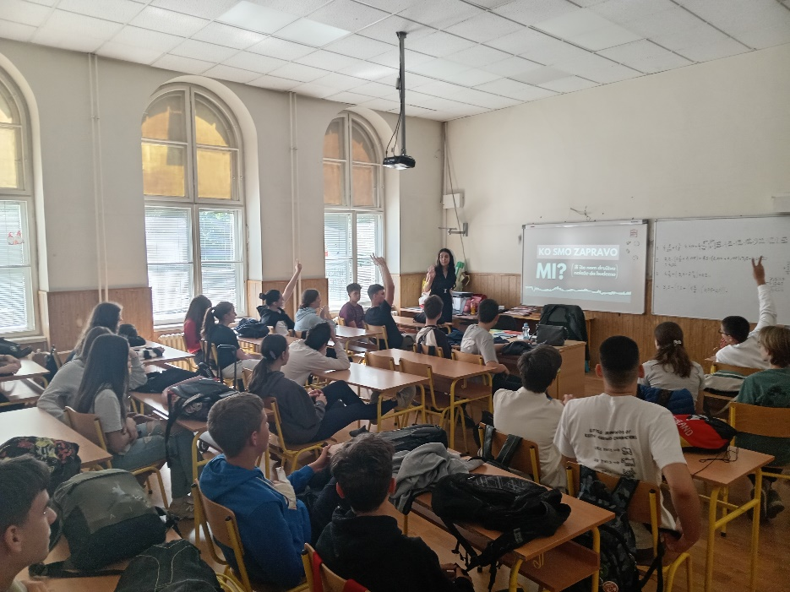
Within the project “Education for Equality” (implemented in cooperation with the Ministry of Education, with the support of the British Council and the Embassy of the United Kingdom in Belgrade), 24 interactive and educational workshops were held for upper-grade primary and secondary school students across Serbia. These workshops addressed the concept and forms of discrimination, the importance of tolerance and equality, as well as gender equality through the promotion of balanced gender roles. The workshops, held in Belgrade, Novi Pazar, Niš, Vrnjačka Banja, Valjevo, Kučevo, Petrovac na Mlavi, Inđija, and Kragujevac, included more than 600 primary and secondary school students.
Within the project “Stop Violence – Achieve Equality” jointly implemented by United Nations agencies in Serbia (UNDP, UNFPA, UNICEF, and UN Women), seven workshops were held for 160 secondary school students in Belgrade, Valjevo, Kučevo, Požarevac, and Inđija. These workshops, titled Protection Against Discrimination and Various Forms of Technology-Mediated Gender-Based Violence, were conducted by peer educators, members of the Commissioner’s Youth Panel.
Within the ERASMUS+ program, since 2024 the Commissioner has been implementing the project “Youth for Equality”. As part of the project activities, members of the Youth Panel conducted five peer education sessions for a total of one hundred students in schools in Belgrade, Novi Pazar, and Smederevska Palanka.
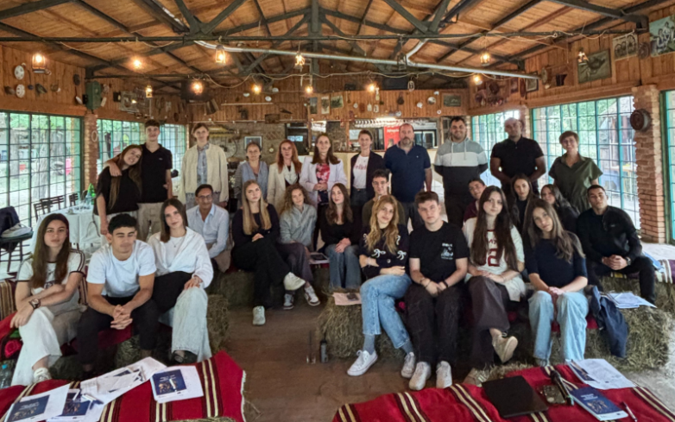
Taking into account that the internet offers countless opportunities for learning, socialising, and creativity, but also carries risks of peer violence and discrimination, a training on digital safety and discrimination in the online environment was organised for members of the Commissioner’s Youth Panel. The training was supported by the Embassy of the Republic of Austria.
In cooperation with the Center for Educational Policies, within the project “Youth Listening: Empowering Student Parliaments to Promote and Advocate for Human Rights”, representatives of the Commissioner held a workshop and lecture on the concept of discrimination and the institution’s competencies for students from 16 secondary schools.
The event “Together and Safe Through Childhood” was held at the Criminal Police University campus to mark the beginning of the new school year. Through socialising, entertainment, and play, the Commissioner’s representatives introduced primary and secondary school students to the concepts of discrimination, equality, and tolerance.
Within the Summer School on the Right to Equality and Protection Against Discrimination at the Faculty of Law, University of Niš, and at the invitation of the OSCE Mission to Serbia, a lecture was held on the competencies and procedures for protection against discrimination, along with a workshop in which participants practiced filing complaints based on scenario-based cases from the Commissioner’s practice, adapted to the needs of the workshop.
In addition, peer workshops were conducted in four schools in southwestern Serbia (Prijepolje and Priboj) to raise awareness of the importance of mutual respect and creating an inclusive school environment. Through collaborative activities, students had the opportunity to exchange views, recognise prejudices and stereotypes, and become empowered to actively advocate for equality in their communities. This activity was organised with the support of the OSCE Mission to Serbia.
A lecture on the concept and forms of discrimination, as well as on the competencies of the Commissioner, was also held for representatives of the Youth Forum of Persons with Disabilities.
For young Roma men and women, a lecture and workshop titled “The Role of the Commissioner for the Protection of Equality in Preventing and Responding to Discrimination” were held as part of the project “Guiding Young Roma Men and Women Toward Quality Education and Employment” (part of the broader German-Serbian development cooperation project implemented by GIZ in collaboration with the Ministry of Labour, Employment, Veteran and Social Affairs).
In cooperation with the Office for Gender Equality of the Human Resources Sector of the Ministry of Defence, and with the support of the OSCE Mission to Serbia, the training program “Recognising and Responding to Discrimination” continued for members of the Ministry of Defence and the Serbian Armed Forces. These trainings are an activity foreseen by the Third National Action Plan for the Implementation of UN Security Council Resolution 1325, adopted in April 2025.

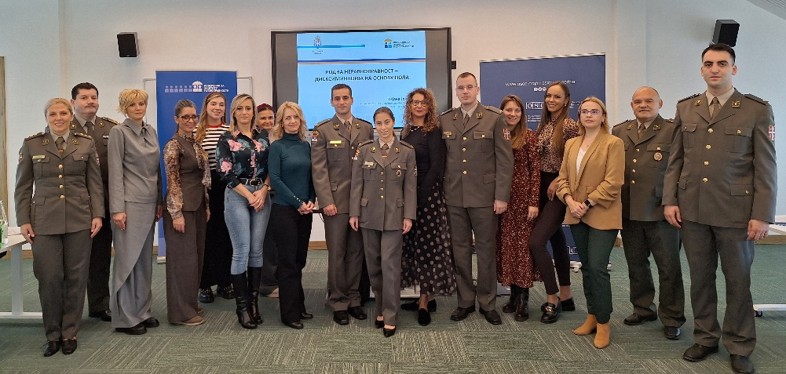
Training for members of the Ministry of Defence and the Serbian Armed Forces, 2025.
During 2025, two seminars were held, and evaluations indicate progress. At the beginning of the seminars, the average number of correct answers was 7.9, increasing to 12.7 by the end. Knowledge gains were particularly noted in response to the question “Which of the listed personal characteristics can constitute grounds for discrimination?”, where correct answers rose from 37% at the beginning to 71% at the end. Regarding the institution’s competencies, 53% of participants answered correctly at the start, increasing to 84% by the end of the seminars. Recognition of discrimination cases improved from 26% initially to 74% at the conclusion. The concept of gender equality was recognised by 50% of participants at the start and 68% by the end of the seminars.
The training program for police officers, “Recognising and Responding to Discrimination,” was attended by 69 participants in 2025. Evaluations showed that the greatest knowledge gain was achieved in understanding personal characteristics as a basis for discrimination. For the question regarding which personal characteristics can constitute grounds for discrimination, the percentage of correct answers increased from 15% at the start of the training to 38% at the end. Regarding the question on which legal act establishes the Commissioner, correct responses rose from 37% at the beginning of the seminar to 80% in the post-training questionnaire.
The Commissioner held an educational workshop titled “Achieving Equality in the Workplace” for employers in Kragujevac. In addition to a lecture on the prohibition of discrimination and protection mechanisms, the “Equality Code,” a publication developed by the Commissioner to promote equality in the workplace, was presented.
At the invitation of Group 484, as part of the regional project “Inclusion of Foreigners in the Western Balkans,” a lecture was held on the concept and forms of discrimination and the procedure before the Commissioner for representatives of civil society organisations working with migrants.
Taking into account the “Perceptions of Roma on Discrimination” survey conducted by the Commissioner in 2024, and the respondents’ reports that discriminatory situations occur, among other places, in Social Welfare Centres as well, the Council of Europe organised, and the Commissioner conducted, a training on anti-Roma discrimination (anti-gypsyism) for employees of Social Welfare Centres. The workshop presented cases from the Commissioner’s practice relating to discrimination against members of the Roma national minority in the process of exercising their social protection rights.
The Commissioner also participated in trainings on the prevention of intersectional discrimination in local government units in Serbia. The trainings were held in Valjevo, Šabac, Novi Pazar, Vršac, Požarevac, Bač, Arilje, Leskovac, and Kruševac, as part of the project “Support for Social Inclusion in Serbia,” implemented by GIZ since 2024. Approximately 500 employees of local government units attended these trainings.
At the invitation of the consortium of the project “Career and Mother – SAM2025” (consortium members include: the Administration Union of Republika Srpska, the Union of Civil Servants and Employees in BiH Institutions, the Independent Union of Civil Servants and Employees in State Administration, Judiciary, and Public Institutions in the Federation of BiH, the Institute for Philosophy and Social Theory at the University of Belgrade, the Creative Gathering Organisation Belgrade, and the Trade Union Educational Center Banja Luka), the Commissioner delivered a lecture on gender equality, discrimination against women in the labour market based on family status, and the balance between career and family. The lecture was held for female trade union activists from Bosnia and Herzegovina during their study visit to the Republic of Serbia.
A lecture on gender equality was also organised for employees of the Institute of Comparative Law, in line with activities from the Institute’s Gender Equality Implementation Plan and in accordance with the Cooperation Agreement signed between the Commissioner and the Institute of Comparative Law.
As part of the general training program for civil servants at the National Academy for Public Administration, approximately 300 civil servants attended the “Protection Against Discrimination” training.

Professional Meetings, Conferences, and Other Activities
One of the Commissioner’s competencies concerns the promotion of equality through cooperation with all societal actors. This activity is carried out both by organising professional meetings and other events by the institution itself, and by participating in professional gatherings—conferences, round tables, workshops, debates, working groups—as well as holding meetings with representatives of other state bodies, civil society organisations, regional and international organisations, and their representatives.
During the year, representatives of the institution took part in over 400 different gatherings, actively contributing by highlighting issues of inequality affecting specific social groups at greater risk of discrimination, explaining possible protection mechanisms, and pointing out to examples of good practice, as well as concrete and specific ways on how to improve the situation. These efforts contribute to the understanding and realisation of human rights across various areas of social life.
The following section presents selected professional meetings organised by the Commissioner, while certain gatherings organised by the Commissioner are detailed in the part of this report covering implemented projects. This is followed by an overview of professional meetings and conferences in which the Commissioner participated.

Professional Meetings Organised by the Commissioner
On the occasion of International Tolerance Day and the fifteenth anniversary of the institution, the Commissioner organised a major annual conference dedicated to promoting equality and tolerance. Titled “Women’s Status – Big Steps, Small Progress: How Education Can Help Us”, this year’s conference was organised in cooperation with the Embassy of the United Kingdom in Serbia, the British Council, the United Nations Entity for Gender Equality and the Empowerment of Women (UN Women), and the OSCE Mission to Serbia, aiming to raise awareness about the status of women, especially those from rural areas, and the importance of educating children and young people about discrimination and its prevention. These topics were discussed in panel sessions featuring representatives of institutions and civil society from Serbia, the region, and Europe.
At the conference, the annual Media Awards for Tolerance were presented for the tenth time, with the support of the OSCE Mission to Serbia and the Delegation of the European Union to Serbia. In the TV/Radio category, the awardees were: Višnja Višnjić Milić (RTS), Vladimir Malešić (TV Forum), Maja Simić (TV N1), and Jasna Đurović (TV Una). In the Online Media/Portals category, the awardees were: Dina Đorđević (CINS), Milica Mihajlović (danas.rs), and Zoran Strika (021.rs). In the Print Media category, the awardees were: Vuk Vučković (Lice ulice), Miroslava Pudar (Novi magazin), and Teodora Škobo (NIN).
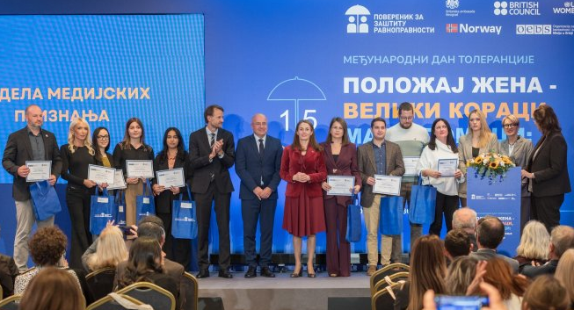
Presentation of the Annual Media Awards, 2025
During the working part of the conference, a manual for teaching topics on protection against discrimination and the promotion of equality was presented, along with the results of the project “Education for Equality,” implemented in cooperation with the British Council. The opening speeches were delivered by Nevena Petrušić, former Commissioner for the Protection of Equality; Kristin Melsom, Ambassador of the Kingdom of Norway to Serbia; Edward Ferguson, Ambassador of the United Kingdom to Serbia; Andreas von Beckerath, Head of the Delegation of the European Union to Serbia; Marcel Peško, Head of the OSCE Mission to Serbia; and Milana Rikanović, Director of the United Nations Entity for Gender Equality and the Empowerment of Women (UN Women) in Serbia. The conference was attended by numerous representatives of the diplomatic corps, European equality institutions, civil society organisations, media, and other relevant stakeholders.
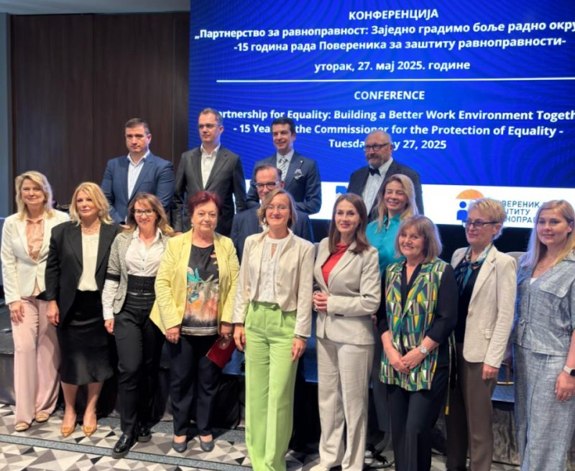
“Partnership for Equality: Building a Better Work Environment Together” was the title of the conference dedicated to marking the 15th anniversary of the Commissioner’s work. At the event, Commissioner Janković emphasised that since its establishment, the institution has faced numerous challenges, but owing to the continuous and dedicated work in protecting the rights and dignity of every individual, it is today recognised as an institution of trust. The conference presented the achievements of the Commissioner’s Partnership for Equality, which has so far been joined by several hundred companies, chambers of commerce, and business associations committed to implementing anti-discrimination policies in their operations. The project “Promoting Equality in Labour and Employment – A Joint Initiative for Workplace Equality” was implemented by the Commissioner with the support of the Federal Ministry for Economic Cooperation and Development of Germany (BMZ), through German development cooperation (GIZ).
At the event “Women Leaders of Serbia and Israel Networking”, jointly organised by the Commissioner and the Embassy of Israel in Belgrade on the occasion of International Women’s Solidarity Month, the importance of support, cooperation, and unity among women from different parts of the world was highlighted. Women leaders, visionaries, and experts from diverse fields such as business, medicine, science, and civil society from Israel and Serbia had the opportunity, through a series of short sessions, to get to know each other, exchange experiences, and explore opportunities for collaboration in shared interests. The event emphasised that when women are included in decision-making, the world becomes a better place for everyone, underlining the need to ensure equal opportunities for women to shape society.

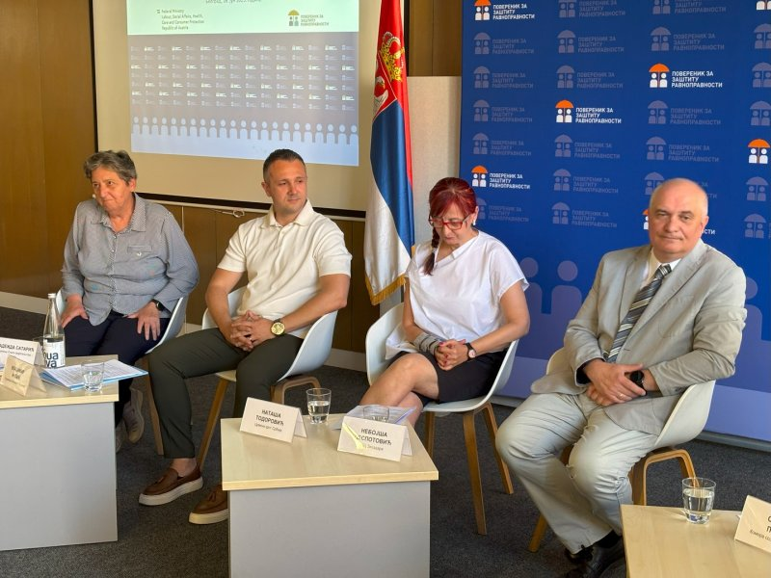
The Commissioner, in cooperation with the Austrian Federal Ministry of Labour, Social Affairs, Health, and Consumer Protection, organised an event on the occasion of International Day of Combating Violence against the Elderly (World Elder Abuse Awareness Day). It was concluded that it is necessary to discuss this topic more frequently and to change both the narrative and the way aging is perceived, alongside fostering a shift in mindset and building a culture that respects older persons as equal members of society and enables them to fully exercise all their human rights. The need to revise protocols for all state bodies in cases of domestic violence, with a special focus on violence against the elderly, was emphasised, as well as the necessity for better coordination among all system actors, including civil society organisations. The importance of introducing specialised training for all professionals in the system for the protection against violence was also highlighted. It was concluded that interventions in the field of criminal legislation are necessary, including the introduction of a specific criminal offence for violence against the elderly. Furthermore, a more proactive role of the media, especially public service media, was stressed, as older individuals here primarily rely on these sources for information.
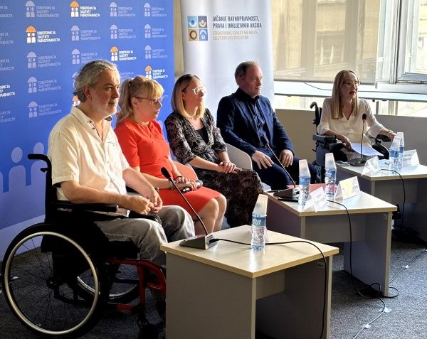
At the end of September, a professional meeting was held titled “Presentation of the Commissioner for the Protection of Equality’s Special Report on Discrimination Against Persons with Disabilities”. The main findings of the report were presented, highlighting that persons with disabilities remain one of the most vulnerable social groups, often exposed to various forms of discrimination. In addition to representatives of the institution, the event featured a speech by the Head of the UN Population Fund Office in Serbia, which supported the preparation of this report, as well as representatives of state institutions, including the Ministry of Labour, Employment, Veteran and Social Affairs, the Ministry of Human and Minority Rights and Social Dialogue, and the Republic Institute for Social Protection. Panels were also organised focusing on the role of the private sector in improving the position of persons with disabilities, featuring representatives from the Association of Enterprises for Professional Rehabilitation and Employment of Persons with Disabilities (UIPS), Novitas Consult, Delta Holding, and the National Employment Service. A separate panel on the role of civil society included representatives from the National Organisation of Persons with Disabilities of Serbia (NOOIS), the Association of the Blind of Serbia, the Association of the Deaf and Hard of Hearing of Serbia, the Association of Dystrophy Patients of Serbia, and the Association of Organisations of Serbia for Assistance to Persons with Autism.
Under the symbolic slogan “Tomorrow Might Be Too Late”, and in anticipation of the “16 Days of Activism Against Gender-Based Violence” campaign, the Special Report on Discrimination Against Women was presented. This is the second special report by the Commissioner on discrimination against women, produced as a result of continuous, multi-year institutional monitoring of women’s status and the application of anti-discrimination legislation in Serbia. The Commissioner’s practice shows that protection mechanisms are functioning, but faster procedures, clearer standards, and stronger intersectoral cooperation are necessary for more effective protection. According to the report’s findings, the greatest degree of inequality remains in the field of labour and employment, ranging from career choice limitations and restricted access to certain professions to wage gaps and slower career progression, especially following maternity leave or parental care-giving absences. Sexual harassment remains one of the most widespread forms of workplace discrimination, with two out of five women experiencing some form of it. Gender-based violence, including femicide, continues to be the most severe violation of women’s rights and safety, and discrimination particularly affects women with disabilities, Roma women, women in rural areas, LGBTI+ women, older women, and migrant women. Serious problems persist in the areas of healthcare and reproductive rights, including obstetric violence. In political and public life, there have been some improvements in women’s numerical representation, but often in lower levels of power, while influential positions remain predominantly held by men.
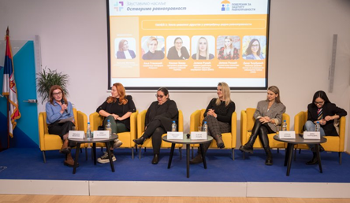
Presentation of the Special Report on Discrimination Against Women, 2025.
This year as well, the conference “My Future – Whose Responsibility? An Inclusive Society for All – Part Two” was organised jointly by the Office of the Labour, Social Affairs, Health and Consumer Protection Attaché of the Republic of Austria, the United Nations Population Fund (UNFPA), the Commissioner, and the Red Cross of Serbia. The event brought together decision-makers, civil society representatives, and experts from Serbia and Austria, serving as a platform to discuss innovative approaches to active and healthy ageing, digital inclusion, the silver economy, and intergenerational cooperation – key priorities for ensuring that older persons live dignified, active, and fulfilling lives. The conference conclusions emphasised the need to change both the narrative and the way ageing is perceived, alongside fostering a shift in mindset and building a culture that respects older persons as equal members of society. The need to revise protocols for the actions of state authorities in cases of domestic violence, with a particular emphasis on violence against the elderly, was highlighted, as well as the necessity for improved coordination among all system actors, including the involvement of civil society organisations. The importance of introducing specialised training for all professionals within the system for protection against violence was also emphasised. At the conference, the exhibition “Stop Violence Against the Elderly” was also presented, and attendees had the opportunity to watch a performance excerpt from the play “Waiting for the Rain” by the Artichoke Association.
The closing segment of the conference was marked by the official award ceremony for the Commissioner’s competition in the categories of literary work, visual art, and photography, titled “Bridge of Understanding – Intergenerational Solidarity”. This competition, intended for upper-grade primary school students in Serbia, was held for the eighth time, and this year more than 550 entries were submitted. According to the expert jury, comprising Goran Zlatković, Master of Visual Arts; Gordana Vlajić, writer; and Jelena Milatović, independent artist and graduate mural painter, the quality of submissions continues to improve each year. Children are becoming increasingly familiar with the theme and the importance of intergenerational solidarity, as illustrated by one student’s remark: “By learning from the elderly, the young gain roots, and by learning from the young, the elderly gain wings.”
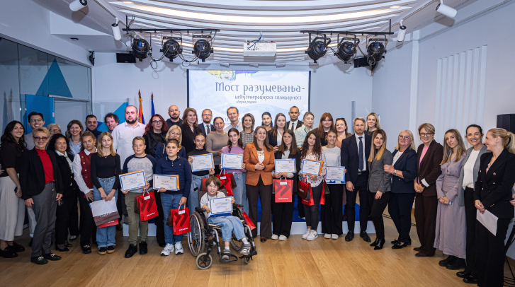
Award-winning students of the “Bridge of Understanding” competition, 2025.
In the Literary Work category, the first prize was awarded to Petar Soleša, VII/2, Primary School “Dragomir Marković,” Kruševac, while the second and third prizes went to Lea Aleksić, 6/1, Primary School “Vuk Karadžić,” Ćuprija, and Maša Radović, VII/5, Primary School “Nikola Tesla,” Belgrade. In the Visual Art category, the first prize was awarded to Anđelka Bogić, VII/2, Primary School “Milisav Nikolić,” Crvljanac branch (Malo Crniće), while the second and third prizes were awarded to Aleksandra Maksimović, VII/2, Primary School “Živomir Savković,” Kovačevac (Mladenovac), and Nikola Cmiljanić, VII/3, Primary School “20 October,” Sivac (Kula). In the Photography category, the first prize was awarded to Anđela Jakovljević, VII/2, Primary School “Mićo Matović,” Močioci branch (Ivanjica), while the second and third prizes went to Nađa Ličina, VIII/1, Primary School “Slobodan Bajić Baja,” Novi Karlovci, and Luka Lukić, VIII/5, Primary School “Nikolaj Velimirović,” Dobrić (Šabac).
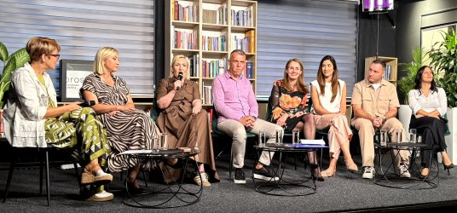
During the year, a gathering of previous recipients of the Annual Media Award for Tolerance was also organised. This award has been traditionally presented for 10 years by the Commissioner in cooperation with the OSCE Mission to Serbia, recognising the media as one of the institution’s key allies in promoting tolerance and advancing equality in society. At the panel titled “Ideas Worth Spreading,” the award laureates discussed their experiences in covering topics related to human rights, equality, and discrimination, the role of the media, as well as the importance of such awards as an incentive for further work. At the event, the documentary film “Voices of Equality – Ten Years of the Tolerance Award” was screened, summarising the decade-long history of the award and the experiences of the awarded journalists.
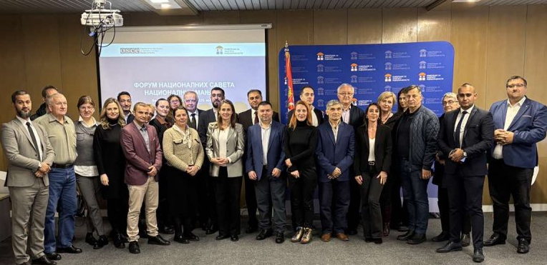 Conference “Forum of National Councils of National Minorities”, 2025
Taking into account that a significant proportion of the population of the Republic of Serbia consists of members of various national minorities, as well as that the issue of their status ranks high on the list of priorities, the Commissioner prepared, over the course of the year, a Collection of selected opinions, recommendations, initiatives, warnings, and other acts concerning discrimination on the grounds of national affiliation and ethnic origin for the period 2015 – 2025, which was presented at the conference entitled “Forum of National Minority Councils”. At this conference, which featured three panels on the following topics: The Voice of Women in National Councils, Cultural Identity, Partnership with Institutions, and the Role of Youth in Preserving Minority Identity, representatives of all national councils participated in. These councils represent a unique mechanism for the inclusion, participation, and empowerment of members of minority communities, as well as natural partners of the Commissioner in the shared task of promoting tolerance and respect for diversity as fundamental values of a modern and democratic society, as emphasised by the Commissioner in her opening address.
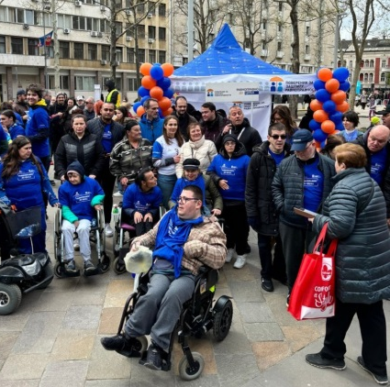
During the year, the traditional event now called “Equal to the Finish Line”, organised by the Commissioner and the Sports Association of Persons with Disabilities of Belgrade, was held as part of the 38th Belgrade Marathon.
The aim of this initiative is to break down prejudices regarding the abilities of persons with disabilities, to highlight their capacities, and to draw attention to the need to address the challenges they face in everyday life.
At Nikola Pašić Square in Belgrade, as in previous years, an information stand was set up where informational materials were distributed to citizens and marathon participants on the concept and forms of discrimination, as well as on ways to recognise and prevent it.
In 2025, the Commissioner also implemented the program “Trial Simulation (Moot Court) in the Field of Protection against Discrimination”, with the aim of building the capacities of future legal professionals – law students in Serbia – for protection against discrimination, through knowledge of legal mechanisms and the development and acquisition of legal argumentation skills. Teams from the Faculty of Law of the University of Niš won first and second place in the competition, while the third-place team came from the Faculty of Law of the University of Belgrade. Mila Jovanović and Kristina Stojanović from the first-place team from Niš were declared the best speakers.
This year, the competition was organised for the 12th time, with the support of the Commissioner’s traditional partner, the Foundation “Registry of the National Internet Domain of Serbia” (RNIDS), and the case concerned discrimination in the digital sphere and on social media.
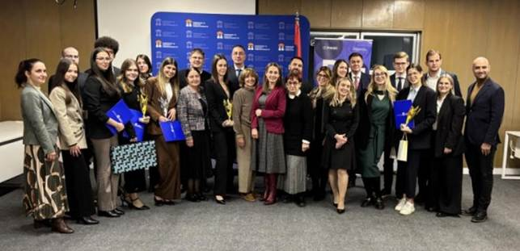
Announcement of the winners of the Moot Court competition in the field of protection against discrimination, 2025.
Activities of the Youth Panel during 2025 began with an online training dedicated to issues of gender equality, discrimination, and equal opportunities within the Erasmus+ project Youth Panel – Youth for Equality. The lectures covered topics such as the historical development of gender roles, gender stereotypes, sexism, and gender-based violence, as well as the issue of dividing professions into “male” and “female.” During the presentation of the Peer Education Program on recognising and responding to discrimination, panellists were introduced to examples of good practice, the role of young people in promoting human rights, and methods of peer education. The panellists conducted five peer education sessions in Belgrade, Novi Pazar, and Smederevska Palanka, empowering their peers to recognise various forms of discrimination and respond appropriately in everyday situations.
In parallel with these activities, work continued on implementing the national campaign #bodyright, in collaboration with the United Nations Population Fund. Through seven workshops held in various high schools across Serbia, young panellists exchanged views with their peers on support in school and the community, as well as on familiarising themselves with the terminology of gender-based violence committed through technology, aiming to foster critical thinking and solidarity through interactive discussions, case studies, and creative activities. With the support of the Austrian Embassy in Serbia, a training session was organised on digital safety and discrimination in the online environment, to further strengthen the Youth Panel members and enable them to use the internet and the digital ecosystem safely. Subsequently, in Priboj and Prijepolje, Youth Panel members conducted peer education workshops in four high schools, while young panellists Luka and Sofija participated in the Commissioner’s Annual Conference, where each shared their experiences of collaborating with the Commissioner, as well as the significance of the peer education sessions they conducted.

Professional meetings organised by other actors
Throughout the year, representatives of the Commissioner participate in numerous dialogues, professional meetings, conferences, and similar events organised by various social actors, with the aim of shedding light on and addressing social phenomena and occurrences that may deepen existing inequalities or create new instances of injustice and discrimination. The following text, as an illustration, mentions only some of these gatherings and other events where attention was drawn to discrimination as a phenomenon, ways to overcome specific problems, and measures to promote equality, based primarily on the institution’s practice, but also on other relevant sources.
The implementation of the project “Together and Safe Through Childhood”, in which the Commissioner participates together with the Ministry of Internal Affairs and the Ministry of Education, continued during the 2025/26 school year through a variety of educational activities aimed at raising awareness among primary school students about the consequences of violent behaviour in both real and virtual environments. The topics of the educational workshops for students focus on recognising different forms of violence and discrimination, adopting strategies to help others in need, developing non-violent conflict resolution skills, fostering empathy, and providing information on ways to offer assistance, support, and protection. On the occasion of the start of the school year and the continuation of the project, an event was held at the Criminal Police University complex, where, through socialising, play, and fun activities, representatives of the Commissioner’s professional team and the Ministry of Internal Affairs, along with firefighters, traffic police, gendarmerie, divers, and rescuers, introduced children to the concepts of discrimination, equality, and tolerance, and discussed the importance of cultivating mutual respect and understanding. During the first semester of the 2025/26 school year, a total of 16,055 workshops were conducted within the project, with 211,993 students from grades III, IV, V, and VIII participating.
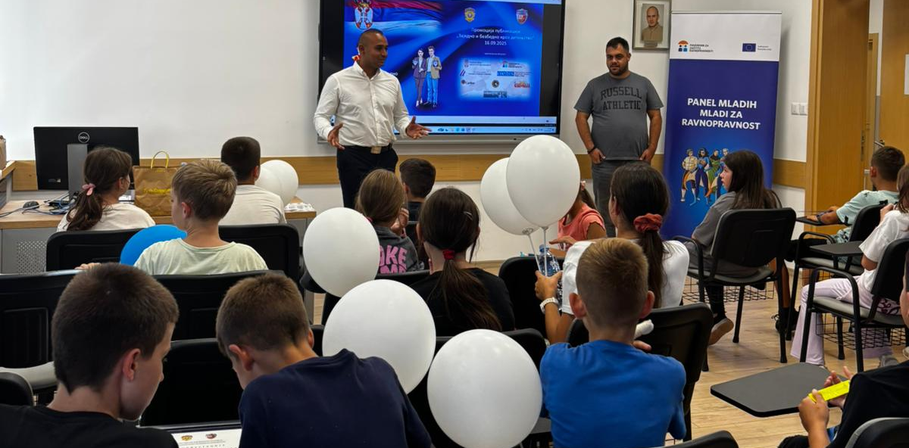
Representatives of the Commissioner at the “Together and Safe Through Childhood” event, CPU, 2025
At the Serbian Academy of Sciences and Arts (SANU), a scientific conference titled “Equality through Affirmative Action” was held, organised by the Commissioner in collaboration with the SANU Committee for the Study of the Life and Customs of Roma and the Committee for the Study of National Minorities and Human Rights. The event brought together experts and researchers from various fields to highlight the importance of particular (affirmative) measures for achieving social equality and equity. Following opening remarks by the President of SANU, academician Zoran Knežević, and academician Tibor Varadi, the scientific conference was held in three thematic sections: Affirmative Measures Regarding National Minorities, Affirmative Measures: Gender Equality and Persons with Disabilities, and Application of Affirmative Measures for Serbs Outside Serbia (Hungary, Romania, Croatia, North Macedonia). At this scientific conference, Commissioner Brankica Janković presented her paper on the role and position of women in political life. Assistant Commissioners Mirjana Kecman and Tatjana Prijić also presented their papers on the application of affirmative measures concerning members of national minorities and persons with disabilities.
At the panel “National and International Standards for the Protection of Minority Rights”, held at the Serbian Academy of Sciences and Arts as part of the project “Ethno-Confessional Minorities in Serbia – Challenges and Human Rights Perspectives”, it was emphasised that in multiethnic environments it is crucial to work continuously on intercultural integration and combating discrimination based on national affiliation and ethnic origin.
On the occasion of the 20th anniversary of the Roma Women’s Network of Serbia, which brings together 33 organisations and initiatives from across the country, Commissioner Janković highlighted at the Ethnographic Institute of SANU the importance of women’s organising and all forms of support. On this occasion, she also emphasised the crucial role of education as a prerequisite for the realisation of many human rights. Many Roma women themselves identified education as key to overcoming multiple forms of discrimination, poverty, and limited opportunities in the labour market, as well as for full social inclusion. This underscores the importance of investing in education and training, as well as in breaking down stereotypes and prejudices.
On the eve of World Roma Day, the Commissioner spoke with residents of the Veliki Rit settlement in Novi Sad, emphasising that the Commissioner’s practice has shown for years that Roma are exposed to discrimination in nearly all areas of social life. When it comes to Roma women, they are often subject to multiple forms of discrimination, based on both gender and national affiliation, and face higher risks of poverty and limited opportunities in the labour market.
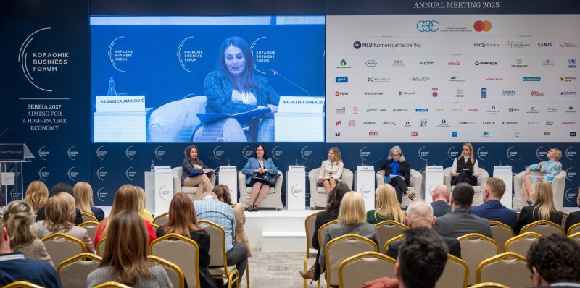
Kopaonuk business forum, 2025.
How gender inequality exacerbates vulnerability to climate change and how the inclusion of women in decision-making can accelerate the transition to a sustainable future were the topics of the panel “Women, Climate Change, and Power: Bridging the Gap for a Greener Tomorrow,” led by Commissioner Janković at the Kopaonik Business Forum. Panel participants shared their insights and practical experiences, highlighting that countries with a higher proportion of women in parliament adopt more effective climate policies and stricter legislation, while companies with more women in leadership positions are more proactive in implementing environmentally responsible practices. Therefore, it is essential to create a healthy and supportive environment that enables women to be part of the solution, rather than merely victims of climate change.
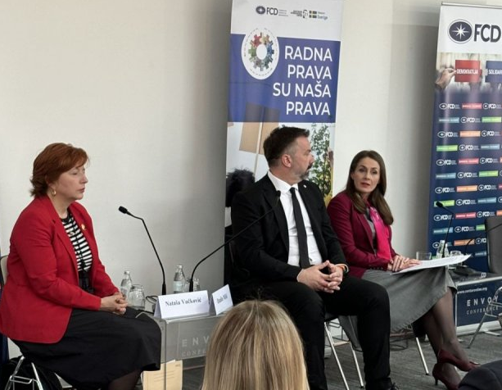
At the conference “Is There Decent Work for the Citizens of Serbia? Between Reality and Possibilities,” organised by the Center for Democracy Foundation, the main topics discussed were the state of labour rights in Serbia, changes to labour legislation, the role of trade unions in protecting workers’ rights, and greater inclusion of young people.
It was emphasised that the issue of labour and social rights must remain high on the list of societal priorities, as employment is of existential importance for everyone. Furthermore, when drafting regulations and public policies, it is necessary to carefully define all labour law institutions and to conduct impact assessments of these regulations and policies on socio-economically vulnerable individuals or groups, ensuring their alignment with the principle of equality before such measures are adopted.
Corporate social responsibility (CSR) must be an inseparable part of business operations, along with respect for human rights without discrimination on any grounds, it was emphasised at the opening of the “CSR Serbia 2025” conference, organised by Color Media Communications. The Commissioner noted that it is encouraging that an increasing number of companies understand the importance of respecting equality principles and creating a work environment free from discrimination. Integrating ESG principles (Environmental, Social and Governance) into business strategies is becoming a necessity and an important factor in building sustainable business success for all companies.
On the topic of sustainable business, the conference “Social Sustainability as a Strategy: Turning Due Diligence into a Business Advantage”, organised by the German-Serbian Chamber of Commerce, highlighted the importance of an inclusive work environment that values diverse life experiences, knowledge, and personal characteristics of employees. The conference was opened by the Ambassador of the Federal Republic of Germany to Serbia, Anke Conrad, and brought together numerous representatives from companies, institutions, and international organisations, with the aim of showcasing the tangible benefits of integrating human rights and social responsibility into business strategies.
The conference “Integration of ESG Standards for a More Resilient and Inclusive Financial Sector in Serbia,” organised by the International Finance Corporation, the Association of Banks of Serbia, Sustineri Partners, the Chamber of Commerce and Industry of Serbia, and the regional association Women on Boards Adria, focused on the importance of gender equality in the financial sector. On this occasion, the initiative Partnership for Equality, with the Commissioner as one of the examples of good practice, was also presented, showcasing collaboration with companies to raise awareness of the importance of respecting principles of gender equality, inclusion, and equal opportunities for all.
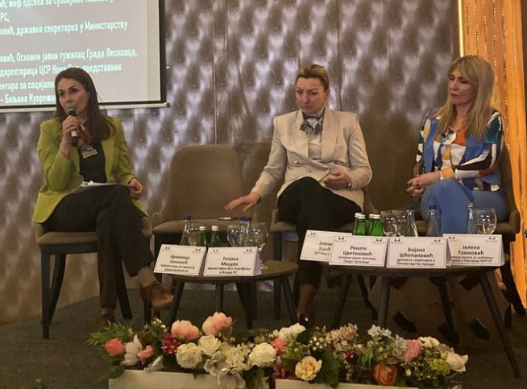
At the international conference “Festival of Law and Social Protection” organised in Leskovac entitled “I Retain the Right to Walk Upright” by the Association of Social Protection Lawyers and the Chamber of Social Protection, discussions focused on the trust citizens have in institutions dealing with social issues, key problems within the social protection system that affect the quality of life, especially for those in need who are often victims of discrimination, and the importance of responsible and timely communication with the media. The social protection system must serve as the foundation of any just society, providing security for the most vulnerable, be it children, the elderly, persons with disabilities, or socially disadvantaged groups.
The Commissioner participated in the official opening of the 15th Annual Conference of the Victimology Society of Serbia, entitled “Modern Technologies and Victims: Risks of Victimisation and Opportunities for Improving Social Responses”, where she emphasised that the fight against digital violence is not only a technological issue but, above all, a matter of justice, equality, and the protection of human dignity. She highlighted the need to improve the legislative framework, strengthen institutional responses, focus on prevention and comprehensive support for victims, and stressed the importance of cooperation among state authorities, educational institutions, the media, civil society, and technology companies to create a safe and inclusive digital environment.
A joint event of the Council of Europe, the European Union, and the United Nations in Serbia, titled “Words that Build a More Tolerant Society” was organised on the occasion of the International Day Against Hate Speech, officially launching the six-month “Tolerance” campaign. During the interactive panel “Dialogue with Youth”, it was emphasised that the inclusion of young people in decision-making processes and the shaping of public narratives is essential for building a more tolerant society. A mural against hate speech was also officially unveiled, supported through the project “Combating Discrimination and Promoting Diversity in Serbia,” which is part of the joint EU–Council of Europe program “Horizontal Facility for the Western Balkans and Turkey,” in cooperation with the United Nations in Serbia, with the Commissioner serving as a partner.
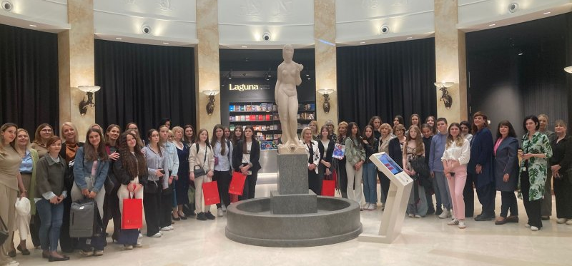
Celebrating International Girls in Information and Communication Technology, Palace of Science, 2025
The fifteenth edition of the “Catch the Idea” competition at the Palace of Science marked International Girls in Information and Communication Technology (ICT) Day. The conference highlighted that, despite the full swing of the digital era, girls remain underrepresented in this sector and in the broader field of STEM. Organised by the Association of Business Women of Serbia and the company A1, the competition brought together over 100 girls from the final grades of 29 primary schools across Serbia, who presented their ideas focused on themes such as solidarity, environmental protection, and the impact of social media.
At the conference dedicated to the “Nobel Prize Teacher Summit” program, organised by the Embassy of Sweden in Belgrade, discussions focused on education as a bridge between science and society, as well as between the individual and the community. One of the topics addressed the similarities and challenges faced by the school systems in Serbia and Sweden. Scholarship recipients of the Nobel Committee Museum and the Swedish Institute, who had participated in previous editions of the conference in Stockholm, spoke about innovative approaches in education and the transmission of values through teaching.
The main topics of the meeting with representatives of the National Youth Council of Serbia (KOMS) were the prevention of discrimination against young people and the need for their greater involvement in decision-making processes, in line with UN Security Council Resolution 2250 and the Youth, Peace, and Security Agenda. As part of the cooperation with KOMS, an event was also held to promote the Youth Impact Assessment Tool and the integration of European practices for youth participation in decision-making at both the national and local levels.
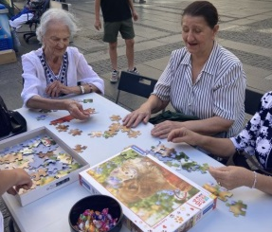
Commissioner Janković participated in the public event “Ask About Alzheimer’s Disease/Ask About Dementia”, which was organised by the Serbian Association for Alzheimer’s Disease (SUAB) in cooperation with the humanitarian organisation “Bread of Life,” in Knez Mihailova Street in Belgrade, ahead of World Alzheimer’s Day. The program included discussions between doctors and elderly citizens about risk factors for dementia, conducting a survey, and distributing educational materials on prevention and support for those affected. According to SUAB data, around 140,000 people in Serbia suffer from Alzheimer’s disease, most of whom largely depend on the care of their closest relatives. People with Alzheimer’s disease point out the lack of day centres, as well as the need to develop psychosocial support programs for the families of those affected.
The international scientific conference “20 Years Since the Adoption of the United Nations Convention on the Rights of Persons with Disabilities”, organised by the Institute for Comparative Law, brought together prominent scholars and experts from both Serbia and abroad. During the two-day program, participants examined the legal and social aspects of the situation of persons with disabilities, with a particular focus on comparative legal perspectives.
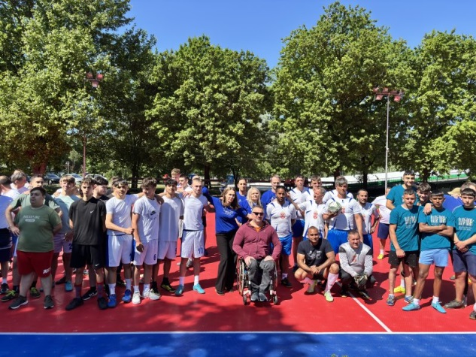
At Ada Ciganlija, the “Memorial Tournament – In Memory of Our Athletes” was held, a sports event dedicated to athletes with disabilities who, through their achievements, engagement, and dedication, left an indelible mark on the development of sports and the advancement of the position of persons with disabilities in Belgrade. The tournament promoted a shared message of inclusion and equal opportunities for all. The small-sided football competition was inclusive, with teams composed of both persons with and without disabilities, ensuring equal participation of women and men.

Implemented Projects
During the reporting year, the implementation of the project “Promoting Equality in the Field of Work and Employment – Joint Initiative for Workplace Equality” was completed, as part of the “Global Solidarity Initiative” of German development cooperation. The project aimed to raise awareness and strengthen employers’ capacities to adopt the Equality Code, prevent discriminatory practices, and promote responsible business conduct
With the support of GIZ Serbia, the Commissioner organised a series of activities within this project during 2024 and 2025 aimed at expanding the network of companies that implement inclusive workplace policies and strengthening their capacities through the Equality Partnership with the Commissioner. Regional workshops with employers were held in Novi Sad, Belgrade, and Kragujevac, during which the updated guidelines for developing employer anti-discrimination policies in Serbia – the Equality Code – were presented. At the concluding conference, professional panels with representatives of the business community showcased examples of good practices in the field of work and employment. Over 50 different companies and business associations signed the Equality Partnership Charter during the project, thereby committing to the active implementation and promotion of equality principles in employment relationships.
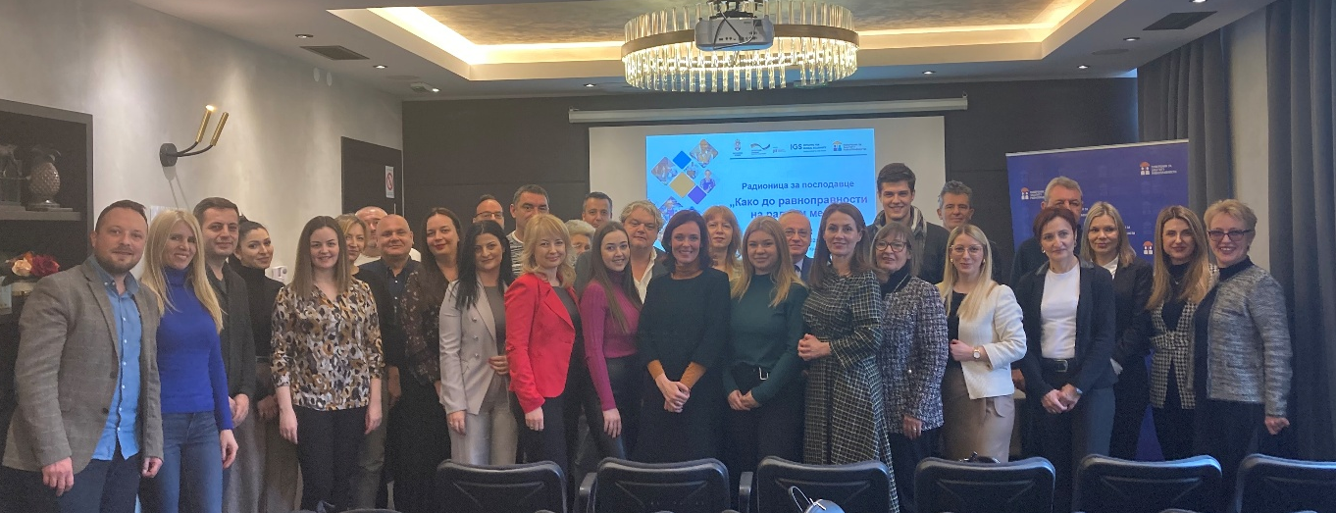
Employer Workshop “Achieving Workplace Equality”, Kragujevac, 2025
During the year, all project activities under the program “Commissioner’s Youth Panel for the Protection of Equality – Youth for Equality” were successfully implemented, aiming to promote equality among children and young people, empower them, and raise awareness about discrimination. In partnership with the Ombudswoman for Gender Equality of Croatia, and with the support of the European Union’s Erasmus+ program, the Commissioner developed a peer education program designed to help recognise and respond to discrimination, as well as to establish a network of peer educators. This manual is presented in greater detail in the Publications section of the Commissioner’s report.
The young peer educators, who had previously undergone training within the project on recognising discrimination, public speaking, and gender equality, with a special focus on European Union legal standards, designed and conducted five educational sessions in primary and secondary schools across Serbia. The aim was to raise their peers’ awareness of various forms of discrimination and ways to oppose such behaviour.
Within the project “Empowering Women in Rural Areas of Serbia to Recognise and Respond to Discrimination and Violence”, and with the support of UN Women in Serbia and the Embassy of the Kingdom of Norway, the Commissioner participated in 2025 in activities aimed at empowering women and girls from rural areas in Eastern, Southern, and Western Serbia. The project aimed to strengthen women’s capacities to recognise, protect, and exercise their rights, particularly in the areas of gender-based discrimination and violence.
Through the project, two study visits were organised for women from rural areas and representatives of the Commissioner’s institution, as well as targeted support for women’s non-governmental organisations in rural areas through the distribution of technical equipment (15 local associations were supported). In addition, more than 40 women received agricultural equipment to empower them in starting or improving agricultural businesses.
Two two-day training sessions were organised to empower women in recognising mechanisms for preventing discrimination, economic empowerment, access to financial resources, health prevention, and digital literacy. Additionally, conferences were held on the occasion of International Rural Women’s Day and the project’s concluding conference, as well as the presentation of the Annual Media Award to journalists reporting on the situation of women and girls in rural areas. Furthermore, a continuous media campaign was conducted throughout the project to increase the visibility of activities and promote the rights of women in rural communities.
During the reporting year, the activities under the program Horizontal Facility for the Western Balkans and Turkey – Phase III (2023–2025) and the project “Combating Discrimination and Promoting Diversity in Serbia” were completed, implemented in partnership with the Council of Europe Office in Belgrade and with the support of the European Union Delegation.
Within this project, the Commissioner participated in a series of activities aimed at strengthening the capacities of institutions and relevant social actors to act in the areas of combating discrimination and hate speech.
A special focus was placed on training the staff of the Commissioner’s institution and members of the Youth Panel, as well as conducting workshops for teachers in 20 schools across five regions of Serbia, aiming to enhance preventive mechanisms within the educational environment. The project also included an analysis of the presence of hate speech in the media, as well as surveys on the attitudes of citizens and public authority representatives toward discrimination. The results were presented and used as a basis for further developing recommendations and public policies.
Within the project, activities were also carried out to raise public awareness about the importance of respecting human rights and equality, including the observance of the International Day Against Hate Speech, as well as four workshops for journalists and media representatives aimed at improving professional standards and responsible reporting. In addition, the project initiated the production of three promotional video spots and accompanying communication campaigns, contributing to the long-term visibility of the Commissioner’s work and the promotion of equality values.
Within the project “Stop Violence, Achieve Equality” (2023–2025), implemented as a joint initiative of the Government of the Republic of Serbia and United Nations agencies in cooperation with the UN Team in Serbia, the Commissioner participated in activities aimed at promoting gender equality and preventing discrimination and violence against women and girls.
As part of the project, the research study “Why Women Do Not Report Violence” was conducted, along with an analysis of the implementation of the Beijing Declaration and Platform for Action in the areas of education, the economy, women’s participation in decision-making, and the media. In the same context, the preparation and presentation of the Commissioner’s Special Report on Discrimination Against Women were supported, with the assistance of UN Women.
Additionally, within the project, a two-day training for trainers of the Commissioner’s Youth Panel was conducted, along with seven workshops focused on gender equality and the right to bodily integrity, with the support of UNFPA. In addition, two grants of €35,000 each were awarded to improve the status of women in rural areas, aiming at women’s economic empowerment and the reduction of inequalities in less developed communities.
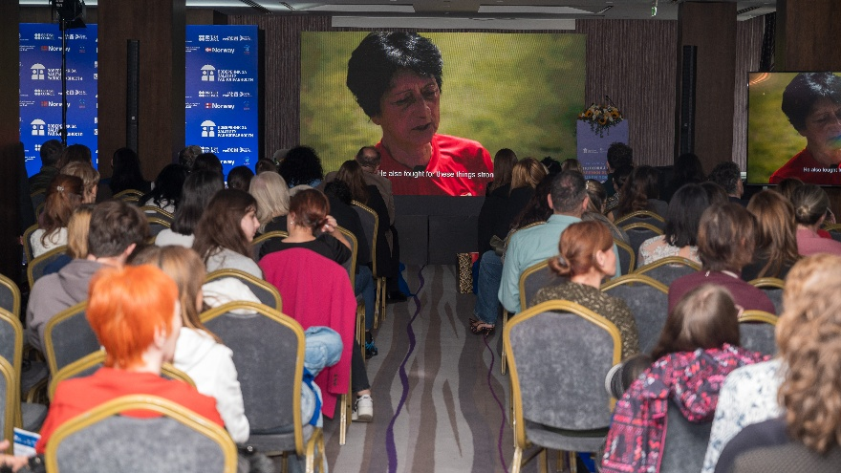
The project “Education for Equality”, implemented with the support of the British Embassy in Belgrade, is aimed at empowering young people and promoting the development of a society based on tolerance, cultural diversity, and solidarity.
Within the project, the exhibition “Great Women of Serbian Culture” was supported, a total of 24 workshops for students were held (12 in Belgrade and 12 in other cities in Serbia), as well as workshops for teachers, with a focus on gender equality. In addition, a teacher’s manual on anti-discrimination and gender equality was prepared, and the project results were presented at the Commissioner’s annual conference on the occasion of the International Day of Tolerance, where the key activities and achieved impacts of the project were showcased.
The project also supported the production and screening of the film “Pele, Džaja, and Slavka”, as part of activities aimed at promoting the values of equality, tolerance, and respect for diversity among young people.
Aiming to strengthen intercultural dialogue and develop democratic competencies, the Commissioner participated in activities within the MILAGRO project – “Education for Citizens: Empowering Target Groups with Democratic Competencies and Digital Citizenship”, implemented by the University Library “Svetozar Marković” with financial support from the European Union. The project included participants and migrants who underwent training aimed at developing the skills needed for an active and responsible role in a democratic society and the promotion of digital citizenship.
Within the project, the Commissioner contributed to the implementation of all planned activities, ensuring the inclusion of migrant communities and the local population, with the aim of fostering mutual understanding and solidarity.
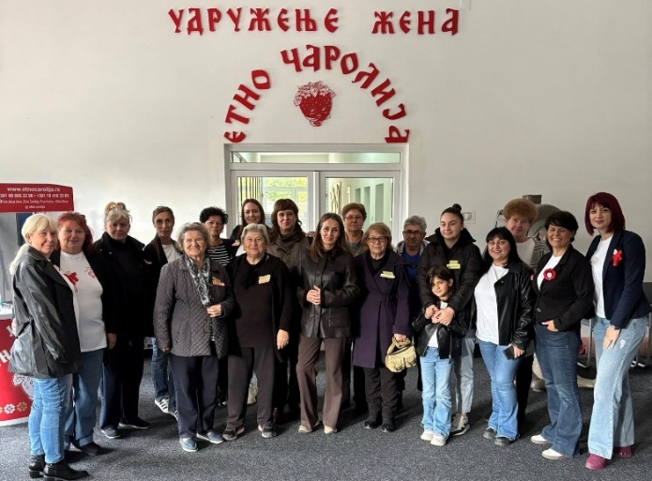
During the year, with the support of the Austrian Embassy, the Commissioner implemented two projects aimed at empowering young people and women. Within the project “Youth Panel on Internet Safety”, training sessions were conducted for members of the Youth Panel on cybersecurity and online equality, with the aim of strengthening their competencies for the safe and responsible use of digital platforms. In addition, within the project “Economic Empowerment of Women in Rural Areas through the Acquisition of Knowledge and Skills”, training sessions were carried out on digital literacy, media visibility, and practical skills that contribute to the economic empowerment of women in rural communities.

International Cooperation
Presenting the experiences of the Republic of Serbia in the field of the protection and promotion of equality, the Commissioner participated in numerous international conferences and forums in the area of human rights.
Within the 69th session of the United Nations Commission on the Status of Women in New York, Commissioner Janković participated in the panel “Women’s Leadership and Challenging Global Trends” and emphasised the importance of the work of institutions for the protection of human rights, the promotion of gender equality, and strengthening of women’s political participation. During the session, the findings of the analysis on the implementation of the Beijing Declaration in the Republic of Serbia were presented, covering achievements in the areas of education, economic empowerment, participation in government and decision-making processes, as well as the representation of women in the media.
A two-day high-level conference titled “Building Resilience through Inclusion and Empowerment” was held in Vienna as part of the Finnish OSCE Chairmanship and was dedicated to gender equality and gender-based violence. At the panel entitled “Violence against Girls and Women”, the legislative framework of the Republic of Serbia in the field of protection against gender-based violence was presented, with a particular focus on the effects of the Law on the Prevention of Domestic Violence. During the conference, a new publication titled “Trends in Addressing Femicide in the OSCE Region” was also presented, analysing institutional responses to femicide and the importance of collecting accurate data. In addition, the strategic document “Roadmap for the Implementation of Commitments in the ‘Women, Peace and Security’ Agenda” was introduced, providing guidance to participants on strengthening gender equality and empowering women in the context of security policies.
Organised by the Government of the Republic of Italy and the OSCE, the International Conference on Combating Femicide was held in the Italian Parliament. The conference was opened by the Minister for Family, Natality and Equal Opportunities, Eugenia Roccella, and the OSCE Secretary General, Feridun H. Sinirlioğlu, and featured speeches by numerous ministers, representatives of the European Union, as well as distinguished experts and civil society organisations, among others.
At the Conference of Special Envoys and Coordinators Combating Antisemitism (SECCA), organised by the World Jewish Congress and held in Washington, D.C. at the United States Department of State, the Commissioner emphasised the need for a continuous fight against antisemitism as a form of hatred and a violation of fundamental human rights, highlighting the importance of using various mechanisms of action in accordance with the mandates and competences of state institutions. On the margins of the conference, meetings were held with prominent experts and officials.
At the round table “Building Sustainable Peace – Why It Is More Important Than Ever to Implement the ‘Women, Peace and Security’ Agenda” hosted by the German Federal Foreign Office as part of the Munich Security Conference 2025, an analysis of 182 peace agreements was presented, and discussions were held on ways to ensure the full participation of women in political processes, the protection of their rights, and the long-term fulfilment of their needs, as well as more effective prevention and suppression of gender-based violence, which poses a threat to social stability and security.
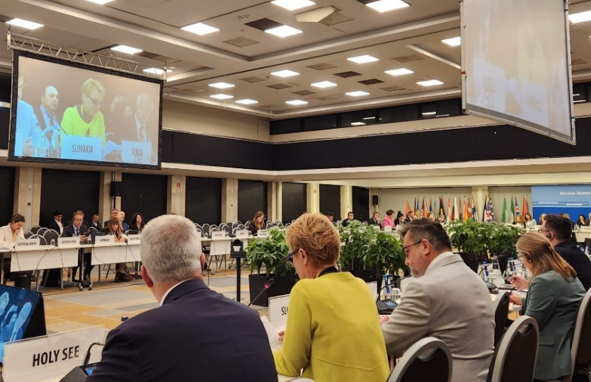
At the ODIHR Human Dimension Conference in Warsaw, during the thematic session “Tolerance and Non-Discrimination” the state of equality in the Republic of Serbia and examples of good practices were presented, including the Commissioner’s practices in the field of protection against discrimination and the advancement of the position of various social groups at higher risk of discrimination, with a particular focus on the situation of the Roma community.
Commissioner Janković attended the World Economic Forum in Davos, where a special focus was placed on the position of women in modern industries, the ethical use of artificial intelligence, and the achievement of sustainable development goals. One of the key events was the panel entitled “AI and Collective Intelligence for Inclusive Action and Impact,” dedicated to exploring the potential of collective intelligence through a combination of shared knowledge, collaboration, and innovation as a tool for translating sustainable goals into concrete and transformative actions. During the forum, it was confirmed that greater representation of women in politics directly impacts the advancement of women’s economic rights. This is supported by the latest findings from a joint report by Oliver Wyman Forum, Women Political Leaders, and The World Bank’s Women, Business and the Law, which indicate that improving women’s rights and their participation in the labour market could potentially double the global growth rate and increase global GDP by 20%.
During her visit to Norway, the Commissioner met with colleagues from Norwegian human rights institutions and exchanged knowledge and experiences in the field of protection against discrimination and the promotion of equality. The host of the visit was Norway’s Ombudsman for Equality and Anti-Discrimination, Bjørn Erik Thon, and meetings were also held with representatives from the Norwegian Institute for Human Rights, the Equality Center, the Directorate for Children, Youth and Family Affairs, the Data Protection Authority, and the Safe Homes Movement.
The Commissioner participated in the international conference in Sarajevo, “From Gender Justice to Sustainable Peace: A 25-Year Vision”, held to mark the 25th anniversary of the adoption of the UN Women, Peace and Security Agenda and the 30th anniversary of the Beijing Declaration. The main themes of the conference included an analysis of changes since the adoption of the Agenda, women’s leadership in peace processes, access to justice, strengthening local and global connections, and enhancing commitment to women’s participation in peacebuilding and mediation processes. At the gathering, it was assessed that the Agenda has not been sufficiently implemented and that its full application requires more active political support, significant financial investment, and greater participation of women at all levels of decision-making. The conference was jointly organised by the Ministry for Human Rights and Refugees of Bosnia and Herzegovina and the United Nations in Bosnia and Herzegovina, with participants including high-ranking officials from the region, as well as representatives of international organisations and civil society.
In Sarajevo, the Gender Equality Forum within the framework of the Berlin Process 2025 – Growth, Security, and Migration in the Western Balkans – was also held, where discussions focused on regional cooperation as a means to achieve and maintain stability in the Western Balkan states. Forum participants emphasised that gender equality is not only a matter of justice and human rights but also a prerequisite for stability, peace, and sustainable development across the region. The forum, jointly organised by the governments of the United Kingdom, Bosnia and Herzegovina, and the Federal Republic of Germany, aimed to promote genuine, rather than merely declarative, gender equality.
Human rights are not a matter of ideology, but a matter of dignity. By strengthening cooperation between institutions and civil society organisations, we can contribute to the substantive quality of life of all citizens, emphasised Commissioner Janković at the ninth regional conference of equality bodies in Southeast Europe, titled “Strengthening Cooperation Between Equality Bodies and Civil Society Organisations”. The theme of the conference was cooperation between equality institutions and civil society organisations, which participants agreed should be systemic, rather than dependent on the goodwill of individuals. This conference was organised by the human rights institutions of the Republic of Croatia – the Ombudsman for Persons with Disabilities, the People's Ombudswoman, the Ombudswoman for Gender Equality, and the Ombudswoman for Children. At the panel “Together We Are Stronger: The Regional Coordination Board of Institutional Mechanisms for Gender Equality and Anti-Discrimination as a Pillar of Peace, Equality and Regional Resilience”, it was assessed that the regional initiative is of great importance for strengthening cooperation among national mechanisms for gender equality and protection against discrimination.
During its visit to the Republic of Serbia, the United Nations Working Group on the issue of human rights and transnational corporations and other business enterprises also held a meeting with a delegation of the Commissioner, with the aim of assessing the implementation of the UN Guiding Principles on Business and Human Rights, identifying good practices, and formulating recommendations for improving the situation. At the end of the visit, the Working Group experts prepared a preliminary report in which the Commissioner was positively recognised for efforts to improve the position of social groups at higher risk of discrimination, including the preparation of guidelines for employers on reasonable adjustment of workplaces and jobs for persons with disabilities. The report also highlighted the “Partnership for Equality” initiative with companies and business associations, as well as the development and promotion of the Equality Code, which together encourage the practical application of equality principles, as well as gender-sensitive and inclusive workplace policies. The final report will be presented at the session of the UN Human Rights Council in June 2026.
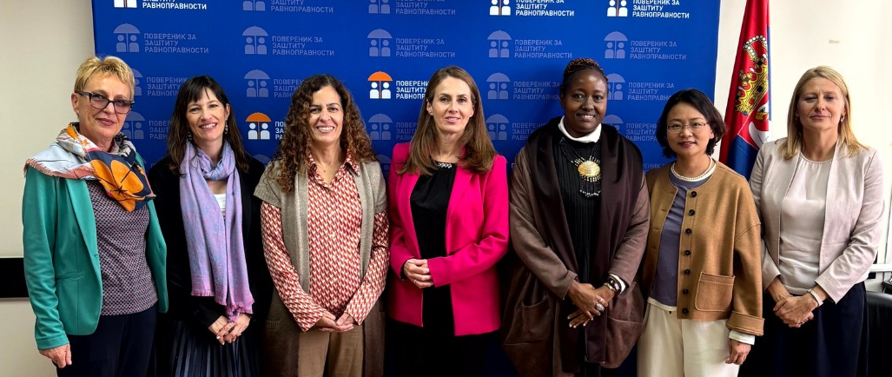

Visit of the United Nations Working Group on discrimination against women and girls, 2025.
During the reporting year, the institution of the Commissioner was visited by the United Nations Working Group on discrimination against women and girls. At the meeting, the Commissioner’s activities aimed at advancing gender equality were presented, including initiatives in education, healthcare, and the labour market, measures for the prevention of gender-based violence and harassment in the digital space, as well as mechanisms for responding to discrimination.
The United Nations High Commissioner for Human Rights, Volker Türk, also visited the institution of the Commissioner during the year and discussed the state of and challenges in the field of human rights and equality in the Republic of Serbia. During the discussion, it was emphasised that, in complex social and political circumstances, the respect for human rights, the protection of equality, and the fight against discrimination are of particular importance, and that all social actors must have and be provided with equal conditions to operate within the framework of the law.
As part of international cooperation, the institution of the Commissioner was visited by a delegation from Tajikistan, with the aim of becoming acquainted with the institution’s competences and activities, as well as exchanging experiences and good practices in the field of protection against discrimination and the advancement of vulnerable social groups. This visit represents a significant contribution to the international exchange of knowledge and experience, with the aim of strengthening inclusive policies and improving equality in Tajikistan.
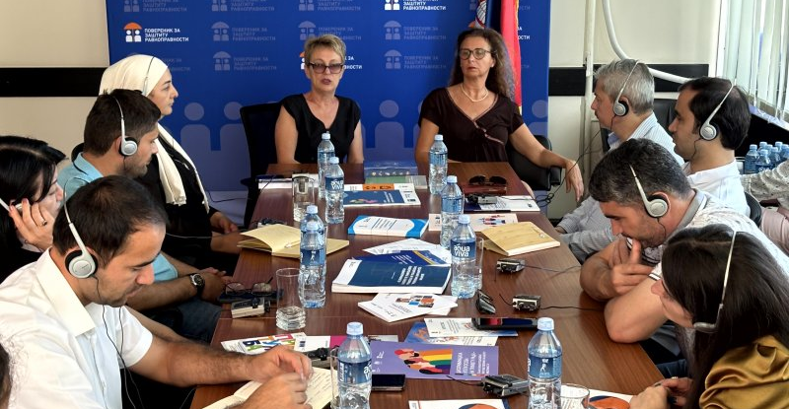
Visit of the delegation from Tajikistan, 2025.
A meeting was held with the United Kingdom Minister of State for Europe, North America and Overseas Territories, Stephen Doughty, dedicated to the importance of maintaining stability in complex times and the role of young people and women in the community. Minister Doughty also visited the exhibition organised by the Commissioner at the House of Jevrem Grujić, entitled “Great Women of Serbian Culture and Science,” where he became acquainted with the achievements of outstanding women who have helped transform Serbian society for the better, including two British women.
As part of bilateral cooperation, the Commissioner met with the Ambassador of Canada to Serbia, Michelle Cameron, to discuss the activities undertaken by the institution in the fight against discrimination. The meeting particularly highlighted the importance of gender equality and greater representation of women in all areas, which can contribute to overcoming the complex challenges the world faces.
During the visit of the Ambassador of Switzerland to Serbia, Anne Lugon-Moulin, discussions focused on the state of equality protection and the role of the institution in preventing and combating discrimination. The Ambassador was presented with some of the most important activities undertaken by the institution, and it was emphasised that respect for human rights cannot be neglected or misused under the pretext of “more important” issues in current global circumstances.
Discussions with the Director of the OSCE Conflict Prevention Centre, Kate Fearon, focused, among other topics, on the importance of equal participation of women in the security sector and the implementation of the UN “Women, Peace, and Security” agenda in Serbia, the significance of independent institutions for the protection of human rights, as well as the Commissioner’s key activities. It was particularly emphasised that, in complex social and security circumstances, it is crucial to preserve the safety, human rights, and equality of all citizens.
At the meeting with the Ambassador of Turkey to Serbia, İlhan Saygılı, particular focus was placed on the status and rights of national minorities, as well as on the importance of continuous cooperation with the national councils of national minorities in Serbia, which are key partners of the Commissioner’s institution in the joint task of promoting tolerance and respect for diversity.
As part of the Commissioner’s cooperation with the Embassy of the Kingdom of the Netherlands in Serbia, a meeting was held with Ambassador Martijn Elgersma to discuss key principles of the rule of law, equality, and the prevention of discrimination. During the meeting, it was emphasised that, in contemporary challenges, human rights are often among the first values to be questioned, and that the role of independent institutions in their protection is crucial. Special attention was given to the role of the media in a democratic society, freedom of expression, and the safety of journalists.
At the end of the reporting year, upon assuming office, the newly appointed Commissioner for the Protection of Equality, Milan Antonijević, held a meeting with the United Nations Resident Coordinator in Serbia, Matilde Mortd, as well as with representatives of UN system agencies, to discuss the further strengthening of cooperation in the field of human rights protection, including the rights of migrants, refugees, and asylum seekers.
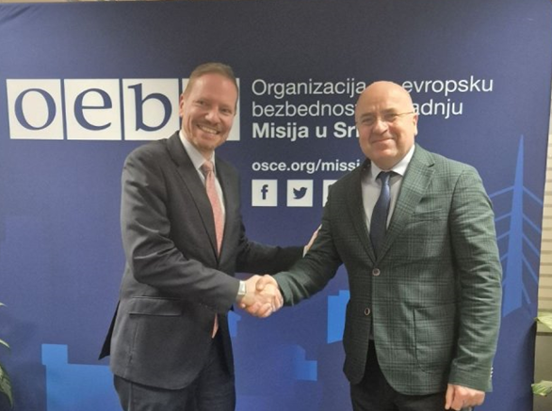
The Commissioner also met with the Head of the OSCE Mission in Serbia, Marcel Peško, with whom he discussed continuing joint efforts to promote tolerance, strengthen institutions and the media, and address key challenges in the areas of human rights, equality, and inclusion, which form the foundation of a safe and just society.
The Commissioner also met with the Ambassador of the United Kingdom, Edward Ferguson, to discuss the continuation of the long-standing cooperation, with a particular focus on promoting gender equality and educating young people through workshops, lectures, and other educational activities to be conducted in schools across Serbia.
Commissioner Antonijević also participated in a meeting of the Network of Officials for Combating Racism and Discrimination at the UNESCO headquarters in Paris, where work continued on establishing the Global Alliance against Racism and Discrimination. The gathering presented global trends highlighting the need for joint action in combating racism and discrimination, as well as the next steps in organising the Alliance’s work and its future activities.
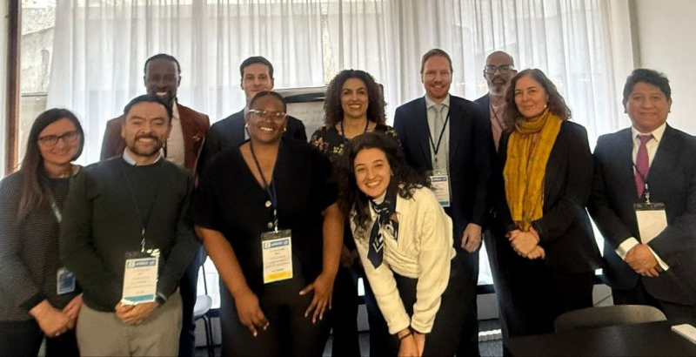

Meeting of the Network of Officials for Combating Racism and Discrimination, UNESCO, 2025.

Cooperation with the European Network of Equality Bodies (EQUINET)
Within the framework of the European Network of Equality Bodies (EQUINET), in 2025, representatives of the institution participated in the work of the following working groups: on communication strategies and practices; on the development of practical policies; on gender equality; on anti-discrimination law; on artificial intelligence; and on research and data collection (the Commissioner’s representative continued in 2025 as moderator of the Research and Data Collection Working Group). The Commissioner also participated in the work of the clusters on age, disability issues, and the cluster on implementing pay transparency, specifically the implementation of the European Union Directive on strengthening the application of the principle of equal pay for men and women for equal work or work of equal value through pay transparency. Within the “Standards for Equality Bodies” project group, meetings and the exchange of experiences among member institutions continued regarding the implementation and transposition into national legislation of EU Member States of the directives establishing a set of minimum standards for equality bodies (Directive 2024/1501 and Directive 2024/1499 ), which were adopted in 2024.
The European Union Artificial Intelligence Regulation was adopted in 2024 and will fully enter into force in August 2026, while certain chapters will apply from 2025. The purpose of this Regulation is to improve the functioning of the internal market and to promote the use of human-centric and trustworthy artificial intelligence, while ensuring a high level of protection for health, safety, and fundamental rights guaranteed by the Charter, including democracy, the rule of law, and the protection of the environment from the harmful effects of artificial intelligence systems in the Union, as well as the promotion of innovation (Chapter I, Article 1). Among other things, the provisions of the Regulation recognise the risk of discrimination in various areas of social life (education, employment, public services). Accordingly, the Working Group on Artificial Intelligence examined the role of equality bodies in implementing the Regulation, as well as strengthening the capacity of equality bodies to handle cases of discrimination caused by artificial intelligence systems. The Regulation is fully binding and will apply directly in all European Union Member States. EQUINET, among other activities, organised a two-day conference dedicated to artificial intelligence, which brought together representatives of equality bodies, international organisations, institutions, the academic community, and civil society. The conference concluded with recommendations on further cooperation and the establishment of monitoring mechanisms, reaching a consensus that human rights and equality must remain at the core of the digital transformation process.
In 2025, EQUINET also published several works addressing the phenomenon of artificial intelligence from an equality perspective, as part of a series entitled: “Coding Equality into Artificial Intelligence: Design, Advice, and Oversight”. Within this series, the following publications were released: “Technical Standards: Opportunities for Equality Bodies and Civil Society Organisations” “Understanding Artificial Intelligence: Concepts, Limitations, and Risks”, and “Explaining the ‘By Design’ Approach: Principles and Implementation”.
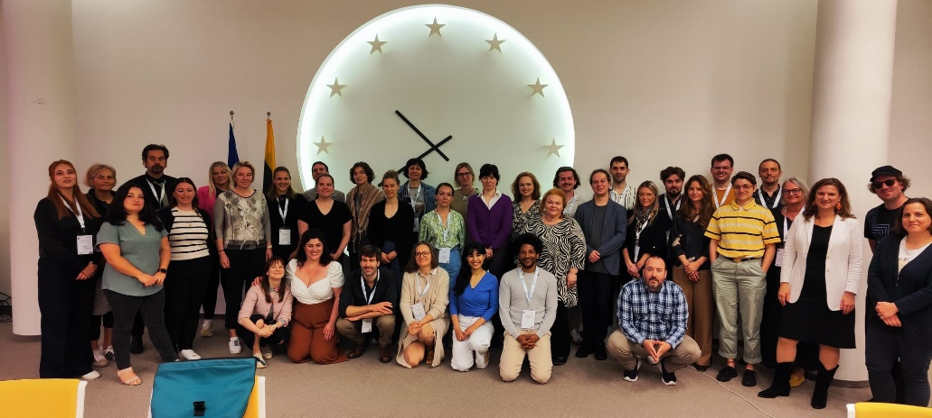

A joint meeting of the Working Group on the Formation of Practical Policies and the Working Group on Communication Strategies was held in September 2025, focusing on current challenges in combating hate speech and disinformation. The representative of the Commissioner presented the definition of hate speech as a form of discrimination provided for under the provisions of the Law on the Prohibition of Discrimination (the Anti-discrimination law) of the Republic of Serbia. Most countries do not define hate speech in their domestic legislation but instead rely on the Recommendation of the Committee of Ministers of the Council of Europe as well as the ECRI Recommendation regarding general policy No. 15 on combating hate speech.
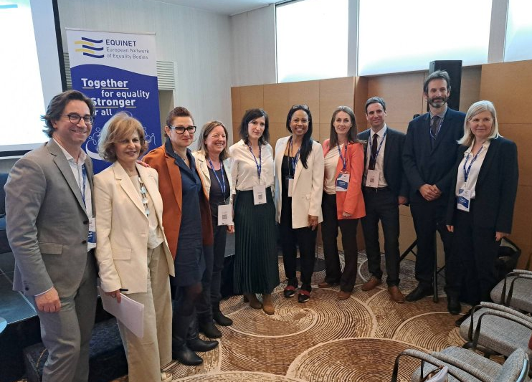
At the meeting, the phenomenon of the “Overton Window” was presented, that is, the process by which hate speech becomes normalised, shifting from unacceptable and shameful ideas to those that become part of public and media discourse. The reasons for the increase in hate speech and misinformation in the online space, media, and public discourse were discussed, among other things, through this concept: when an idea is unacceptable to the public but necessary to achieve a certain political goal, activities can be initiated to “shift the Overton Window,” that is, to turn unacceptable ideas into acceptable ones. The “window” can be shifted through planned public advocacy, so that, over time, radical, unacceptable ideas are recognised as moderate and, eventually, fully acceptable.
Additionally, at the meeting, a multi-stakeholder approach to combating hate speech was presented, along with communication strategies addressing fake news and hate speech, the development of appropriate responses, and the promotion of values of equality and non-discrimination.
The jubilee conference “25 Years of Equality: Milestones, Challenges, and Horizons”, organised by EQUINET, marked a quarter-century since the adoption of key European documents for combating discrimination – Directives 2000/43 and 2000/78, and the EU Charter of Fundamental Rights. Speakers and panellists at the conference highlighted achievements over the past 25 years, pointing to positive legislative, political, and social advancements, despite existing legal gaps and disappointments, such as the Horizontal Equal Treatment Directive, proposed in 2008 but still stalled in the EU Council without the necessary unanimous support. A serious challenge identified was the rise of the far-right and populism, along with negative narratives against equality, inclusion, and diversity policies. These narratives often insist that discrimination in Europe is no longer a major problem and, moreover, claim that the DEI framework, with its measures and legal provisions, poses a threat to European society.
A representative of the Commissioner participated in the 15th meeting of the Platform on Social and Economic Rights. In addition to representatives of the Council of Europe and the European Union Agency for Fundamental Rights (FRA), the meeting was attended by national human rights institutions, equality bodies, representatives of regional and local authorities, members of parliament, academics and legal experts, as well as representatives of rural communities and civil society active in promoting and protecting social rights. The topic of the meeting was “Rights and Rurality: Challenges and Opportunities for the Full Realisation of Socio-Economic Rights of Rural Communities in Europe.” Rafael Benitez, Director of the European Committee of Social Rights, emphasised that the full enjoyment of human rights in practice should not depend on where one lives, and that rural communities often face persistent barriers in the areas of healthcare, education, transport, employment, and digital connectivity. He also recalled the obligations of states to effectively ensure these rights for all, including those living in geographically isolated or economically disadvantaged areas.
In addition, the Commissioner submitted a case from its practice for the EQUINET Calendar for 2026, which was selected and published in the calendar.
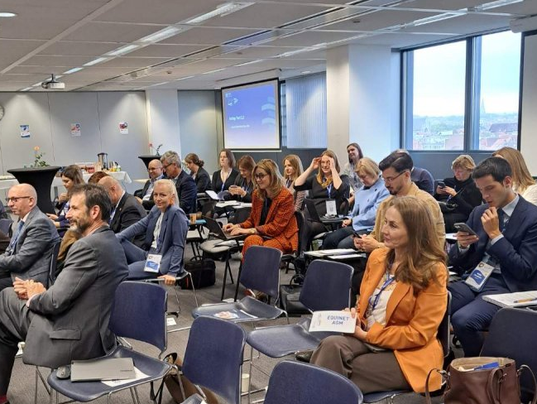
The regular annual General Assembly of EQUINET was held in October in Brussels. By unanimous decision, an equality body from Iceland was admitted to the network’s membership. The General Assembly also adopted EQUINET’s Work Plan for 2026. The plan defines the network’s priorities and activities for the coming year, ensuring that EQUINET continues to support, empower, and connect equality bodies in their work to promote equality and combat discrimination across Europe. In addition, new members of the Executive Board were elected with a two-year mandate.
The Ninth Regional Conference of Equality Bodies of Southeast Europe, titled “Strengthening Cooperation between Equality Bodies and Civil Society Organisations,” held in Split, was organised by colleagues from the human rights protection institutions of the Republic of Croatia – the Ombudsperson for Persons with Disabilities, the Ombudswoman, the Ombudswoman for Gender Equality, and the Ombudswoman for Children. The conference brought together representatives of equality bodies from Albania, Bosnia and Herzegovina, North Macedonia, Slovenia, the Republic of Serbia, the Republic of Croatia, and Montenegro, all of which are also members of EQUINET. The theme of the conference was “Strengthening Cooperation between Equality Institutions and Civil Society Organisations.” Within the second panel, “Civil Society Organisations as Human Rights Defenders – Challenges and Opportunities in Addressing Discrimination”, an example was presented of cooperation between the Commissioner and civil society organisations in the implementation of the Law on Free Legal Aid.

OVERVIEW OF THE SITUATION AND KEY ISSUES IN THE FIELD OF EQUALITY PROTECTION
The state of the realisation and protection of equality among different social groups is assessed at the level of the European Union, by various international organisations and treaty bodies, as well as by domestic institutions and organisations. Based on these sources, it is possible to evaluate the level of implementation of the principle of equality, as well as the problems faced by certain social groups, both at the global level and within the European Union, as well as in our country. Some published reports include examples of good practices at the international level, analyses of different approaches to the realisation of specific rights, as well as perspectives on future courses of action through existing instruments or recommended measures and activities. Particular attention is also paid, for the same reason, to the case law of the European Court of Human Rights in the field of discrimination. All of these parameters are used by the Commissioner to comprehensively monitor the state of human rights protection and to present it through this report.
Below is a brief overview of certain reports and publications reviewed on an annual basis, while some are cited as sources alongside the grounds of discrimination addressed in the later sections of this report, with a list of all reviewed reports and studies provided in Annex 3 of this report.

Reports and other acts of the EU, international organisations, and treaty bodies
In the 2025 Report on Serbia by the European Commission, it is stated that the Commission’s recommendations from the previous year have not been implemented and therefore remain valid. In the coming year, Serbia should, among other things: strengthen the resources of human rights institutions to enable them to fully carry out their mandates; provide sufficient resources for the implementation of ongoing strategies or action plans on violence against women, deinstitutionalisation, combating discrimination—including the rights of LGBTIQ persons—and violence against children; actively counter hate crimes and develop records of investigations and convictions; adopt an action plan on national minorities and demonstrate, through improved data collection, tangible improvements in the effective realisation of the rights of national minority members, including the objectives outlined in the Poznań Declaration on the Inclusion of Roma.
This report emphasises that the legal framework prohibiting discrimination should be further aligned with EU law and European standards, including the Directives on standards for equality bodies. In addition, the legal framework on hate speech and hate crimes should be aligned with EU law and European standards, including the Framework Decision on combating racism and xenophobia and the Racial Equality Directive. Serbia should consistently implement strategic measures to combat discrimination and racism. The report states that the adoption of the action plan to combat discrimination for the period 2024–2025 has been seriously delayed. As of August 2025, the Office of the Commissioner for the Protection of Equality had 45 employees out of 60 established positions. In the field of prohibition of discrimination in employment and social policy, Serbia still needs to fully align with the relevant EU legal acts, including the Equal Treatment in Employment Directive, the Racial Equality Directive, and the Council Directive on standards for equality bodies, as evidenced by the fact that most complaints submitted to the Commissioner for the Protection of Equality relate to the area of employment. In this area, consultations should be initiated on a new Labour Law, including rules on foreign workers posted temporarily in accordance with EU acquis, as well as a new Strike Law and further capacity building of social partners, and delays in the implementation of the action plan for Chapter 19 should be overcome. Furthermore, the European Commission recommends the adoption of the Social Protection Strategy, which is delayed, and amendments to the Social Protection Law to improve the coverage and adequacy of social benefits for persons living below the poverty line, including financial social assistance and child benefits, to address the issue of a large number of cases in social welfare centres, and to take into account the recommendations of the European Commission against Racism and Intolerance (ECRI) regarding the decision-making process for the social card and its impact on Roma and other vulnerable groups. ECRI has called for a review that would include equality bodies and civil society organisations, with “a particular emphasis on ensuring transparency in the functioning of algorithmic systems [...], developing effective legal remedies, and establishing a strong oversight mechanism.” The Law on Financial Support to Families with Children was amended in September 2024 in order to increase several benefits; however, the 2022 recommendation of the UN Committee on Economic, Social and Cultural Rights to eliminate discriminatory conditions has not been implemented. Social assistance programs that are granted based on income levels insufficiently cover poor population groups; a large percentage of children living in poverty are not beneficiaries of these allowances, and the social protection system still lacks sufficient staffing. The system of earmarked transfers at the local level is still not implemented in a systematic or transparent manner. In the area of deinstitutionalisation, the action plan for the implementation of the relevant strategy is also significantly delayed.
In the area of equal opportunities for women and men in employment and social policy, this report states that Serbia still needs to fully align with the EU acquis, including the Work–Life Balance Directive, the Pay Transparency Directive, and the Women on Boards Directive. The position of women in the labour market in Serbia remains less favourable compared to that of men. The employment rate of men (aged 20–64) is higher by 13.9 percentage points, while their activity rate is higher by 13.2 percentage points compared to women. The gender pay gap amounts to 14.5%. The temporary suspension of the implementation of the Law on Gender Equality by the Constitutional Court has suspended the legal obligation of employers to report on gender equality in the workplace, including the principle of equal pay for equal work. The gender pension gap remains at 16.8%. Although legislation provides for parental leave for both parents, stereotypical, gender-based prejudices persist, according to which women are considered responsible for childcare and household duties. The lack of state-provided childcare services in rural areas increases the volume of unpaid domestic work performed by women. Rights related to maternity leave, paternity leave, and parental leave are not aligned with the EU acquis. Continuous efforts are needed to ensure that obligations concerning the prevention of discrimination are translated into consistent practice, particularly in municipalities with limited resources.
The study Proposal for a Horizontal Equal Treatment Directive – Supplementary Impact Assessment provides a complementary impact assessment of the proposed Council of Europe directive on equal treatment outside employment, on the grounds of religion or belief, disability, age, and sexual orientation, aiming to extend protection against discrimination beyond the field of employment. Currently, individuals are protected against discrimination on the grounds of sex and race in employment and in certain areas outside the labour market. However, the grounds of religion or belief, disability, age, and sexual orientation are protected only in relation to employment at the EU level through the Employment Equality Directive (Directive 2000/78/EC), which creates significant gaps in protection in areas such as social and healthcare, education, and access to goods and services. The European Commission presented the proposal for this directive in 2008; however, the legislative process has so far been slow, due both to differing positions among Member States and to the procedural requirement for unanimity. In 2024, during the Belgian Presidency of the Council, renewed discussions resulted in amendments to the proposal aimed at striking a balance between the need for comprehensive protection and the concerns of some Member States regarding subsidiarity, cost implications, the role of service providers, and the division of competences. This study provides a complementary impact assessment to support the Parliament in its consideration of the Commission’s proposal. It examines the need for EU action and its added value, as well as the consistency of the proposed directive with EU and international frameworks. It also provides evidence on the expected effects of the provisions on Member States, target groups, stakeholders, service providers, and society as a whole, and analyses the costs and benefits likely to arise from the implementation of this directive.
The EQUINET publication Technical Standards: Opportunities for Equality Bodies and Civil Society Organisations provides a brief explanation of technical standards and their role within the regulatory framework governing the provision and deployment of artificial intelligence systems, as a key tool of the European Union in ensuring that AI systems comply with specific legal requirements. According to EU regulations, technical standards are defined as “a technical specification adopted by a recognised standardisation body” and refer to “a document that lays down the technical requirements to be fulfilled by a product, process, service or system, and which establishes the characteristics required of a product, including levels of quality, performance, interoperability, environmental protection, health, safety or other dimensions.” These harmonised standards can be invaluable for the work of equality bodies and civil society organisations in addressing cases of inequality and discrimination. This publication aims to enhance knowledge, awareness, and understanding of social equality approaches, including practical guidance intended to “demystify” technical standards.
The EQUINET publication Understanding Artificial Intelligence: Concepts, Limitations and Risks also points out that artificial intelligence models, particularly powerful foundation models, may reinforce bias, which must be carefully considered, as it can lead to discrimination. For example, a recruitment algorithm trained on past hiring practices may learn to favour male candidates for technical positions. Situations such as these highlight the need for a clear understanding of artificial intelligence in the field of human rights.
At the European Union level, the 2025 Gender Equality Report notes that, although a series of decisive initiatives have been adopted under the 2020–2025 Gender Equality Strategy, progress remains slow and uneven across all areas and Member States. One in three women in the EU has experienced physical and/or sexual violence. Employment and pay gaps in the EU are narrowing slowly, but violence against women, discriminatory norms, and stereotypes persist. Women remain overrepresented in lower-paid positions and underrepresented in decision-making roles.
The UN report on women’s rights 30 years after the adoption of the Beijing Declaration, reflects global, regional, and national reviews of 159 countries, summarising progress and priorities for further action. The report notes that many countries have taken steps on gender equality and women’s empowerment, from prohibiting employment discrimination to adopting gender-responsive action plans on climate change. However, gender discrimination remains deeply entrenched across all economies and societies. Globally, only 64% of women exercise their legal rights, and two billion women and girls are not covered by social protection (2023). Among the population aged 25 to 54, only 63% of women are employed compared to 92% of men. Women continue to perform a greater share of unpaid care work than men.
The recommendations from this report relate to the need to:
- ensure that women and girls can reap the economic benefits of the digital revolution by accessing new skills, opportunities, and services, bridging the digital gender gap, and guaranteeing equal access to digital technology, financial services, markets, and networks
- address the issue of women’s poverty by investing national budgets in social protection and high-quality public services, including women’s health, education, and care for girls;
- adopt, implement, and fund legislation to end violence against women and girls, and develop comprehensive national action plans, including support for and coordination with service-providing organisations;
- accelerate the achievement of full and equal women’s participation in decision-making in both the private and public spheres and at all levels of government, including through the implementation of temporary special measures;
- promote accountability for the Women, Peace, and Security agenda and gender-responsive humanitarian action by adopting fully funded national action plans and financing local women’s organisations that respond to crises and conflicts;
- prioritise the rights of women and girls, including those from rural and indigenous communities, in the transition to ecological sustainability by focusing on climate action and biodiversity conservation, ensuring they can develop new skills to access green jobs, and guaranteeing their access to productive resources and land rights.
The report Modalities for the Fifth Review and Appraisal of the Implementation of the Madrid International Plan of Action on Ageing provides updated information on the monitoring of outcomes from the fourth review and appraisal process of the Madrid International Plan of Action on Ageing. Global population ageing, declining fertility, and increasing life expectancy represent one of the most significant demographic transformations of the 21st century. Over the next decade, from 2024 to 2034, the number of people aged 60 and over is projected to increase by 33.3%, from 1.2 billion to 1.6 billion worldwide. By the late 2070s, the global population aged 65 and over is expected to reach 2.2 billion, numerically surpassing the number of children under 18. Global life expectancy has been steadily increasing, and in 2024, life expectancy at birth reached 73.3 years, representing an increase of 8.4 years compared to 1995. This report provides recommendations urging Member States to carry out a national review and appraisal process to identify measures taken to date; to enable civil society participation in planning and evaluation processes; to use evidence-based planning and forecasting to implement policies that address the diverse needs of older persons; and to ensure equal access to services while protecting the human rights of older persons on all grounds.
The report World Employment and Social Outlook: 2025 Trends notes that the global economy is slowing down, making a full labour market recovery more difficult. In 2024, global employment grew in line with the labour force, keeping the unemployment rate stable at 5%, while youth unemployment improved only slightly, remaining high at 12.6%. Informal work and worker poverty have returned to pre-COVID-19 pandemic levels, and low-income countries have faced the greatest challenges in creating decent jobs. Economic growth reached 3.2% in 2024, compared to 3.3% and 3.6% in 2023 and 2022, respectively. A similar growth rate is expected in 2025, although a gradual slowdown is anticipated over the medium term. While inflation has decreased, it remains high, eroding the value of wages, the report notes. Real wages have risen only in some advanced economies, and most countries are still recovering from the effects of the pandemic and inflation.
The World Report on Human Rights notes, among other issues, that discrimination remains a significant problem affecting Roma, LGBTI persons, and refugees and migrants, even though the number of refugees and migrants transiting through the country has decreased. The number of newly arrived refugees and migrants fell by as much as 80% compared to 2023, prompting the Commissariat for Refugees and Migration to close several reception centres, leaving refugees and migrants without access to shelter increasingly vulnerable to abuse and violence. This issue has also been highlighted by the European Commission against Racism and Intolerance (ECRI) in its periodic report. Roma, particularly those living in informal settlements, face poverty and social exclusion, with limited access to education, employment, and healthcare, as well as essential services such as electricity and drinking water. ECRI has called on the authorities to review the provision of social assistance and the implementation of the Social Card Law. The report notes that transgender persons are still subjected to mandatory one-year hormone treatment as a condition for legal gender recognition, and LGBTI individuals continue to face physical, psychological, and sexual harassment and violence, which often goes uninvestigated. The report also highlights that investigative journalists, human rights defenders, and activists face attacks in pro-government media and have been subjected to strategic lawsuits against public participation (SLAPP).

The case law of the European Court of Human Rights in the field of protection against discrimination
During 2025, the Commissioner, as in previous years, monitored the case law of the European Court of Human Rights in the field of the prohibition of discrimination and violations of Article 14 of the European Convention on Human Rights.
The European Court of Human Rights Annual Report 2025 notes that the Court received more applications in 2025 than in 2024 (31,800 compared to 28,800), an increase of 10%. The number of pending cases decreased by 11%, from 60,350 in 2024 to 53,450 in 2025. In 2025, 1,122 new applications were filed against Serbia, compared to 1,118 in 2024 and 1,522 in 2023. Relative to Serbia’s population, this represents 1.71 new applications per 10,000 inhabitants, similar to 2024, when the ratio was 1.61 applications per 10,000 inhabitants.
The following section highlights two Court judgments in cases against Serbia concerning violations of the principle of equality.
Case: Rating Center of Serbia vs. Serbia (Complaint No. 15419/17 of 3 June 2025)
The complainant, an organisation engaged in ranking higher education institutions, requested in 2014 from a public utility company information on the number of employees with higher education, their job positions, and the names of the universities they graduated from. After not receiving a response, the organisation attempted to initiate misdemeanour proceedings against the company’s director. Domestic courts dismissed the organisation’s requests, reasoning that it did not have standing to initiate misdemeanour proceedings. The organisation approached the Court claiming that three rights under the Convention had been violated: Article 6 (Right to a fair trial), because the courts refused to initiate proceedings; Article 14 (Prohibition of discrimination), in connection with the right to a fair trial; and Article 10 (Freedom of expression), because it was denied the right to receive information of public interest. The Court declared the complaint inadmissible on all grounds:
A) Regarding the exercise of the right to a fair trial in connection with the prohibition of discrimination, the Court recalled that the Convention does not grant an individual or organisation the right to demand criminal or misdemeanour prosecution of third parties. Since the proceedings concerned the director, not the civil rights of the organisation itself, the Court stated that Article 6 could not be applied, and therefore no consideration was given to an alleged violation of Article 14 of the Convention.
B) Regarding access to information, the Court applied the criteria from the Magyar Helsinki Bizottság case to determine whether the State had an obligation to provide the information. The Court assessed the request as vague, noting that the organisation stated it needed the data for a “comparative analysis.” In its reasoning, the Court indicated that it was not explained how this information would contribute to public debate. The Court concluded that the organisation had not demonstrated that it acted as a “public watchdog” nor that it had a special role in informing the public about higher education. It was not shown that access to the requested data (the names of the universities attended by employees of the public utility company) was essential for the exercise of the organisation’s freedom of expression.
More details available here: https://hudoc.echr.coe.int/#{"tabview":["document"],"itemid":["001-244064"]}

Case: A. A. vs. Serbia (Complaint No. 50898/20 of 14 October 2025)
The complainant is an Afghan national who was staying at the Asylum Center in Krnjača. The case concerns the period of the coronavirus pandemic and the introduced state of emergency (March–May 2020), during which the authorities imposed temporary restrictions on the freedom of movement for asylum seekers and migrants accommodated in asylum centres. According to the adopted regulations, they were not allowed to leave the asylum centres without a special permit from the Commissariat for Refugees (issued only in exceptional cases, e.g., for visiting a doctor). The complainant raised several grounds, arguing that the introduced measure violated: Article 5 (Right to liberty and security), as the measure constituted an unlawful deprivation of liberty (detention); Article 14 (Prohibition of discrimination), because the measure applied to migrants in asylum centres but not to migrants accommodated in private housing or the general population; and Article 2 of Protocol No. 4 (Restriction of freedom of movement within the state). The European Court unanimously declared the complaint inadmissible, with the key reasons relating to the “credibility of the applicant and lack of victim status.” The Court found that the complainant had not provided reliable information about his identity and date of birth. The data he had provided to the authorities in Serbia differed from that later given in Germany (different surname and year of birth – 2002 versus 2003). The Court noted that the complainant complained about the situation in abstract terms and did not provide any evidence that he personally had ever attempted to leave the centre and was prevented from doing so, nor did he request a permit from the Commissariat that other migrants had used. Regarding victim status (Article 34), the Court stated: “to bring a case to Strasbourg, one must prove that one has been personally affected by a violation of rights.” Since the complainant did not specify when and where he intended to travel, nor how the measures directly affected him, the Court concluded that he did not have victim status. The reasoning also noted that the Republic of Serbia had informed the Council of Europe that, due to the coronavirus pandemic, it would deviate from certain obligations under the Convention. However, since the Court dismissed the complaint on the grounds of victim status, it did not examine whether these deviations were justified or valid.
More details available here: https://hudoc.echr.coe.int/#{"tabview":["document"],"itemid":["001-247387"]}

Court decisions issued in 2024 in cases against other States concerning violations of Article 14 of the European Convention are available at the links provided in the footnote.

Reports and Research of Domestic Institutions and Organisations
The Ministry of Labour, Employment, Veterans, and Social Affairs published the Report on the Implementation of the Strategy for Deinstitutionalisation and the Development of Social Protection Services in the Community 2022/2026 for the period 2022–2024, where among other things, it is stated that, although the Republic of Serbia is formally committed to establishing the process of deinstitutionalisation, in practice certain results have been achieved regarding the user group of children and youth, whereas for persons with intellectual and mental disabilities, satisfactory results have unfortunately not yet been achieved. Their number in residential institutions has remained practically unchanged for years; leaving the institutions is a rare occurrence, and certain community-based services that support staying in a natural environment are insufficiently developed. Key achievements during the three-year period of implementing the Strategy, as noted in this report, include an increase in the number of licensed social protection service providers, which was accompanied by a rise in the number of service users, an increase in the number of municipalities providing licensed services, as well as an increase in the number of employees in these The Ministry of Labour, Employment, Veterans, and Social Affairs published the Report on the Implementation of the Strategy for Deinstitutionalisation and the Development of Social Protection Services in the Community 2022/2026 for the period 2022–2024, where among other things, it is stated that, although the Republic of Serbia is formally committed to establishing the process of deinstitutionalisation, in practice certain results have been achieved regarding theservices. Pluralism among service providers has also been achieved, with providers from the general sector dominating rather than those from the public sector. Challenges identified include ensuring more equitable access to services, especially in rural areas; establishing licensed services in municipalities where no services have yet been set up; achieving uniformity of services across user age groups and service types; standardising new services; increasing the representation of women among both providers and service users; allocating more resources for the development of community-based services; and integrating services from different sectors in accordance with the individual needs of each user.
The report Adults in the Social Protection System in 2024 states that in 2024 the total population of Serbia decreased by 3.7% compared to 2015, with a natural growth rate of -5.7‰, and that the population decreased by 437,257 solely due to natural population decline, as a result of cumulative negative demographic effects over an extended period. Projection results indicate that, up to 2060, one of the most significant features of Serbia’s demographic development will be a markedly aged population structure, with a smaller number of individuals under 15 years of age and a reduced share of this age group in the total projected population.
According to this report, in 2024 a total of 151,033 individuals, or 66,180 families, exercised the right to cash social assistance, representing a continued trend of decreasing numbers of beneficiaries of this support, with a 9.6% reduction compared to 2023, even though the at-risk-of-poverty rate among adults in the same period decreased by only 0.2%. The increased allowance for assistance and care of another person in 2024 was used by 35,745 beneficiaries, which is 2.3% more than the previous year. As of 31 December 2024, residential services were used by a total of 18,369 adults with disabilities, of whom 71.2% were accommodated in institutions for adults and the elderly, 21.6% in institutions specialised for adults with disabilities, and 6.7% in institutions for the accommodation of children and youth.
The report also notes that among all services, the Supported Housing service for young people gaining independence has been the least developed for many years. As a result, in 2024 there were no licensed providers of this service, and one provider was in the process of re-licensing. The number of users of this service in the period 2018–2023 ranged from one to three individuals.
The publication Compassion Fatigue – Secondary Traumatisation of Employees in Long-Term Care Institutions and Family Caregivers states that the role of informal (unpaid) caregivers is becoming increasingly important in our societies due to increased life expectancy, depopulation of rural areas, changes in family structure, shifts in the labour market, and other factors. The assistance of informal caregivers is of vital importance for older adults in need of care, for younger people with disabilities, and for individuals with chronic illnesses and functional limitations. However, support services for this group exist only in a fragmented and occasional manner. A significant challenge in this area is the lack of comprehensive data on the needs and issues of informal caregivers, particularly those providing care over many years, as well as the insufficient number of services and inadequate community support for informal caregivers, who remain largely invisible to both the system and the civil sector.
In the handbook Towards Sustainable Social Inclusion, aimed at professionals in social work centres, a comprehensive approach is outlined for empowering recipients of cash social assistance to improve social inclusion practices in Serbia. The problem of social exclusion among cash social assistance beneficiaries is a complex challenge requiring a systemic response, as these individuals face long-term unemployment, poverty, limited access to services, and various forms of discrimination, which hinder their full participation in society. The handbook also highlights personal challenges such as low self-confidence, fear of losing existential security, and the intergenerational transmission of poverty. Social work centres play a key role in their empowerment, where employees, in addition to professional expertise, must possess additional knowledge and skills.
The study Social Protection, Discrimination and Automation focuses on the social card system, but its findings may also apply to other public administration automation systems, particularly with regard to the cross-referencing of data from different databases and public registers, as well as the use of artificial intelligence. Through this research, a comparative legal framework for decision-making through algorithmic systems was analysed, with a focus on the protection of vulnerable population groups. Examples are also provided from Germany, Denmark, France, Canada, and the United Kingdom, where legal mechanisms have been adopted to “correct” the outcomes of automated decision-making. One of the conclusions of this research relates to the fact that anti-discrimination laws and protection mechanisms are mentioned in the context of the risks of discrimination created by these systems, but there is a lack of understanding of how the legislative framework can protect individuals from automated discrimination.
The report Human Rights in Serbia 2024, published in 2025, concludes that Serbia is facing increasing political polarisation, a shrinking space for civic activism, a lack of institutional accountability, and frequent attacks on civil society organisations, which undermines fundamental democratic standards and makes the struggle to preserve human rights and freedoms increasingly demanding.
The report notes that the economic situation of the majority of citizens in Serbia is unfavourable, with a high at-risk-of-poverty rate of 19.9%. The year 2024 was marked by rising living costs, reduced purchasing power, and high inflation, with the sharpest increases recorded in the prices of basic foodstuffs and energy. Such trends have most severely affected poor and vulnerable social groups, particularly Roma, women, the elderly, young people, and persons with disabilities. As regards economic equality, this report states that women are still in a less favourable position than men, earning on average 20% less despite being more highly educated, while Roma women, women with disabilities, as well as women from rural areas are in an even more difficult position and insufficiently economically empowered.
This report also addresses the issue of access to healthcare services due to the emigration of a large number of doctors, noting that, according to unofficial data, around 6,000 doctors have left Serbia over the past 10 years. This has had a particularly negative impact on rural areas, and due to the inefficiency of the healthcare system within public health institutions, citizens are forced to pay high prices for healthcare services in the private sector.
It is also noted that 2024 marked the 15th anniversary of the adoption of the Anti-discrimination Law, which established the institution of the Commissioner, and that positive developments have been observed in the context of protecting citizens from discrimination in various areas, as well as that a social dialogue on equality and inclusion has been initiated. However, numerous cases of discrimination have continued to be recorded, and the courts have been inconsistent in handling such cases. The delay in adopting the proposed Action Plan for the implementation of the Strategy for the Prevention and Protection against Discrimination for the period 2022–2030 has resulted in a significant number of activities not being completed within the timeframe envisaged by the Strategy, and during 2024 not a single session of the Council for Monitoring the Implementation of the Strategy for the Prevention and Protection against Discrimination was held, the report states.
The Book of Recommendations 2025 of the National Convention on the European Union follows the dynamics of the European Commission’s Annual Progress Report, while also linking them to the measures set out in Serbia’s Reform Agenda, a document adopted by the Government of the Republic of Serbia in October 2024. Among other things, the publication notes that political will to implement key reforms remains fragmented, that the pace of change in the areas of the rule of law, judicial independence, and media freedom continues to be slow, that the definition of the country’s strategic direction is uncertain, and that the authorities often balance between internal political interests and external political pressures. It is also noted that the region is making rapid progress in certain areas, while stagnation in Serbia creates a risk that the country may remain “in limbo” regarding its European perspective. Each new support package and every new initiative of the Union encounter obstacles that are not technical in nature, but deeply political, the report states.
The publication states that the objective of Chapter 23 is to establish an independent, efficient, and accountable judiciary, to combat corruption, and to ensure the full respect of fundamental rights and the rights of EU citizens. Reforms in this area are intended to eliminate political and other forms of influence over the judiciary, strengthen institutional capacities, and guarantee the freedoms and equality of all citizens. Progress in this chapter represents the foundation for the overall EU accession process and for strengthening the rule of law in the Republic of Serbia. With regard to fundamental rights, the report states that despite constitutional guarantees and international obligations, the realisation of fundamental rights in Serbia shows continuous and systemic regression, particularly in the areas of freedom of expression and assembly, children’s rights, the right to a healthy environment, and the right to privacy. It is also noted that children are particularly vulnerable due to shortcomings in the protection system within institutions, as well as the disregard of their rights to express their opinions and to assemble. Despite the existing strategies and obligations under the Istanbul Convention, the institutional response to gender-based violence in Serbia remains inadequate – cases of sexual and digital violence are ignored, specialised women’s organisations lack systemic support, and the number of femicides is alarmingly increasing, including cases where perpetrators had previously been convicted of violence. The report also notes that numerous measures need to be taken as a prerequisite for restoring citizens’ trust in legal security and the rule of law in Serbia.
In the report “Employment and the Position of Foreign Workers in Serbia”, it is pointed out that in recent years the Serbian labour market has faced a noticeable shortage of certain occupations, and it is estimated that in the coming decade this shortfall will amount to between 80,000 and 100,000 job positions. Experts identify the key causes of the labour shortage in depopulation, driven by population ageing and negative population growth. Labour deficits are also largely the result of long-standing and intensive emigration of citizens, primarily to the most developed countries. The report also notes that, according to a Labour Market Study conducted by UNDP in Serbia, the demand for labour is projected to increase from 125,000 workers in 2024 to nearly 144,000 by 2026, with the highest demand expected in the manufacturing and IT sectors, while demand will remain high in the wholesale and retail sectors as well. Younger generations are increasingly choosing high-tech and digital professions, while interest in traditional crafts and industrial jobs is declining, which further complicates the filling of vacancies in these fields.
In this report, it is stated that the number of foreign workers in Serbia is increasing – more than 52,000 work permits were issued in 2024, most of them to nationals of China, Turkey, Russia, India, and Nepal (according to data from the National Employment Service). On the other hand, trade union organisations note that there is no official record of the types of jobs most commonly performed by foreign nationals; however, it is assumed that the majority are engaged in construction sites, fruit and vegetable plantations, health food kiosks, and warehouses, as well as in factory facilities and in positions such as bus and truck drivers.
The report states that foreign workers are often employed informally, without proper registration, most commonly in construction, hospitality, seasonal, and other types of work where they are exposed to serious violations of basic labour and other human rights. The 2024 Report on the Work of the Labour Inspectorate notes that, during inspections, labour inspectors found foreign nationals working “off the books,” with whom employers had not concluded employment contracts, nor registered them for mandatory social insurance, or obtained work permits. During 289 inspections carried out in 2024, labour inspectors found a total of 7,482 foreign nationals at work, of whom 611 did not have a secured work permit.
In the publication “Labour Rights of Vulnerable Foreigners in Serbia and Bosnia and Herzegovina: A Comparative Perspective”, based on a survey conducted on access to labour rights and the integration of vulnerable categories of foreigners in Serbia, respondents’ answers indicate a high level of social acceptance (80% feel they are part of Serbian society) and an absence of perceived discrimination among respondents (none of the respondents reported experiencing discrimination or abuse – 100%). This is reflected in a strong sense of belonging and a positive perception of the attitudes of the local population towards foreigners (100% believe that Serbian society is supportive of foreigners). On the other hand, with regard to awareness of labour rights in Serbia, all respondents stated that they were only partially informed, while they were not informed about the available mechanisms for the protection of labour rights. Based on the analysis of the survey in both countries, it was concluded that a common challenge is the lack of adequate protection mechanisms for undocumented migrants. In both countries, migrant women are exposed to gender-based vulnerability and specific forms of exploitation, including sexual exploitation and domestic servitude, highlighting the need for targeted support measures—such as access to safe houses, legal aid, and professional training. As a conclusion, it is noted that both countries should more systematically integrate a gender perspective into integration policies, ensure access to early childhood education for children, prevent discrimination against pregnant women, and develop measures to promote the economic independence and social inclusion of migrant women. Among the recommendations, there is also an emphasis on the need to strengthen implementation capacities, improve interinstitutional coordination, and increase the predictability of procedures.
Data from the Audit Report of the State Audit Institution regarding the employment of persons with disabilities show that significant inequalities and a less favourable position of persons with disabilities in the labour market persist compared to other citizens. For the purpose of conducting the audit, the State Audit Institution requested data from enterprises in which the Republic of Serbia holds ownership, covering various main activities and employing 500 or more staff. According to the report, this request included questions on the employment of persons with disabilities from January 1, 2022, to June 30, 2024. In these enterprises, persons with disabilities account for an average of 2% of the total workforce. In 18 out of the 33 surveyed enterprises, a decrease in the number of employed persons with disabilities was recorded during the period from January 1, 2022, to June 30, 2024. State auditors warn that an analysis of the position of persons with disabilities in the Republic of Serbia indicates that, despite the results achieved and the activities undertaken in previous years, significant inequalities and a less favourable position of persons with disabilities persist compared to other citizens. The report concludes that the system for employing persons with disabilities would be more effective if the procedure for selecting the legally prescribed method of fulfilling the employment obligation were regulated in a way that, in line with business needs, would contribute most effectively to increasing the employment of persons with disabilities.
The 2024 Report on the Work of the Labour Inspectorate notes that a total of 69,475 inspections were carried out during the year at registered and unregistered entities, of which 35,351 were in the field of labour relations, 33,735 in the field of occupational safety and health, and 389 inspections at unregistered entities. During these inspections, 33 fatal work-related injuries and 18 severe work-related injuries with a fatal outcome were recorded, meaning that a total of 51 persons lost their lives due to fatal and severe work-related injuries, most frequently in the construction and industrial sectors. During inspections, labour inspectors encountered foreign nationals working “off the books,” whose employers had not concluded employment contracts with them, had not registered them for mandatory social insurance, and had not obtained work permits in the Republic of Serbia. Across all inspections conducted, labour inspectors found a total of 7,482 foreign nationals at work, of whom 611 did not have a valid work permit in the Republic of Serbia.
In the Report on Progress in Achieving the Sustainable Development Goals by 2030 in the Republic of Serbia, it is stated, among other things, that over the past decade Serbia has made visible progress in the areas of health, gender equality, poverty reduction, and the improvement of living conditions for vulnerable groups, as well as in the field of environmental protection. Indicators related to women’s sexual and reproductive health, the protection of mothers and children, as well as mortality rates from various diseases and injuries, have improved. However, despite these positive trends, Serbia continues to face significant development challenges, as noted in the publication. These challenges include issues in the area of social development, insufficient investment in social services such as education and social protection, limited availability of certain healthcare professionals, inconsistent trends in literacy and digital skills, as well as an increasing incidence of early marriage among populations from Roma settlements, all of which represent serious obstacles. Despite efforts to ensure that no one is left behind in development, as stated in the publication, several population groups remain at risk of marginalisation. These include the elderly population, which is experiencing rising poverty and a disproportionately high burden of unpaid work, particularly in rural areas. Women employed in agriculture continue to be highly exposed to informal work, with no significant improvements observed over the past decade. Children from rural areas show lower immunisation rates, while their development and access to education continue to lag behind. Rural populations as a whole have not experienced improvements in the distribution of unpaid work, and particular concern is also raised by negative trends regarding children’s involvement in violence, as well as the increasing number of victims of human trafficking. The publication points out a lack of institutional coordination among the competent bodies, as well as a low level of awareness among citizens and decision-makers regarding the importance of the Sustainable Development Goals, which reduces their willingness to actively contribute to the implementation of the 2030 Agenda.
In the Annual Results Report for 2024, the United Nations presents an overview of activities implemented within the framework of the Sustainable Development Cooperation Framework 2021–2025, in partnership with the Government of Serbia, civil society, the private sector, and international organisations. According to the report, the UN invested more than USD 95 million in 2024 to implement over 200 initiatives across Serbia. The focus was on three key areas: green transition and climate resilience; social equality and human capital development; and the advancement of the rule of law, gender equality, and good governance. Concrete support was directed toward the most vulnerable groups, guided by the principle of leaving no one behind. Thus, in the previous year, heating systems and wastewater treatment systems were improved, local circular economy strategies were developed, and Serbia also adopted its first Green Infrastructure Strategy. In the fields of education and healthcare, modern digital tools were introduced, services for early childhood development and mental health were expanded, and mechanisms for protection against gender-based violence were strengthened. Thousands of children, young people, teachers, and families benefited from inclusive programs developed in cooperation with local communities. Gender equality and women’s rights remained a key focus of support by the United Nations in the implementation of various policies. Progress in gender equality was achieved in 130 national and provincial institutions through the financing of 118 budget programs and the development of more than 900 gender-sensitive objectives and indicators. At the local level, gender-responsive governance and budgeting have been introduced in 16 local self-governments, national capacities for human rights have been strengthened, and alignment with international human rights frameworks has been improved through the enhancement of the National Mechanism for Monitoring and Reporting within the Government Council, linking it to UN human rights monitoring and reporting mechanisms via the National Database for Tracking Recommendations. In addition, a child-friendly platform has been developed to enable children’s participation in monitoring the recommendations of the Committee on the Rights of the Child (UNICEF).
The report also highlights the role of the Commissioner for the Protection of Equality and points to the establishment of local resource centres for intergenerational cooperation aimed at promoting active ageing, lifelong learning, and voluntary work. It notes the continuation of the Bodyright initiative and efforts to address discrimination on the basis of disability through the preparation of a Special Report on Disability-Based Discrimination, with a focus on intersectionality and reasonable workplace accommodations.

Actions of State Authorities on the Recommendations of the Commissioner
Based on an assessment of the situation using available data and the institution’s practice over the year, the Commissioner provides recommendations in regular annual reports to public authorities for addressing identified issues, particularly those affecting social groups at higher risk of discrimination, as was done in the Regular Annual Report for 2024. The National Assembly of the Republic of Serbia adopted Conclusion RS No. 25 on 16 June 2025, which, among other things, called on the Government to continuously report to the National Assembly on the implementation of this conclusion. To monitor the implementation of the National Assembly’s Conclusion, a brief overview of activities carried out during 2025 is provided below, based on reports submitted by state authorities to the Commissioner.
The Commissioner did not receive reports from the Ministry of Economy, the Ministry of Finance, or the offices of the ministers without portfolio responsible for coordinating activities and measures in the field of relations with the diaspora, and for the development of underdeveloped municipalities.
The Ministry of Foreign Affairs reported that it participated in a regional ministerial meeting on strengthening the role of women in diplomacy, at which a Joint Declaration was adopted and a Network of Women Diplomats in the Western Balkans was established. The Ministry also took part in the Conference on the Economic and Political Empowerment of Women, supported the U.S. Senior Women Talent Pipeline (SWTP) program, and during the 80th session of the UN General Assembly joined the statement of the LGBT Group.
The Ministry of Tourism and Youth continued implementing grants to support youth associations in carrying out youth policy projects. In 2025, 34 projects led by local self-government units in the field of education were supported, as well as 31 projects in the areas of youth health, safety, and social inclusion.
The Ministry of Agriculture, Forestry, and Water Management included Measures to Improve the Position of Women at the Program level in the 2026–2028 Program Budget – under the Programs Regulation and Supervision in Agriculture and Rural Development and Administration in Agriculture and Rural Development. Ministry representatives participated in the workshop “Women Connecting Villages – for Resilience and Sustainability” within the project supported by the FAO: “Strengthening the Resilience of the Agricultural Sector to Natural Disasters”. Under the implementation of the IPARD III program for the period 2021–2027, women heads of agricultural holdings had 98 IPARD requests approved by the end of 2025, representing 37.4% of the total number of approved projects.
The largest number of submitted and approved requests was achieved under Measure 1 – Support to the Primary Agricultural Production Sector, with EUR 7.8 million in approved eligible costs. By the end of 2025, no payments had been made for IPARD requests submitted by women heads of agricultural holdings. Additionally, 432 loan applications from women heads of registered agricultural holdings were approved, with preferential interest rates of 1% per annum.
The Ministry of Internal and Foreign Trade carried out activities aimed at empowering consumers and developing their critical thinking to make responsible decisions, as well as to better protect them from abuse, fraud, and unfair commercial practices, with a particular focus on vulnerable consumer groups – youth (school-age children) and the elderly (pensioners). World Consumer Rights Day was marked with an educational event on the topic “Consult Before You Buy – You Have the Right to Change Your Mind”, organised in cooperation with the local self-government to inform consumers about potential abuses and fraud. Plans are also underway for a tripartite collaboration with local self-government units and consumer protection associations as partners in the process of informing and protecting pensioners as consumers.
In line with the Plan for Achieving and Promoting Gender Equality and the Risk Management Plan for Violations of the Principle of Gender Equality, this ministry fosters a culture of equality based on gender, health status, age, disability, and other factors. It ensures the protection of women in relation to pregnancy and maternity, equal access to job positions, opportunities for career advancement, professional development, and recognition, regardless of the above-mentioned or other personal characteristics of employees.
Since August 2025, the Ministry for Family Care and Demography has managed the Alimony Fund in accordance with the Law on the Realisation of Rights from the Alimony Fund. In 2025, alimony payments covered approximately 600 children and young people up to the age of 26. The Ministry has included the development of a Strategy for the Protection of Children from Violence in its 2026 work plan, which will be implemented in cooperation with UNICEF.
The Ministry of Justice continued working on amendments to the Criminal Code, and after an additional round of public consultation, the draft law was submitted to the European Commission for an expert opinion. Special emphasis was placed on strengthening the criminal policy for offences against sexual freedom, including rape, sexual abuse of a child, sexual abuse of a helpless person, as well as the crime of domestic violence. The crime of rape was redefined in accordance with the concept of the absence of freely given consent, in line with the Istanbul Convention and relevant international standards. The definition of “family member” has been expanded to include former spouses, without the requirement of a shared household. A new criminal offence of the misuse of recordings and other media with sexually explicit content has also been introduced, in response to the growing forms of digital and gender-based violence, with particular attention paid to protecting the privacy and dignity of victims, who are most often women and children. The recommendation to introduce a specific criminal offence of femicide was considered but, at this stage, was not adopted, given that the current Criminal Code already allows for the strictest punishment of the killing of women through existing criminal provisions.
The draft law on amendments to the Law on the Prevention of Domestic Violence has been submitted to the European Commission for an opinion. The primary aim of the amendments is to improve intersectoral cooperation, provide clearer definitions of the rights and obligations of participants in proceedings, and enhance the protection of victims, in accordance with international standards.
Guidelines for the establishment of free legal aid services in local self-government units were also adopted, setting out clear staffing and organisational criteria, with particular emphasis on support for vulnerable social groups. In addition, activities continued on the digitalisation of procedures and the simplification of the exercise of citizens’ rights, especially in the area of accessing rights from the Alimony Fund.
In order to improve coordinated and efficient action by institutions within the system for protection against violence, and to further develop support services for victims and child witnesses of violence, the drafting of the Strategy for the Exercise of the Rights of Victims and Witnesses of Criminal Offences was initiated, along with the accompanying Action Plan, and public consultations have been completed. An additional six victim and witness support services were established at higher courts, thereby ensuring more balanced and accessible support to victims across the territory of the Republic of Serbia, in line with the National Strategy for the Exercise of the Rights of Victims and Witnesses of Criminal Offences.
Within the project ‘Strengthening the Rule of Law in Serbia’, implemented by the Austrian Development Agency (ADA), the Institute of Criminological and Sociological Research prepared an Analysis and Report on existing practices of examining particularly vulnerable victims in the role of injured party–witness in criminal proceedings, as well as a Methodology for the sustainable monitoring of these practices. The documents include an assessment of existing procedures, protection measures, and sanctions for endangering witnesses, along with recommendations for improvement. A Catalogue of Standards for basic and higher courts was also developed, defining models for the protection and support of victims and witnesses, as well as a Feasibility Study for the establishment of a dedicated call center for victims and witnesses of criminal offences, including an analysis of best practices from Austria and Croatia, as a basis for establishing a specialised telephone line in Serbia.
The implementation of the EU project ‘Rule of Law – Strengthening the Justice System for Children’ also commenced under the IPA 2024 National Programme, with the aim of improving the legal and institutional framework for the protection of children’s rights through the training of courts, public prosecutor’s offices, and service providers, while strengthening the capacities of free legal aid providers.”
In order to enhance the successful resocialisation of convicted persons, efforts to improve the education, training, and work engagement of inmates have continued. Special attention has been devoted to female prisoners and juveniles through the development of specialised treatment and support programs. In cooperation with the Ministry of Education, a programme of functional primary and secondary education for adults is being implemented. At the Juvenile Correctional Facility in Kruševac (including training for work in a dog shelter, after which participants are awarded a certificate enabling employment) and at the Juvenile Correctional Institution in Valjevo, the education of juveniles is carried out in cooperation with local educational institutions, while all juveniles also receive vocational training in a specific trade within the institution itself.”
Convicted persons engaged in work during the serving of their sentences receive training through theoretical instruction and practical training in workshops (tailoring, carpentry, auto mechanics, metalwork, etc.). In the previous period, classrooms have been refurbished and equipment modernised. Activities have also been carried out with regard to the vocational training and work engagement of female prisoners at the Correctional Institution for Women in Požarevac.
Training is also organised for employees in institutional services, who take part in the development of new programmes intended for convicted persons. Within the Council of Europe project “Strengthening the Protection of the Human Rights of Persons Deprived of Liberty and Sentenced Persons in Serbia,” funded by the EU, ten new specialised programmes and treatments have been designed, including, among others, a Programme for the Preparation for Release of persons sentenced to more than five years of imprisonment, with the aim of facilitating their reintegration into society.
The Ministry of Culture continued to invest in cultural infrastructure across Serbia. Through the “Cities in Focus” call, 35 local self-government units were supported, and funds were allocated, among other things, for the reconstruction of the Mileva Marić-Einstein Memorial House in Ruma, as well as for improving the accessibility of cultural facilities for persons with disabilities in Bosilegrad and Kladovo. Within the framework of “the Capital of Culture of Serbia” programme, the implementation of the project “Leskovac – 2026 Capital of Culture” has begun, along with the launch of significant infrastructure and programme initiatives.
In the area of support for persons with disabilities, 38 projects were supported, with particular importance given to participatory and accessible programmes, as well as those contributing to strengthening the capacities of organisations and improving the cultural life of particularly vulnerable groups. The project “You Are Not Alone, Mom,” aimed at supporting mothers of children with cerebral palsy, stands out, as does the International Inclusive Festival “Hearts in Harmony 2025.” The Ministry also supported the development of the library and information activities of the Association of the Blind of Serbia by providing publishing in Braille, recording audiobooks, and improving the conditions for preserving library materials. Within this call, 10 projects also contribute to gender equality, such as the Ladies’ Festival of Contemporary Women Poets, as well as publishing projects and the acquisition of publications that highlight the historical role and contributions of women.
Regarding national minorities, in 2025, 106 projects were supported out of a total of 346 applications, with the participation of representatives of 23 national minorities. The supported projects covered the preservation of language, tradition, and cultural heritage, as well as the strengthening of intercultural dialogue. Special attention was given to vulnerable groups within minority communities – women, youth, and children. As part of the support for the Roma community, 12 projects were funded, and the commemoration of the International Day of the Roma Language further highlighted the importance of preserving this language and cultural identity.
Through the “Cities in Focus” programme, support was also provided to 12 local self-government units with a significant minority population, contributing to the development of cultural infrastructure in multiethnic environments. In the area of support for the LGBTI community, the project of the Regional Award for the best queer story “Leposava Mijušković” was supported. Support for children and youth was implemented through several funding lines. In the field of dance, 13 projects were supported, while more than one hundred titles intended for children and youth were acquired for libraries.
The Office of the Minister without Portfolio responsible for gender equality, prevention of violence against women, and the economic and political empowerment of women implemented activities aimed at improving intersectoral cooperation and preventing violence against women and domestic violence, with a particular focus on awareness-raising and education. The Office supported 104 projects of civil society organisations in the field of advancing gender equality and preventing violence against women. The Office also organised the second national conference “Equal, Safe, Empowered” on the occasion of the International Day for the Elimination of Violence against Women. The Office participated in the work of the Working Group for amendments to the Law on the Prevention of Domestic Violence and initiated the development of a Protocol on Procedures in Cases of Sexual Violence, as well as a new protocol on the procedures of healthcare professionals when dealing with victims of domestic violence.
For the purpose of women’s political empowerment, the campaign “Female Leaders – Nothing About Us Without Us” was launched, and work began on an analysis of the profiles of female politicians in the Republic of Serbia, with the aim of designing public policies and developing support programmes for women in political and public life. The objective of the analysis is to identify the values, behaviours, and characteristics of women active in the country’s political life, in order to measure eight key traits considered particularly relevant for successful functioning in a professional context. The collected data will serve to create a database that will be used as a basis for: developing public policies in the field of women’s political empowerment, encouraging young women to engage in political life by providing inspirational examples, and developing training, mentorship, and educational programmes.
In cooperation with the Ministry for Human and Minority Rights and Social Dialogue and civil society organisations, the Office implemented activities aimed at improving the position of Roma men and women and signed a Cooperation Protocol with the Roma Women’s Center Bibija and the Center for Missing and Abused Children.
The Ministry of the Interior reported numerous trainings and meetings in which police officers participated, aimed at improving cooperation, exchanging good practices, and raising awareness of gender equality, non-discrimination, and the protection of human rights. Particular emphasis was placed on strengthening the capacities of police officers to respond in cases of femicide, protect victims of violence – especially children – and conduct risk assessments. Constructive cooperation with international organisations and civil society organisations continued. Numerous educational activities were organised, including training for police officers and cadets on gender-responsive and victim-centred approaches, participation in the “16 Days of Activism Against Gender-Based Violence” campaign, the production and distribution of preventive materials, as well as the continued operation of the free helpline 0800 100 600 for reporting domestic violence, thereby making a significant contribution to improving prevention, victim protection, and strengthening citizens’ trust in institutions.
As part of the commemoration of important international dates, panel discussions, workshops, and counselling services were held, along with preventive projects aimed at children, young people, persons with disabilities, and national minorities. The implementation of the project “Together and Safe Through Childhood” continued, in cooperation with the Commissioner and the Ministry of Education, as well as the organisation of “Open Days” to improve direct contact with citizens and strengthen public trust in the work of the police.
A specialised training for police officers was conducted within the EU4FAST project, aimed at improving knowledge of the rights of LGBTI+ refugees, asylum seekers, and persons on the move, as well as the application of the principles of non-discrimination and humane treatment. The implementation of mandatory theoretical instruction and annual training on identifying and responding to discrimination also continued, in cooperation with the Commissioner.
The Women in Police Network implemented numerous activities aimed at promoting gender equality, professional empowerment, and international cooperation, including the organisation of conferences, seminars, and workshops in cooperation with UNDP, the Swedish Police, and the OSCE Mission to Serbia. Of particular significance was the election of the President of the Women in Police Network of the Republic of Serbia as the President of the European Network of Women in Police.
The Ministry of Public Administration and Local Self-Government cited the content of legal provisions enabling the application of affirmative measures for the employment of members of national minorities, as well as the legal basis for collecting data on the national affiliation of employees.
The Ministry of Information and Telecommunications supported 34 projects aimed at preventing hate speech and discrimination, reducing social exclusion of socially vulnerable groups, improving inter-ethnic and political tolerance, and promoting gender equality and the empowerment of women, including women from rural areas, minority communities, and other vulnerable groups. In order to enhance equality, a culture of dialogue, and respect for human rights in the public media space, particular attention was given to media content highlighting the contribution of women in social, cultural, economic, and historical spheres, as well as to projects addressing women’s activism, entrepreneurship, and protection from multiple discrimination.
The Ministry of Sports stated that, in the process of drafting the Sports Development Strategy for the period 2026–2035 and the accompanying Action Plan, it collected data on the representation of women in sports organisations and in their governing and supervisory bodies. Within the new strategy, it is planned to define a specific objective aimed at the development and promotion of women’s sport at all levels, taking into account the diverse personal characteristics of women in sport, with a view to increasing participation in women’s sport, achieving gender equality, and preventing gender-based violence, as well as increasing investment and ensuring the adequate allocation of funds for these purposes. In addition, the financing of the construction and adaptation of sports facilities for persons with disabilities has continued, along with support for programs of national sports federations, the Olympic and Paralympic Committee of Serbia, and other organisations, as well as regular programs, sports camps, and international competitions.
Representatives of the Ministry attended training sessions on the development of gender equality impact assessment tests, organised by UN Women and the Ministry of Finance, with the aim of improving their skills and understanding of ex-post gender analysis of expenditures.
The Ministry for European Integration reported on coordinating the preparation of multiannual IPA programmes, which resulted in the signing of two Financing Agreements between the Republic of Serbia and the European Commission. The Financing Agreement on the Multiannual Operational Programme for Employment, Skills and Social Inclusion for the period 2024–2027 is aimed at improving the position of young people and vulnerable groups through the enhancement of employment programmes and the implementation of the Youth Guarantee, while the education system will be oriented towards better alignment of skills with labour market needs. Support will also be provided to the process of deinstitutionalisation and the development of community-based services, with funds allocated to improve housing and social inclusion at the local level, particularly for young people leaving the social protection system, persons with disabilities, Roma, and other vulnerable groups.
A Financing Agreement for the implementation of the multiannual programme for the period 2025–2027 was also signed, under which EUR 2 million has been allocated for 2025 for activities benefiting the Ministry for Human and Minority Rights and Social Dialogue. The support is aimed at strengthening measures to combat discrimination, promoting diversity and multiculturalism, enhancing intersectoral cooperation, and protecting the rights of vulnerable groups.
The Ministry also performs the role of the Managing Authority, i.e. the National Authority, in the European territorial cooperation programmes in which the Republic of Serbia participates. These programmes contribute to addressing regional and cross-border challenges, including the promotion of citizens’ rights and the reduction of discrimination. Within the cross-border cooperation programmes with Romania and Hungary, a number of projects are being implemented that contribute to strengthening social inclusion and ensuring equal access to services at the local level, with a particular focus on children with developmental difficulties, older persons with dementia, as well as on improving educational and extracurricular programmes for children from vulnerable and Roma families.
The Ministry of Defence informed the Commissioner that the Government of the Republic of Serbia adopted the National Action Plan for the implementation of United Nations Security Council Resolution 1325 – Women, Peace and Security for the period 2025–2027. On the occasion of marking the 25th anniversary of the adoption of United Nations Security Council Resolution 1325, the Ministry, within the framework of its two-year chairmanship of the South-Eastern Europe Defence Ministerial Process, organised an international conference entitled “From Adoption to Implementation – 25 Years of Resolution 1325 in Practice.” The Ministry and the Serbian Armed Forces have continued to strengthen capacities in the field of advancing gender equality through international cooperation, as well as through cooperation with domestic public administration bodies, institutions, and organisations
The Ministry for Public Investment informed the Commissioner that it had not carried out any activities related to the protection of equality.
The Ministry of Mining and Energy implemented activities relating to property status as a personal characteristic that significantly affects individuals’ quality of life and social position. In this regard, within the project “Clean Energy and Energy Efficiency for Citizens (SURCE)”, measures for energy rehabilitation have been enabled in households belonging to socially vulnerable categories, with the aim of reducing energy consumption and costs, as well as improving housing conditions. The scope of beneficiaries has been expanded to include all households that meet the conditions for acquiring the status of energy-vulnerable customer, while the public call for socially vulnerable categories is being implemented in all local self-government units, with co-financing of measures of up to 90% from ministry funds, including the replacement of windows and doors, thermal insulation, and the installation of energy-efficient heating systems. In addition, the Regulation on energy-vulnerable customers, which guarantees reduced energy costs and protection from the suspension of supply in cases where such suspension would endanger the life or health of household members, has been improved in order to expand the scope of beneficiaries.
In addition, in cooperation with UN Women, an analysis is being conducted of the impact of energy efficiency measures on gender equality, with the aim of improving the inclusiveness and effectiveness of future policies.
The Ministry of Health reported that the Institute of Public Health of Serbia has developed indicators for assessing the mental health of young people, which will be monitored on an annual and triennial basis.
With the aim of improving regulations related to emergency medical services, the Rulebook on the manner and organisation of emergency medical care has been adopted. In addition, a Draft Law on Amendments to the Law on Human Cells and Tissues, as well as a Draft Law on Amendments to the Law on Human Organ Transplantation, have been created.
The Ministry for Rural Welfare provided information that, with the aim of strengthening the economic position of entrepreneurs in rural areas and promoting sustainable rural development, it awarded non-repayable grants, thereby supporting 94 entrepreneurs in 14 local self-government units, of whom 22 were women. The funds were also intended for young beneficiaries of the programme for the purchase of rural houses with a garden and were used for the procurement of new machinery and equipment for carrying out craft, production, and service activities. In order to improve the availability of cultural, social, welfare, and educational content for all rural residents, including members of vulnerable groups, 23 local self-government units received non-repayable funds for equipping and furnishing rural community centres, including the renovation of cultural centres. Non-repayable grants were awarded for the purchase of rural houses with a garden to 473 applicants, including 43 persons of Roma nationality, 13 individuals, 12 unmarried partners, 13 single parents, and 5 married couples.
As part of preserving rural traditions and cultural and historical heritage, non-repayable grants were awarded for the organisation of the “Miholjski Susreti Sela” (St. Michael’s Village Encounters) event in 130 local self-government units. This event contributed to strengthening community ties, intergenerational solidarity, gender equality, and respect for diversity, as well as to the preservation of traditional crafts and cultural heritage.
The Ministry of Construction, Transport and Infrastructure, within the framework of the project “Modernisation of the Railway Sector in Serbia,” financed by the International Bank for Reconstruction and Development and the French Development Agency, provided scholarships to female doctoral students in scientific fields related to railway traffic and transport. The reconstruction and adaptation of 18 public facilities in 10 local self-government units has been completed, including the installation of ramps, platforms, and other accessibility measures. The IPA 2018 project “European Union Support to Social Housing and Active Inclusion” was also successfully completed, providing permanent housing solutions for around 500 families from the most vulnerable social groups in at least 20 local self-government units, including Roma, women in disadvantaged situations – particularly victims of domestic violence – young people leaving institutional care, persons with disabilities, and others
The drafting of the Law on the Deployment of Alternative Fuels Infrastructure has commenced, introducing an obligation to ensure the accessibility of publicly available alternative fuel charging points for older persons, persons with reduced mobility, and persons with disabilities, as well as an obligation to provide users with clear information on the availability of accessible parking spaces. In addition, the drafting of the Law on Passenger Rights in Bus Transport and Contracts for the Carriage of Passengers in Road Transport is underway. Through the application of the principle of non-discrimination and the provision of appropriate assistance during travel, particular attention will be given to the protection and advancement of the rights of persons with disabilities and persons with reduced mobility.
The Ministry for Human and Minority Rights and Social Dialogue, on the occasion of the global campaign “16 Days of Activism against Violence against Women,” organised a social dialogue as well as the international conference “Break the Silence – Together!”, dedicated to digital violence against women, at which models for its regulation were considered and examined. A public call for projects aimed at combating hate speech in local communities and the digital space was conducted, within which four projects were funded. In addition, the application for collecting gender-disaggregated data was improved, and training sessions for its administration were held, with the aim of enhancing the preparation of the Annual Consolidated Report on the Implementation of Gender Equality.
Within the framework of the project “Roma Integration III,” 50 facilities were legalised in five local self-government units, the process of employing members of the Roma community in the public sector was initiated, and training was organised for representatives of local self-government units on monitoring the implementation of measures under the Strategy for the Social Inclusion of Roma Women and Men. In cooperation with the Ministry of Health and the City of Kragujevac, a social dialogue on the health of the Roma population was held, during which the results of research on health status and barriers to accessing healthcare were presented. International Roma Day was marked by a public hearing titled “About Roma with Roma,” while the International Day of the Girl Child was dedicated to improving the position of girls belonging to national minorities.
The process of amending and supplementing the Strategy for the Prevention of and Protection against Discrimination for the period 2022–2030 has been initiated, as well as the drafting of action plans for the implementation of the Strategy for the Social Inclusion of Roma Women and Men and the Gender Equality Strategy for the period 2026–2027. A Draft Action Plan for the Exercise of the Rights of National Minorities for the period 2026–2029 has also been prepared, encompassing measures against discrimination, hate speech, and hate crimes. In addition, an analysis of the existing framework for the legal recognition of same-sex unions has been initiated.
On the occasion of the completion of the project “Support to Strengthening the Rule of Law in the Republic of Serbia – Protection of Minorities in the EU Accession Process,” a closing conference dedicated to the exercise of the rights and freedoms of members of national minorities was held. Meetings were held with presidents of national councils and representatives of local self-government units, and in addition to the regular financing of national councils, funds were allocated for 46 cultural and six multicultural projects. An internship programme for seven interns in five state authorities was prepared, with the support of the OSCE Mission to Serbia
The Ministry participated in the project “Support to Social Inclusion in Serbia,” within which a brochure on the rights of persons with variations in sex characteristics was developed, and two panel discussions were held in Niš and Belgrade.
The Ministry of Education continued the systematic improvement of legislative and by-law regulations, as well as curricula and teaching programmes in the areas of violence prevention, human rights, and inclusive education, with a particular emphasis on the development of students’ socio-emotional skills, constructive conflict resolution, and fostering a tolerant school environment. Topics of violence prevention have been integrated into primary and secondary education curricula, and through the programme “Skills for Adolescence,” implemented in cooperation with UNODC, 366 staff members and 6,800 students were reached in 2024 and 2025. The project “Together and Safely Through Childhood” was also continued, within which 31,530 workshops were conducted for more than 407,000 students in the 2024/25 school year, while activities continue into 2025/26. New trainings and brochures for parents in the field of digital literacy were also developed and made available on the “Čuvam te” platform.
In the area of protecting the mental health of children and young people, efforts to strengthen schools’ capacities to respond to crisis situations were continued, with 4,250 members of school teams empowered by the end of 2025, as well as the implementation of the programme “Minimum Package of Services for Youth Mental Health Support,” in cooperation with the Institute of Mental Health and UNICEF. Particular attention was paid to student participation in decision-making, protection from discrimination, and the creation of a safe and supportive school environment, especially for Roma children and children with developmental disabilities and disabilities.
To improve the accessibility and quality of education for children from vulnerable social groups, the implementation of affirmative and systemic measures continued. The affirmative measure for enrolment in secondary schools was used by 2,443 students of Roma nationality, while a total of 10,931 Roma secondary school students have been supported through the scholarship system over the past 11 years, 65% of whom were girls. The network of Roma pedagogical assistants was expanded to 296 members, with training and technical support provided, and during 2025, schools with an increased risk of segregation were mapped. Systemic support for inclusive education is also provided by education advisors, with 110 advisors of various professional profiles engaged, and four primary schools obtaining the status of model institutions for inclusive education. The resource network was further enhanced by equipping six centres with 11 humanoid robots, thereby providing support to more than 2,700 students and their families.
To ensure equal access to education, 1,684 textbook units were adapted in 2025, while a total of 14,351 adapted textbooks have been provided over the past six years. The implementation of the World Bank project “Inclusive Early Childhood Education and Care” also continued, along with activities aimed at engaging pedagogical assistants for children with developmental difficulties and disabilities. The Ministry undertook a series of initiatives to adopt the necessary by-laws that will enable the engagement of pedagogical assistants for children and students with developmental difficulties and disabilities. In order to ensure the most effective preparation for their future engagement, training programs were delivered to 440 participants.
The Ministry also continued the implementation of good practices for the inclusion of migrant, refugee, and asylum-seeking students, integrating 108 students into the education system, while providing support to schools through mentorship, small grants, and the development of teaching and didactic materials, including the translation of content into Ukrainian and Arabic. Two national reports in the field of inclusive education were also prepared, further strengthening the basis for planning and monitoring public policies in this area.
Within the framework of active employment policy, the Ministry of Labour, Employment, Veteran and Social Affairs covered 11,084 persons through financial measures, of whom 57.6% were women, while non-financial activities – such as training programs, job fairs, and workshops – reached 76,279 persons, with women accounting for 56.8%. Young people aged 15–29 were given priority in access to financial measures through the pilot Youth Guarantee implemented in three districts, involving 7,999 participants, of whom 4,135 were women. A positive outcome in the form of employment, internships, or further education was achieved by 40.4% of participants. Members of the Roma community, as persons facing multiple barriers to employability, were included in financial measures in 1,112 cases (488 women), and in non-financial measures in 5,059 cases (2,530 women), with an additional 216 persons included through local agreements and the Autonomous Province of Vojvodina, of whom 100 were women.
Persons with disabilities were included in financial measures in 1,536 cases, of which 845 were women, while additional inclusion was achieved through the IPA 2020 programme, the Youth Guarantee, and local action plans. The implementation of four programmes aimed at improving the position of women with disabilities was supported, including programmes conducted by the associations “Adoptopia”, “Iz kruga – Srbija”, the National Organisation of Persons with Disabilities of Serbia (NOOIS), and the Union of the Blind of Serbia, with total funding exceeding five million dinars. A new Strategy for the Improvement of the Position of Persons with Disabilities for the period 2025–2030, along with an action plan for 2025–2027, were also prepared.
To support the resocialisation of former offenders, 11 persons (1 woman) were included in financial measures, while 96 persons, including 6 women, were covered by non-financial measures. In addition, a Cooperation Agreement was signed with the Correctional Institution Požarevac – Zabela, and the conclusion of a similar agreement with the Correctional Institution in Sremska Mitrovica is planned.
The Ministry established a working group to prepare amendments to the Law on Occupational Safety and Health, while the Labour Inspectorate conducted 242 inspections related to the implementation of the Law on Gender Equality, with no reported cases of discrimination or harassment.
The Government established the Council for Persons with Disabilities, which held two sessions in 2025 and considered the accessibility of spaces and programs, the analysis of the application of the institute of deprivation of legal capacity, and the initiative to connect the pension and disability insurance system (PIO) and the social welfare system in order to automate the recording of the status of persons with disabilities (PwDs).
The Ministry of Science, Technological Development and Innovation implemented affirmative measures aimed at retaining young talent in the country. From 2018 to 2025, through eight public calls, 2,846 young researchers were included, of which 330 in 2025. Public calls and scholarship programs support doctoral students and secondary school students, with a special focus on the most talented. In 2025, 384 individuals were awarded scholarships, 65% of whom were women. These programs also provide financial support for studies, scientific conferences, study stays abroad, and postdoctoral training.
In order to improve gender equality in science, in partnership with the Commission for Cooperation with UNESCO (Serbia) and company L'Oréal Balkan, an additional 3 national “For Women in Science” scholarships were awarded, increasing the total number of supported researchers to 44.
The Science and Technology Parks in Belgrade, Novi Sad, Čačak, and Niš organised programs aimed at increasing the participation of women in the startup, innovation, and entrepreneurial ecosystem, with female participation ranging from 40% to 70%. The presence of women in mentoring, founding, and management structures is also significant.
In 2025, the Center for the Promotion of Science (Serbia) supported the visibility of women in STEM and the inclusion of marginalised groups through projects such as FemPower and the exhibition “Heroines: The Power of Roma Women!”, radio programs on Radio Element, and the call for the European Prize for Women Innovators, promoting gender equality in science, technology, and entrepreneurship at both national and international levels.
The Innovation Fund continued supporting innovative projects in 2025, with a focus on gender equality: 15.7% of funded companies are fully owned by women, 4.1% are co-owned equally, and at least one woman is present in 28.3% of projects. Among research projects in 2025, 59% of researchers were women, and 55.5% of projects were led by women. The Fund for Young Talents supported 168 girls out of 279 scholarship recipients studying abroad, and 901 girls out of 1,650 awards for secondary school students.
The Ministry of Environmental Protection continued integrating a gender equality and anti-discrimination perspective into public policies and programs. The Waste Prevention Plan was adopted, including measures to encourage the employment of women and vulnerable groups in the recycling sector and green technologies. A draft Environmental Protection Strategy – Green Agenda was in the process of adoption, while the development of the Programme for the implementation of the Convention on Access to Information, Public Participation in Decision-Making and Access to Justice in Environmental Matters (Aarhus Convention) was in its final phase. Drafts of the Industrial Safety Programme and the Circular Economy Development Programme are also in the final phase; they envisage activities to support vulnerable groups and raise public awareness. Within the Nature Protection Programme, the application of a gender-sensitive approach is planned.
In 2025, the Ministry implemented the project “Circular Communities,” including the Circular Awards for Women Entrepreneurs – Innovative and Responsible, providing financial support to 20 of the most successful initiatives. Women-led initiatives covered agriculture, architecture, food production, cosmetics, and textiles, contributing to the development of sustainable entrepreneurship and the circular economy. In addition, an event dedicated to women’s participation in the cooling sector was organised, and the national environmental campaign “Nature Has No Alternative. Act Now!” engaged over 2,000 young people in 10 local communities, with a focus on youth participation in nature conservation.
The Ministry of Public Investments informed the Commissioner that it had not carried out any activities related to the protection of equality.
The Office of the Minister without portfolio in charge of international economic cooperation and the area of the social status of the Church in the country and abroad undertook activities to establish international cooperation in transplantation medicine with Belarus, as well as in the application of innovative therapies, including mRNA vaccines against oncological diseases, in cooperation with Russia. These activities resulted in the signing of a Memorandum of Cooperation, the establishment of working groups, and the facilitation of the exchange of experts and medical technologies.
The Office of the Minister without portfolio responsible for reconciliation, regional cooperation and social stability places particular emphasis on the prevention of discrimination, strengthening institutional accountability, and the promotion of equality for national minorities, women, children, and other vulnerable social groups.
In the course of 2025, the Office provided support to women from Prijepolje who reported discrimination in a preschool institution on the grounds of wearing religious symbols. The Office also provided support to the families of victims of the crimes in Štrpci and Sjeverin, participated in commemorative activities, and initiated efforts for the formal recognition of the status of civilian victims and the systematic resolution of their rights. The Office also drew attention to the situation of citizens of the Republic of Serbia who have been residing for many years in Syria, in a camp under the control of Kurdish forces (“Roj”), particularly women and children, who are facing extremely difficult and discriminatory conditions.

KEY ISSUES IN EQUALITY PROTECTION
Based on the overall assessment of the state of protection against discrimination and attainment of equality, taking into account in particular the Commissioner’s practice, which includes acting on complaints and other communications submitted by citizens to this institution, as well as our other activities, such as surveys, reports, analyses, participation in meetings, at conferences and other events addressing specific issues relevant for achieving progress in the exercise and protection of human rights, certain key issues regarding equality protection have been identified, as outlined below. Considering that these activities are not an absolute indicator of prevalence of discrimination in the society, other available sources were also examined for more comprehensive insights, primarily the legal and strategic framework through enacted and/or amended acts on an annual basis, certain judgments of the European Court of Human Rights, as well as other sources such as reports and acts of the EU, international organisations and treaty bodies, reports and surveys by domestic institutions and organisations, as well as reports by public authorities submitted to the Commissioner for a review of compliance with previously issued recommendations and the progress achieved during the year. Members of parliament in the National Assembly, as well as other state bodies and civil society organisations, should have a comprehensive overview to proactively act and undertake activities to improve equality for all citizens.
During this year, as in previous years, certain issues common across multiple areas emerged, namely issues that affect multiple social groups or have a broader impact. The remainder of the text presents the key issues that are common to the exercise of rights and the prohibition of discrimination on all personal characteristics, while some issues specifically related to certain societal groups are addressed in the sections relating to those particular characteristics, which also summarize some of the instances of progress observed in relation to the relevant societal groups.
Based on the overall assessment of the current state of play, this Report provides general recommendations to improve equality and eliminate discrimination and identifies the authorities responsible for resolving the issues addressed by each recommendation.
The reporting year in Serbia was characterised by certain social events, including citizens’ protests, suspensions of teaching in the education sector, as well as individual cases of attacks on journalists, activists, human rights defenders and citizens with different actual or presumed political beliefs. Such circumstances and divisions in society may affect excersising of human rights and equality, particularly with regard to the conditions of vulnerable social groups. The United Nations points out that human rights violations pose a challenge to social stability and democratic development, especially when vulnerable groups such as the poor, children, minorities, persons with disabilities and women are affected.
Proceeding from its mandate, the Commissioner for Protection of Equality drew attention to the importance of protecting human rights and the need to continuously improve public dialogue and institutional cooperation. The Commissioner emphasised that the protection of human rights requires close cooperation with the National Assembly of the Republic of Serbia, through monitoring of legislation and oversight mechanisms, as well as cooperation with other institutions, courts, the public prosecution service, administrative authorities and local self-government units, civil society organisations and other competent stakeholders, with effective implementation of the law and a joint effort to achieve full equality, because issues concerning equality, dignity and fairness cannot be postponed.
Some of the issues identified in 2025 recur over the years, which in some cases is to be expected because they cannot be resolved within a single year. This is the case, for example, with strengthening the qualitative and quantitative capacities of certain services, such as social and health care, inspection services, education, etc. which are of vital importance for citizens’ lives, a point to which the Commissioner has been drawing attention for years.
However, certain issues could have been resolved, especially when the legal and strategic framework is considered, an issue to which we have also been consistently drawing attention. Thus, for example, although the 2021 Law on Amendments and Supplements to the Law on the Prohibition of Discrimination set a deadline for the adoption of a by-law prescribing how courts are to keep records of final judgments and decisions in misdemeanour, criminal and civil proceedings concerning violations of provisions prohibiting discrimination, the Ministry of Justice has still not adopted that act. In addition, notwithstanding announcements and the Commissioner’s general recommendations, certain other regulations have still not been amended, as is the case with the Family Law, the Law on Civil Procedure, the Labour Law and the Law on Work Placement. ILO Convention No. 190 has not been ratified, nor have amendments been made in relation to the Law on Certification of Signatures, Manuscripts and Transcripts, the Misdemeanour Law, Law on Enforcement of Criminal Sanctions, the Criminal Code, etc., as well as documents relating to the development of adult education, corporate social responsibility, the improvement of the position of national minorities, and others.
While certain regulations have been adopted, for example, the Alimony Fund began operating this year, a regulation was adopted enabling young people to purchase their first real estate under more favourable conditions, and the Law on Special Conditions for Recording and Registration of Rights in Real Estate was adopted. Amendments were also made to the Law on Textbooks and the Law on Higher Education, among others.
The adoption of strategic documents and action plans is essential to establish a framework for action and to ensure continuity in implementation of measures and activities. It is equally important that strategic documents be developed on the basis of a thorough assessment of the current situation, grounded in realistic foundations and in citizens’ needs, with resources allocated to achieve objectives that contribute to improving the position of the groups to whom they apply.
In 2025, certain authorities did not act in accordance with the statutory obligation to submit draft laws and other acts to the Commissioner for review. Moreover, the majority of the submitted acts did not include an assessment of the compliance of regulations relevant to the realization of the rights of socio-economically vulnerable individuals or groups with the principle of equality, as required under Article 14 of the Law on the Prohibition of Discrimination. In the coming period, it is necessary for all authorities to consistently comply with their legal obligations by ensuring timely submission of draft acts for review, following transparent public consultations, with the aim of adopting the best possible regulation that responds to citizens’ needs while ensuring adequate protection of their rights. Failure to consistently observe the prescribed procedure for drafting regulations and submitting them for review to all relevant authorities subsequently results in an increased number of petitions to the Constitutional Court seeking an assessment of the constitutionality and legality of such acts.
During the reporting year, the Commissioner submitted three proposals for review of constitutionality and legality (a Proposal for the review of constitutionality and legality of Article 27(2) and (3) and Article 31(4) and (5) of the Special Collective Agreement for Employees in Primary and Secondary Schools and Student Dormitories, a Proposal for the review of constitutionality and legality of Article 3, paragraph 1, item 7) of the Rulebook on Work Discipline and Rules of Conduct of Employees and Compensation for Damage at the National Theatre in Belgrade, and a Proposal for the review of constitutionality and legality of Article 114 of the Law on Health Insurance), as well as several initiatives addressed to the competent authorities to amend and supplement certain regulations. At the very beginning of the year, an Initiative was submitted to the Ministry of Finance, the Ministry of Economy, the Ministry of Health, the Ministry for Family Welfare and Demography, and the Ministry of Labour, Employment, Veteran and Social Affairs proposing amendments and harmonization of regulations concerning the equal treatment of women during pregnancy, maternity leave, and childcare leave, regardless of the basis of their employment. The Initiative further called for aligning the position of female entrepreneurs and women engaged under non-employment contracts with that of women employed by an employer, in terms of exercising rights related to the same life event—pregnancy and childbirth. Further details on legislative initiatives submitted during the year are provided in the parts of this report relating to specific personal characteristics.
The Commissioner’s practice regarding the acceptance of initiatives addressed to the competent authorities indicates that the majority of executive authorities undertake the proposed activities, while some, for various reasons, do not respond to submitted initiatives or, for an extended period, do not proceed with amending regulations and do not take measures.
Consistent application of the legal and strategic framework, further improvement of that framework accompanied by accountability for the implementation of regulations and political will, as well as continuous training of all stakeholders, are key to respecting and advancing the principle of equality and protection against discrimination. Training for citizens, employees in the public services and representatives of the civil sector on recognising discrimination, responding to unequal treatment, and education on human rights is one of the Commissioner’s priorities. More than 2,000 participants from various sectors have been covered by training and workshops. Interest in education programmes is very low, which is why the implementation of these activities is always in the focus of the institution’s work when it comes to advancing equality. In order to respond to all needs for various training related to protection against discrimination and the advancement of equality, and thereby strengthen the qualitative capacities primarily of public services whose work is directed towards citizens, but also of citizens’ associations and employers, it is also necessary to strengthen the capacities of the Commissioner.
In the previous period, the Commissioner pointed to the institution’s limited human resource capacities and the fact that the number of employees has remained unchanged for years. The Rulebook on the internal organisation and job classification in the Professional Service of the Commissioner systematizes a total of 60 civil servants and employees (excluding the person who is elected by the National Assembly—the Commissioner). In the Commissioner’s Professional Service, as of 31 December 2025, 43 civil servants and employees were employed on indefinite contracts and 2 employees on fixed-term contracts. The occupancy rate of systematized posts in 2025 was 71.66%. The need to increase the institution’s capacities is also highlighted in the ECRI Report on Serbia , where one of the recommendations concerns the need to ensure an appropriate budget for the Commissioner’s institution so that all planned posts can be filled and the de facto independence of the institution ensured in managing the budget, recruiting and assigning staff.

Furthermore, to ensure timely and appropriate response to citizens’ needs, as already emphasised, it is necessary to build the quantitative and qualitative capacities of other institutions, in particular social, health care, child care, education and free legal aid services, inspection authorities, the police and others, and this is another issue to which we have been continually drawing attention for years. A conclusion that can be drawn from citizens’ communications is that they are, in some cases, unable to exercise rights and services or face difficulties in doing so, due to a lack of capacity of certain local self-government units. However, it often occurs that appropriate bodies are not established, adequate measures and activities are not developed, or that systemic approaches to improving the position of certain social groups are not undertaken at the local level. Strengthened institutional capacities, equal treatment, and continuous training of officials would contribute to a more effective response to the citizens’ needs.
During the year, several trade union organisations and a significant number of employees in social work services submitted complaints to the Commissioner, pointing to the less favourable position in which certain individuals found themselves following the adoption of the Regulation supplementing the Regulation on Coefficients for the Calculation and Payment of Salaries of Employees in Public Services, because they were excluded from the planned increase in the salary calculation coefficient for employees in 2025. In this regard, the Ministry of Public Administration and Local Self-Government and the Ministry of Labour, Employment, Veteran and Social Affairs were recommended to undertake all necessary measures and activities within their jurisdictions in order to amend and supplement the said regulation in the part relating to social welfare, so as to comply with the statutory guarantee of equal pay for the same work or work of equal value, work requiring the same level of professional qualifications, education, knowledge and abilities, where an equal work contribution has been made with equal responsibility.
Although intensive work has been carried out in recent years on the e-government system and its modernisation and digitalisation, citizens often point to the complexity of procedures for exercising certain rights, the length of proceedings, an excessive number of required documents, waiting times, unclear ways of exercising rights, errors in the implementation of regulations and similar, which leads to the conclusion that more work on these issues is necessary, towards simplifying procedures, carrying out regular monitoring of compliance with and implementation of all regulations, and strengthening inspection and oversight bodies. During the year, the Commissioner issued recommended measures for advancing equality to the Ministry of Labour, Employment, Veteran and Social Affairs related to problems that arose due to the termination of the right to financial social assistance for certain persons because of an error made by employees in social work centres. Due to incorrect classification of income relevant to exercising the right to financial social assistance, some persons had their entitlement reduced, or the right to social assistance revoked.
Furthermore, it is important to bear in mind that not all citizens, especially among the older population, are familiar with the use of modern ICT tools and the possibility of accessing services in this way. Issues also arise regarding network coverage, possession of appropriate devices (a smartphone or computer), etc. For these reasons, due attention must be paid to these matters and the unobstructed exercise of rights must be ensured for all citizens. A decision has still not been taken on the Commissioner’s proposal for review of the constitutionality and legality of Article 18 and Article 25(1) of the Law on the Procedure for Registration in the Real Estate Cadastre and Infrastructure Cadastre, submitted due to provisions that deny citizens the possibility of contacting the Cadastre Office directly by coming to the counter or by mail. Instead, they must contact this authority exclusively via the e-counter, and the correctness of the accompanying documentation must first be verified by professional users (lawyers and geodetic organisations). There are also examples of systemic issues in relation to which the Commissioner issued recommended measures or took other measures within his mandate, as discussed in greater detail in the preceding section of this report. Thus, for example, one of the problems is the lack of various services, above all, social welfare services, both in terms of scope and in terms of the type of services, their availability and continuity. Examples from the Commissioner’s practice indicate that persons cannot access certain social welfare services at all or cannot access them continuously, as a result of which they cannot integrate into society, pursue education, obtain employment, etc., which leads to an unequal position, i.e., discrimination against those persons on the basis of various personal characteristics, most often disability, age and health status.
Although several years have passed since the adoption of the Strategy for Deinstitutionalisation and Development of Community-Based Social Welfare Services for the Period 2022–2026, and although the Republic of Serbia is formally committed to establishing the deinstitutionalisation process, the action plan and the funds for financing the implementation of this strategy and the development of community-based social welfare services are delayed. Attention to this problem was also drawn in the European Commission’s Serbia 2025 Report, which inter alia states that the new Social Protection Strategy and the amendments to the Law on Social Protection have been significantly delayed, that social assistance programmes insufficiently cover the poor, that a large percentage of children live in poverty, and that the social protection system still does not have enough human resources.
Certain issues concerning availability of social welfare and health care are described in more detail in the relevant parts of this report, however, it is important to note that they have been present for a long time and that we have been pointing to these problems over the years through various opinions and recommendations, as well as through regular annual reports. Integrated social and health protection services are lacking (Article 60 of the Law on Social Protection), as is cross-sectoral cooperation between these systems, as well as collaboration with institutions in the fields of education, employment, policing, judiciary, and other state bodies, local self-government units, and civil society organizations. Strengthening such cooperation is necessary to achieve more optimal results in the realization of rights and, consequently, in improving the position of citizens.
For assessing the situation and position of the population, as well as for planning and designing data-driven policies, the statistical data collected and published by the Statistical Office of the Republic of Serbia are of great importance. According to this Office’s data, the estimated population of the Republic of Serbia in 2024 was 6,586,476 (the estimates are based on the results of the 2022 Census of Population, Households and Dwellings and the results of annual statistics on natural population change and internal migration). By sex, 51.4% are women and 48.6% are men. Over the period 2002–2024, the population of the Republic of Serbia has been continuously declining (the total population decreased by around 1,000,000). The process of demographic aging is manifested in a low share of young people and a high, continuously increasing share of older persons in the total population. According to data for the Republic of Serbia, in 2024 the share of persons aged 65 and over was 22.6%, while those under 15 accounted for 14.4%. The challenges of depopulation and population ageing are numerous, from the need to ensure material security for all generations, to ensuring a sufficient number of workers in various sectors, services, etc., which particularly affects children and their rights, persons with disabilities, persons with chronic illnesses and those affected by rare diseases, Roma women and men, persons living in remote or rural areas, and others. These persons often cannot access certain social welfare and health care services because services are not organised in less populated areas, there are no adequate personnel or opportunities to employ qualified professionals, transport to larger centres is lacking, etc. Pre-school institutions and schools are also challenging, given that the number of pupils in certain settlements is decreasing, and due to depopulation some classes or schools are being closed. Significant funds are allocated for planned population policy measures, while at the same time significantly smaller funds are allocated for necessary family support services. In almost all larger cities, there is an evident shortage of places for children in public kindergartens. This is compensated for by private kindergartens, although the conditions and prices are most commonly not the same. To achieve equality in the exercise of rights and services, it is necessary to undertake various forms of intervention across multiple domains, from population policy measures to the provision of infrastructure, transportation to and from remote and less populated areas, employment and consequent retention of young persons, provision of all necessary services, including in particular social welfare and health care, according to the needs of the population. To achieve significant effects on the birth rate, population policy and birth support measures should, in addition to financial support, focus on achieving gender equality in the full sense of the word, through a compulsory parental leave period for fathers, flexible forms of work, provision of appropriate capacity of preschool institutions, extended stay at schools etc. Availability of preschool institutions and other options to support child care is a precondition for a sound work-life balance and opportunities for career development and professional advancement.
All these factors also affect poverty, which is one of the main causes of inequality and social exclusion. Poor and materially disadvantaged persons are not a homogeneous group, rather, it includes persons of different sex, age, national affiliation, marital or family status, place of residence, etc. The social inclusion of persons living in poverty requires coordinated action by various systems (local self-government, social and health services, education and culture, security, pension and disability insurance, the labour market, free legal aid, etc.), as well as cooperation and action by civil society organisations. In order to respond to citizens’ needs in a timely and appropriate manner, it is necessary for all authorities to focus more on these problems. Given that free legal aid is of particular importance for persons of limited financial means or for uneducated parties, to whom the state thereby provides support in exercising equal rights in terms of access to justice, the Commissioner issued a recommendation to all local self-government units to establish a legal aid service if they have not already done so, or, alternatively, to undertake all appropriate measures that will ensure full information for potential beneficiaries regarding their rights and the modalities of utilizing the existing free legal aid.
The ability to exit poverty is greatly influenced by the state of the labour market, the level of education and employability, and the level of exercise of labour and labour-related rights. The area of labour and employment has once again been among those with the highest number of complaints submitted to the Commissioner, and complaints are filed on the grounds of all personal characteristics.
According to data from the Labour Force Survey, in Q3 2025, the number of employed persons decreased (the employment rate fell by 0.6 pp), the number of unemployed persons decreased slightly (the unemployment rate increased by 0.1 pp), and the population outside the labour force increased by 0.5 pp compared to the same quarter of the previous year. Overall informal employment rate was 11.9%, with the informal employment rate in the agriculture sector at 50.8%, and in non-agricultural sectors at 6.8%.
In this area as well, the legal framework has not been fully consolidated or aligned either with the current situation and needs or with European legislation. Implementing regulations pursuant to the Law on Entrepreneurship have still not been adopted, the Law on Work Placement has not been adopted, nor has ILO Convention No. 190, relating to the prohibition of violence and harassment at work, been ratified. The Commissioner has pointed this out in previous reports, along with the need to adapt labour regulations with regard to more precise regulation of the rights of workers engaged outside an employment relationship and platform workers, and to strengthen inspection supervision and the inspection authorities themselves in relation to various violations of workers’ rights. When designing active employment policy measures and mechanisms, especially in the local labour markets, the effects of such measures on employment and keeping jobs for persons who face difficulties finding employment (including young persons in residential, foster and guardianship care; persons over 50 years of age, and in particular women aged 55+; Roma men and women; persons with disabilities, long-term unemployed etc.) Accordingly, the Commissioner issued recommended measures to the National Employment Service to give particular consideration, when preparing an individual employment plan, to persons who provide direct care to a close family member, with the aim of their inclusion in active labour market policy measures. The position of persons with disabilities in the labour market is, among other areas, the focus of the Special Report of the Commissioner for Protection of Equality on discrimination against persons with disabilities. For the purposes of this report and assessing the situation in the labour market, guided by the principle “nothing about us without us,” the Commissioner conducted the study The Position of Persons with Disabilities in the Labour Market, the results of which pointed to significant challenges in the field of education, i.e., preparation for inclusion in the labour market and the application of assistive technologies, as well as the need for greater support from the state and employers in the employment and retention of persons with disabilities. For these reasons, the Commissioner also prepared a clear and practical Guide to undertaking activities related to the reasonable accommodation of the workplace/work tasks, which contains numerous examples that can serve employers effectively in practice. This guide, along with a brief overview of the Guidelines for drafting an employer anti-discrimination policy code in Serbia – the Equality Code and examples of socially responsible business conduct, particularly with regard to persons with disabilities, is provided in an annex to this report.
Positive long-term effects in terms of increased employment as well as in improving the position of employees require more active involvement of employers. To improve equality in the labour market, and to include as many employers as possible in inclusive labour policies and prevent discrimination, in 2024 and 2025 the Commissioner implemented the project “Advancing Equality in the Field of Work and Employment – A Joint Initiative for Equality in the Workplace”. During the project, the Partnership for Equality Charter was signed by more than 50 different companies and business associations, thereby committing to the active application and promotion of the principles of equality in employment. In addition, within the project “Stop Violence, Achieve Equality”, two grants were awarded to improve the position of women in rural areas, in the amount of EUR 35,000 each, with the aim of economically empowering women and reducing inequalities in less developed communities.
These, and other activities implemented by the institution, were discussed with representatives of the UN Working Group on the issue of human rights and transnational corporations and other business enterprises, with the aim of assessing the implementation of the UN Guiding Principles on Business and Human Rights, identifying good practices, and formulating recommendations for improving the situation. Following meetings with numerous representatives of various authorities, the experts of this Working Group prepared a preliminary report, in which the Commissioner was recognised for work to improve the position of social groups at higher risk of discrimination, including the preparation of guidance for employers on the reasonable accommodation of workplaces and work tasks for persons with disabilities. The report also highlighted the “Partnership for Equality” initiative, as well as the development and promotion of the Equality Cod. The final report on this matter will be presented at a session of the UN Human Rights Council in June 2026.
One of the issues that persisted in 2025, as well as in previous years, was violence, gender-based, domestic, and digital, particularly affecting women, as well as peer violence affecting children and young persons. The root causes of violence lie in unequal status, patriarchal patterns of behaviour, sexism, misogyny, prejudice and stereotypes towards certain social groups, i.e., discrimination as a negative social phenomenon. The Commissioner continuously highlights the link between discrimination and various forms of violence.
Femicide, the most extreme outcome of gender-based violence, remains present. According to available reports and media information, during 2025 at least 14 to 17 cases of femicide were recorded in Serbia. Most of the women killed were killed by an intimate partner, while some cases involved violence by family members. Nearly half of the victims had previously reported violence. This year, like in previous years, the Commissioner reminded of the importance of adopting the initiative to establish a national oversight mechanism for monitoring femicide cases, which was submitted to the National Assembly. However, this mechanism has still not been established, although it is planned by the Strategy for Combating Violence against Women. Gender-based violence requires continuous assessment of the situation and urgent responses through appropriate measures within the protection and prevention system, which we also regularly outline.
The Commissioner continuously points out that every woman has the right to a life without fear, and that society’s response to violence against women is a test of genuine commitment to equality and the protection of human rights, an issue given particular attention in the Special Report of the Commissioner for Protection of Equality on Discrimination against Women. Furthermore, the project “Empowering Women in Rural Areas of Serbia to Recognise and Respond to Discrimination and Violence” was implemented, encompassing activities aimed at empowering women and girls from rural communities in Eastern, Southern and Western Serbia to report discrimination and violence. Within the project “Stop Violence, Achieve Equality”, the study “Why Women Do Not Report Violence” was carried out, as well as an analysis of the implementation of the Beijing Declaration and Platform for Action in the areas of education, the economy, women’s participation in decision-making, and the media.
Furthermore, as one of the responses to peer violence and discrimination in general, and particularly in the area of education, during the year, within various programmes, a series of training, lectures and educational campaigns was organised on recognising and responding to discrimination, tailored to primary and secondary school students. The educators included employees of the Commissioner’s Professional Service as well as members of the Youth Panel, acting as peer educators, as already noted. Activities aimed at improving children’s safety were also continued within the project “Together and Safe Through Childhood”, with the goal of raising students’ awareness about recognizing different forms of violence and discrimination in real-life and virtual environments, and of acquiring knowledge on safe behaviour in emergency situations as well as in traffic.
One of the issues that persisted in 2025, as well as in previous years, was the still prevalent discriminatory speech in the public space, promoting an atmosphere of intolerance, fearmongering and creating a hostile environment, perpetuated also by numerous inappropriate humiliating and offensive statements and comments, usually targeted at political opponents, women, LGBT persons and Roma. The media are an important means for receiving and exchanging information and ideas. Their role can be supportive to the development, exercise and protection of human rights, or it can lead to the deepening of prejudice through inadequate and unprofessional reporting, the incitement of intolerance, and even hatred towards certain social groups. An analysis of media content also suggests that the public scene is biased and sensationalist. Discriminatory attitudes, harassment and degrading treatment by public figures are particularly dangerous, because they influence public opinion to a greater extent, encouraging stereotype and prejudice, which have far-reaching consequences, an issue the Commissioner addressed during the year through warnings and other activities.
All of the above prompted recommended measures to be issued to television broadcasters with national coverage, print media and online portals, to undertake all necessary steps to prevent the publication, and to remove already published content and comments that incite discrimination, hatred or violence against individuals or groups of individuals on the basis of a personal characteristic, or that constitute harassing, degrading conduct and sexual and gender-based harassment aimed at violating the dignity of an individual or group of individuals on the basis of a personal characteristic, particularly where this creates a fearful, intimidating, hostile, degrading, humiliating or offensive environment.
In addition to these general issues, considered through the Commissioner’s practice and other relevant sources, the following text presents problems affecting particular social groups, taking into account the frequency of complaints submitted to the Commissioner.
Based on the examined key issues, we issued general recommendations presented in the summary of this Report, together with recommendations relating to specific personal characteristics.

Discrimination on the Grounds of Age
In accordance with the Law on Prohibition of Discrimination, the personal characteristic “age” encompasses all age categories and implies discrimination against children and youth, discrimination against individuals belonging to the so-called middle generation, as well as discrimination against individuals over the age of 65. In 2025, 114 cases were opened pursuant to complaints on these grounds, putting age as the grounds for discrimination fourth on the list of most common grounds for discrimination alleged in the complaints.
The majority of complaints were filed due to discrimination in the field of education and vocational training (82), followed by provision of public services (8), labour and employment (8), in proceedings before public authorities (4), healthcare (2), while other areas saw fewer complaints. The majority of complaints, 102 in total, were filed by natural persons, with women filing 83 complaints and men filing 19, while civil society organisations filed 5 complaints, groups of persons 4, state authorities 2 complaints, and a legal entity 1.
Discrimination on the grounds of age, as already emphasised, also includes discrimination against children and young persons. In 2025 the Commissioner devoted particular attention to improving their position. During the year, challenges in the education system were particularly visible, as its functioning was disrupted due to the suspension of work and the reduction in the scope of work in a certain number of schools and higher education institutions in Serbia, as well as the intensification of public discourse directed at some young people who participated in protest activities and blockades. In response to certain events, the institution of the Commissioner most strongly condemned violence and the excessive use of force, especially against minors, journalists and women, warning of the need to prosecute perpetrators and initiate an urgent social dialogue.
To assess the position of children in general, we refer to data from various reports. Thus, data from the Annual Report for 2024 on Children in the Social Welfare System in Serbia indicate that the number of children in Serbia is continuously declining. In the period 2015–2024, the number of children in Serbia decreased by 7%. However, this report notes that the latest reliable data on the number of children registered with Centres for Social Work date from 2022. According to data, within the social welfare system, a total of 179,802 children were registered with Centres for Social Work (CSR). Observed over a longer timeframe, an increase in the number of children in the system is noted in the period 2013–2018 (10%), followed by a decrease of 12.3% in the period 2018–2022. In 2022, 14.5% of the total number of children in Serbia were covered by the social welfare system, which is below the ten-year average. The gender structure of children registered with CSR is balanced, with a slight predominance of boys. The largest share of children in the social welfare system consists of socio-economically disadvantaged children (50.3%), which is consistent with data on the risks of poverty. The at-risk-of-poverty rate for children in Serbia is 21.1% and is higher than the European average. Single-parent households are recognised as particularly vulnerable, which indicates the need for targeted and strengthened support measures for this group. Data for 2024 indicate that a total of 5,338 children without parental care used family-based and residential placement services, with family-based placement being the dominant form of protection. Specifically, 88.8% of children were placed in foster or kinship families, while 11.2% of children were covered by residential placement. This structure confirms the system’s continued orientation towards deinstitutionalisation and the development of family-based forms of protection. The rate of children in family-based and residential placement is 529 per 100,000 children in the population and is below the average for European Union countries. The age structure of children in family-based and residential placement remains stable, with a continued decrease in the share of the youngest children in institutions. The share of children under three years of age in residential placement is 5.1%, representing a slight decrease compared to the previous year.
A detailed overview of the situation of children is also provided by the Situation Analysis of the Rights and Status of Children and Adolescents in Serbia, published by UNICEF. The analysis states that social reforms, especially those aimed at equity and children, have not fully realised their potential. Children remain among the most vulnerable groups, with a significant risk of poverty, particularly in large households, rural and Roma households, as well as among children with developmental disabilities. Despite the expansion of the social welfare system, the coverage and effectiveness of measures remain limited. The education system continues to reproduce inequalities, with insufficient inclusion, low quality of learning outcomes, and inadequate teacher preparedness. Health outcomes lag behind the EU average, with pronounced regional and social disparities, particularly among Roma children. The child protection system faces a lack of resources, community-based services and data, while deinstitutionalisation has slowed.
On the other hand, the National Report on Inclusive Education in the Republic of Serbia 2022–2024 states that, during this period, Republic of Serbia continued to implement reform measures aimed at improving the quality and accessibility of inclusive education, with visible and measurable results. For the first time, a system for providing assistive technology was established through 13 resource centres, which supported a large number of students and school staff. Simultaneously, capacities of educational institutions were strengthened through horizontal learning and communities of professional practice, as well as through the engagement of teaching assistants. Furthermore, this report states that the number of students educated in accordance with individual education plans in state-owned schools is continually growing, while the number of students in special schools and classes is decreasing, indicating progress in the inclusion process. However, despite positive developments, challenges remain with regards to uneven implementation of regulations, insufficient financial and human resources, and limited teacher preparedness. Insufficient intersectoral coordination and uneven territorial availability of support measures pose a particular challenge. The adopted Education Development Strategy until 2030 represents the key framework for the further development of inclusive education and for systematically overcoming the identified challenges.
With regard to problems in the field of inclusive education, as well as the accessibility of pre-school and school institutions, the Commissioner is most often contacted by parents of children with disabilities and health conditions, while parents of Roma children also frequently seek assistance with problems relating to enrolment and/or opportunities to attend classes in an inclusive environment. These problems are described in detail in the relevant parts of this report. However, in practice, situations also arise relating to the insufficient capacity of preschool institutions, the accessibility of such institutions, the administration of the trial final exam, and other similar issues.
Recommended measures for achieving equality and protection from discrimination

The Commissioner recommended to the City of Požarevac:
- to undertake all necessary measures and activities within its powers, with the aim of equalising the position of children attending the pre-school institution established by the City of Požarevac and children who have been referred to attend a private pre-school institution due to insufficient capacity in institutions established by the City of Požarevac, specifically with regard to the disproportionate transfer of the economic burden for periods of absence of children attending public pre-school institutions and those referred to private pre-school institutions due to insufficient capacity in the public institutions founded by the City.
More at: https://ravnopravnost.gov.rs/30-25-preporuka-mera-gradu-pozarevcu/

The Commissioner received a letter from several parents of eighth-grade students indicating that holding the trial final exam at different times may lead to unequal positions of students.
The Commissioner reviewed complaints from parents of eighth-grade students regarding different times for taking the trial final exam, as there were concerns that this could lead to an unequal position of students. An analysis of the Calendar of Activities for the 2024/2025 school year found that the trial exams in Serbian/mother tongue and the third test are held at different times determined by schools, while the mathematics test is scheduled uniformly. Although discrimination was not established, the Commissioner issued the Ministry of Education recommended measures pointing to the risk of deepening inequalities and recommended considering a single time slot for all students, as well as the possibility of changing the choice of the third subject after the trial exam, in order to ensure equal conditions and opportunities for preparation. The recommendation of measures was acted upon.
More at: https://ravnopravnost.gov.rs/308-25-preporuka-mera-ministarstvu-prosvete-u-vezi-termina-odrzavanja-pripremnog-testa-za-decu/
The Commissioner also acted in cases relating to the payment of financial assistance of RSD 20,000 to parents of primary school students in the territory of the City of Niš. Namely, the Commissioner was informed that, in accordance with the Decision on the allocation of assistance to students in the territory of the City of Niš, assistance was not paid to children attending the Primary School for Children with Developmental Disabilities. Having regard to the above, the Commissioner issued recommended measures to the City of Niš.
Recommended measures for achieving equality and protection from discrimination
The Commissioner recommended to the City of Niš to apply the Decision on the allocation of assistance to students in the territory of the City of Niš to children attending the Primary School for Children with Developmental Disabilities “School Plus”, Niš, taking into account the provisions of the Decision, the provisions of the Law on the Prohibition of Discrimination which prescribe the right to education under equal conditions, the prohibition of discrimination against educational institutions that perform activities in accordance with the law and other regulations, as well as against persons who use the services of these institutions in accordance with the law.
In addition, to the City Administration for Social and Family Protection, Education, Culture and Sport of the City of Niš and to the City of Niš, the Commissioner recommended that they undertake measures within their power and issue instructions to the city municipalities of the City of Niš to harmonise the regulations governing the criteria for rewarding primary and secondary school students and students who achieve the best results, so that the reward criteria are formulated in a manner that ensures equal access for all students without discrimination on any personal characteristic, including the personal characteristic of place of residence.
The Mayor of the City of Niš informed the Commissioner that, at the City Council session held on 27 February 2026, a recommendation was adopted recommending that the authorities of the Medijana and Niška Banja city municipalities, jointly and, where applicable, together with other city municipalities (if they conduct calls/competitions), review and harmonise procedures relating to the determination of criteria for awarding prizes to the best primary and secondary school students from the territories of these city municipalities, so that no student is denied a prize on the basis of any personal characteristic, including the personal characteristic of place of residence, all with the aim of preventing discrimination and ensuring compliance with the Law on the Prohibition of Discrimination.
More at: https://ravnopravnost.gov.rs/1103-25-preporuka-mera-gradu-nisu/

The data indicate a continuation of the upward trend in the number of reports of violence against children recorded in centres for social work. The majority of reports relate to emotional violence, which accounts for 44.6% of all cases. The gender structure of reports is balanced, with a slight predominance of girls, while in cases of sexual violence there is a significantly higher share of girls, who account for 81.4% of reported cases, indicating the particular vulnerability of this group. Measures and actions taken by centres for social work in cases of domestic violence are to the greatest extent directed towards providing material, legal and professional counselling assistance, which makes up around 60% of all interventions. However, the capacities of centres for social work are limited, both in terms of human and financial resources, which affects the availability and quality of support to victims.

The network of licensed services for child victims of violence in Serbia is insufficiently developed and territorially uneven. In 2024, 348 children were accommodated in shelters, while drop-in centre and SOS hotline services were used by street children and girls who are victims of gender-based violence, which indicates the importance, but also the limited coverage, of existing support services.
In the Analysis of the Work of Professional Teams for the Protection of Children from Abuse and Neglect in Health Institutions of the Republic of Serbia in 2023, published by the Institute of Public Health of Serbia “Dr Milan Jovanović Batut”, 942 child victims of abuse and neglect were reported to health institutions in the Republic of Serbia, that is 980 reports from 68 institutions. The most prevalent form was physical abuse, while emotional and sexual abuse were also significant forms, with girls more frequently victims of sexual and digital violence. Multiple forms of abuse were experienced by 18% of children. Most children received appropriate health treatment, while some were referred to a higher level of protection or hospitalised. A significant number of cases were reported to the police, social welfare centres and the public prosecutor’s office, indicating the active role of the health system in protecting children.
The Alternative Civil Society Report to the Committee on the Rights of the Child also notes, inter alia, that the tragic events of 2023 and 2024 exposed weaknesses in violence prevention, mental health, and intersectoral coordination, and that vulnerable groups of children were particularly affected.
The prevalence of peer violence is discussed in the study Violence in Schools and Student Well-being in Serbia, conducted on a representative sample of 77 primary and secondary schools and around 5,200 students, parents and staff, which emphasises that peer violence is a widespread problem. As many as 60% of students stated that, in the previous three months, they had experienced at least one form of violence. The most prevalent is verbal violence, experienced by almost every other student, while 40% of students were exposed to social exclusion and 16% to physical violence. Digital violence was reported by 28% of students, with a strong association identified between online and offline victimisation. This research shows that violence is more frequent in primary than in secondary schools, as well as in schools that students perceive as unsafe. In more than 80% of schools, more than half of students were exposed to some form of violence. One fifth of students report that violent groups exist at school, and 17% observed the presence of dangerous objects or the availability of drugs in the school environment. Violence is associated with an increased sense of insecurity, anxiety, and poorer school performance. The study underscores the importance of improving and strengthening preventive measures and systemic support for students in order to create a safe and stimulating school environment.

A civil society organisation approached the Commissioner through a complaint on behalf of the mother of a minor child, filing a complaint against the principal, deputy principal and a teacher of a primary school on grounds of discrimination against the child. The proceedings on the complaint were discontinued by a decision, however, in view of the statutory objectives of primary education, among which are ensuring a supportive and safe environment for the holistic development of pupils, promoting non-violent behaviour and establishing zero tolerance for violence, and fostering equality, tolerance and respect for diversity, the Commissioner recommended that the School organise training for all school staff, as well as for the pupils in the class attended by the complainant’s child, on peer violence and discrimination, the consequences of such behaviour, and available protection mechanisms. It was specifically recommended that the training highlight the importance of sensitisation and enhanced empathy in work with social groups that are more frequently exposed to discrimination. The Commissioner also recommended that the School, either independently or in cooperation with the Centre for Social Work, take all measures to improve cooperation with the child’s legal representatives, with the aim of providing necessary support to the child, as the evidence presented leads to the conclusion that cooperation between the institution and the child’s mother has been disrupted.
The recommendation was acted upon.

Difficulties are noted in the process of young persons becoming independent, as their access to the labour market is hindered. Discrimination in the area of work and employment affecting young persons implies a high share of fixed-term employment contracts or contracts for work outside an employment relationship, while “older” workers indicated that, due to their age, they face problems relating to employment, professional development, or dismissal. In the strategic litigation initiated by the Commissioner in the previous year due to age discrimination in the area of work and employment, at the beginning of 2026 the Higher Court rendered a judgment upholding the Commissioner’s claim and finding that the defendant, the Niš Bar Association, discriminated against a 65-year-old person on the grounds of age as a personal characteristic by rejecting the application for entry in the Register of volunteer trainee lawyers of the Niš Bar Association, stating: “the legal profession must be rejuvenated, and that growth can be positively expressed only if legal practice is performed and expanded by young persons... whereas AA, who has already given everything he had and could give in professional work, has already given it within his mental and physical capacities.. ”, thereby violating the principle of equal rights and obligations. The Bar Association was prohibited from repeating discriminatory acts and was ordered to publish, at its own expense, the operative part of this judgment in a daily newspaper with nationwide circulation.
Safety, violence and discrimination were also, in the previous year, an important segment of the Alternative Report on the Position and Needs of Young People, published annually by the Umbrella youth organisation. The results indicate the continuation of positive trends, alongside the emergence of new challenges. The percentage of young people exposed to physical violence continued to decline and stands at 19%, compared to 21% the previous year and as much as 49% in 2023. A significant decrease in digital violence was also recorded: 31.8% of young people experienced it this year, while that percentage was 50% last year. A similar share of young people was exposed to violence based on a personal characteristic.
With regard to discrimination, 34.6% of young persons stated that they had been exposed to some form of it, a trend which continues the decline compared to the previous year, when that percentage was 43%. At the same time, an increase in violence motivated by personal characteristics of about 7% was recorded. Discrimination on the grounds of political affiliation was highlighted in particular, having been experienced by 42.4% of young persons.
In assessing the causes of violence, young people this year cite poor penal policy as the most significant factor, followed by a decline in societal values and political tensions created by political actors. At the same time, the report notes a noticeable decline in the justification of violence across all scenarios. Data on gender and ethnic attitudes indicate a gradual increase in tolerance, as well as a slight improvement in young people’s attitudes towards the European Union, with a predominantly neutral stance (46%).
The Study on the Position and Needs of Young People in the Republic of Serbia, conducted by the Ministry of Tourism and Youth, states that most young people (71%) have never been exposed to violence, while those who have most often mention peer violence (15%). Other forms of violence, such as digital violence, domestic violence, workplace bullying (mobbing), and sexual harassment, are present at a similar rate (around 5%). Over the past year, 14% of young persons witnessed physical or verbal violence, however, 62% of those who were exposed to or witnessed violence did not report it, most often because they did not want to get involved or did not know whom to contact. Only 6% of young persons participated in programmes promoting tolerance and anti-discrimination. A smaller share of young people consider that they belong to vulnerable groups (5%), while 9% feel threatened or discriminated against. The greatest exposure to discrimination is experienced by young persons affected by poverty, Roma youth, young persons with disabilities, and members of the LGBTIQA+ population. Most young persons believe that their community does not provide sufficient space for young persons with developmental disoreders, although a slight increase in positive attitudes is noticeable compared to previous periods.
Taking into account data on violence among children and young persons, especially digital violence, in 2025 the Commissioner organised training for members of the Youth Panel, with a focus on online safety through lectures on risks on social media and on the functioning of, and challenges related to, internet infrastructure. The training was supported by the Austrian Embassy in Serbia.
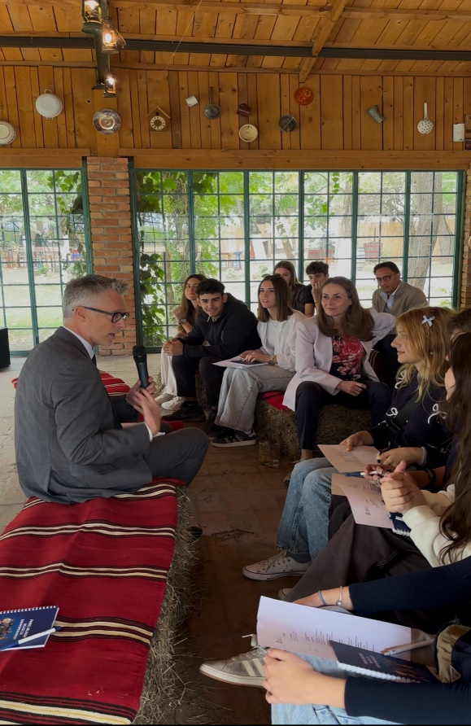
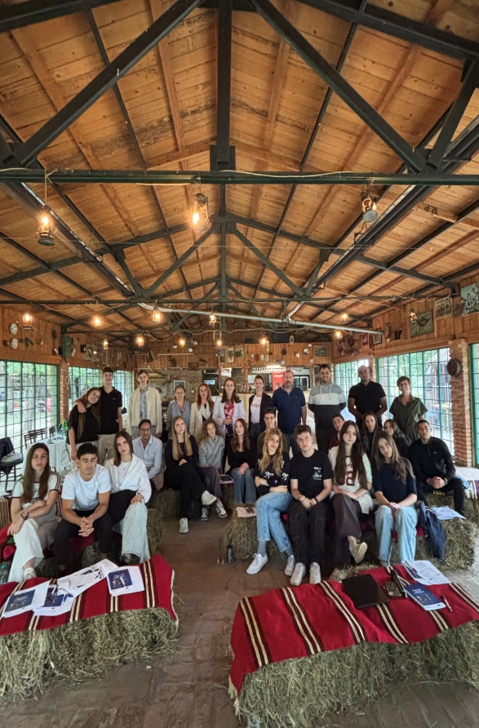
From the Youth Panel training on online safety, 2025.
Furthermore, recognising the need to increase awareness of children and young persons on issues of combating discrimination and promoting gender equality, the Commissioner, within the framework of the project “Education for Equality”, delivered 24 workshops in primary and secondary schools in Serbia. As part of the said project, supported by the British Embassy, a workshop for teachers was also held, and the previously mentioned Manual for delivering teaching on topics of protection from discrimination and the advancement of equality was published. In addition, education was the topic of the second day of the Commissioner’s Annual Conference, on which occasion teachers, pedagogues and students shared their experiences.
Additionally, in 2025 the project “The Commissioner’s Youth Panel for the Protection of Equality – Youth for Equality” was completed, supported by the EU’s Erasmus+ programme, in partnership with the Ombudsperson for Gender Equality of the Republic of Croatia. Within the project, three trainings for peer educators were held, the Peer Education Programme on recognising and responding to discrimination was published, and 5 peer-education sessions were delivered in secondary and primary schools in Belgrade, Novi Pazar and Smederevska Palanka. The project’s final conference brought together the heads of equality bodies in the region, the EU Ambassador to the Republic of Serbia, as well as representatives of educational institutions and CSOs.
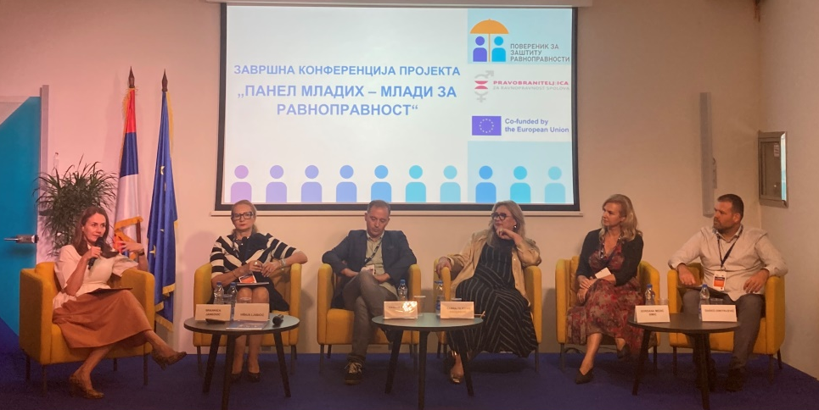
From the final conference of the project “The Commissioner’s Youth Panel for the Protection of Equality – Youth for Equality”, 2025.

Under the Programme, peer educators, with the support of the OSCE Office in Novi Pazar, delivered four educational sessions in secondary schools in Prijepolje and Priboj. On the occasion of the beginning of the new school year and the rollout of training programmes on recognising violence and discrimination in schools, the event “Together and Safe Through Childhood” was held in the premises of the Criminalistics and Police University, where, through socialising, fun and play, staff of the Commissioner’s expert service introduced children to the concepts of discrimination, equality and tolerance and discussed why it is important to nurture mutual respect and understanding. The need for continuous education of children and young persons on tolerance, understanding, human rights and cooperation is also illustrated by a case from the Commissioner’s practice.
The need for continuous education of children and young persons on tolerance, understanding, human rights and cooperation is also illustrated by a case from the Commissioner’s practice.

Welcoming the swift response of the Higher Public Prosecutor’s Office in Pančevo following the detention of a young man responsible for writing hate graffiti in that city, Commissioner Antonijević pointed out that the fight against hate speech cannot be reduced to repressive measures alone, but requires continuous prevention through education, the family environment and responsible public discourse, with a particular focus on the role of the media and social networks.
Young people must learn to respect the dignity of every human being, to understand the gravity of violence and war suffering, and to develop awareness of equality and responsibility for the spoken word. He also emphasised that, should Serbia decide to introduce compulsory military service and modern forms of youth training, it is important that such programmes also include content on equality, the prohibition of hate speech, respect for victims, and responsibility towards others, in order to prevent the spread of intolerance and violent messages.
More at: https://ravnopravnost.gov.rs/saopstenje-poverenika-povodom-grafita-mrznje-u-pancevu/

Considering the position of older persons worldwide and various forms of human rights violations, including discrimination, violence, abuse and neglect, the UN Human Rights Council established an intergovernmental working group tasked with preparing a Draft UN Convention on the Rights of Older Persons. This represents an important step towards the adoption of a legally binding international treaty that strengthens and protects the rights of older persons worldwide. A UN Convention on the Rights of Older Persons would help address existing gaps in protection by requiring states around the world to take concrete measures to advance and protect the rights of older persons. This convention should set a course and regulate key guidelines on promoting and protecting the rights of older persons, contribute to eliminating ageism and discrimination on the grounds of age, and enable older persons to seek legal protection in cases where their rights are violated.
In addition, the Parliamentary Assembly of the Council of Europe adopted Resolution 2592, calling on member states to take concrete measures in combating discrimination on the grounds of age, emphasising that human rights should not diminish with age and advocating for a “human rights-based approach to ageing”. The resolution highlights that many legal frameworks do not provide the same level of protection from age discrimination as they do for other forms of discrimination, and calls for urgent reforms. The Assembly called on governments to promote intergenerational solidarity, ensure equal access to digital technologies, and combat age-related stereotypes through education and awareness-raising campaigns. The Committee of Ministers was also invited to review the implementation of the 2014 Recommendation (CM/Rec(2014)2) on the rights of older persons, identify existing gaps, and explore the feasibility of a European legal instrument for the protection of the human rights of older persons.
A study by the European Parliamentary Research Service assesses the potential impact of the proposed horizontal EU Equal Treatment Directive outside employment, which includes age as a protected ground. The findings suggest that the directive is in line with the principles of subsidiarity and proportionality and that it would significantly strengthen fundamental rights while improving protection from discrimination. Study also suggests that the social and economic benefits—particularly improved access to goods and services—are substantial. It is also indicated that the proposed directive could address emerging challenges such as algorithmic discrimination and forms of inequality arising from the digitalisation of essential services.
Older persons facing intersecting forms of discrimination, such as older women, persons with disabilities, migrants, members of ethnic minorities, LGBT+ persons, refugees and internally displaced persons are particularly affected by disparities and inequalities. An analysis of the intersectionality between older persons’ right to social protection and their right to work is addressed in the report of the independent expert on the protection of the rights of older persons, which emphasises that social protection systems in most countries typically do not meet the needs of older persons, with the main problems relating to the adequacy and accessibility of services. Pensions are often insufficient to ensure an adequate standard of living, with many older persons relying on family or charitable organisations. Mechanisms for indexing and adjusting pensions to inflation are either absent or ineffective, while in the labour market older persons continue to be systematically discriminated against, which prevents them from remaining in, or re-entering, the labour market, even when they wish to do so or must do so in order to maintain their standard of living.
Labour shortages, accelerated digitalisation and the green transition are changing the way work is carried out and the types of jobs available, thus transforming the labour market. At the same time, demographic aging is changing the composition of the workforce, with older workers representing an increasingly vital component of human capital. These trends raise urgent questions about the sustainability and quality of working life, as well as inclusivity of the current and future labour market strategies. The AGE Barometer 2025 examines how these changes affect older workers and how they may shape future opportunities and challenges. The findings of this publication indicate that new digital tools and processes exclude older workers due to a lack of digital skills and appropriate training, as well as low mobility, which leads to loss of knowledge, unemployment and discrimination against older workers. On the other hand, the green transition promotes the creation of jobs in sectors where older workers have the necessary experience (for example, construction, recycling, maintenance) and where traditional knowledge and practical skills are valued, enabling older workers to transfer their knowledge to younger generations and encouraging intergenerational cooperation. Some of the recommendations in this report relate to: developing inclusive digital training programmes, promoting lifelong learning systems, encouraging flexible work arrangements for older workers and care-givers, with particular attention to women and gender equality, investing in digital infrastructure in rural areas, developing tailored regional policies to address local disparities, encouraging intergenerational cooperation, and others.
Throughout 2025, the Commissioner drew attention to discrimination against older persons. Thus, on the occasion of the International Day of Older Persons, a conference entitled “My Future–Whose Concern Is It? An Inclusive Society for All. Part Two” was organised jointly with the Office of the Attaché for Labour, Social Affairs, Health and Consumer Protection of the Republic of Austria, UNFPA in Serbia and the Red Cross of Serbia. The event brought together decision-makers, civil society representatives and experts from Serbia and Austria, serving as a platform to discuss innovative approaches to active and healthy ageing, digital inclusion, the silver economy and intergenerational cooperation—key priorities for ensuring that older persons live dignified, active and fulfilling lives. It was noted that, between 1974 and 2024, the share of people over the age of 65 worldwide almost doubled—from 5.5% to 10.3%—and that, according to United Nations projections, between 2024 and 2074 this figure will double again and reach 20.7%. In Serbia, every fifth person is already over the age of 65, and it is expected that by 2041 every fourth person will be over the age of 65, which calls for strategic commitment to policies and measures that protect dignity and ensure the continuous, active contribution of older persons to society and the economy—from promoting digital inclusion to encouraging the “silver economy”.
The final part of the event was dedicated to the official presentation of the awards “Bridge of Understanding – Intergenerational Solidarity”, granted to the winners, as previously mentioned. In addition, a performance of an excerpt from the play “Waiting for the Rain” by the Artichoke Association was held, which highlights the importance of social responsibility and intergenerational solidarity and calls for active engagement in the fight against ageism.
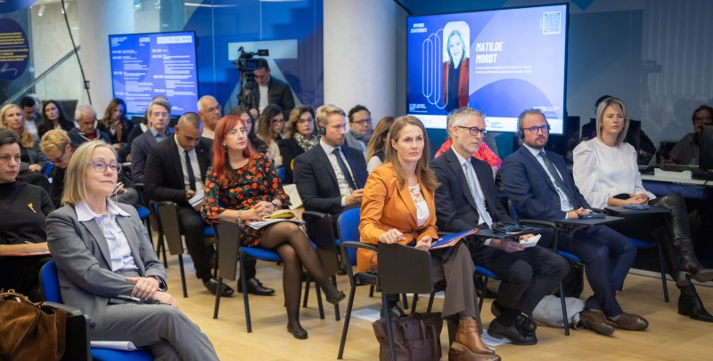
From the conference “My Future – Whose Concern Is It? An Inclusive Society for All. Part II”, October 2025.
The conference also featured an excerpt from the interactive theatre performance “Waiting for the Rain”, part of the European project “Age Against the Machine”. The project aims to challenge ageism, one of the most widespread, yet least recognised, forms of discrimination in Europe, which is often normalised through language, humour, media narratives, and public policies. Led by the “Novi Sad – European Capital of Culture” Foundation and implemented in partnership with organisations from Serbia, Denmark, Italy, Portugal, and Poland, the project used socially engaged theatre as its central approach. A special component of the project was research on ageism (based on World Health Organization tools). The results of the research, conducted by the Red Cross of Serbia and tracking audience attitudes towards older persons before and after performances, showed that: there was a rapid decrease in openly negative stereotypes about older persons (the share of the audience viewing older persons as a “burden” decreased from 38% to 22%), fear of one’s own ageing and discomfort in contact with older persons declined immediately after the performances (the view that older persons “do not adapt to change” fell from 55% to 39%), emotions changed faster than rational beliefs, and paternalistic attitudes and issues related to power, decision-making, and older persons’ participation in public life remained the most resilient (more than half of respondents (52%) still supported “shielding older people from difficult decisions”). At the same time, fear of one’s own ageing decreased from 61% to 45%.
In addition, representatives of the institution participated in the development of the Programme for the Prevention and Suppression of Ageism in the Republic of Serbia – Years Are a Treasure: Promoting the Inclusion and Equality of Older Persons at the Local Level within the Programme: PRO – Local Governance for People and Nature. This programme is one of the responses to the need to identify and analyse the causes of age-based discrimination, as well as to define measures, recommendations, and policies aimed at its prevention and elimination. The development of the Programme was based on the results of round tables held during 2024 in 12 units of local self-government. The Programme is primarily intended for local self-governments and all competent actors at the local level, including civil society organisations, health and social care institutions, educational institutions, and the media, which play a significant role in creating conditions for a dignified, active, and fulfilling life for older persons, and it serves as a practical guide for developing inclusive policies, planning local initiatives, and implementing specific measures aimed at strengthening intergenerational solidarity and reducing ageism in all spheres of society. The ultimate goal of the Programme is to promote a fair and positive attitude towards ageing and older persons, as well as to build a society in which the human rights, dignity, and equal opportunities of all citizens are permanently protected and advanced, in line with national legislation and international standards.
In cooperation with the United Nations Population Fund (UNFPA) in Serbia, the Commissioner, through the PRO – Local Governance for People and Nature project, supported the opening of three resource centres for intergenerational cooperation in Pirot, Svilajnac, and Trstenik. Through these centres, an innovative approach will be used to address challenges faced by older persons, recognise and value their contribution to society, and create opportunities for active participation in social and economic life. Bearing in mind widespread stereotypes about older persons, insufficient opportunities for social engagement and inclusion of older persons, as well as population ageing in general, the concept of resource centres entails: respect for the rights of older persons; preserving and enhancing their capacities to actively contribute to society; creating opportunities for older persons to become constructively involved in community life and improving understanding and cooperation between older persons and young people. The work of these centres is based on the coordination of a large number of actors at the level of the local community, including employers, institutions, civil society organisations, and others, it is designed as part of the local self-government unit.
The practice of the Commissioner for Protection of Equality indicates that older persons often face prejudices which affect their quality of life. Attitudes towards older persons are an important indicator of the level of social responsibility and humanity of a community, therefore, it is necessary for institutions and individuals to act with particular care and respect for their needs. Placing persons in an unequal position on the grounds of age when providing services is a common reason why older citizens reach out to the institution.
Recommended measures to the Institute for Emergency Medical Care Belgrade
Commissioner issued recommended measures to the Institute for Emergency Medical Care Belgrade to include the category of older persons in the Code of Conduct, and to ensure priority in the provision of health care in the same manner as the prescribed duty of employees to treat persons with disabilities with particular care and to ensure them priority in the provision of health care, provided that this does not jeopardise the interests of other patients, and to comply with this duty in practice. It was also recommended that training be organised for employees on sensitisation in working with older persons, in order to obtain, in an appropriate manner, the necessary information on health status and the need to provide emergency medical assistance.
More at https://ravnopravnost.gov.rs/291-25-preporuka-mera-zavodu-za-urgentnu-medicinu-beograd/
Commissioner’s practice shows that the introduction of digital technologies in accessing various services most often affects older persons.
Citizens contacted the Commissioner, pointing out that the service of issuing train tickets by the conductor is charged an additional 500 dinars and that in this way all persons who do not have a mobile application, the necessary digital skills, the ability to make electronic payments, or who do not know how to use electronic ticket vending machines they are put in a less favourable position. This problem particularly affects older citizens, as well as persons of low socio-economic status. Bearing in mind that it is not possible to pay in cash at ticket machines, but only by card, the Commissioner issued recommended measures to the commercial company Srbijavoz a.d., to refrain from charging passengers departing from stations that have only ticket machines a fee of 500 dinars for issuing a ticket on the train.
More at: https://ravnopravnost.gov.rs/619-24-preporuka-mera-srbija-vozu-prilikom-pruzanja-usluga/

The statement of the well-known sports official Miodrag Božović that people over the age of 65 should be deprived of the right to vote offers an illustration of attitudes towards older persons and their position in society. In response, it was pointed out that challenging fundamental human rights, such as the right to vote for older persons solely because of their age, is not only prohibited by the Law on the Prohibition of Discrimination, but is also dangerous, as it fuels prejudice and contributes to the creation of a hostile and humiliating environment for older citizens. Supporting young people and their ideas is entirely legitimate, but it in no way justifies depriving other age groups of their rights. It is particularly harmful to society when such statements come from public figures who have a certain credibility or influence in society.
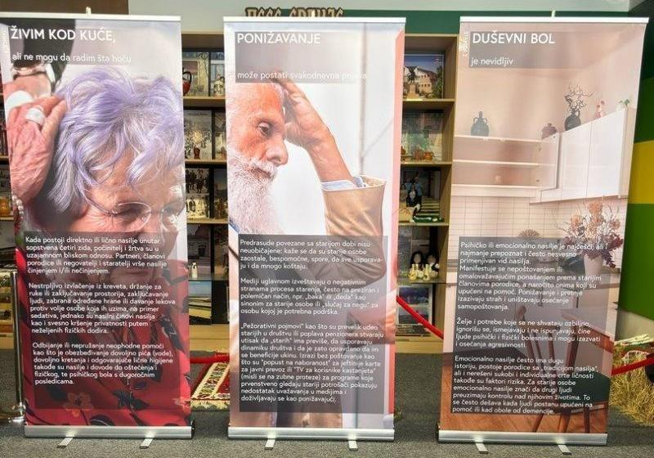
A particular issue when discussing the position of older persons in society is violence, which may be physical, emotional, psychological, financial, legal, social, health-related, as well as abuse and neglect. Family members are frequently perpetrators of violence against older persons. This topic is insufficiently discussed, because victims often fear the perpetrator, distrust institutions, feel shame and guilt. To raise awareness on this important issue, the Commissioner, in cooperation with the Austrian Federal Ministry of Labour, Social Affairs, Health and Consumer Protection, organised an event to mark the International Day of Awareness of Abuse and Neglect of Older Persons. It was emphasised that, according to World Health Organization data, one in six people aged 60 and over worldwide experience some form of violence. The event concluded that it is necessary to discuss this topic more frequently and to change the narrative, as well as the way old age is perceived, with an essential change in awareness and the building of a culture that respects older persons as equal members of society and enables them to exercise all human rights. It was emphasized that there is a need to revise the protocols governing the actions of all state authorities in cases of domestic violence, with particular attention to violence against the elderly. Equally highlighted was the necessity of improved coordination among all actors within the system, including the involvement of civil society organizations, as well as the introduction of specialized training for all professionals engaged in the system of protection against violence. It was concluded that interventions in the domain of criminal legislation are necessary, including the introduction of a specific criminal offense addressing violence against the elderly. It was also emphasized that a more proactive role of the media, particularly the public service broadcaster, is essential, given that older persons predominantly rely on this medium for information.
Relevant recommendations are issued based on the overview of the situation and the issues in the exercise of equality and the protection against discrimination on the grounds of age, which are provided in the summary of this Report.

Discrimination on the Grounds of Health Status
Based on the Commissioner’s practice, health status was the second most common discriminatory ground in 2025. Out of the total number of citizens’ communications, the institution formed 112 cases pursuant to complaints alleging discrimination on the grounds of this personal characteristic. This discriminatory ground is often alleged in conjunction with another personal characteristic, usually disability, age, sex etc.

In terms of specific areas of social life, majority of the complaints filed concerned labour and employment (26), education and vocational training (24), followed by healthcare (20), procedures before public authorities (17), in the provision of services and/or the use of public areas and facilities (17), etc. The majority of complaints, 102 in total, were filed by individuals, with women filing 83 complaints and men filing 19, while civil society organisations filed 5 complaints, groups of persons 4, state bodies 2 complaints, and a legal entity 1.

In the area of health care, diverse problems arise, as shown not only by the Commissioner’s practice, but also by numerous studies and reports. In this reporting period, citizens’ complaints once again confirmed the importance of conducting regulatory impact assessments of the effects of regulations on the enjoyment of citizens’ rights, as well as carrying out ex-post analysis of the measures introduced.
Examples from the Commissioner’s practice illustrate the impact of regulations on citizens’ rights. During the year, citizens contacted the institution pointing to the inability to exercise the right to health insurance coverage for insured persons in emergency situations when they find themselves abroad, within the meaning of the Health Insurance Law. This law makes the right to use health care abroad at the expense of mandatory health insurance conditional by limiting the entitlement only to those insured persons who, in the previous 12 months, have not suffered from acute or chronic diseases in an acute phase that require long-term or continuous treatment. This provision unquestionably excludes a large number of people with chronic, developmental, rare, or long-term diseases—such as, for example, diabetes, arthritis, or lupus, etc., from the possibility of exercising the right to emergency medical assistance abroad, even when there is an immediate danger to their life that is not related to the underlying disease, although they pay health insurance contributions like other citizens.
The Commissioner submitted to the Constitutional Court a Proposal for the assessment of constitutionality and legality of Article114 of the Health Insurance Act.
In analysing whether there is proportionality between the measures undertaken and the objective to be achieved, the Commissioner pointed out that the condition prescribed by the Health Insurance Act is neither appropriate nor necessary, because it excludes a large number of insured persons of the Republic Fund for Health Insurance from the possibility of exercising the right to health care abroad at the expense of mandatory health insurance funds. More on the above is provided in the section of the report relating to the Commissioner’s proposals for the assessment of constitutionality and legality submitted to the Constitutional Court.
More at: https://ravnopravnost.gov.rs/453-24-predlog-za-ocenu-ustavnosti-i-zakonitosti-zakona-o-zdravstvenom-osiguranju/

In addition, the institution was alerted to unequal treatment by the Institute for Health Protection of Workers of the Ministry of the Interior when issuing assessments of the medical fitness of candidates for training at the Basic Police Training Centre (COP) and in other organisational units of the Ministry of the Interior. The Commissioner’s practice has shown that, in certain cases, candidates for admission to basic police training and employment in the Ministry were rejected due to their appearance or due to certain illnesses and congenital conditions that do not constitute a functional impediment to performing police work. For example, communications to the Commissioner pointed out that certain skin conditions and diseases, such as vitiligo, psoriasis, and the like, are on the List of Morbid Conditions as a disqualifying condition for performing police duties. The same applies to certain congenital conditions, such as congenital and acquired defects of the oral cavity, tongue, jaw, temporomandibular joints, and salivary glands. For example, a candidate was rejected after a review of earlier medical documentation established that he was born with a cleft upper lip and palate and was operated on as a child. Candidates were also rejected in cases where they have a tattoo or have had it removed, after which a scar remained. Namely, it was pointed out that in certain cases tattoos were treated as a disqualifying factor, while in others, such as for example, the call for applications for the Gendarmerie, were acceptable, i.e., they did not constitute a contraindication for admission to service. The communications pointed out that candidates who were admitted to training, and then began the process of tattoo removal so that they would not have to cover them with clothing in accordance with the provisions of the Rulebook on the Conduct and Personal Appearance of Police Officers and Other Employees in the Ministry of the Interior are, upon a repeat medical examination, assessed as “medically unfit” for training at the Basic Police Training Centre (COP). It was stated that such inconsistent practice by the Institute in assessing medical fitness creates uncertainty among candidates as to whether they will be deemed fit to perform police work or not. Proceeding from the premise that the selection of participants for basic police training, as well as persons employed in the Ministry of the Interior, should be based on objective, formal criteria such as medical fitness to perform the duties of a police officer, education, assessment of competencies and skills, motivation, work experience, and similar factors, the Commissioner pointed out that, when issuing an assessment of the medical fitness of candidates for admission to the police service, it is necessary, alongside the regulations governing work in the police, to also take into account anti-discrimination regulations that prohibit unjustified unequal treatment on the grounds of actual or presumed personal characteristics such as appearance and health status. In that regard, it is necessary to consider whether all the diseases and conditions listed in the List of Morbid Conditions genuinely affect the ability to perform police duties and therefore justifiably constitute an obstacle to work in the police, i.e., whether the limitations set out in the List are appropriate, necessary, and proportionate to the legitimate aim pursued.

The Commissioner issued a recommended measure to the Institute for Health Protection of Workers of the Ministry of the Interior, requesting that, guided by anti-discrimination regulations, it review and amend the List of Morbid Conditions by considering whether all diseases and conditions on the List have an essential impact and objectively constitute an obstacle, i.e., a disqualifying condition for obtaining a positive assessment of medical fitness for work in the police, and whether the established exclusionary criteria and benchmarks are appropriate and necessary with regard to the medical-fitness standards for performing the duties of a police officer.
More at: https://ravnopravnost.gov.rs/rs/229-25-preporuka-mera-ministarstvu-unutrasnjih-poslova/

The Commissioner’s practice shows that complaints on the grounds of health status and disability are common when it comes to exercising rights and accessing services in the field of social protection.
For example, this year, like previous years, parents of children with autism and other health conditions contacted the institution due to the inability to exercise the right to the personal assistant service. As a reminder, due to the frequency of this problem in the past, the Commissioner previously pointed to the need for its urgent resolution, and issued recommended measures to all units of local self-government to ensure the provision of this important service to all children who need it. The Commissioner also initiated strategic litigation against a Centre for Social Work and the local self-governance, as further described in the part of this report relating to the Commissioner’s strategic litigation. In addition to this lawsuit, the Commissioner is an intervener in proceedings initiated by the mother of a child with autism against a private preschool institution, due to discrimination against her child during attendance at kindergarten. To provide adequate and inclusive education and improve the position of children with health problems and disabilities, it is necessary to take into account the number of children in a preschool group, especially if it exceeds the legally prescribed number, as this directly affects the quality of education as well as the provision of additional support to children with health-related difficulties and disabilities. In our regular annual and special reports, we have indicated that it is necessary to increase the number of preschool institutions and/or educational groups within preschool institutions, as well as the number of employed preschool teachers and medical technicians, to provide the necessary additional support, including mandatory attendance of the preparatory preschool programme for children who have health difficulties or disabilities.
In proceedings regarding a complaint submitted by a mother on behalf of her minor son against a preschool institution, the mother complained that over a period of three years the institution had repeatedly refused to enroll her son in kindergarten, although it should have considered the request as a priority given the child’s health status and disability. Only after contacting the Ministry of Education and the Education Inspectorate did the preschool institution offer to enroll the child in a kindergarten that is very far from the family’s place of residence, failing to take into account the health status and disability of the minor boy.
The Commissioner determined this was discriminatory and issued a recommendation to the preschool institution to act upon the transfer request submitted by the complainant, so as to enable the child to attend the preparatory preschool programme in the kindergarten that is geographically closest to his place of residence.
More at: https://ravnopravnost.gov.rs/rs/375-24-misljenje-povodom-prituzbe-protiv-predskolske-ustanove/

In the Commissioner’s Special Report on Discrimination against Persons with Disabilities attention was drawn to the situation of informal caregivers, most frequently women, which results in their complex position, inability to participate in the labour market, economic dependence, and poor prospects for the future.
The Commissioner issued recommended measures to the National Employment Service that employment counsellors, in accordance with the Instruction on the conditions for including unemployed persons in active labour market policy measures, should, when preparing an individual employment plan, give particular consideration to persons who directly provide care to a member of their immediate family, that is, they should assess their socio-demographic characteristics, as well as the opportunities and difficulties they face, with a view to their more effective inclusion in active labour market policy measures.
More at: https://ravnopravnost.gov.rs/969-25-preporuka-mera-nacionalnoj-sluzbi-za-zaposljavanje/

In addition, at the end of 2025, a group of citizens and parents of children with developmental disabilities approached the Commissioner with an initiative to legally regulate the status of “parent-caregiver”. Following contact with the competent ministries, the Ministry of Labour, Employment, Veteran and Social Affairs, in cooperation with the Ministry of Human and Minority Rights and Social Dialogue, issued a Public Call for civil society organisations to submit nominations for membership in the working group for preparing the first draft of the law that will regulate the issue of “parent-caregivers”. The aim is for parents who provide daily care for children with health conditions and disabilities to receive, as soon as possible, systemic solutions that will ease their burden and make their rights more secure.
The findings of the research “Compassion Fatigue – Secondary Traumatization of Employees in Long-Term Care Institutions and Family Caregivers” also indicate that the burden of informal care is distributed disproportionately and represents a serious social and institutional challenge. The research emphasized that one of the key challenges for societies worldwide is the need to develop and expand formal community-based services, as well as to ensure the availability of services in the home environment. At the same time, it pointed to the lack of comprehensive data on the needs and problems of informal caregivers, especially those who provide care over a longer period of time, as well as the absence of systematic data on their physical and mental health.
During the reporting year, a number of complaints were related to access to newer-generation medicines and therapies financed from the Fund’s resources, as well as to the availability of these therapies in an equal and affordable manner across the entire territory of the country.
Initiative to the RFZO
The associations MS Platform Serbia and MS Platform Smederevo informed the Commissioner about the challenges faced by people with multiple sclerosis in accessing medicines and necessary therapies. It was emphasized that, although two years prior the practice was introduced that people living with this disease receive moderately effective injectable therapies at health centres in their local communities, it is still necessary for them to collect oral therapies at clinical centres, as well as one injectable therapy. In order to receive these therapies, they often have to travel more than 60 kilometres to obtain the necessary medicines.
The RFZO informed the Commissioner that it has increased the number of healthcare institutions, including hospitals and clinical-hospital centres, where it is possible to receive medicines. Specifically, the RFZO clarified that in 2022 it enabled persons with multiple sclerosis to receive certain medicines from List C of medicines in a larger number of healthcare institutions that provide healthcare services at the secondary level of healthcare. At that time, the so-called decentralisation was carried out in the administration of the medicines interferon beta 1a, interferon beta 1b and glatiramer acetate, which also marked the beginning of this process. During 2024, the RFZO also expanded the possibility of administering these medicines to an additional five healthcare institutions, and this year the administration of additional medicines for the treatment of multiple sclerosis (medicines from List C of the List of Medicines with the INN teriflunomide and dimethyl fumarate) has been enabled in 27 healthcare institutions.
More at: https://ravnopravnost.gov.rs/rs/913-24-republicki-fond-za-zdravstveno-osiguranje/
In this reporting period, like previously, associations of citizens living with rare diseases, i.e. representatives of associations, contacted the Commissioner, stating that the medicines prescribed to them are not sufficiently effective, and that there are numerous other medicines that are not only more effective, but are also better tolerated or have other advantages in use, and that certain medicines for specific conditions are not registered in our country. They point to problems in the application of the existing regulations, inconsistent practice, as well as the need for better information for families of children with rare diseases about the rights to which they are entitled. They also state that it is necessary to adapt, that is, standardise, new social welfare services that would better meet the needs of persons living with a rare disease.
The Ministry of Health has continuously ^{increased} allocations and carrie^{d} out activities aimed at improving the position of persons ^{affected by} rare diseases. In Serbia, in 2012, 130 million dinars were allocated for the treatment of 8 patients with rare diseases (for two diagnoses), while for 2025, 10.2 billion dinars have been earmarked. In the Register of Persons with Rare Diseases maintained by the Institute of Public Health of Serbia “Dr Milan Jovanović Batut”, in Serbia, as of 14 February 2025, 14,528 persons had been recorded. The National Organization for Rare Diseases of Serbia (NORBS) assesses that data are not being entered into the register to a sufficient extent, and that accurate statistical data on the number of persons affected still do not exist, which prevents proper planning of healthcare.
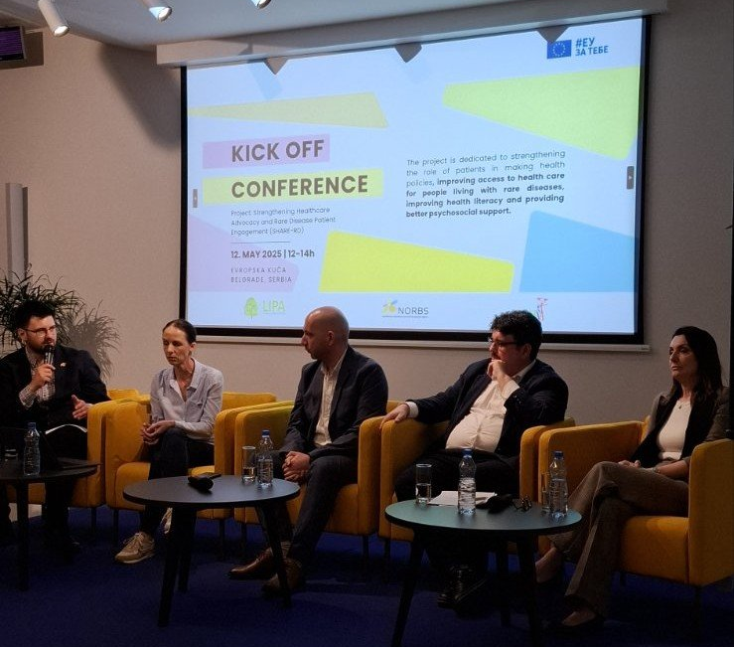
An equal position of persons with rare diseases requires continuous improvement of the legislative framework and the development of support systems, as well as the removal of various barriers and prejudices towards persons affected, it was emphasized at the opening of the fifth regional conference organized by the National Organization for Rare Diseases of Serbia (NORBS), held with the aim of raising awareness of the challenges faced by these persons and their families. On that occasion, the then Commissioner Janković received recognition for her special contribution to improving the position of persons living with rare diseases.
The NORBS Report on the state and prospects for the development of labour legislation de lege ferenda for the exercise and protection of labour rights of persons living with rare diseases in the Republic of Serbia states that, in order to improve the position of persons living with rare diseases, it is necessary to ensure clear legal recognition, flexible forms of work, better health and social support, incentives for employment, protection from discrimination, and efficient data collection.
The institution’s practice has shown that strengthening an intersectoral approach is extremely important for persons who, due to their specific social and health status, need both social care and continuous healthcare protection or supervision. The implementation of Article 60 of the Law on Social Protection, which relates to the establishment of social and healthcare institutions and the standards for the provision of services in these institutions, has still not been implemented adequately, as the Commissioner has already pointed out.
The importance of an intersectoral approach has been recognized in other health systems as well. The report Alzheimer’s disease EU-IN Horizon Scanning Report states that numerous health systems are not adequately prepared to apply complex diagnostic and therapeutic methods due to a lack of specialized staff, infrastructure, and monitoring mechanisms. Together with the increasing health, social, and economic burden, including heavy reliance on informal care, this clearly indicates an urgent need for coordinated investments in early diagnosis, health system preparedness, equitable access to services, and integrated health and social responses.
In addition, citizens have for years pointed to problems arising from long waiting lists for organ transplantation. As part of the opening panel of the international conference “Legal Challenges and Perspectives of Organ Transplantation: Three Years Without Amendments to the Contested Law”, organized by the association “Donation is Heroism”, attention was drawn to the seriousness of the problem of a legal vacuum that has existed for several years, after the Constitutional Court in 2021 ruled that certain provisions of the Law on the Transplantation of Human Organs and the Law on Human Cells and Tissues were not in conformity with the Constitution. The right to life and healthcare, especially for those on organ transplant waiting lists, are seriously jeopardized by the current lack of legal regulation.
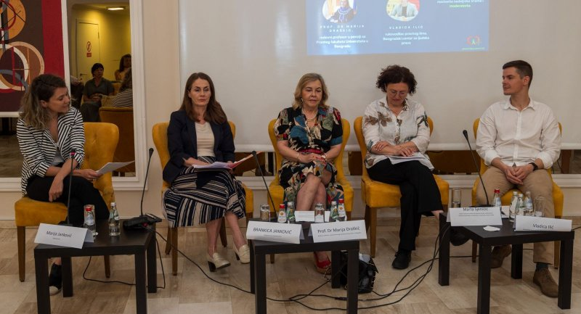
From the conference “Legal Challenges and Perspectives of Organ Transplantation: Three Years Without Amendments to the Contested Law”, 2025.
Namely, following the decision of the Constitutional Court, transplantation has almost completely come to a halt. In addition, besides the missing legislative framework, an intensive public awareness-raising campaign is also needed to highlight the importance of transplantation.
Similarly to previous years, the Commissioner addressed the Ministry of Health regarding the adoption of amendments and supplements to the Law on the Transplantation of Human Organs and the Law on Human Cells and Tissues, in order to, following the decisions of the Constitutional Court, re-establish a complete legal framework and regulate the transplantation of organs and tissues from deceased persons. The Ministry informed that the drafting of the law is under way and that the initiatives have been taken into consideration.
More at: https://ravnopravnost.gov.rs/rs/407-24-ponovno-obracanje-ministarstvu-zdravlja-povodom-izrade-nacrta-zakona-u-vezi-sa-transplantacijom-organa-i-tkiva/
When it comes to discrimination on the grounds of health status, a significant recurring problem is access to healthcare, as well as discrimination against and stigmatization of persons living with HIV/AIDS. Specifically, the Commissioner’s practice, as well as various studies regarding the provision of healthcare services to persons living with HIV, show that they encounter various obstacles in accessing healthcare services if they disclose their HIV status. The Commissioner received several complaints in this regard, although far fewer than in previous years. The position of persons living with HIV/AIDS is also illustrated by an example from this institution’s practice, where the complainant indicated that a hospital refused to perform an intervention solely because he has HIV. After the Commissioner requested the hospital’s statement, the hospital contacted the complainant, issued an apology, and enabled him to schedule the requested intervention. As a result, the complainant informed this authority that he agreed that the consequences of the conduct that had been the reason for addressing the Commissioner had been remedied, and the proceedings were therefore discontinued in accordance with the law.
In the procedure pursuant to a complaint against a hospital, it was stated that, following an examination, the complainant was advised to undergo an intervention, but that after disclosing his HIV-positive status, this intervention was not performed. Instead, the complainant was referred to have the procedure at a general hospital, with the explanation that most of their patients are children and that they could not take the risk.
In order to properly establish the facts and the reasons for denying the surgical intervention, the Commissioner requested clarification from the Ministry of Health as to whether the hospital could perform the surgical intervention sought by the complainant, i.e. whether it had authorization to carry out such procedures given the associated diseases and the decision issued by the Ministry of Health. In a letter from the health inspector, it was stated, inter alia, that the hospital has a decision of the Ministry of Health confirming that it meets the conditions for providing secondary healthcare in the field of otorhinolaryngology, including surgical procedures under general anaesthesia; and that it is obliged to organize its work in a manner that enables the care of patients with various chronic and infectious diseases, with the application of standard protective measures when working with patients with HIV infection. It was further stated that the hospital is not registered exclusively for the treatment of children and, as such, cannot be limited to providing healthcare services only to one population group. It was also noted that the institution is obliged to provide healthcare services to all patients regardless of age and health status, unless there are clear medical contraindications documented in accordance with the relevant professional protocol. The review of the evidence established that, in addition to specialist physicians in anaesthesiology with resuscitation medicine and in otorhinolaryngology, the hospital also engages physicians of all other specialties. The opinion was given that the hospital violated the provisions of the Law on the Prohibition of Discrimination, for which reason a recommendation was issued to the hospital, and the recommendation has been complied with.
More at: https://ravnopravnost.gov.rs/62-25-postupak-po-prituzbi-zbog-diskriminacije-prilikom-pruzanja-zdravstvenih-usluga/

Fear of discrimination often leads to postponed testing, belated treatment, and avoidance of health and social services, which directly affects health outcomes and quality of life. UNAIDS states that ending AIDS as a public health threat is an achievable goal, but only with decisive action by states and the international community. This includes ensuring stable and sustainable funding, protecting human rights, removing discriminatory laws and practices, ensuring equitable access to innovative methods of prevention and treatment, and integrating public policies related to combating HIV infection into broader health and social systems. From the perspective of equality and the prohibition of discrimination, the report clearly emphasizes that respect for the rights and dignity of persons living with HIV is not only a legal and moral obligation, but also a key precondition for an effective and sustainable response to HIV infection.
In a procedure pursuant to a complaint against a hospital, the case was terminated, but recommended measure was issued for the hospital to conduct staff training on discrimination against persons living with HIV and the effects of the contemporary therapies on the virus. The recommendation has been complied with.

In addition to the above, the association Doctors Against Corruption also pointed to problems in the area of exercising rights in healthcare, in a press release issued on the occasion of the International Anti-Corruption Day. The press release states that citizens of Serbia persistently assess the healthcare system as highly corrupt. This assessment is based on their lived experience of the inability or difficulty in exercising a fundamental human right, the right to treatment within the public healthcare system in an efficient manner, in accordance with the standards of modern medicine. In addition, it is stated that in December 2005, the National Assembly of Serbia adopted a set of systemic laws in the field of healthcare, which legalised a conflict between public and private interest, i.e. doctors employed in the public healthcare system were given the possibility of additional work in the private sector. The press release concludes that, despite high total annual spending of nearly 11% of GDP, i.e. eight billion euros, health outcomes are alarming and citizens’ dissatisfaction is justified, and that additional private work by public-sector doctors has reduced productivity in the public sector and created artificial waiting lists.
Based on the examined state of play and issues in the achievement of equality and protection against discrimination on the grounds of health status as a personal characteristic, we issued the relevant recommendations presented in the summary section of this Report.

Discrimination on the Grounds of Income Level
Income level as a ground of discrimination was introduced into the Law on the Prohibition of Discrimination through its 2021 amendments, and this is the first time that this ground has ranked among the highest by number of complaints submitted (110).
Specifically, the Commissioner received more than one hundred complaints from several trade-union organizations, as well as from a larger number of employees in the social welfare system, who pointed to the less favourable position in which certain employees in centres for social work found themselves following the adoption of the Regulation on Amendments to the Regulation on Coefficients for the Calculation and Payment of Salaries of Employees in Public Services.
The complaints stated that, through amendments and supplements to the Regulation, certain professional staff employed in social work centers were excluded from the planned increase in the coefficients for calculating employees’ salaries during 2025. By amending the Regulation, an increase in coefficients was established for certain groups of jobs, but attorneys, sociologists, and complex economic and financial positions in social welfare institutions for the accommodation of beneficiaries and in centres for social work (VII level of vocational training) were omitted, which placed them in a less favourable position compared to employees in other services. The complaints subsequently pointed out that the Regulation on Coefficients for the Calculation and Payment of Salaries of Employees in Public Services does not recognize the profession of andragogue, and thus this profession is not recognized either in the Regulation on Amendments to the Regulation on Coefficients of 13 February 2025, by which the coefficient for salary calculation is increased for certain categories of employees. A number of complaints were also submitted by economists performing complex financial and accounting tasks who are employed in social work centers. It was stated that the officer for administrative and legal affairs and a graduate economist for financial and accounting affairs in centres for social work, given their level of education and the complexity of the tasks they perform, cannot in any way be valued less than other staff with the same level of education in public services.
The Commissioner issued recommended measures to improve equality to the Ministry of Labour, Employment, Veteran and Social Affairs and the Ministry of Public Administration and Local Self-Government and emphasized that adopting the inequalities in the coefficients for calculating and paying salaries of employees in public services, in the part relating to employees in the social welfare system, may lead to additional disruption of work and a deepening of unequal treatment towards a significant part of employees in this very important system. Determining the coefficient directly affects the level of income they earn, which, for work of equal value at the same level of education, should be harmonized. In addition to the potential for an intensified outflow of experienced and trained employees from the social welfare system, different treatment of employees who make an equal work contribution with equal responsibility will lead to disincentives to work in this key system, which will directly affect the functioning and quality of work towards beneficiaries, i.e. make it more difficult for citizens to exercise their rights. The Commissioner expressed particular concern about how this will affect beneficiaries of social welfare rights and services who belong to the most vulnerable populations, such as, for example, persons with disabilities, health difficulties, older citizens, persons with low incomes, homeless persons, etc., who are otherwise at increased risk of poverty and discrimination. The Commissioner emphasized that the Law on Social Protection stipulates that personnel in centres for social work consists of: a lawyer, a sociologist, a social worker, a psychologist, a pedagogue, an andragogue and a special education teacher, while a special education professional (defectologist) and a physician can be personnel in other social welfare institutions as well, and that the Labour Law guarantees employees equal pay for the same work or work of equal value performed for the employer, while work of equal value means work requiring the same level of qualifications/education, knowledge and abilities, with an equal work contribution and equal responsibility.
In the replies from both ministries, the Commissioner was informed that, by Government Conclusion No. 05: 119-1219/2025 of 13 February 2025, the text of the Protocol between the Government of the Republic of Serbia and the Trade Union of Employees in Health Care and Social Protection and the Confederation of Trade Unions of Serbia, signed on 13 February 2025, was accepted, and that the Ministry of Labour, Employment, Veteran and Social Affairs initiated an amendment, i.e. an increase in the coefficient for all groups of employees that were not covered by the supplement to the Regulation on Coefficients for the Calculation and Payment of Salaries of Employees in Public Services.
On 22 April 2025, inter alia, the Ministry of Public Administration and Local Self-Government informed the Commissioner that the Protocol between the Government and the social partners provides for the establishment of a Working Group tasked with preparing a proposal for adjusting coefficients for employees who were not covered by the Regulation on Amendments to the Regulation at that time, i.e. a proposal for adjusting the coefficient for the calculation and payment of salaries of non-medical staff in social welfare institutions, with the aim of aligning their salaries with those of employees in state bodies and public services who perform work of the same complexity and for which the same level of qualifications, knowledge and abilities is required, as well as the same level of responsibility. By a letter from October 2025, the Commissioner was informed that the adopted amendments to the Regulation established new basic coefficients for the performance of work by employees in social welfare institutions and institutes, in accordance with the Law on Social Protection, with the aim of increasing their salaries, and that, in line with the said agreement, a new single base amount for all employees would be determined, to be applied from the calculation and payment of salaries for January 2026.
More at: https://ravnopravnost.gov.rs/111-25-preporuka-minrzs-za-izmenu-uredbe-o-koeficijentima-za-obracun-i-isplatu-plata-zaposlenim-u-javnim-sluzbama/

Despite the above, employees in public services, such as employees in physical education institutions, administrative staff in the social welfare system with secondary vocational qualifications, and employees in preschool education, continue to contact the Commissioner regarding the coefficients for the calculation and payment of salaries of employees in public services. For this reason, at the beginning of 2026 the Commissioner addressed the competent ministries again.

Discrimination on the Grounds of Disability
In 2025, 91 complaints were filed alleging discrimination on the grounds of disability, making it the fourth most frequently cited discriminatory ground stated in citizens’ complaints.
The majority of complaints were filed due to discrimination in the provision of services or in the use of facilities and public areas (28), followed by labour and employment (22), proceedings before public authorities (19), in the field of education and vocational training, as well as public information and the media (10), healthcare (4), etc. This year, the majority of complaints were submitted by natural persons (81), of whom women submitted 43 and men 38 complaints, while organizations submitted 8 complaints, and one complaint each was submitted by a public authority and by a group of persons.
Discrimination on the grounds of disability has been among the top five discriminatory grounds since the establishment of the Commissioner’s institution, and disability was the most common discriminatory ground based on the total number of citizens’ communication which resulted in the forming of cases pursuant to complaints between 2015 and 2024. The scale and variety of problems they face on a daily basis when exercising fundamental rights and accessing services, alongside the failure to recognize capacities and abilities of persons with disabilities, puts persons with disabilities at a greater risk of discrimination. It should be borne in mind that persons with disabilities are a heterogeneous group, composed of persons of different age, gender, health status, marital and family status, and economic and social status. This affects the diversity of their needs, and contributes to the fact that they are more exposed to multiple and intersectional discrimination, i.e. discrimination on multiple personal characteristics, which further aggravates their position.
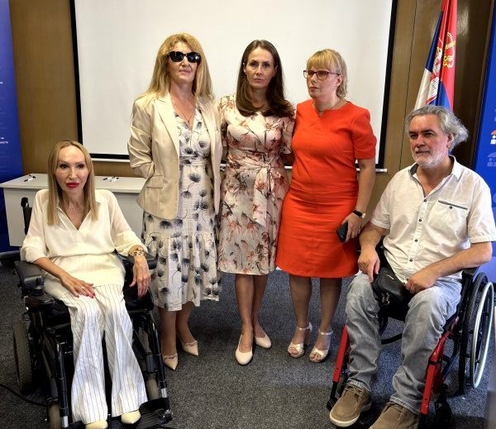
These were the reasons that prompted the Commissioner for Protection of Equality to submit to the National Assembly the second in a series of Special Reports on discrimination against persons with disabilities (which has already been discussed in earlier parts of this report). This report analyzed and presented the problems faced by persons with disabilities, in the areas in which, over the years, they submitted a large number of complaints, primarily in the provision of public services or in the use of facilities and public spaces, in the area of labour and employment, education and vocational training, as well as in the fields of social and health care. Special emphasis was placed on the activities undertaken by the institution to promote equality and protect against discrimination, as well as on the Commissioner’s research and publications highlighting the position of persons with disabilities. Particular attention was given to the Research on the position of persons with disabilities in the labour market, bearing in mind the significance of this area for the life of every individual. The inclusion of persons with disabilities in the labour market is a particular challenge due to the often low level of education and inadequate educational profiles, employers’ reluctance to hire them, issues in assessing work capacity, and insufficient protection in cases of dismissal. In order to familiarize employers with the concept of reasonable accommodation, business practices, and the inclusion of persons with disabilities in the workplace, the Commissioner, as an annex to this report, prepared and presented the Guidelines for implementing activities related to reasonable accommodation of workplaces/jobs for persons with disabilities, which further clarifies this statutory obligation and offers examples of activities for its practical implementation. In addition, the report provides recommendations for continued work to improve the position of persons with disabilities in the stated areas of social life. This report was presented in 2025 to the professional community, in cooperation with the Office of the United Nations Population Fund (UNFPA), UN Women, and UNDP Serbia, with the support of the Global Disability Fund.
European Commission’s Serbia Report 2025 also states, inter alia, that the Commissioner prepared a Special Report on discrimination against persons with disabilities, with an emphasis on intersectionality, accessibility, and the denial of reasonable accommodation in employment.
Recognising the variety of problems faced by persons with disabilities in the labour market, the Association of Enterprises for Vocational Rehabilitation and Employment of Persons with Disabilities of the Republic of Serbia also produced the Guide to reasonable accommodation of the workplace, which presents the experiences of enterprises for vocational rehabilitation and employment of persons with disabilities, in order to demonstrate to employers that workplace and working-conditions adjustments can be simple and easily applicable with minimal effort. The Guide also points to examples of assistive technology that can help enable a person with a disability to achieve their full potential in the workplace.
An example from the Commissioner’s practice confirms the need for such publications and for educating employers about the possibilities for accommodating workplaces/jobs for persons with disabilities.
In proceedings for protection from discrimination on the grounds of disability initiated against an employer due to assignment to a job position that did not correspond to the complainant’s remaining work capacity, the Commissioner issued an opinion that, by failing to assign the employee in line with his health condition and disability, i.e., in line with his work capacity, the employer violated the provisions of the Law on the Prohibition of Discrimination. The employer was given a recommendation to remedy the consequences of the discriminatory conduct towards the complainant with regard to assignment to a job position that corresponds to his work capacity.
More at: https://ravnopravnost.gov.rs/280-25-postupak-povodom-diskriminacije-po-osnovu-invaliditeta/

In the complaint for discrimination on the grounds of disability, the complainant stated that solely her employment contract was not amended after she obtained a Master’s diploma as a preschool educator, unlike all other employees in the same situation. In its reasoning, the employer stated that she does not perform direct work with children due to an established disability, which is why her contract was not amended and a higher level of education was not recognised. In the proceedings, it was established that the complainant is a person with a disability for whom a first degree of difficulties in work was determined, and that a decision of the competent authority recommended that she not perform direct educational work with children. The employer provided reasonable accommodation for the job position by first assigning her to the position of librarian, and then to the position of educator associate, with a job description that does not involve direct work with children. The obligation to provide reasonable accommodation of workplaces/jobs aims to ensure that all workers have equal access to employment, performing work, i.e., retaining employment, as well as career advancement, regardless of their disability. The Commissioner found that, due to the adjustment of duties to the complainant’s work capacity, she must not suffer adverse consequences, and issued an opinion that the preschool institution violated the provisions of the Law on the Prohibition of Discrimination, and the institution was therefore recommended to remedy the consequences of such conduct and place the complainant in an equal position with regard to employment related rights in relation to other employees holding the same professional title.
The preschool institution informed the Commissioner that it had submitted a request to the founder to increase the payroll budget for employees—preschool educators—who have obtained a second-level higher education diploma, and that, once approval is received from the founder, an annex to the employment contract will be concluded with the complainant, including the same coefficient as that applied to other preschool educators with the same level of education.
More at: https://ravnopravnost.gov.rs/560-24-prituzba-zbog-diskriminaicje-u-oblasti-zaposljavanja-ili-na-poslu-na-osnovu-licnog-svojstva-invaliditet/

Employment related issues for persons with disabilities persist in other countries, as is affirmed by the findings of the Global Report on Disability Inclusion, which analyses the global situation in the labour market and concludes that persons with disabilities are more likely to be unemployed. Although some countries have seen a small increase in the employment rate of persons with disabilities, employment gaps between persons with and without disabilities have largely remained unchanged over the past 10 years. In 90 countries, persons with disabilities were half as likely to be employed compared to persons without disabilities. Persons with disabilities earn, on average, 12% less than persons without disabilities in 30 countries. Women with disabilities earn even less, an additional 5–6% less compared to men with disabilities.
In addition to the aforementioned issues, one of the fundamental problems faced by persons with disabilities, as well as by other citizens, is the challenge of architectural, informational, and communication accessibility, a matter to which the Commissioner has been drawing attention for many years. Examples from the institution’s practice illustrate the scope of this problem. For instance, proceedings were initiated against a residential community on the grounds that the building entrance was not accessible, while another entrance that was accessible remained locked. The Commissioner issued an opinion that the residential community and the building manager had not undertaken all actions within their competence to enable the complainant unobstructed access to the building, and that they thereby violated the provisions of the Law on the Prohibition of Discrimination. The residential community was recommended to undertake all actions within its power to provide an accessible entrance to the residential building, either by constructing a ramp or by making available the entrance previously used by the complainant, which is level with the ground surface, but currently not in use.
In the complaint against a bank, it was stated that the complainant is a deaf person and that the bank’s employees did not accept communication via an authorised sign-language interpreter, nor did they acknowledge his speech, which, as a deaf person, he develops and uses in line with his capabilities. He explained that he attempted to reactivate the bank’s mobile application by phone and that, during the phone call, via the interpreter, he duly provided all requested data necessary for identification—first name, last name, and JMBG (Unique Master Citizen Number), as well as that the call-centre operator refused to carry out the reactivation of the application, stating that the procedure could be completed exclusively in person at a branch. In its response, the bank stated that, at the beginning of the call, the employee could not, with certainty, establish that the person calling on the client’s behalf was an authorised interpreter and represented the client, which is why, for the sake of security and protection of the client’s interests, she indicated that the client needed to reactivate the application at a bank branch. The bank further stated that the complainant contacted the bank the following day through an authorised interpreter, and that the bank “accommodated him” and reactivated the requested service. The Commissioner issued an opinion that the provisions of the Law on the Prohibition of Discrimination had been violated and issued recommendations to the bank to issue a written apology for such conduct; to establish a clear procedure for reactivating the mobile application that will not be discriminatory towards deaf persons and persons with hearing impairments, including deaf persons who use sign-language interpreter services, to provide employees with clear instructions on the application of the procedure in cases involving clients who use sign-language interpreter services, and, in the future, to adhere in its work to regulations prohibiting discrimination. The deadline for compliance is still ongoing.
More at: https://ravnopravnost.gov.rs/494-25-prituzba-protiv-banke-zbog-diskriminacije-na-osnovu-invaliditeta/
Recommended measures to banks to advance equality
The Commissioner issued a recommendation to all banks to enable blind persons to sign documents using a stamp bearing an engraved signature. Specifically, with a view to advancing equality for persons with disabilities who have permanent consequences of physical or sensory impairments and therefore are unable to sign by hand and instead use a facsimile, the Commissioner recommended that banks improve access to banking products and services (opening an account, withdrawing funds from an account, etc.) without discrimination and without imposing additional conditions (such as, for example, signing through an authorised representative) whenever this is legally possible.
More at: https://ravnopravnost.gov.rs/394-25-preporuka-mera-bankama/

Regarding the use of a facsimile, i.e., a stamp bearing an engraved signature, in legal transactions, the Commissioner also addressed the Notaries Public Chamber through an initiative, pointing out that, since the start of the application of Articles 34 and 34a of the Law on the Prevention of Discrimination against Persons with Disabilities, practice has shown differing interpretations and application of these provisions. This has resulted in inconsistent treatment and unequal positions for persons with disabilities when addressing authorities. The Commissioner emphasized that, until the Law on the Prevention of Discrimination against Persons with Disabilities is amended in the part relating to the use of facsimiles, the Chamber may undertake a range of activities to ensure a harmonised and minimally restrictive application of these provisions in proceedings before notaries public, particularly in relation to the use of facsimiles when providing their services.
The complexity of accessibility issues is further illustrated by an example of a complaint in which the complainant drew the Commissioner’s attention to the problems faced by persons with disabilities regarding the accessibility of traffic routes. The complaint requested that the pedestrian crossing in central Belgrade, between Hotel Moskva and Hotel Balkan, be reinstated given its importance for persons with reduced mobility or who move using a wheelchair, and pointed out that the use of the electric ramp in the nearby underpass is complicated and significantly slows down movement. This is because electric ramp usage must be announced in advance, so that a mobile team can come to the site to provide assistance at the scheduled time. Given that the pedestrian crossing that previously existed at the stated location has been reinstated, the complainant agreed that the consequences of the conduct due to which he approached the Commissioner had been remedied and withdrew the complaint, and the proceedings were discontinued.
Throughout the year, we also initiated one misdemeanour proceeding against a public transport company due to a well-founded suspicion that a misdemeanour under Article 52(1) of the Law on the Prohibition of Discrimination had been committed, when a bus driver refused to lower the ramp for a wheelchair user to board the bus.
The aforementioned European Commission’s Serbia Report 2025 noted issues regarding accessibility and stated that the legal framework concerning the rights of persons with disabilities needs to be further aligned with the EU and European standards, including the European Accessibility Act and the Commission Guidelines on independent living and inclusion in the community of persons with disabilities. It also notes that the enforcement mechanisms for existing regulations should be improved. It was further noted that there is still no legal basis for ensuring that decisions on placement in residential care institutions are subject to regular judicial review, that proceedings for deprivation of legal capacity should be changed, and that amendments to the Family Law aimed at abolishing the existing system of full deprivation of legal capacity have still not been adopted, an issue the institution of the Commissioner continuously emphasises. Delays were also noted in the adoption of the action plan for the 2022 deinstitutionalisation strategy, as well as the lack of significant progress in developing sustainable community-based services, while women with disabilities in residential institutions continue facing gender-specific forms of violence.
That persons with disabilities and their families face such issues on a daily basis was brought to the Commissioner’s attention by the informal group of parents of children and adults with developmental disorders and disabilities who require round-the-clock care, “You are not abandoned, you are not alone”. This group’s submission concerned the years-long neglect of the position of parent-caregivers within the legislative framework of the Republic of Serbia, the absence of their legal status, which leads to the inability to exercise rights to work, social protection, health insurance, and pension insurance, as well as discriminatory treatment of parents who care for persons with the most severe forms of disability. The Commissioner highlighted one of the general recommended measures issued in 2024 to the Ministry of Labour, Employment, Veteran and Social Affairs, the Ministry for the Care of the Family and Demography, as well as local self-government units, emphasising the necessity of continuously improving the position and strengthening the capacities of informal caregivers (including parent-caregivers). This encompasses working hours, remote work, paid leave, respite care, mutual support groups, training, etc. In response to these issues, the Association of Professional Social Protection Practitioners prepared the publication Guidelines for the development and improvement of the home assistance service for children with developmental disorders, which aims to ensure quality and effective support to children with developmental disorders and their families through professional training and strengthening the skills and competences of service providers. Although the guidelines are primarily intended for entities that develop and provide home care services, their significance extends much further, as they also address the needs of the families of children with developmental disorders, and are also relevant to local community representatives who design social policies and coordinate among various stakeholders.
In the complaint submitted by an association of citizens against the City Administration of the City of Belgrade, concerning discrimination against a group of persons on the grounds of disability, it was stated that the Decision on the Rights and Services of Social Protection of the City of Belgrade violated the principle of equality because it prescribes that the supported living service for children and young people with developmental disorders is provided only to children and young people with “mild and moderate impairments”, who can achieve a certain degree of independence, and that this service is provided for a period of up to five years. The City Administration of the City of Belgrade was recommended to amend the disputed provisions of this decision so that the right to the supported living service is enjoyed by persons with intellectual and mental difficulties, without limiting it to “mild and moderate impairment” and without limiting the period for which support is provided.
As the opinion was not complied with, a warning measure was imposed.
More at: https://ravnopravnost.gov.rs/949-25-diskriminacija-osoba-sa-invaliditetom-u-oblasti-socijalne-zastite/
Citizens continuously complain about the insufficient number and poor coverage of social welfare services, and in previous years the Commissioner repeatedly issued recommended measures to advance equality and protect from discrimination. A particular issue is the provision of the personal assistant service for children for whom this service has been determined as a mandatory form of support in the education process. A specific example from the Commissioner’s practice relating to access to this type of social welfare service is provided in the part of this report that addresses multiple discrimination.
In addition to issues in exercising rights to social welfare services, children with disabilities or health difficulties and their parents face a variety of other problems in exercising rights on an equal basis with other citizens, such as the right to health care, education, etc., as shown by examples from the Commissioner’s practice. Thus, in a complaint against a preschool institution, it was stated that, over a number of years, the mother regularly applied for the enrolment of a child with cerebral palsy in a particular kindergarten and was refused. In this specific case, bearing in mind the importance of inclusive education for children with developmental disorders and disabilities, the Commissioner issued an opinion that the kindergarten’s conduct violated the provisions of the Law on the Prohibition of Discrimination and recommended that the request of the complainant be granted.
The opinion was issued in proceedings initiated on the basis of a complaint against the Institute for Diagnostics in Novi Sad, due to discrimination on the grounds of disability in the procedure for the diagnostic magnetic resonance imaging (MRI). The complaint clarified that the Institute refused to provide this health care service after he explained that, due to the complexity of his health condition, he needed the MRI scan to be performed under analgesic sedation. In the director’s statement, it was indicated that the Institute is a health institution engaged exclusively in radiological diagnostics, and that it is therefore not possible to schedule an MRI examination under analgesic sedation, because this requires anaesthesia equipment and specialist anaesthesiologists. In order to correctly and fully establish the facts of the case, the Commissioner approached the Ministry of Health, which, inter alia, stated that performing an MRI procedure under analgesic sedation requires a multidisciplinary approach and that this service cannot be provided at the Institute. Assessing the established facts and the applicable regulations, the Commissioner issued an opinion that the Institute did not violate the provisions of the Law on the Prohibition of Discrimination and the Law on the Prevention of Discrimination against Persons with Disabilities. However, taking into account all circumstances of the case and considering the difficulties faced by persons with disabilities in procedures for exercising the right to health care, the Commissioner issued recommended measures to the Institute to advance equality and protection from discrimination, namely that in the future it should explain to persons with disabilities the diagnostic MRI procedure, i.e., inform them in more detail, if it cannot be provided at the Institute, of the reasons why it cannot be provided, and refer them to a health-care institution where the service can be provided. The recommendation was complied with.
More at: https://ravnopravnost.gov.rs/888-24-prituzba-zbog-diskriminacije-na-osnovu-invalidita-prilikom-pruzanja-zdravstvene-usluge/

Although work to improve the position of persons with disabilities in various areas in our country has been carried out continuously for many years, the findings of the Ex post analysis of the effects of the Strategy for Improving the Position of Persons with Disabilities in the Republic of Serbia for the period 2020 to 2024 speak to the results achieved. One of the key conclusions was that the planned objectives and measures were general and difficult to measure, which resulted in insufficient specification of the desired change within the objectives and a larger number of measures. It was also found that indicators for a given measure were met even though the activities constituting said measure were not implemented, and that certain indicators suggest that a specific objective was achieved even though not all measures in that area were implemented. An issue was also identified in reporting on implemented measures and activities carried out at the level of local self-government. It was observed that certain local self-government units submit reports in one year, while not in the next, which led to inconsistent data year-to-year. Accordingly, the analysis found that both the Strategy and the action plans for its implementation failed to recognise the importance of presenting activities and measures to the broader public, especially to end users, which would be of great significance for their perception of the issue of the rights of persons with disabilities, as well as of the success of the Strategy itself.
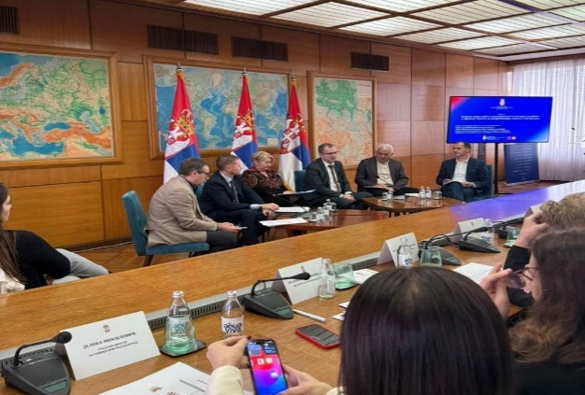
Issues related to improving the enjoyment of the rights of persons with disabilities, challenges and future directions in the implementation of the Convention on the Rights of Persons with Disabilities at both the national and international levels, were the topic of the International Scientific Conference “20 years since the adoption of the United Nations Convention on the Rights of Persons with Disabilities”, organized by the Institute of Comparative Law. At this conference, the Commissioner drew attention to domestic and comparative legal practice concerning: equality, non-discrimination and awareness-raising; the position of women and children with disabilities; accessibility, personal mobility and health; labour and employment; independent living and inclusion in the community—an appropriate standard of living and social protection; political rights and multisectoral issues.
Efforts to improve the position of persons with disabilities are undertaken by both the competent authorities and civil society. Thus, at the end of the year, the Ministry of Human and Minority Rights and Social Dialogue, with the aim of involving all social actors, organized the social dialogue “Guaranteed Rights and the Real Life of Persons with Disabilities”, in which Commissioner Antonijević also took part. On the panel “Enjoyment of the right of persons with disabilities to legal capacity and effective protection from discrimination, violence and abuse”, he noted the institution’s practice and, in particular, the problems caused to individuals by deprivation of their legal capacity. In addition, the National Organization of Persons with Disabilities of Serbia (NOOIS) on the occasion of 10 December, International Human Rights Day, observed it under the slogan “Human Rights: Our Everyday Needs”, with the aim of raising awareness of the inclusion of persons with disabilities. NOOIS organized an awards ceremony through three competitions “Ј=ДНАКИ 2025”, the photo contest “Serbia Without Barriers”, and the competition “Dr Damjan Tatić –Vision for the Future”.
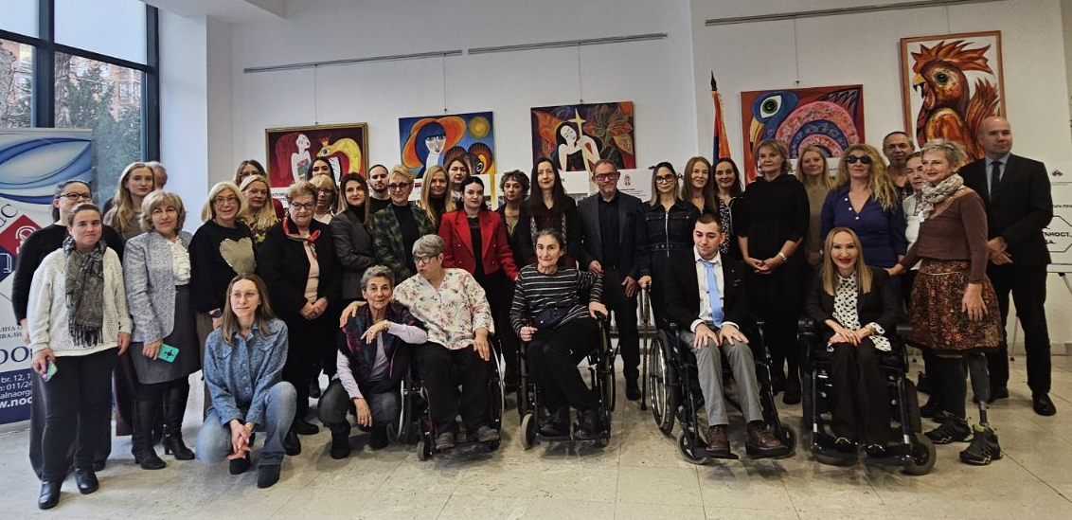
Celebration of the International Human Rights Day, NOOIS, 2025.
Based on the examined state of play and issues in the achievement of equality and protection against discrimination on the grounds of disability, we issued the relevant recommendations presented in the summary section of this Report.

Discrimination on the Grounds of Sex and Marital and Family Status
The trends observed in previous years regarding frequency of complaints and citizens’ communications alleging discrimination on the grounds of sex as a personal characteristic continued in 2025. A total of 89 complaints were submitted to the Commissioner on the ground of sex as a personal characteristic. The largest number of complaints was submitted by natural persons, 73 in total, of whom 52 were women and 21 were men. In 2025, the Commissioner also received 43 complaints on the grounds of marital and family status as a personal characteristic, mostly submitted by natural persons, 27 women and 14 men. Bearing in mind that complaints on the ground of marital and family status were most often submitted by women, and that in a large number of cases this involved multiple discrimination, these two grounds are addressed jointly.

The majority of complaints related to the area of labour and employment (27), actions of public authorities (24), the public sphere/general public (16), and the provision of services (7), while a smaller number concerned other areas such as health and social protection, education, and public information. The Commissioner’s practice is also corroborated by the findings of various reports and studies indicating pronounced gender inequalities in almost all spheres of life, both in the area of private and family relations and in public life and participation in decision-making.
Data from the report of the United Nations Entity for Gender Equality and the Empowerment of Women entitled “Gender Equality in 2025: Gains, Gaps and the USD 342 trillion choice” indicate that certain advances have been recorded in the recent period, such as increased coverage of girls’ education, greater participation of women in parliaments, and the repeal of discriminatory laws in almost one hundred countries worldwide. At the same time, the report notes that poverty, hunger, armed conflicts, climate disasters, as well as strong backlash against feminism, significantly threaten the progress achieved. Almost 10% of women still live in extreme poverty, and it is noted that, without additional interventions, as many as 351 million women and girls could remain in this situation by 2030.
Global Gender Gap Report emphasizes that economic inequality, alongside the prevention of violence, is an area with slowest progress. At the global level, only 61% of the economic gap between women and men has been bridged. Given current trends, it would take as many as 135 years for it to be fully eliminated. Data on the position of women in the Republic of Serbia are also provided in the publication “Women and Men in the Republic of Serbia”, according to which the gender pay gap is 8.8%. However, if we observe gaps by level of education and specific occupations, they are more pronounced and significantly favour men. The largest pay gap was recorded in the finance and insurance sector (20.6%), followed by the information and communication sector (20.3%), as well as manufacturing (19.6%).
The unequal position of women is also reflected in the area of decision-making, given that women remain underrepresented in positions involving strategic power and influence. Limited access to capital, business networks and decision-making, social expectations related to family roles, as well as institutional patterns that do not recognize gender balance as an economic and development priority, continue to constitute significant obstacles to achieving gender equality.
The analysis Invisible Withdrawal examined women’s political participation in Serbia and the impact of violence on their position. Although the formal representation of women has increased thanks to gender quotas, the research shows that the political and public space is still neither safe nor equal for women. Female politicians and activists are systematically exposed to gender-based violence, including verbal, psychological, physical, sexual and digital violence, as well as semiotic violence through stereotypes, media smearing and misogynistic discourse. The aim of these practices is to intimidate, discredit and exclude women from public life. This analysis, based on interviews with 30 politically active women, shows that violence leads to self-censorship, exhaustion, temporary or permanent withdrawal from politics, as well as fear for personal and family safety. Although the legal framework formally exists, political violence against women is not explicitly recognized, institutional responses are weak, and violence often goes unpunished, especially in the online space. Recommendations from this analysis include legislative reform, strengthening institutional and party protection mechanisms, more ethical media reporting, and the development of permanent support networks, in order to ensure safe and equal political participation of women in Serbia.
In accordance with international and domestic documents, balanced participation of men and women in decision-making is one of the priorities for the overall development of society, ensuring a fairer distribution of influence, making use of the capacities and potential of all its members, and ensuring sustainable development. Thus, under the Universal Declaration of Human Rights, everyone has the right to take part in the government of their country, and without the active participation of women and the inclusion of women’s perspectives at all levels of decision-making, the goals of equality, development and peace cannot be achieved. The obligation to ensure women equal access to, and full participation in, structures of power and decision-making is also regulated by the Beijing Declaration and Platform for Action of 1995, which state that the empowerment and improvement of the social, economic and political status of women is of fundamental importance for achieving accountable and transparent governance, and that a low percentage of women in decision-making bodies at different levels perpetuates structural barriers.
Data on women in executive positions and in national parliaments as of 1 January 2025, is presented in the publication Women in Politics: 2025, prepared by the Inter-Parliamentary Union (IPU) and UN Women. Data continues to show a higher representation of men in decision-making worldwide, thereby slowing the achievement of equality between women and men in politics. Women are heads of state and/or government in only 25 countries and make up 27.2 percent of members of parliament. At the global level, less than one quarter of cabinet ministers are women (22.9 percent). The 2025 mapping shows that, while women lead major policy areas such as human rights, gender equality and social protection, men dominate policy areas such as foreign affairs, financial and fiscal affairs, internal affairs and defence. The Republic of Serbia ranks 32nd with 37.5% representation of women, i.e., nine women holding ministerial posts out of the existing 24 portfolios.
Proceeding from the need for continuous improvement in the respect for equality and human rights, as well as the right to gender equality, the Commissioner issued to the Prime Minister-designate for the formation of the Government recommended measures aimed at achieving gender balance, both in terms of the composition of the Government and the portfolios assigned. The recommendation noted that balanced representation of the sexes exists when the representation of one sex is between 40% and 50% relative to the other. The Commissioner also recalled that the report of the Office for Democratic Institutions and Human Rights (ODIHR) of 28 February 2024, through recommendation No. 14, pointed to the need to establish additional mechanisms and incentives to motivate political parties to promote women’s participation in political life, increase their visibility during election campaigns, and strengthen their role in politics.
More at: https://ravnopravnost.gov.rs/rs/294-25-preporuka-mera-mandataru-za-sastav-vlade-2025/
While in recent years women’s representation in municipal/city councils has been steadily increasing, certain local self-government units are still made up predominantly, or exclusively, of men. Thus, a submission to the Commissioner indicated that all members of the Municipal Council in Vladimirci are men. In this regard, the Commissioner reviewed the municipality’s official website and established that there were no women among the members, for which reason recommended measures were sent to this municipality.
The Municipality of Vladimirci was recommended to undertake all measures and activities within its power to ensure the inclusion and encouragement of balanced representation of women and men in all spheres of political and public decision-making, in the exercise of public functions within the bodies of this local self-government unit.
More at: https://ravnopravnost.gov.rs/419-25-preporuka-mera-opstini-vladimirci/
In addition to gender imbalance in political participation, the Commissioner’s practice shows that women still find themselves in an unequal position more often in the area of labour and employment, and are particularly exposed to discrimination due to expected childbirth or parenthood. Women have a lower activity and employment rate than men, and a higher inactivity rate. Although they are, on average, more educated than men, they are often paid less at work, while they continue to bear a greater burden in household work and in caring for children and other members of the household. As in previous years, women approached the Commissioner pointing to being placed at a disadvantage in connection with employment, promotion, professional training, as well as after returning from maternity leave and leave from work for the care of a child. Examples from practice also show that employers often lack understanding and do not take any measures aimed at reconciling professional and private life. The Commissioner’s practice also shows that this lack of understanding is particularly present when it comes to absence from work due to a child’s needs, sick leave, and the like.
An opinion was issued following a complaint filed by a woman against her employer for discrimination on the grounds of marital and family status. She stated that she had been employed for an indefinite period and, as a single mother, submitted a written request to use a day off due to family obligations. The employer rejected the request the next day, and two days thereafter served her with notice of termination, explaining that she had committed a “serious breach of work duties” and that she “does not respect work discipline”. In the employer’s statement, inter alia, it was asserted that it could be concluded that her job “is not a priority”.
It was also established that, on 11 June, the woman came to work and performed her regular work duties until she was served with the notice of termination, while she had requested the day off for 13 June, i.e., for a day that had not yet occurred, therefore, there were no grounds to conclude that she had arbitrarily been absent from work or that there was a real intention not to come to work. Following the procedure conducted, the Commissioner assessed that the complainant had made the act of discrimination plausible, while the employer failed to provide adequate evidence that the termination was based on objective and justified reasons unrelated to her marital and family status. The opinion stated that the employer had violated the provisions of the Law on the Prohibition of Discrimination, and it was therefore recommended that the employer remedy the consequences of such discriminatory conduct and refrain from violating anti-discrimination regulations in the future.
More at: https://ravnopravnost.gov.rs/523-25-diskriminacija-na-osnovu-bracnog-i-porodicnog-statusa-na-radu/

The Commissioner’s practice shows that complaints in the area of work and employment are also filed by men.
In one of the proceedings, the Commissioner considered a complaint filed by a man alleging discrimination on the grounds of sex and age in a recruitment procedure. In the complaint, he stated that he believed he had been discriminated against, given that women are predominantly employed in human resources, which in practice prevents or reduces men’s opportunities to gain employment in this service, and that it appeared to him that the company was seeking a female candidate, given that women constitute the majority in the HR departments at other locations as well. Although discrimination was not established in the specific case, the Commissioner recommended that the employer, at the level of the company as a whole, review the gender structure of its employees and consider the application of special measures aimed at achieving a more balanced representation of the underrepresented sex, in accordance with the law.
More at: https://ravnopravnost.gov.rs/679-24-misljenje-sa-preporukom-mera-u-oblasti-zaposljavanja/

Women make up approximately one third of all entrepreneurs in the Republic of Serbia, while their representation in the management structures of medium-sized and large companies remains low. Although the number of female founders or women holding managerial positions has a mild upward trend, with women accounting for a quarter of the total number, this progress is not sufficient to significantly reduce the gap between women and men. These developments have been influenced by measures supporting the development of women’s entrepreneurship, primarily through the allocation of non-refundable funds, which continued throughout 2025. Nevertheless, the systemic absence of women from management structures continues to have multiple negative consequences, not only for women’s economic empowerment, but also for the competitiveness of the economy and the sustainability of economic development as a whole.
The Commissioner submitted to the Ministry of Economy an initiative to amend the Law on Companies, the Law on Public Enterprises, and the Law on the Management of Companies Owned by the Republic of Serbia, to introduce quotas for the underrepresented sex in management bodies. Insufficient representation of women in management bodies is not only an equality issue, but also a significant missed opportunity to improve corporate governance and social development. Given that women account for more than half of the highly educated population in the European Union, as well as in the Republic of Serbia, it is necessary to ensure conditions for this resource to be fully utilized through more balanced representation in decision-making bodies. Introducing quotas of at least 40% for the underrepresented sex aims to ensure a fairer decision-making structure, without interfering with the freedom to choose specific candidates.
More at: https://ravnopravnost.gov.rs/960-25-inicijativa-za-izmenu-zakona-o-privrednim-drustvima-zakona-o-javnim-preduzecima-i-zakona-o-upravljanju-privrednim-drustvima-koja-su-u-vlasnistvu-republike-srbije-radi-uvodjenja-kvota-za-manje/

Improvement and promotion of women’s entrepreneurship is equally important. The Strategy for the Development of Small and Medium-Sized Enterprises for the period 2023–2027 identified improved availability of financial support to female entrepreneurs, as well as improving statistical monitoring of women’s entrepreneurship. In that context, the Programme for Encouraging the Development of Entrepreneurship through Financial Support for Women’s Entrepreneurship in 2025 was adopted, providing non-refundable funds, including for the development of women’s entrepreneurship and the implementation of gender equality policies at the local level.
To equalize the position of women in the area of work, during the year several initiatives were submitted to the competent ministries to amend and mutually harmonize regulations relating to women’s rights during pregnancy, maternity leave and leave from work for the care of a child, regardless of the basis of work engagement.
An analysis of regulations and the institution’s practice showed that female entrepreneurs and women working under various types of non-employment contracts receive allowances based on childbirth, care for children and special child care that do not include paid taxes and contributions, while employed women have these taxes and contributions paid by the state in addition to salary compensation. In addition, the applicable legislation does not guarantee the same rights to women working under employment contract outside full-time employment as to women employed with employers, they do not have protection from overtime work, night work, the right to redistribution of work, the right to paid vacation, sick leave and other rights, although they should have these rights according to the Constitution and ratified conventions.
Initiatives were submitted with the aim of fully equalizing the position of female entrepreneurs and women engaged under non-employment contracts with that of women employed by an employer, given that they do not enjoy equal rights during pregnancy, maternity leave, and childcare leave. It is the same life event (pregnancy and childbirth) and thus there should be no difference in women’s rights in fully comparable circumstances. Also, this demotivates and weakens female entrepreneurship, self-employment and makes difficult the position on the labour market during a very demanding and sensitive period of life. The Commissioner emphasized that women should not be treated differently during pregnancy and childbirth depending on the type of work engagement, that is, regulations should not favour only one form of engagement, employment with an employer, over other forms of work engagement (work outside an employment relationship, self-employment, entrepreneurship).
These amendments require harmonization of several laws, including the Labour Law, the Law on Financial Support to Families with Children, the Law on Contributions for Mandatory Social Insurance, the Personal Income Tax Law, the Health Insurance Law, the Law on Companies, and the Law on Pension and Disability Insurance, which is why the initiatives were addressed to the ministries competent to propose these regulations.
More at: https://ravnopravnost.gov.rs/16-25-inicijativa-ministarstvu-finansija-za-izjednacavanje-preduzetnica-i-zena-koje-rade-po-ugovoru-sa-zaposlenim-zenama-kod-poslodavca-tokom-trudnoce-i-porodjaja/

We also received a complaint from parents regarding a child’s enrollment in an all-day school programme. The complaint stated that, when enrolling the child in the first grade, the parents were informed that the child did not meet the requirements to attend all-day classes because the father was not employed within the meaning of the Labour Law, i.e., because the father is the owner of an agricultural holding. The complainants pointed out that the fact that the father is a farmer does not mean that he does not work, and they believe that their child was discriminated against and unjustifiably prevented from attending all-day classes. The school was issued a recommendation to undertake measures and activities within its competence in order to amend the conditions and, in the future, when considering parents’ work engagement, to take into account not only employment in accordance with the Labour Law (fixed-term and open-ended employment), but also other forms of work engagement that likewise entail the need to reconcile work and parenthood, and, in the best interests of the pupil, to consider enabling her to attend all-day classes from the next school year, or earlier if possible.
This institutional position is further supported by the views of the International Labour Organization (ILO), which advocates the adoption and effective implementation of laws that would clarify and establish the existence of an employment relationship on the basis of facts rather than the form of the contract (Recommendation No. 198 of 2006.), in order to ensure the recognition and protection of rights for part-time workers, temporary workers, the self-employed, and others. Similarly, the report of the ILO and the Office of the High Commissioner for Human Rights on the rights to social protection states that casual employment and the increase in “flexible” forms of employment are often associated with lower levels of labour and social protection and higher levels of economic and social insecurity. This view is supported by the findings of the report The Right to Social Security, which states that there are more than 100 judicial decisions of European courts that, in the vast majority of cases, require that workers engaged on an “independent” basis or who are self-employed also be classified as workers. These topics are increasingly discussed in our country as well, and it is highlighted that workers in contractual arrangements (primarily those with contracts for performing temporary and occasional jobs) are prevented from exercising even some of the most basic rights, such as the right to a minimum wage, limited working hours, rest periods, and leave, and that the Labour Law does not specify the status of “other persons engaged in work,” and that none of the contracts for performing work outside an employment relationship is regulated in a complete and satisfactory manner; accordingly, practice operates to the detriment of workers.
In addition, during the reporting year the Commissioner for Protection of Equality emphasised the need to ensure the highest standard of health care and full respect for women’s human rights during pregnancy and childbirth. Obstetric violence constitutes a specific form of gender-based and institutional violence, the consequences of which can seriously affect women’s physical and mental health. The report Obstetric and Gynaecological Violence in the EU – Prevalence, Legal Frameworks and Education states that obstetric and gynaecological violence is a widespread but underreported problem in EU Member States, and that the lack of uniform definitions, data collection, and awareness contributes to invisibility and impunity. In addition, it notes that combating obstetric and gynaecological violence requires improved understanding and recognition, strengthening of the legal framework and access to justice, as well as enhanced prevention. At the regional conference “The Gender Aspect of Medical Ethics: The Example of Obstetric Violence,” the Commissioner stressed that every society must create a stimulating and safe environment for women and ensure the highest standards and humane treatment during pregnancy and childbirth. This is not only a matter of health and quality of life, but an essential issue of women’s equality. Across the entire region, there are cases of inadequate or inhumane treatment of women during pregnancy and childbirth, therefore, responsibility lies with system institutions and health-care professionals, as well as with all of us as individuals, to eradicate this problem in a systemic manner.
As a reminder, to improve health care for women during pregnancy and childbirth, as well as in the implementation of induced abortion procedures, and to ensure the highest standard of health care and humane treatment, without degrading and insulting conduct, in accordance with regulations and established professional standards, in 2024 the Commissioner for the Protection of Equality issued recommended measures to obstetrics and gynaecology clinics and the Ministry of Health. Among other things, the recommendation called for strengthening the health-care institution’s capacity, regarding both infrastructure and regular checks of the quality of health-care services provided, ensuring continuous professional development of health-care workers, and enabling women, during childbirth, if they so wish, to have the presence/support of family members or other persons. Following these recommendations, the Ministry of Health carried out inspections of all 55 maternity wards in Serbia, with the aim of improving conditions and assessing needs for the reconstruction of maternity wards, delivery rooms, and family rooms. Shortcomings were identified in terms of spatial and staffing capacities as well. Improvements in treatment before, during, and after childbirth were confirmed by women who contacted us following the recommended measures, stating that the situation has improved, particularly regarding the conduct and attitude of medical staff towards pregnant women and women in labour.
In 2025, the Ministry of Health, together with the Academy of Medical Sciences of the Serbian Medical Society and the Republic Expert Commission for Gynaecology and Obstetrics, presented the National Guideline of Good Clinical Practice for physiological vaginal childbirth, aimed at improving the quality of health care in Serbia, particularly in the area of primary health care. Its implementation should enable a standardised approach to the treatment and monitoring of pregnant women, reduce variability in practice, and improve outcomes for mothers and children. This guideline, among other things, states that communication with a pregnant woman in a maternity hospital must be dignified, courteous, and respectful, that she should be encouraged to ask questions, that she must be given the necessary time to make decisions relating to her childbirth and supported with professional advice in making such decisions, and that all staff present in the maternity ward should provide full support to the pregnant woman during her stay in the delivery room and, as far as possible, respect her individual, cultural and/or religious customs.
The broader social and institutional context of women’s position in the field of health is further highlighted by data indicating that more than 500 million women worldwide live in conditions of menstrual poverty, while the process of addressing this problem systemically is progressing slowly and unevenly. The importance of advancing women’s sexual and reproductive health and rights is also underscored by activities at European Union level, including the European Parliament Resolution on the state of sexual and reproductive health and rights in the context of women’s health, as well as EU Directive 2022/542 on value added tax rates, which enabled Member States to apply reduced, including zero, VAT rates to female hygiene products. In this way, states are encouraged to make menstrual hygiene products more accessible and to contribute to safeguarding the health and dignity of women and girls.
Building on the above-mentioned international standards and recommendations, the Commissioner for the Protection of Equality again submitted to the Ministry of Finance an initiative to exempt from VAT payment products used for female hygiene, i.e., to reduce the established tax rate on these products. It was pointed out that the right to menstrual dignity is an integral part of fundamental human rights, and that the state has an obligation to ensure systemic support through amendments to regulations and appropriate budgetary interventions. Maintaining menstrual hygiene must be accessible to every girl from the moment she begins menstruating, with full and comprehensive information provided, bearing in mind that access to safe menstrual products directly affects health improvement, disease prevention, family planning, safe pregnancy and childbirth, as well as overall reproductive health.
In that context, the Commissioner also pointed to examples of good practice, including the provision of free hygiene products for female students of the Secondary School of Internal Affairs “Jakov Nenadović” and female trainees at the Basic Police Training Centre, as an example of a concrete measure contributing to the protection of the health and dignity of girls and women.
More at: https://ravnopravnost.gov.rs/531-25-inicijativa-za-oslobadjanje-od-placanja-pdv-a-na-proizvode-koji-se-koriste-za-zensku-higijenu/

In 2025, the initiatives relating to amendments to the Criminal Code and the Law on the Execution of Criminal Sanctions were reiterated.
In the earlier period, the Commissioner repeatedly submitted to the competent ministry a number of substantiated initiatives concerning the amendment and/or supplementation of several provisions of the Criminal Code, as well as the Law on the Execution of Criminal Sanctions. The Commissioner recalled the necessity of amending the Criminal Code and aligning it with Directive 2012/29/EU in regards to the concept of the victim, and further with the Directive of the European Parliament and of the Council on combating violence against women and domestic violence (2022/0066(COD) PE-CONS 33/24).
Given that the Commissioner’s previous initiatives were not adopted, i.e., that the Criminal Code was not amended, the initiatives from previous years were reiterated. The need to amend several articles of the Criminal Code prescribing the following criminal offences was highlighted: Unlawful Termination of Pregnancy (Art. 120), Rape (Art. 178), Sexual Intercourse with a Helpless Person (Art. 179), and Transmission of HIV Infection under Article 250 of the Criminal Code, as well as amendments to Chapter 14 of the Criminal Code with regard to introducing a new offence that would criminalise the abuse and publication of recordings with sexually explicit content by specifically sanctioning the misuse of real or fake recordings with sexually explicit content. It is particularly necessary to sanction making such content available to a third person or to a larger number of persons, as well as cases where the content is published or shared using a computer, information or communication technologies, or in another manner. In addition to the fact that the consequences of this offence affect the victim, the fact that they also affect the victim’s family members and immediate environment should not be overlooked. Moreover, the victim’s recovery is difficult because the content may remain accessible for many years and repeatedly re-traumatise the victim. Victims of these offences are most often women and children, but they may also be men. In view of the consequences of the offence, it is necessary to improve their protection, which in a large number of cases is impossible without the assistance of the prosecution service and the police.
Such changes require securing additional human and technical resources, however, this cannot be a reason for failing to sanction this form of violence and for failing to protect the victims. Prescribing the abuse and publication of recordings with sexually explicit content as a criminal offence would, among other things, also have a preventive function by deterring potential perpetrators from committing this offence. As a qualified form of this criminal offence, the situation in which a child appears as the victim should certainly be envisaged. It is a fact that our Criminal Code already defines a series of offences regulating unauthorised photographing, recording, wiretapping, publishing and displaying another person’s writing, portrait, or recording, unauthorised collection of personal data, etc., however, these offences do not sufficiently recognise the specificities of such sophisticated forms of violence and the making of content available to a large number of persons through information technologies.
Considering the number of femicides over the years, we indicated that it should be considered whether introducing femicide as a separate criminal offence would contribute to a better response to this form of violence, given that there are certain characteristics and specificities that distinguish this offence from the criminal offence of murder. Introducing the offence of femicide would send a clear message about the importance of addressing this acute social problem, while also enabling adequate and centralised data collection that would contribute, among other things, to better planning of preventive activities and other appropriate measures.
As a reminder, on 6 December 2024 the Ministry of Justice informed the Commissioner that amendments to the Criminal Code were under way, and that the forthcoming amendments would include the best legislative solution, either by introducing a new criminal offence of Unauthorised Sharing and Misuse of Recordings of Intimate Content or by expanding the acts of perpetration within one of the existing criminal offences, in line with the Commissioner’s relevant initiative.
The Commissioner reiterated the initiative to amend Article 181 of the Law on the Execution of Criminal Sanctions, so as to consider introducing an obligation for the competent authorities to inform the victim ex officio, in cases of gender-based and domestic violence, of the convicted person’s release or escape from prison, regardless of the risk assessment made by the institution in the case. It was also proposed that, if the initiative on mandatory notification of the victim is not adopted, an obligation should be prescribed for the competent authorities to indicate to the victim, at every stage of the procedure, how and in what manner they can obtain, i.e., request to obtain, the notification referred to in Article 181(1) of the Law. Furthermore, in the initiative the Commissioner proposed that the obligation to notify the victim should be planned for a wider range of criminal offences than those currently prescribed by law. As a reminder, following submissions by the associations “Athena” and “Astra,” a supplement to the initiative was also filed, requesting that notifications of release from prison be extended to victims of trafficking in human beings, as this would have far-reaching positive effects on the safety, recovery, and reintegration of victims into society. It was emphasised that Article 30 of the Council of Europe Convention on Action against Trafficking in Human Beings affirms measures for the protection of victims, witnesses, and persons cooperating with judicial authorities, and underscores the obligation of the Parties to adopt legislative or other measures to ensure, during court proceedings, the protection of the victim’s privacy, as well as safety and protection from intimidation.
More at: https://ravnopravnost.gov.rs/473-25-inicijativa-za-izmenu-krivicnog-zakonika
Complaints on the grounds of marital and family status are often related to the exercise of parental rights, access to information concerning a child’s education and development, as well as the exercise of rights in the area of social and child protection. The Commissioner’s practice indicates that entrenched stereotypes about gender roles still persist, according to which childcare and family care are largely attributed to women, which leads to an unequal position both in the private and in the public sphere.
In one of the cases, a complaint was submitted by a woman who, after the death of her child’s father, with whom she had been in a non-marital partnership, attempted to add the father’s surname to the child’s existing surname, after paternity was subsequently established by a court decision. In proceedings before the registry office, she was informed that this was not possible, with the explanation that the child would thereby have a surname different from that of the parent, and that the possibility of registering two surnames would exist if the mother had been married and herself had two surnames.
The Commissioner referred to an earlier practice in which it was found that the competent authority had violated the provisions of the Law on the Prohibition of Discrimination by providing interpretations that, regardless of marital status, placed parents in an unequal position when determining a child’s surname in accordance with the Family Law Act. During the proceedings, the complainant informed the Commissioner that, in the meantime, she had exercised her right and changed the child’s personal name at the registry office, as a result of which the proceedings were discontinued, bearing in mind that the complainant agreed that the consequences of the conduct that had been the reason for submitting the complaint had been remedied.
Gender stereotypes are particularly pronounced in the private sphere, in the performance of household chores, the exercise of parental rights, as well as in the area of childcare and support for children and older family members, including nutrition, upbringing, hygiene, and health. Gender imbalance is reflected in social norms that often stigmatise men’s departure from full-time and permanent employment, and such expectations have a clear gender and class dimension. The traditional notion of the “ideal worker” among men implies their role as the primary material providers for the family, which aligns with modern, yet still dominant, models of the husband’s and father’s role. By contrast, in practice women are most often perceived as the sole parents when it comes to obligations related to informal childcare and care work, as well as in the area of household and auxiliary work, in which almost half of persons are informally employed.
Cases in which one parent, after divorce, despite a final and enforceable court decision, does not pay child support present a particular problem in the area of marital and family status. In the previous period, the Commissioner supported initiatives aimed at establishing mechanisms that would contribute to improving the position of children and of parents who independently provide for them. In that context, the adoption of the Law on the Exercise of Rights from the Alimony Fund constitutes progress, since it provides for the establishment of an alimony fund that will ensure temporary financial support for children in cases where the obligated parent does not pay alimony, while the state will subsequently seek recovery of the debt from the non-paying party. For the implementation of this law in 2025, 500 million dinars were allocated, and the maximum amount per child was set at up to 25,000 dinars. The alimony fund’s significance is in ensuring the regularity of childcare and meeting children’s basic needs, as well as in preventing families from entering a state of social exclusion and poverty.
It is precisely examples like this that show that gender inequality is not remedied by the formal recognition of rights, rather, its consequences become most visible when effective implementation of regulations and systemic support for families are lacking, especially in situations that most often affect women as primary caregivers and parents who shoulder the burden of day-to-day childcare. Therefore, data on the gender pay gap, the uneven distribution of unpaid household work, and the lower representation of women in decision-making positions indicates that formal equality is not sufficient without actual enforcement of regulations and changes in social patterns. Gender stereotypes and patriarchal norms continue to affect the position of women, but also men, limiting their life choices and opportunities.
Gender-based violence, including violence in the family, intimate partner relationships and the digital sphere continues to pose a significant challenge in achieving gender equality. Femicide, as the most drastic outcome of gender-based violence, remains present, which indicates the need for systematic, timely and coordinated action by all competent institutions. In the reporting year, the Commissioner pointed out that every woman has the right to live without fear and that society’s response to violence against women is a test of genuine commitment to equality and the protection of human rights.
In that context, the Commissioner’s Special Report on Discrimination against Women 2015–2025 is of particular importance, as it provides a comprehensive overview of the situation, challenges and systemic shortcomings in achieving gender equality in the Republic of Serbia. Although the normative framework in the field of protection against discrimination is well developed, the Commissioner’s practice, based on citizens’ complaints and communications, unequivocally shows that women in Serbia are more frequently exposed to discrimination in almost all areas of social life. As early as 2015, on the Commissioner’s own initiative, the first Special Report on Discrimination against Women was submitted to the National Assembly, and a decade later important reasons have emerged to comprehensively reassess the situation..
The need for a new report has been further intensified by developments in recent years, including growing public resistance to equal-opportunity policies and the temporary suspension of the application of the Law on Gender Equality in 2024. International human-rights protection mechanisms expose problems in the implementation of regulations and the insufficient effectiveness of measures in countering gender stereotypes. Both data and women’s experiences confirm that formal equality has not led to substantive equality, and that, alongside existing, new forms of discrimination have been identified, particularly in the digital environment and the cultural and media sphere. Women facing multiple and intersecting forms of discrimination and inequalities, such as Roma women, single mothers, women with disabilities, women living in poverty, and women from rural areas are the most vulnerable.
The report draws on women’s experiences, relevant research, and the Commissioner’s practice, and presents the key patterns of discrimination in the areas of labour and employment, education, public and political life, the media and culture, health and social protection, as well as gender-based and digital violence. Gender-based violence, including digital violence and the misuse of technology, remains one of the most widespread forms of discrimination against women, with severe consequences for women’s dignity, safety, and participation in the public sphere.
According to the OSCE report Development Finance for Gender Equality, violence takes a wide range of forms: physical, sexual, and psychological violence, including—but not limited to—intimate partner violence, sexual violence, and trafficking of women and girls. Gender-based violence is a global social problem with far-reaching consequences and often remains invisible, with women, at times, living in abusive relationships for many years. One of the key factors in the decision to leave an abusive relationship is a woman's financial security. The findings of the Global Gender Gap Report indicate that economic dependence is as an important mechanism that prolongs women’s exposure to violence: a financially dependent woman is twice as likely to remain in an abusive relationship for longer than five years (48%) compared to a financially independent woman (22%), while 41% of women cite socio-economic reasons (lack of housing or means of subsistence) as a key barrier to leaving an abusive partner.
The results of the Trapped in Violence analysis further indicate that women who are unable to provide basic necessities for themselves and their children, and at the same time lack support from their family or institutions, often remain compelled to stay in abusive relationships. Data shows that over half of women have been exposed to some form of violence in partner relationships, while 37% of women have been exposed to domestic violence by a current or former partner with whom they lived in the same household. Particularly concerning is the finding that one third of women in abusive relationships lived in them for longer than five years, and 74% state that they experienced violence frequently. Economic violence stands out as a common but insufficiently visible form of domestic violence: 53% of women currently in a situation of domestic violence state that they feel financially dependent on their partner, while 46% report that the partner makes all financial decisions in the household. Given the complexity of the phenomenon of violence, which is also manifested through socio-economic relations, there is a need for the systematic development of effective and targeted support and the economic empowerment of women, so they can ensure a dignified life free from violence.
Child Marriage and Adolescent Pregnancies in Serbia – Responses and Challenges research notes that violence against women is more often justified by girls and women who enter marriage as children. Every fifth woman from the Roma population considers it acceptable for a partner to hit her if she neglects the children, while among women who did not enter into a child marriage that percentage is 11.8%. The study also shows that the sexual and reproductive rights of girls and women in the context of child marriage are significantly violated, and that women who entered into a child marriage more often report that they cannot refuse sexual intercourse with their partner if he wants it. The National Coalition for Ending child marriages was established in Serbia in 2019, and the Commissioner has been a member of this coalition since its establishment.
In addition to well-known forms of violence against women, digital violence emerged as a challenge of the modern age. New and evolving forms of violence facilitated through digital technologies represent a key area of gender-based violence and harassment, and combating them is essential for dignity and equality in both the physical and digital environment. National research indicates an increasing prevalence of digital violence, with unwanted content and the public humiliation of girls and women on social media being among the most common forms of violence in the digital space in Serbia, where every third woman and girl experiences some form of digital violence. The Commissioner’s practice confirms the seriousness of these phenomena.
An opinion was issued in proceedings following a complaint of discrimination on the grounds of sex, which stated that a female student had been a victim of digital violence when a male student used her photographs published on social media and, through digital editing, created nude images of her and shared them via his social media account. It was further stated that the school had not taken measures to ensure that the student felt safe and secure in the school environment, and that the school had adopted a decision to sanction the student in an unlawful manner, knowing that by annulling the unlawful decision the student would remain unsanctioned. Following the procedure, the Commissioner issued an opinion that the school had violated the provisions of the Law on the Prohibition of Discrimination, and recommended that it continue to provide support to the student for as long as necessary, and that it organise peer education for students and training for employees of the school on the topic of gender-based digital violence.
More at: https://ravnopravnost.gov.rs/645-24-prituzba-ucenice-protiv-gimnazije-zbog-diskriminacije-na-osnovu-pola/

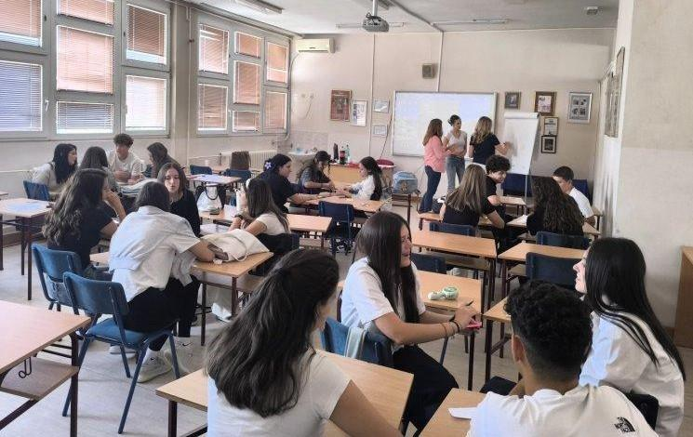
Within the previously mentioned project “Stop Violence, Achieve Equality”, the Commissioner participated in the implementation of activities aimed at advancing gender equality and preventing discrimination and violence against women and girls. Research entitled “Why Women Do Not Report Violence” was also conducted, as well as an analysis of the implementation of the Beijing Declaration and the Platform for Action in the areas of education, the economy, women’s participation in decision-making, and the media. In addition, two grants were awarded to improve the position of women in rural areas, in the amount of 35,000 euros each, with the aim of economically empowering women and reducing inequalities in less developed communities. Peer workshops were also held in a number of secondary schools across Serbia, with a particular emphasis on equality and the prevention of violence.
The most severe outcome of gender-based violence is femicide, i.e. the killing of a woman because she is a woman. However, despite initiatives by civil society organisations, as well as the Commissioner’s recommendations, a National oversight mechanism for monitoring cases of femicide in the Republic of Serbia has still not been established, in line with the Strategy for the Prevention and Combating of Gender-Based Violence against Women and Domestic Violence. The number of femicides remains high—17 femicides during 2025, according to media reports.
Every woman has the right to life without fear
During the National Day of Remembrance for Women Victims of Violence, attention was drawn to the scale and continuity of gender-based violence in Serbia. The statement noted that, over the past 14 years, more than 430 women have been killed in instances of domestic violence. Data points to the need for the society as a whole, including institutions and individuals, to assume full responsibility for prevention of violence and creation of a safe environment for women. Although a system for protection from violence exists, it must be improved to ensure a timely and effective response. Strengthening of institutional capacities, continuous prevention, comprehensive support—from encouraging the reporting of violence, to providing psychological, social, and material assistance—remain particularly important.
It was also noted that femicide is the most extreme outcome of gender-based violence, deeply linked to patriarchal patterns and gender stereotypes that view women as men’s property. In that regard, the need was emphasised for systematic efforts to dismantle stereotypes through education, the media, and culture, with the active involvement of all competent societal actors.
More at: https://ravnopravnost.gov.rs/rs/poverenica-svaka-zena-ima-pravo-na-zivot-bez-straha/
Roma women, women with disabilities, refugees and migrant women, older and younger women, women living in rural areas, as well as members of the LGBTI+ community, are exposed to multiple and intersectional discrimination that significantly limits their full participation in social and public life. The position of these groups of women points to the existence of deeply rooted inequalities and to the need for comprehensive, targeted, and long-term measures that will ensure equal access to education, employment, health and social protection, justice, as well as political and public life.
Older women are particularly disadvantaged, especially in rural areas, where they often face limited access to health care due to poverty, inaccessible transport, and long waiting lists for examinations. Limited access to education, the labour market, development funds, and support services further deepens their economic dependence, while poverty remains one of the key challenges. Most women in rural areas are not land owners nor do they participate in decision-making within the household and the community, and their situation is further aggravated by traditional social and cultural norms that assign them the role of caregivers and unpaid workers in the household.
Bearing these challenges in mind, the Commissioner implemented the “Improving the Position of Women and Girls in Rural Areas” project, within the UN Women programme, with financial support from the Embassy of the Kingdom of Norway in Belgrade. The aim of the project was to strengthen the safety and economic independence of women and girls in rural communities by raising awareness of mechanisms for protection from violence and discrimination, as well as by strengthening the capacities of local organisations working in this field. In addition to educational activities and mentoring support, financial assistance was provided to rural women for the procurement of necessary resources and equipment for work in agriculture, with the aim of their economic empowerment and long-term self-reliance.
The implementation of the project contributed to a better understanding of the specific challenges faced by women in rural areas, as well as to strengthening cooperation among institutions, civil society organisations, and local communities. As part of the project, the two previously mentioned publications were issued—“The Position of Women and Girls in Rural Areas of the Zlatibor, Moravica and Raška Districts” and “Authentic Stories from the Lives of Rural Women”, which are available on the Commissioner’s website.

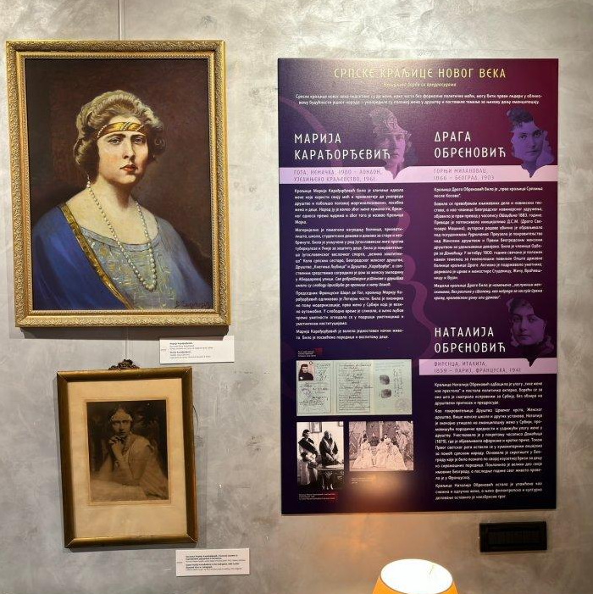
The intersection of varying grounds of discrimination leads to profound social exclusion, poverty, and limited access to rights, with structural and long-term consequences, as it affects entire communities, being passed from generation to generation. For this reason, it is necessary for all competent actors to consistently apply the principle of equality between women and men through clear institutional measures, public policies, and budget decisions that will systematically improve the position of women at higher risk of discrimination and contribute to building a more inclusive and just society.
The Commissioner continuously points to the benefits of achieving gender equality. For example, through the project “Education for Equality”, an exhibition was organised entitled “Great Women of Serbian Culture”, dedicated to uncovering and presenting prominent women from Serbian history and culture such as Žanka Stokić, Mira Trailović, Marija Trandafil, and others. Young people who visited the exhibition, followed its virtual version or participated in accompanying workshops and discussions were encouraged to think critically, acquire new knowledge, and create an anti-discriminatory and anti-misogynistic cultural model. During the project, a total of 24 workshops on gender equality were held for students (12 in Belgrade and 12 in other cities in Serbia), alongside workshops for teachers. In addition, a handbook for teachers on the topic of anti-discrimination and gender equality was produced.
The importance the institution gives to this topic is further demonstrated by the fact that the Commissioner’s annual conference, entitled “The Position of Women—Big Steps, Small Shifts: How Education Can Help Us”, traditionally organised on the occasion of the International Day for Tolerance, was dedicated to the position of women, especially those from rural areas, as well as to the importance of educating youth in overcoming the gap in achieving gender equality, raising awareness, and recognising discrimination. These topics were discussed in panel discussions with the participation of representatives of institutions and civil society from Serbia, the region, and Europe.
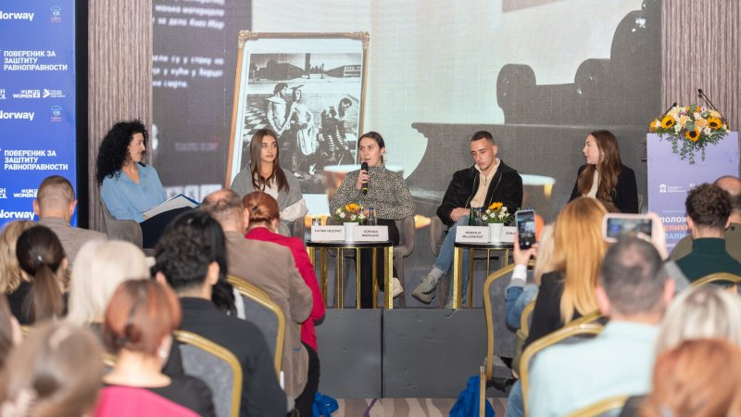
The Commissioner’s Annual Conference, 2025
Relevant recommendations are issued based on the overview of the situation and the issues in the exercise of equality and the protection against discrimination on the grounds of sex and marital and family status, which are provided in the summary of this Report.

Discrimination on the Grounds of National Affiliation or Ethnic Origin
n 2025, the number of complaints received on the grounds of national affiliation or ethnic origin as a personal characteristic slightly increased compared to 2024. A total of 88 complaints were submitted, meaning that this ground remains among the most common discriminatory grounds.

Out of the total number of the complaints filed on this ground, 52 related to the Roma national minority, accounting for 59% of all complaints. In terms of frequency of complaints, this is followed by complaints concerning members of the Albanian national minority (7), Montenegrin (4), Bosniak (3), Slovak (3), Bulgarian and Jewish (2 each), as well as the Hungarian, Slovenian, and Macedonian national minorities (1 each). In the remaining complaints, national affiliation was not specified. As in the previous year, most of the complaints were filed by natural persons (41), predominantly men (30), as well as civil society organisations, which submitted the same number of complaints (41). In addition, four cases were filed by state authorities, inspectorates, and two were submitted by a group of persons.

The highest number of complaints was filed in the area of procedures before public authorities (28), followed by the area of labour and employment (14), the public sphere/general public (12—this area includes social media, various internet platforms, and other places accessible to the public), public information and the media (11), education and vocational training (6), and three each in the provision of public services, health care, and in the area of private relations. A smaller number of complaints were filed in other areas. A comparative overview of data from previous years shows that there have been no substantive changes in the structure of complaints on the grounds of national affiliation or ethnic origin, with complaints still largely relating to the conduct of public authorities, as well as the areas of work and employment and the public sphere.
As in previous years, the majority of complaints on this ground were filed due to discrimination against members of the Roma national minority. Discrimination and gypsyism as its form, poverty, and social exclusion remain among the greatest issues faced by the Roma national minority. A number of members of the Roma national minority continue to live in severe poverty and in conditions that do not ensure a dignified life, particularly with regard to housing and access to basic infrastructure. These long-standing adverse living conditions and discrimination jointly affect education, health care, employment opportunities, full participation in social life, and political participation.
Continuity of the structural problems affecting the position of the Roma national minority was also highlighted in previously mentioned 2025 Serbia Report. This report states that, although Roma pupils benefit from scholarships through affirmative measures, the school dropout rate remains high, especially among Roma girls. Roma children continue to attend special schools and classes in disproportionately high numbers. The report emphasises that the transition from education to the labour market is particularly challenging, and that members of the Roma national minority remain under-represented in public administration. The report also points to the continuation of the practice of forced evictions. In addition, as in previous reporting periods, it notes that early and child marriages remain a significant issue in Roma communities, and that domestic violence often remains unreported.
Data from the Strategy for Social Inclusion of Roma Men and Women in the Republic of Serbia for the Period 2022–2030 indicates that Roma children are facing significant challenges, including the increased risk of discrimination in the field of education. The percentage of Roma children up to the age of five who participate in preschool education programmes is only 7.4%, compared to the 60% of children of the general population. Insufficient participation in preschool education affects the subsequent course of schooling, bearing in mind its importance for the development of basic skills, socialisation, and preparation for starting school, as well as achievement in the preparatory preschool programme and primary education. This situation contributes to maintaining existing disparities and deepening them later in life.
Compared to the previous years, a somewhat smaller number of complaints is observed in the field of education relating to discrimination and peer violence against Roma children, but such cases still exist. Thus, a civil society organisation informed the Commissioner about peer violence against a pupil who is a member of the Roma national minority, stating that the school had not reacted adequately. Consequently, the Commissioner issued recommended measures to the school to conduct training for employees and pupils on peer violence and discrimination, and to improve cooperation with the children’s legal representatives.
A discriminatory narrative towards the Roma national minority is often present in the public sphere, as well as in certain media, which further increases stigmatisation, prejudice, and social distance towards members of this national minority. A particular problem arises in reporting on violence, criminal offences, or other unlawful behaviour where a person’s national affiliation is highlighted publicly even though it is not relevant for understanding the case. In this way, an entire community is linked to such events even though responsibility is individual and is not conditioned by national affiliation. This leads to generalisation and the collective stigmatisation of the entire group. Examples from the institution’s practice attest to this trend.
A citizens’ association submitted a complaint against the head of the police directorate because, at a press conference, he disclosed information about the Roma national affiliation of a person involved in the incident, even though that information was not relevant for understanding the incident itself. An opinion was issued that the provisions of the Law on the Prohibition of Discrimination had been violated, and a recommendation was made that, in the future, when informing the public about a criminal or other unlawful incident, he should not disclose information on a person’s national, religious, ethnic, racial, or other affiliation, unless that characteristic is relevant for the correct understanding of the incident. The recommendation was complied with.
More at: https://ravnopravnost.gov.rs/289-25-utvrdjena-diskriminacija-na-osnovu-romske-nacionalne-pripadnosti/
Civil society organisations submitted a complaint against an internet portal for discrimination on the grounds of national affiliation, because the portal published a news item entitled “Roma man M. P. hit a female student with his car”. In the proceedings, it was established that the suspect’s national affiliation was not relevant for understanding the incident and that stating it was not justified. The Commissioner issued an opinion that the provisions of the Law on the Prohibition of Discrimination had thereby been violated, and addressed a recommendation to the editor-in-chief of the internet portal that, in the future, it should not publish content that violates the dignity of a person or group of persons on the grounds of national affiliation or that incites prejudice.
More at: https://ravnopravnost.gov.rs/32-25-diskriminacija-na-osnovu-nacionalne-pripadnosti/
The media can be an important factor in countering stereotypes and prejudice, but they can also deepen them. Thus, a complaint was filed against a television broadcaster regarding the content of a programme in which a guest, speaking about Roma people, stated, inter alia: “I have asked the question a thousand times and it is all connected: why do Roma people have the permission, why are Roma people who ride horses in the centre of Belgrade not sanctioned, why can they drive an unregistered, partially defective motor cultivator, harness four half-dead animals, and ride around the city like that?”, and instead of the presenter interrupting such speech and protecting the dignity of the Roma community, she affirmed it in the following words: “Yes, that is true, and why are they given money at the centre for social work, while people who are not Roma have to submit applications.” The Commissioner issued an opinion finding discrimination and recommended measures to the television broadcaster: to familiarise their journalists with the opinion, and to organise training for them on the notions and forms of discrimination and on the position and issues members of the Roma national minority face. Additionally, the opinion stated that the broadcaster needs to ensure respecting regulations that prohibit discrimination.
In cases such as these, particular weight is carried by statements made by highest public officials, which can significantly contribute to reinforcing stereotypes and deepening the social distance. When, in such statements, certain social groups are portrayed as a burden on the state or on local self-government units, or when their social position is explained exclusively by personal responsibility while broader social circumstances are disregarded, the consequences of such messages can be particularly harmful.
The Commissioner acted on a complaint concerning a statement made at a session of the National Assembly’s Committee on Culture and Information during the debate on the election of a new composition of the Regulatory Authority for Electronic Media, which stated: “...not to mention that we have, in programmes at 7 p.m., please don’t take offence, at 7 p.m. there is a programme in the Gypsy language. Is that possible?..” In this regard, the Commissioner issued an opinion indicating that such a statement calls into question the justification for the existence of programme content in the Romani language, especially in prime time, and conveys the message that the presence of Roma in the media space is less acceptable or less valuable, thereby calling into question the principle of equality and the right to information in one’s mother tongue. Also, the use of the term “Gypsy” is a derogatory and offensive label that insults the dignity of members of the Roma national minority and deepens prejudice and stereotypes. A recommendation was made to issue a public apology to members of the Roma national minority and, in future, to ensure that statements do not call into question their dignity and equal participation in public life. This recommendation was complied with.
More at: https://ravnopravnost.gov.rs/47-25-diskriminacija-na-osnovu-nacionalne-pripadnosti/
Several civil society organisations filed complaints against a minister, in connection with a statement where he noted, among other things: “I do not separate Roma from other residents. On the contrary, I think they are our neighbours and our brothers, but I have an objection. Roma, as our neighbours, must understand that neither the state nor municipalities nor local self-government units are ATMs. We must bring them to the point of completing schools, being employed, and creating useful members of society.” The complaints stated that such statements repeat an established narrative in which members of the Roma national minority are collectively portrayed as a social burden and their disadvantaged position is explained as a matter of personal responsibility, while disregarding the fact that it is the consequence of long-term and systemic discrimination. Bearing in mind the heightened responsibility of public officials, who through their public statements should encourage inclusion and tolerance, and not deepen stereotypes and social distance towards members of national minorities, a recommendation was issued to send a public apology to members of the Roma national minority. This recommendation was complied with.
More at: https://ravnopravnost.gov.rs/921-25-misljenje-u-postupku-po-prituzbi-protiv-ministra-zbog-diskriminacije-roma/
In 2025, citizens’ submissions regarding content in the culture and entertainment were considered, particularly regarding the dissemination of stereotypes and prejudices in song lyrics and other music content. Although artistic freedom is often asserted in this regard, the Commissioner offered a standpoint that public space entails responsibility, especially when the use of certain expressions may create a humiliating or offensive environment for members of certain social groups.
Following submissions by a large number of citizens who pointed to the frequent encouragement of stereotypes and prejudices about Roma in song lyrics, the Commissioner issued a recommendation of measures to the Organisation of Music Authors of Serbia (SOKOJ) to develop ethical guidelines for the assessment of music content, with a particular focus on preventing the dissemination of racist and sexist narratives and content that incites discrimination, hatred or violence, or that constitutes harassing and degrading treatment. SOKOJ informed all of its members about the Commissioner’s recommendation, and the recommendation was also published on the organisation’s official website.
More at: https://ravnopravnost.gov.rs/924-25-preporuka-mera-za-ostvarivanje-ravnopravnosti-sokoj-u/
The Commissioner’s practice shows that members of the Roma national minority face various obstacles in exercising their rights, particularly in procedures in which authorities require evidence that they do not have or cannot obtain.
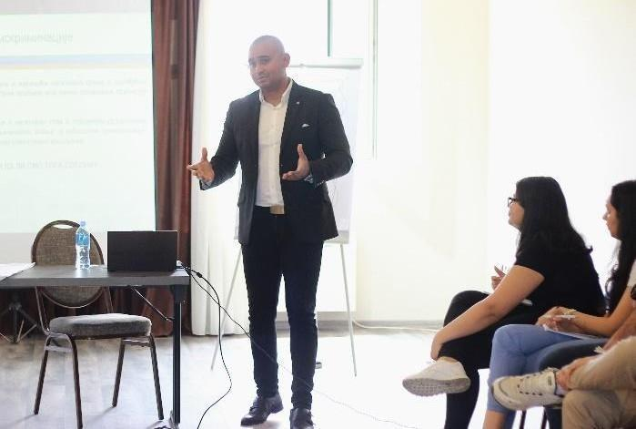
The results of the survey “Perception of the Roma Community about Discrimination”, conducted by the Commissioner in 2024, indicate a widespread presence of discrimination within the social welfare system. As many as 59% of respondents stated that they themselves or a member of their family had experienced discrimination in centres for social work. In view of these findings, in 2025 the Commissioner, in cooperation with the Council of Europe, organised a two-day training course on gypsyism, intended for employees of centres for social work. During the training, the institution’s practices were presented, with the aim of highlighting the consequences of such conduct and preventing its repetition, as well as drawing attention to the obligation of acting in accordance with the principles of equality and the prohibition of discrimination.
In 2025, the Commissioner, in cooperation with the Roma Education Fund, held a workshop at the seminar “Roots and Wings: I Know Who I Am and Where I Am Going”, which was organised in Ub and brought together young, educated members of the Roma national minority from different parts of the Republic of Serbia. The workshop was organised with the aim of familiarising participants with the role and competences of the Commissioner’s institution, as well as other mechanisms for protection against discrimination.
On International Roma Day, the Commissioner carried out activities focused on direct contact with members of the Roma community. During field visits, information about the institution’s competences and mechanisms for protection against discrimination was shared, and citizens were encouraged to recognise discrimination and contact us in cases of violations of the right to equality. Such activities have a significant preventive role, as they contribute to greater visibility of the institution and strengthen trust in institutional protection of rights, especially among groups that are less likely to decide to file a complaint.

During the year, the Commissioner carried out other activities aimed at drawing attention to the position of the Roma national minority and the need for synergistic action to improve their situation and curb stereotypes and prejudices.
During the year, the Commissioner carried out other activities aimed at drawing attention to the position of the Roma national minority and the need for synergistic action to improve their situation and curb stereotypes and prejudices.
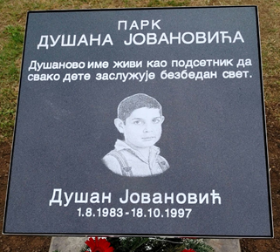
Three years after the submission of a joint initiative by the Commissioner and the Initiative for Economic and Social Rights – A11, a park in central Belgrade was named after Dušan Jovanović, a boy who was killed in 1997 solely because he was Roma. The name of this park should be a lasting symbol of the fight against hatred and intolerance, as well as a reminder of society’s responsibility to protect human dignity and every individual’s right to life. It was pointed out that, although certain advances have been made in recent years, they are not sufficient, and that continuous institutional action is necessary to prevent hate-crimes and strengthen equality. Hate-motivated violence remains a serious problem, as evidenced by certain events from 2025.
Warning
The Commissioner condemned the attack on a Roma family which, according to media reports, took place in the village of Tavnik near Kraljevo, when several individuals physically and verbally assaulted members of a family and demanded that they move out of their home. On this occasion, it was noted that any form of violence, especially when motivated by hatred on the grounds of national, ethnic, religious or other affiliation, is strictly prohibited by law and requires an urgent, effective and non-selective response by the competent authorities, as well as the prosecution and appropriate sanctioning of the perpetrators. It was emphasised that it is unacceptable for victims of violence and discrimination to be forced to leave their homes and live in fear, and that it is exceptionally important for the competent authorities to establish all facts, circumstances and motives of the attack, ensure the protection of this family, and take all measures in accordance with the law. Only through consistent and responsible action by state institutions can the recurrence of such incidents be prevented and equal protection of the rights of all citizens of the Republic of Serbia ensured, regardless of their national, ethnic, religious or any other affiliation.
More at: https://ravnopravnost.gov.rs/upozorenje-za-javnost-14/
In 2025, the Commissioner addressed the Basic Public Prosecutor’s Office in Novi Sad following indications regarding the conduct of police officers towards several persons of Roma ethnicity in the “Bangladeš” settlement in Novi Sad. The Basic Public Prosecutor’s Office in Novi Sad informed the Commissioner that, in connection with the said information, it had opened a case file and sent a request for the collection of information to the Internal Control Sector – Novi Sad Unit.
Members of other national minorities also contacted the Commissioner in 2025, to a lesser extent. A number of cases concerned the official use of the languages and scripts of national minorities, and recommended measures were therefore issued to certain local self-government units.
Following a submission by the National Council of the Hungarian National Minority, recommended measures were sent to the City of Subotica, as well as to the municipalities of Novi Kneževac, Senta, Mali Iđoš, Kanjiža, Bačka Topola and Ada, to carry out checks and, where necessary, replace traffic signs that are not written in the language of the national minority that is in official use in the competent local self-government unit, in accordance with the applicable regulations.
In 2025, members of the Albanian national minority most often contacted the Commissioner by submitting complaints against public authorities. One complaint was filed by the Youth Initiative for Human Rights against the Ćuprija Cultural Institution regarding a published call for proposals for the creation of a mural. In another complaint, the complainant stated that the Army had discriminated against him because his request for reassignment had been rejected, that in 27 years of service he had had only one opportunity to participate in a peacekeeping mission, which he took, and that in 2009 he had been subjected to verbal insults by a colleague. One complaint concerned employment at the Vranje Police Directorate, while two complaints were filed against the Police Station and the Misdemeanour Court in Preševo. As the complainants in these cases did not comply with requests to supplement their complaints, the proceedings were discontinued in accordance with the law. Other complaints filed on the ground of belonging to the Albanian national minority are ongoing.
We received a complaint from the Youth Initiative for Human Rights against the Ćuprija Cultural Institution because, on 10 December 2024, this institution published a request for proposals to create a mural of General Nebojša Pavković. Bearing in mind that the mural has not yet been created, but that the winning design was published on 6 February 2025, the Commissioner issued recommended measures to this cultural institution to immediately suspend the implementation of the published call and the public display of the mural in a location accessible to the public.
Bearing in mind that the mural has not yet been created, the recommendation noted that, in connection with the painting of a similar mural in Belgrade, municipal inspectors of the Department for Inspection Affairs, as the competent authority, issued a decision ordering the removal of the mural from the building façade within two days from the date of notification of the decision.
The recommendation noted that, when selecting topics for thematic calls, the cultural institution must take into account the reasons for its establishment and the objective it is expected to achieve through its activities. The fact that, in the specific case, the person concerned had been convicted of serious criminal offences and was serving a multi-year prison sentence certainly does not contribute to that objective.
This recommendation was complied with.
More at: https://ravnopravnost.gov.rs/264-25-preporuka-mera-ustanovi-kulture-curija/
To a somewhat lesser extent, members of the Bosniak national minority as well as the Montenegrin national minority also approached the Commissioner, pointing to issues in the financing of national minority councils, as well as associations in the territory of the Autonomous Province of Vojvodina. In two cases, opinions were issued: in one, discrimination was established, while in the other it was not.

Also in 2025, two complaints regarding discrimination against members of the Jewish community, manifested through hate speech in the digital space. Bearing in mind that in both cases it was not possible to establish the identity of the persons behind the disputed posts, as well as the prescribed criminal offence of Inciting National, Racial and Religious Hatred and Intolerance, the Commissioner addressed the Higher Public Prosecutor’s Office in Belgrade, as well as the Special Prosecutor’s Office for Combating High-Tech Crime, also drawing attention to the application of Article 54a of the Criminal Code. More information on this is provided in the section of the report relating to criminal complaints filed. In the case of a disturbing video recording of violence against a minor from Slankamenički Vinogradi in the municipality of Inđija, published in certain media and on social networks, the Commissioner also addressed the Higher Public Prosecutor’s Office in Sremska Mitrovica. Media reports stated that the attacks on the minor were linked to the fact that he is a member of the Slovak national minority.
With the aim of improving the position of members of national minorities, in addition to education and training, the Commissioner carries out various activities. During the year, in cooperation with the OSCE Mission to Serbia, we organised a two-day Forum of National Minority Councils, which brought together representatives of all national councils, an important partner of the Commissioner in advancing equality and combating discrimination. The Forum also presented the Compilation of Selected Opinions, Recommendations, Initiatives, Warnings and Other Acts of the Commissioner in Cases of Discrimination on the Grounds of National Affiliation and Ethnic Origin for the Period 2015–2025, mentioned earlier. The Forum was dedicated to the exchange of views on issues of common interest, including the preservation of cultural identity of national minorities, education, the position and role of women in national councils, cooperation between national councils and the institutions of the Republic of Serbia, as well as the application of affirmative measures aimed at achieving full equality.
National Minority Councils forum, November 2025.
In cooperation with the Serbian Academy of Sciences and Arts, as a co-organiser of the scientific conference “Equality through Affirmative Action”, we examined the application of affirmative measures as a mechanism for achieving full equality. During the conference, special attention was devoted to the position of vulnerable and marginalised social groups, including national minorities, women, persons with disabilities and other groups that face structural obstacles in exercising their rights. The Assistant Commissioner presented a case study relating to the application of affirmative measures towards national minorities in the field of labour and employment.
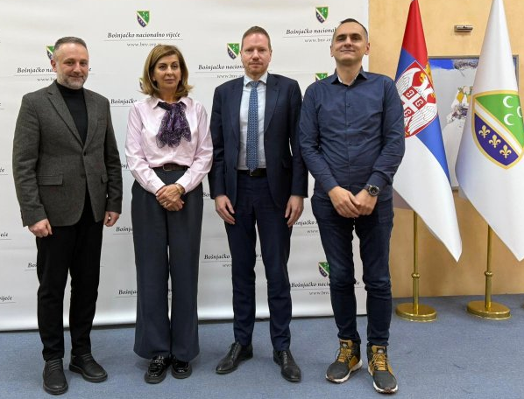
ТField work plays an important role in bringing the institution closer to citizens and in understanding the specific problems they face in everyday life, especially in multi-ethnic communities. In that spirit, the Commissioner visited Novi Pazar, where a meeting was held with the Mayor, representatives of the Bosniak National Council and the Islamic Community in Serbia, as well as with representatives of civil society organisations. During the discussions, issues of equality and the prohibition of discrimination were discussed, as well as the importance of timely responses in cases of rights violations. During the visit, exchange of information on the Commissioner’s competences and the procedure for submitting complaints took place, with the aim of strengthening cooperation and improving access to protection against discrimination.
Based on the examined state of play and issues in the achievement of equality and protection against discrimination on the grounds of national affiliation or ethnic origin as a personal characteristic, we issued the relevant recommendations presented in the summary section of this Report.

Discrimination on the Grounds of Membership in Political, Trade Union and Other Organisations and on the Grounds of Religious and Political Beliefs

In 2025, Commissioner formed 70 cases pursuant to complaints on the grounds of membership in political, trade union and other organisations and 76 on the grounds of political beliefs, as a personal characteristic. Complaints were most frequently filed by natural persons and by trade union organisations on behalf of employees. The number of complaints on these grounds has nearly doubled compared to the previous year. The increase in this number was also influenced by number of complaints from educational workers, who indicated that, although they had been working in the education system for many years, their fixed-term employment contracts were neither renewed nor re-concluded in schools this year, due to the fact that they participated in protests organised within schools, as well as in trade union or other activities that supported the protests following the canopy collapse in Novi Sad. As in previous years, the majority of complaints were filed against the employers with whom these individuals are employed. Having regard to the existential importance of the right to work and the fact that various forms of pressure, conditional treatment, and less favourable treatment most frequently manifest in the workplace on account of actual or presumed political beliefs or trade union engagement of employees, the Commissioner, in the course of the year, initiated one strategic litigation on these grounds, while in another proceeding on the same grounds intervened as a third party on the side of the employee as the plaintiff.
At the same time, practice indicates that such pressures are not confined exclusively to employment relationships, but also occur in a broader social context, through public discourse, media narratives, and various forms of discrimination. In this sense, during the reporting period, the Commissioner, through public warnings, also emphasized the impermissibility of linking a person’s origin, place of birth, or ancestors with their political or other forms of public and professional activity, recalling that discrimination, hate speech, as well as insults and denigration on any actual or presumed personal ground, are prohibited by law. In that context, it was particularly emphasized that the escalation of abusive and threatening speech in the public sphere may have serious consequences, including the incitement of violence and the further deepening of social divisions.
Such patterns of public discourse and social polarization create an environment in which pressures become normalized and extend into employment relationships, which, as noted, is also confirmed by the institution’s practice. It is particularly noticeable that, in a large number of cases, the reported discrimination does not pertain to “explicit” prohibitions, but rather to more subtle mechanisms – transfer to a less favorable job position, demotion, non-renewal of contracts, denial of promotion, selective treatment regarding work obligations and responsibilities, as well as the creation of an atmosphere of fear that may lead employees to self-restrict in exercising their labour rights.
In proceedings initiated on complaints by trade unions on behalf of two employees at the Centre for Social Work in Gadžin Han, against the director at that time, it was stated that the director asked them whether they would attend a political gathering in Jagodina and requested that they provide reasons for not attending “even though it is requested by the local government,” to which both replied that “they could not attend due to work obligations at the centre.” According to further statements, the director of the Centre immediately thereafter called the complainants by phone and asked them to prepare their employment contracts so that he could take them to local government representatives. A few days later, one of the complainants was informed that her job was being considered for termination, with verbal threats, after which certain authorities she had previously held were revoked and were only restored when a new director was appointed. The Commissioner provided an opinion that the complainants were discriminated against, and recommended that the director at the time send the complainants a written apology for his actions, which exposed them to harassment and humiliating treatment between January 23 and February 13, 2025. Since the director did not act on the recommendation within the legal deadline, even after a formal warning was issued, the public was informed of the matter in accordance with the Law.

More at: https://ravnopravnost.gov.rs/158-161-25-postupak-povodom-diskriminacije-po-osnovu-politickog-ubedjenja/

In another case, based on a complaint filed by a secondary school teacher who was also active in a trade union organisation, it was established that the school principal, through her statements and conduct, created a hostile and humiliating environment in connection with the teacher’s trade union activities. In this case as well, the Commissioner found a violation of the Law on the Prohibition of Discrimination and issued a recommendation to rectify the consequences.
In two complaints filed by employees against the PE “Pošta Srbije” (Serbia Postal Service), it was stated that the complainants were employed in a small post office where three positions had been formally established, while the work was actually carried out by only the two of them. They pointed out that they participated in a protest by workers of the PE “Pošta Srbije” in front of the Main Post Office in Belgrade, during which one of them, as a trade union member, read out the employees’ demands addressed to the Supervisory Board. Following their participation in the protest, the complainants received multiple calls from the Human Resources Department, alleging that there were complaints that they were not performing their work duties. Following the order, colleagues from another post office were sent to the post office where they had been working, their salaries were reduced, and they were offered an annex to their employment contracts transferring them to another, more remote workplace, whereby one of the complainants being offered a transfer to a lower-ranking position. Subsequently, the employment of one of the complainants was terminated by the employer’s dismissal, while the employment of the other ended at her own request.

In this proceeding, it was found that the PE “Pošta Srbije” did not demonstrate that the reasons for these actions were unrelated to their personal characteristics stated in the complaints, nor that there were justified and objective grounds for their transfer to another post office and their dismissal. Therefore, the Commissioner issued an opinion that the PE “Pošta Srbije” violated the provisions of the Law on the Prohibition of Discrimination. Recommendations were issued for which the deadline for compliance had not expired during the reporting year.

More at: https://ravnopravnost.gov.rs/489-25-prituzba-zbog-diskriminacije-na-osnovu-politickog-ubedjenja-u-oblasti-rada/

In certain cases, the Commissioner found that discriminatory treatment was based on the personal characteristic of an associated person.
In a complaint filed by a citizen on behalf of his son against a local football club, it was stated that the child was subjected to discrimination on the basis of his father’s political affiliation, the father being an opposition councilor in the local parliament, as he was prevented from playing for the club, and only his allowance suspended. Following the conducted proceedings, the Commissioner issued an opinion that the football club had violated the provisions of the Law on the Prohibition of Discrimination. Considering that the complainant’s son changed clubs, a recommendation was issued to the club to rectify the consequences of the discriminatory conduct by providing him with a written apology and paying his allowance in accordance with the sports regulations. The club complied with the Commissioner’s recommendation.

More at: https://ravnopravnost.gov.rs/514-24-diskriminacija-po-osnovu-clanstva-u-politickoj-organizaciji/

Also, in the Commissioner's practice, there have been cases where employees have been made to believe that their political or union involvement may have negative consequences for their position.
The complainant was employed at the school for 16 years on a fixed-term basis, and immediately before the start of the 2025/26 school year, her contract was not renewed. The complainant stated that this occurred due to her trade union involvement, noting that she had been the president of the union and the strike committee, and had organised a strike in support of student protests.
Following the proceedings, applying the rules on the shifting of the burden of proof, the Commissioner found that the school, after 16 years of employment, had failed to enter into a new employment contract solely with the complainant, despite the existence of a need for a mathematics teacher in three positions. At the same time, the school hired teachers whom it stated in its response were not qualified, that is, had not completed the appropriate studies for the subjects they were teaching. The allegations that the principal was guided by a better organisation of educational work were also contradictory, since the applicant was replaced by a teacher with significantly shorter work experience at the school, who had not previously taught mathematics and who did not meet the requirements for the position of mathematics teacher.
An opinion was issued concluding that the school had violated the provisions of the Law on the Prohibition of Discrimination, and it was recommended that the school rectify the consequences of the discriminatory conduct by reinstating the complainant to her position as a teacher, providing her with a written apology, and ensuring compliance with the anti-discrimination regulations in the future. Considering that the school did not comply with the recommendation within the given deadline, a warning was issued.
For more information, see: https://ravnopravnost.gov.rs/1040-25-misljenje-zbog-diskriminacije-u-oblasti-rada/

In 2025, the Commissioner actively used his legal powers to initiate assessments of the constitutionality and legality of regulations and general acts, when it was observed that certain normative solutions could have systemic negative consequences for freedom of association, freedom of expression, and the principle of equality, i.e. could lead to unequal treatment of employees on the basis of their trade union membership or political beliefs. Accordingly, the Commissioner submitted a proposal for the assessment of the constitutionality and legality of certain provisions of the Special Collective Agreement for employees in primary and secondary schools and student dormitories, whose right to the full amount of the jubilee award and more favorable conditions for severance pay upon retirement are linked exclusively to membership in representative trade unions, which are signatories to this agreement. In addition, the Commissioner also submitted a proposal for the assessment of the constitutionality and legality of certain provisions of the Rules on Work Discipline and Employee Conduct for Employees of the National Theatre in Belgrade, which classified the public expression of political and “other affiliations” as a violation of work discipline, with the possibility of termination of the employment contract as a sanction. More information on the strategic litigations and the proposals submitted for the assessment of constitutionality is provided in the previous section of this report.
The Commissioner’s practice in proceedings on complaints in the field of labour and employment, particularly those based on political beliefs and trade union membership, shows that complainants and witnesses often report feeling fear of repercussions when filing complaints or testifying, that is, they fear that their position may worsen after reporting such conduct. This significantly complicates the establishment of the facts and the proof of discrimination. It is also not uncommon for complainants to withdraw from further proceedings after filing a complaint when they learn that the procedure cannot be conducted on the basis of an anonymous complaint.
In view of the foregoing, the Commissioner continued in 2025 to carry out activities related to educating employees about protection mechanisms, as well as informing employers about the importance of adopting equality codes, which will be communicated to all employees. The implementation of the project “Advancing Equality in the Field of Work and employment – Joint Initiative for Equality in the Workplace” also continued. Last year, we signed the Charter on Partnership for Equality with the German Development Agency, the Chamber of Commerce and Industry of Serbia, and the German-Serbian Chamber of Commerce, with the aim of promoting the creation of a business environment free from discrimination, ensuring equal treatment, and fostering mutual trust and cooperation based on respect for rights.
We are also working intensively on expanding the network of companies and strengthening their capacities through the Partnership for Equality, which we started back in 2017, when the first edition of the Equality Code was prepared, followed later by a revised edition of the code. This topic remains a focus of the institution’s work, with the aim of further strengthening cooperation with employers in developing preventive measures against human rights violations and discrimination in the workplace.
Considering that the Law on the Prohibition of Discrimination recognizes religious or political belief as a personal characteristic, a number of complaints in 2025 related to religious belief.
Following a request from the Church Council of the Greek Catholic Parish of St. Apostles Peter and Paul in Novi Sad the Commissioner issued a recommendation of measures to the Museum of Vojvodina to remove the word “Uniates” from the text of a panel containing basic information about Greek Catholics. In their address to the Commissioner, it was stated that the use of this term creates the impression that it is an active or alternative name for Greek Catholics, whereas in fact it is a term that has a pejorative meaning for members of this community. Having in mind that members of the Greek Catholic religious community consider this term outdated and believe that it carries a negative connotation today for members of this community, the Commissioner issued this recommendation.
More at: https://ravnopravnost.gov.rs/1137-25-preporuka-mera-muzeju-vojvodine/

Discrimination on the basis of religion can also manifest through hate speech, humiliating, or offensive conduct. Regarding the comparison of students, citizens of the Republic of Serbia, walking from Novi Pazar to Novi Sad with “Islamic fanatics” and “orchestrated extremists,” and labeling them as “veiled” and “Hamas supporters”, Commissioner Janković issued a warning and stated that such conduct is prohibited by law as it constitutes hate speech and creates fear, humiliation and a hostile environment toward members of the Islamic faith. Additionally, during the year, the Commissioner filed a criminal complaint with the Higher Public Prosecutor’s Office in Belgrade regarding attacks against members of the Union of Christian Baptist Churches in Serbia on social media (from the account zemlja.predaka), which were directed at the pastor of the Baptist Church in Vrnjačka Banja and members of his family. More information on this is provided in the section of the report presenting the criminal complaints submitted by the institution.

Discrimination on the Grounds of Sexual Orientation and Gender Identity
In 2025, out of the total citizen submissions, 11 complaints were filed on the basis of sexual orientation and 10 complaints on the basis of gender identity, in proceedings before public authorities, in the public sphere, and in the areas of employment, education, and professional development. Some of the complaints concerned discrimination on both of these grounds. The complaints were primarily filed by individuals, predominantly men.
When discussing the situation of the LGBT+ population in 2025, members of this community still face social distancing, discrimination, and various forms of violence. The status of this community in our country is evidenced by data from the publication “Rainbow Map”, according to which, in the area of human rights and the legal status of LGBT+ persons in 2025, Serbia ranked 27th out of 49 European countries. According to this map, Serbia has an index of 35.26% for the period from January to December 2025, which means that it meets slightly more than one-third of the criteria that ILGA Europe considers relevant for assessing the situation of the LGBT+ community. Our country achieved the best result, 83.33%, in the area of space for the operation of civil society organisations, and its worst result (0%) in the criteria related to the recognition and protection of the family rights of LGBT+ persons, as well as in meeting the criteria for the bodily integrity of intersex persons, i.e. the prohibition of any surgical or medical interventions on a minor before they acquire the right to give their informed consent. Serbia has met 64.17% of the criteria relating to the existence of legal provisions against discrimination, which explicitly list sexual orientation, gender identity and gender expression as grounds. The recommendations in this publication advise the adoption of legal regulations for the recognition and protection of same-sex partnerships, the reform of the legal framework for legal gender recognition, the prohibition of medical interventions on intersex minors before they are able to give informed consent, and the establishment of effective monitoring mechanisms to ensure the implementation of this prohibition.
The European Commission’s 2025 Report on the Republic of Serbia notes that cases of incitement to violence or hatred continue particularly targeted at human rights defenders, Roma, LGBTIQ persons, and migrants, and that the legal protection of the rights of lesbian, gay, bisexual, transgender, intersex, and queer persons must be improved. It is also noted that Serbia needs to consistently implement strategic measures to combat discrimination and strengthen the rights of LGBTIQ persons, who continue to face high levels of discrimination. The report also states that the withdrawal of US funding has led to a significant reduction in the activities of civil society organisations, including the provision of legal and psychosocial support to LGBTIQ persons. The European Commission noted that there has been no progress regarding the Draft Law on Same-Sex Partnerships, nor on the legal regulation of gender recognition, as planned in the previous Anti-Discrimination Strategy, and that Serbia needs to align with EU legal acquis and the case law of the European Court of Human Rights in this area. It was also noted that there are difficulties, particularly in smaller municipalities, in implementing amendments to the Law on Civil Registry Books that enable the entry of data on gender reassignment into civil registry books, and that the implementation of legislation on combating hate crimes, including those based on sexual orientation, remains inadequate. LGBTIQ persons, and particularly transgender persons, are exposed to hate speech, violence, abuse, and discrimination. Due to a lack of trust in institutions and fear of secondary victimization, cases of violence and discrimination against LGBTIQ persons are often not reported, while intersex persons remain socially and legally invisible. The report notes that the Commission’s recommendations from the previous year have not been implemented, and that, in the following year, Serbia should, among other measures, allocate and provide adequate resources to combat discrimination, including the rights of LGBTIQ persons, and violence against children; actively address hate crimes, and establish a record of outcomes regarding investigations and convictions.
Incidents motivated by hatred against LGBTI+ persons are also addressed in the report Transphobia and Homophobia in Serbia, which recorded a total of 105 reported incidents, including 16 physical attacks. Of the total documented unlawful conduct, 62 cases (59%) involved criminal offenses, while 43 cases (41%) involved discrimination and according to available data, as many as 80% of the cases remained beyond the reach of the police, prosecution, and courts. This report states that the case of an attack on two queer people in a residential area by police officers and the subsequent dismissal of the criminal charges, as well as the media campaign against the association and attempts at intimidation, following a protest against police brutality, is of particular importance. The closure of the Pride Info Center, a place that was the target of frequent attacks motivated by prejudice against the queer community, was also cited as a very significant event. The Commissioner attended the presentation of this report and, during the panel in which she participated, spoke about efforts to establish the Commissioner’s institution as an address of trust for all citizens whose right to dignity and equality is denied due to discrimination. She also emphasized that the number of complaints filed on the basis of sexual orientation and gender identity does not reflect the actual situation, as many members of the LGBTI+ community, for various reasons, still choose not to approach the institution.
A case from the Commissioner’s practice also illustrates the existence of social distance and the situation of the LGBTI+ population.
The Commissioner issued an opinion in which discrimination was found in the proceedings against the director of the Cultural Center of Jagodina. After reviewing the case and analyzing the evidence, the Commissioner concluded that the Jagodina Cultural Center failed to provide any objective and justified reasons for canceling the screening of the film “Pored nas”, and that the evidence submitted with the complaint indicates that the cancellation was motivated by the film’s LGBTI+ content. The Commissioner noted that the Jagodina Cultural Center is a cultural institution responsible for ensuring the realization of citizens’ rights and addressing their cultural needs, and that the actions of its director constituted a violation of the provisions of the Anti-Discrimination Act. The Commissioner issued a recommendation that the Jagodina Cultural Center rectify the consequences of the act of discrimination and enable the screening of the film “Pored nas” at the Center, and ensure future compliance with the provisions of the Anti-Discrimination Act. The recommendation has been complied with.
More at: https://ravnopravnost.gov.rs/rs/2-25-misljenje-u-postupku-povodom-prituzbe-zbog-diskriminacije-na-osnovu-seksualne-orijentacije/

The Commissioner’s practice, as well as various studies and analyses, show that hate speech and inappropriate or offensive narratives are increasingly present in the media and public sphere, often inciting discrimination, hatred, or violence against individuals or groups based on an actual or assumed personal characteristic. The Commissioner has repeatedly pointed this out, reminding that words spoken in the public space carry particular weight and the greatest responsibility, which especially obliges holders of public office. Considering the extremely important role of the media in promoting tolerance and examples of good practice that help dismantle stereotypes and prejudices, a recommendation on measures to achieve equality and protection against discrimination was addressed to national television broadcasters, print media, and online portals registered in the Media Register maintained by the Business Registers Agency.
Recommended Measures to Achieve Equality and Protection against Discrimination Addressed to the Media
The Commissioner recommended that media outlets take all necessary measures to prevent the publication, as well as to remove already published content and comments that incite discrimination, hatred, or violence against individuals or groups on the basis of their personal characteristics, or that constitute harassment, degrading treatment, or sexual and gender-based harassment aimed at violating the dignity of individuals or groups on such grounds, particularly where such conduct creates fear or an intimidating, hostile, degrading, humiliating, or offensive environment.
For more information, see: https://ravnopravnost.gov.rs/292-25-preporuka-mera-za-medije/

Members of this community also face other problems. Thus, individuals and organisations working on the rights of transgender persons approached the Commissioner with information that the Cabinet for Transgender Conditions in Belgrade, known as the only center of its kind in the Balkans, was to cease operations following the departure of Dr. Dragana Duišin, the only psychiatrist at the Cabinet who had worked with transgender persons. This office, founded in 1989 within the Psychiatric Clinic of the Clinical Center of Serbia, provides support to people who feel a discrepancy between their gender identity and biological sex, including psychological counseling and assessment, as well as coordination of medical interventions for “gender reassignment.” According to current regulations, long-term psychiatric observation of transgender people is a prerequisite for referral to hormone therapy, and the signature of a psychiatrist is necessary to issue a certificate from the competent healthcare institution, on the basis of which the gender marker in official documents is changed. Also, for the gender reassignment surgery itself, two signatures of psychiatrists are required. The information about the closure of the Cabinet for Transgender Conditions, and the lack of psychiatrists who would work with transgender people, caused great concern in the community. Immediately upon receiving complaints from citizens and organisations for the protection of the rights of LGBT persons, the Commissioner addressed the University Clinical Center of Serbia, requesting the necessary clarifications and additional information. In its response, the Clinical Center proposed the temporary assignment of other psychiatric specialists to the vacant positions, which would create the conditions for the resumption of the work of the Cabinet for Transgender Conditions, with mandatory supervision and consultation by an experienced physician in the field of transgender healthcare. Subsequently, the Psychiatric Clinic informed us that the proposed temporary assignments had been implemented and that the Cabinet is functioning and carrying out its regular activities, which is of great importance for transgender persons.
Transgender persons also face other problems, such as the recognition of their legal identity following gender reassignment, including the issuance of diplomas on completed education. In the process of legal transition, the competent state authorities issue decisions on each recorded change (of gender marker, name and personal identification number) in official documents, thereby ensuring legal continuity and unequivocally confirming that it is the same person, in order to exclude any possibility of misuse. On this occasion, a recommendation for measures regarding the actions of secondary schools in the case of issuing diplomas of acquired education to persons who have undergone gender reassignment was sent to the Ministry of Education.
Recommended Measures to the Ministry of Education
The Commissioner recommended to the Ministry of Education to take measures within its competence to enable the issuance of diplomas and other public documents, which are issued by educational institutions, at the request of individuals who have undergone gender transition (change of gender marker) after completing their education, so that the personal data (name, surname, personal ID number, gender marker) in the educational certificates correspond to the data in identification documents and other public records.
The Commissioner pointed out the need to consider the problem of issuing new documents in the context of the overall social position of transgender people, as the human rights of this group have long been ignored and neglected, even though the problems they face are serious and specific. Transgender people are exposed to a very high level of discrimination, intolerance and open violence. They are denied or face significant obstacles in exercising some basic human rights, including the right to inviolability of mental and physical integrity and the right to healthcare. All social actors must provide support and take all measures within their respective competences to ensure that transgender people in Serbia exercise all rights guaranteed to citizens, without discrimination.
For more information, see: https://ravnopravnost.gov.rs/520-25-preporuke-mera-ministarstvu-prosvete-u-vezi-sa-izdavaljnem-diplome-nakon-prilagodjavanja-pola/

In order to provide both the professional community and the general public with insight into the forms of discrimination faced by members of the LGBTI+ community, as well as into the work of the institution in handling complaints and implementing anti-discrimination regulations, this year we have prepared a Collection of Opinions, Recommendations, and Warnings based on sexual orientation and gender identity, issued between January 1, 2018, and December 31, 2024. The Collection includes summaries of opinions and recommendations issued in response to complaints, recommendations for measures to public authorities and other parties to ensure equality and protection against discrimination, opinions on draft laws, examples of strategic litigation, criminal complaints, as well as warnings addressed to the public regarding the most common, typical, and severe cases of discrimination. These are also the tools that the Commissioner uses to protect equality and combat discrimination, in accordance with the Law on the Prohibition of Discrimination. Although the Commissioner does not receive a large number of complaints based on this personal characteristic, this Collection can help both the professional community and the wider interested public to better understand the phenomenon of discrimination and the responses to it, as well as to gain insight into the real-life challenges faced by individual citizens.
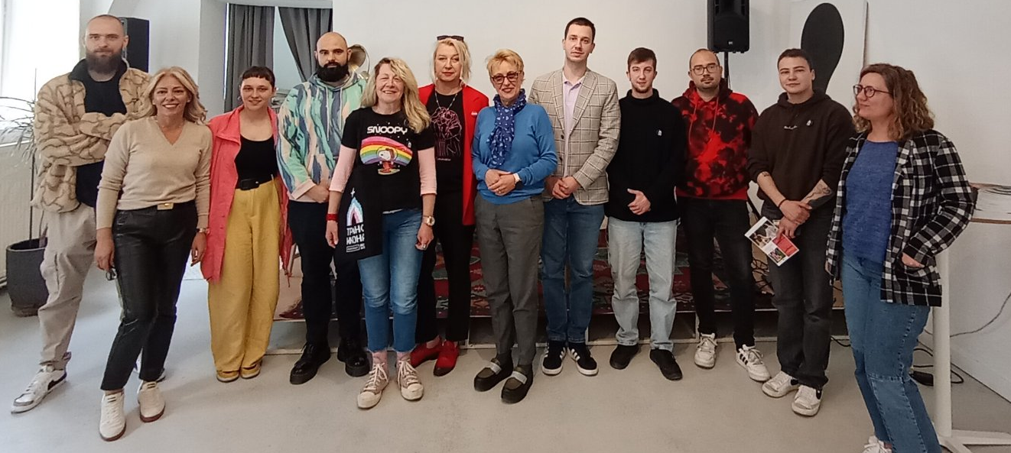
Presentation of the “Collection of Opinions, Recommendations, and Warnings,” Novi Sad, 2025

Discrimination against Refugees, Internally Displaced Persons, Migrants and Asylum-seekers
Discrimination against refugees and displaced persons is a significant social and humanitarian problem that infringes upon fundamental human rights and the principles of solidarity and equality. Refugees and internally displaced persons are among the most vulnerable social groups, as they have been forced to leave their homes due to armed conflict, political instability or other forms of violence.
From a global perspective, although refugees and displaced persons are legally recognized as a particularly vulnerable category, in practice they face various forms of discrimination and social exclusion. These forms of discrimination most often manifest through difficult access to employment, education, healthcare and social services, as well as through problems in exercising the right to housing and obtaining personal documents. However, members of this group rarely address institutions, including the Commissioner. Their disadvantaged socio-economic position, prolonged insecurity, and limited resources further worsen their situation and deepen inequality compared to the rest of the population. A particular challenge is posed by prejudice and negative social attitudes towards refugees and displaced persons, which can lead to stigmatization, marginalization and exclusion from local communities.
Discrimination can also manifest through institutional failures, selective enforcement of regulations, and insufficiently effective protection mechanisms, further complicating the integration of these individuals into society.
The United Nations International Organisation for Migration Report shows that the vast majority of people still live in the countries where they were born – only one in thirty individuals is migrant. In most discussions about migration, the starting point is usually numbers. According to current global estimates, there were approximately 281 million international migrants in the world in 2020, representing 3.6% of the total world population. Overall, the estimated number of international migrants has increased over the past five decades. The total number of people living in a country different from their country of birth in 2020 was 128 million higher than in 1990 and more than three times higher than the estimated number in 1970.
The report Support for (Potential) Victims of Migrant Smuggling and Human Trafficking in Serbia states that migrants and refugees continue to rely largely on support from international and non-governmental organisations due to the lack of sustainable systemic solutions and effective intersectoral cooperation. Instead of perceiving Serbia as a country of refuge, the majority of refugees still view it primarily as a transit country, where they will stay for a shorter or longer period before continuing their journey toward the European Union.
Strengthening institutional support, improving integration policies, and developing a culture of tolerance are necessary steps towards ensuring a dignified life and full equality for refugees and displaced persons in the Republic of Serbia.
Recommended measures for ensuring equality and protection against discrimination
The Commissioner recommended measures to the City of Pančevo to enable the purchase of housing units acquired through construction for the purposes of refugee integration within the framework of the implementation of this programme, in accordance with the Law on Refugees and the Government Conclusion, and in order to complete the process of integration of refugees, beneficiaries of the SIRP Programme, and to apply the provisions of the Law on Refugees, which relate to addressing their housing needs, to the purchase and sale procedure and to the rent procedure of the housing units in question. The Commissioner particularly pointed out the provisions of Article 13 of the United Nations Convention relating to the Status of Refugees, which our country has ratified and which stipulates that contracting states shall apply to each refugee the most favorable treatment possible, and in any case, treatment no less favorable than that accorded, under the same circumstances, to other foreigners with regard to the acquisition of movable and immovable property and other related rights, as well as the lease and other contracts concerning movable and immovable property.
For more information, see: https://ravnopravnost.gov.rs/477-24-preporuka-mera-gradu-pancevu/

The survey Attitudes of Citizens of Serbia towards Migrants and Refugees from the Middle East and Africa stated that the vast majority of respondents (85%) do not know how many migrants and refugees are currently residing in Serbia. Through questions concerning the integration of refugees in terms of employment, education, family, and neighborhood – women, highly educated individuals, urban residents, and young people show a higher degree of tolerance toward refugees. Regarding education, citizens of Serbia see refugee children as members of society who have the right to education and improvement through the school system. The vast majority of respondents (75%) accept the situation in which a child from a refugee family from the Middle East or Africa attend school with their child, having access to medical services (83%), and to their temporary stay in Serbia (83%) and in their city (79%). The tolerance of Serbian citizens also extends to the workplace, where 63% of respondents stated they would not mind having a colleague from the refugee population.
The report The Rights of Seasonal and Informally Employed Workers in Serbia: Exploitation, Insecure Conditions, and Legal Uncertainty analyzed global regulatory practices to identify mechanisms for preventing labour exploitation and to explore effective models for protecting the rights of seasonal and informally employed workers. This report states that, for example, in the construction sector, the conditions under which workers are employed often bypass legal regulations, leading to uncertain payments of agreed wages and failure to provide work equipment, which places workers in a position of dependence on their employer and forces them to continue working in exploitative conditions. In addition, migrant workers can often be exposed to social isolation due to language barriers and separation from their communities, which further increases their exposure to exploitation. This report emphasizes that risks manifest differently among specific vulnerable groups (women, children, persons with disabilities, etc.). Elimination of these exploitation risks requires comprehensive legal interventions and public policy measures, including consistent enforcement of labour rights, provision of social protection, and the promotion of social dialogue between workers, employers, and state authorities.
In addition, increased migration flows also carry a higher risk of human trafficking, which represents one of the most serious forms of human rights violations in modern society and a complex social phenomenon closely linked to migration processes. In the context of intense global and regional migration, economic inequalities, a growing number of armed conflicts, and political instability, a large number of people are forced to leave their homes in search of a safer and more dignified life. It is in such circumstances that migrants and refugees become a particularly vulnerable group, exposed to various forms of exploitation, among which human trafficking occupies a special place.
Due to its geographical location on the so-called Balkan migration route, Serbia has a specific role in migration flows – it is simultaneously a country of origin, a transit country, and, to a lesser extent, a destination country for victims of human trafficking. Human trafficking in the context of migration most often involves labour and sexual exploitation, forced labour, begging, forced marriages, as well as other forms of abuse. Victims are often women, children, and young people, but men are not exempt either, particularly in cases of labour exploitation. A particular problem is the fact that many victims do not recognize themselves as such or, due to fear of deportation and punishment, do not approach the competent institutions.
Viewing human trafficking as a consequence of migration requires an interdisciplinary approach that includes legal, sociological, economic, and security aspects. Understanding the causal links between migration and human trafficking is a key prerequisite for developing effective policies for prevention, victim protection and criminal prosecution of perpetrators. In this context, The Second Report of the Ombudsman – National Rapporteur on Human Trafficking for 2024 states that Serbia has made progress in the fight against human trafficking and that the U.S. State Department has removed the country from the “Watch List” ranking of countries regarding human trafficking. This report points to visible progress in strengthening institutional capacities and developing cooperation between the police, judiciary, social protection system and the civil sector. However, the report also points to existing challenges in the consistent implementation of recommendations, victim protection, proactive activities, and information sharing. Special emphasis is placed on the role of the Center for the Protection of Victims of Human Trafficking, which, in cooperation with the relevant ministry, must take on greater responsibility in the upcoming period. The report also points to new challenges, including a large number of complaints related to labour exploitation that often do not fit the definition of human trafficking. Such cases, as emphasized, slow down procedures and waste state resources, while there is a risk of concealing situations where victims are in real life danger. The Ombudsman assessed that the judiciary must overcome its “winter sleep” and ensure the effective prosecution of perpetrators. A call was also made to international partners, primarily the Council of Europe and the International Organisation for Migration (IOM), to further strengthen their support to Serbia in the upcoming period, in order to make the national system more resilient, visible and efficient.
Serbia is classified at the second level, which includes countries whose governments have made significant efforts to combat human trafficking but have not yet fully met minimum international standards, according to the Trafficking in Persons Report 2025: Serbia. The report further states that the Government of Serbia does not fully meet the minimum standards for the elimination of human trafficking but is making significant efforts to do so, and adds that the Government has demonstrated an overall increase in efforts compared to the previous reporting period.
In order to improve the systemic response to the problem of human trafficking, the Government of the Republic of Serbia adopted in 2024 the Programme for Combating Human Trafficking in the Republic of Serbia for the period 2024-2029, along with an Action Plan for its Implementation for the period 2024-2026. The Programme is an inter-sectoral planning document that comprehensively establishes goals and measures to combat human trafficking, promotes respect for and protection of human rights, and ensures a continuous comprehensive response of society to the problem of human trafficking through an improved system of prevention, timely identification, assistance and protection of victims, as well as the suppression of human trafficking. The Programme sets out four specific objectives that will contribute to a more effective suppression of human trafficking by improving the regulatory framework, investigations, and criminal prosecution of perpetrators of human trafficking, whether they are natural or legal persons, with special focus on a proactive approach, specialization, strengthening competencies, and expanding the circle of trained subjects for recognizing the criminal act.
Considering the complex and difficult position of this vulnerable group, the Commissioner actively cooperates with all social actors engaged in improving the position of refugees and migrants.
Within the project “European Union Support for Migration Management in Serbia: Promoting the Integration of Refugees and Migrants”, implemented by UNHCR Serbia in partnership with IOM Serbia, the Commissariat for Refugees and Migration of the Republic of Serbia and the Commissioner, representatives of the institution took an active part. At the roundtable titled “Financial Inclusion of Refugees: Next Steps”, it was concluded that following the 2024 recommendation issued by the Commissioner which advised all banks to provide refugees, persons with subsidiary protection, and asylum seekers access to banking products and services without discrimination, access to opening payment accounts for refugees and asylum seekers in the Republic of Serbia has improved over the past year. All individuals who contacted UNHCR and its partners for support during this period successfully opened accounts, encountering fewer challenges than in previous years. All banks complied with the Commissioner’s recommendation, improved their procedures, and took other measures within their competence, after which the Commissioner recorded no complaints regarding the banks’ operations or access to their products. It is essential that branch staff are familiar with clients’ personal documents, rights and status, and that they can, if necessary, consult with UNHCR and other relevant organisations. Furthermore, in the coming period, it will be important to enable refugees and asylum seekers to access other bank products and services that are important for their quality of life, such as credit cards, overdraft facilities, and other credit and savings products. In addition, refugees and asylum seekers who have been residing continuously in Serbia for more than one year should have the possibility to use payment accounts for residents. UNHCR has announced the continuation of its activities with the Association of Serbian Banks to inform banks through workshops, trainings, as well as presentations and distribution of information within the Association’s activities, concerning the personal documents, rights, and status of refugees. It is also commendable that some banks, in communication with UNHCR, have mentioned that they are ready to provide mentoring and credit support to refugee entrepreneurs. Finally, in line with the conclusions of last year’s roundtable, UNHCR, the Commissariat for Refugees and Migration, the Asylum Office of the Ministry of Internal Affairs and the Commissioner remain available to financial institutions with their expertise, experience, and data to contribute to improving access to financial products.
Commissioner Janković discussed with UNHCR Representative in Serbia Soufiane Adjali, the improvement of software for the biometric data of asylum seekers and the need for further improvement of software solutions used for collecting and processing biometric data of asylum seekers, with the aim of improving access to rights and services in accordance with international standards. The discussion was also about the scope of free legal aid, the need to ensure a sufficient number of qualified translators in the organizational units of the Ministry of Internal Affairs responsible for asylum procedures, and the possibility of making recommendations to universities and faculties to charge asylum seekers and persons granted asylum tuition fees under the same conditions as domestic students, among other measures.
Shortly after taking office, Commissioner Antonijević also met with UNHCR Representative for Serbia representative Soufiane Adjali on the occasion of International Migrants Day, during which they agreed on continued cooperation in the protection of the rights of migrants, refugees, and asylum seekers. The importance of data collection, raising public awareness, and strengthening institutional capacities in this area was emphasized. The discussion also addressed opportunities for cooperation with employers to enhance the inclusion of asylum seekers and persons granted asylum in the labour market. It was emphasized that everyone has the right to a dignified and safe life, and that the protection of human rights must not be conditioned by race, religion, nationality, origin, or any other personal characteristic. The Commissioner supported UNHCR’s recommendations to improve the position of refugees, asylum seekers, and persons granted subsidiary protection.

Discrimination on Other Grounds
After discrimination based on personal characteristics that resulted in the largest number of complaints, follows a summary of discrimination based on personal characteristics, which resulted in the smallest number of complaints.
In 2025, a smaller number of complaints were filed on the basis of other personal characteristics, including property status (18), citizenship (17), language (11), criminal record (9), appearance (7), race (5), ancestry (3), genetic characteristics (2), etc.

Property status is one the most important factors that shape the quality of life of both individuals and society as a whole, and it significantly influences whether someone will face numerous life difficulties, including discrimination. Unfavorable financial situation, including its more severe forms such as poverty, is one of the main causes of social inequalities and processes of social marginalization, most often affecting Roma, older persons, persons with disabilities, and other individuals who are at higher risk of discrimination. These individuals are often discriminated against on multiple grounds, as confirmed by cases in which the Commissioner acted. Given that poverty leaves lasting and harmful effects on all areas of an individual’s life, the institution devotes special attention to the protection of these persons.
The at-risk-of-poverty or social exclusion rate, which indicates the percentage of individuals who are at risk of poverty, are severely materially and socially deprived, or live in households with very low work intensity. According to the latest data from the Republic Statistical Office, in 2024 the at-risk-of-poverty rate was 19.7%, 0.2 percentage points lower than in 2023. In monetary terms, the poverty risk threshold for a single-member household in 2024 was 35,606 dinars; for a household with two adults and one child under 14 years old, it was 64,091 dinars; and for a four-member household with two adults and two children under 14 years old, it was 74,773 dinars.
Data from the latest survey conducted by the Commissioner on citizens’ attitudes towards discrimination in Serbia show that respondents identify Roma and poor people as the most frequently discriminated groups, regardless of the area of social life, including employment, education, healthcare, the work of public authorities and the judiciary. Regarding the justification for introducing special measures to improve the position of certain groups, the highest support was expressed for persons with disabilities (35%), the poor (34%), and young people and women (29% each). Respondents also believe that the media most often report negatively on the poor, Roma, older persons, persons with disabilities, and people living with HIV/AIDS. At the same time, the results indicate a low social distance toward the poor, as very few respondents oppose close kinship (5%), socializing (1%), or holding leadership positions (3%) by poor citizens.
The Commissioner’s experience shows that poor citizens rarely turn to the institution regarding discrimination based on property status. Moreover, this group is not homogeneous, but includes individuals with different personal and social characteristics. The fact that poor citizens rarely turn to institutions is also a consequence of insufficient information about protection mechanisms. Complaints submitted to the Commissioner mainly relate to the exercise of rights in the field of social protection or the actions of public authorities.
An elderly resident of the village of Miljakovica, near Prokuplje, contacted the Commissioner, pointing out that her family does not have the means to finance the construction of an electrical network, and that members of her family live without electricity, including a relative who is a person with a disability, which is particularly problematic in winter, when heating the homes is necessary. She also pointed out the inaccessibility of the village, i.e. the lack of roads and transportation, which forces residents to walk several kilometers to the doctor, shop, or to meet other basic life needs. The Commissioner issued a recommendation to the city of Prokuplje to take urgent measures to provide electricity for households in the village of Miljakovica and humane living conditions, without discrimination.
The letter from the Mayor of the City of Prokuplje, states that in the coming period it is necessary to trace the road in the village of Miljkovica and procedurally ensure the conditions for the implementation of this road project, as well as that the priority is to connect these households to the electricity grid. In this regard, representatives of the City of Prokuplje organised a meeting with representatives of Electric Power Industry of Serbia to find the best financial solution, and the possibility of installing solar panels was also considered. The City of Prokuplje informed the Commissioner that it is awaiting a response from the Electric Power Industry of Serbia in order to consider the best options for resolving the aforementioned issues related to electricity supply.
More at: https://ravnopravnost.gov.rs/290-25-preporuka-mera-mere-gradu-prokuplju-obezbedjivanje-elektricne-energije-domacinstvima-i-humanih-uslova-za-zivot-u-selu-miljkovica/

Combating poverty and reducing inequality are important goals of the United Nations 2030 Agenda for Sustainable Development, the implementation of which is also monitored through national reports. Of particular importance is the legal obligation to assess the impact of regulations on socio-economically vulnerable groups and equality when adopting them, introduced by the amendments to the 2021 Law on the Prohibition of Discrimination, whose implementation the Commissioner consistently highlights. Social inclusion of the poor requires coordinated action of different systems (local self-government, social and health services, education and culture, security, pension and disability insurance, labour market, free legal aid, etc.), as well as cooperation and action of civil society organisations. In communications from citizens and civil society organisations to the Commissioner, it was noted that in some local self-governments free legal aid services have not been established, or that these tasks are carried out by a single staff member, even though the needs of citizens are significantly greater.
The Commissioner issued a recommendation to all units of local self-government to establish free legal aid services, where they have not yet done so, and to take all appropriate measures to ensure that potential users are fully informed about their rights and the ways to access existing free legal aid. The Commissioner had in mind that free legal aid is of particular importance for persons of poorer financial status, who are most often ignorant litigants, and whom the state thus helps in exercising equal rights in terms of access to justice.
More at https://ravnopravnost.gov.rs/527-25-preporuka-mera-svim-jls-radi-obezbedjivanja-i-unapredjenja-besplatne-pravne-pomoci/

The European Commission, in its 2025 Report on Serbia, also notes that social protection expenditures and budgetary transfers as a share of GDP remain low, that the poor are insufficiently covered by social assistance programmes allocated based on income, and that it is necessary to improve both the coverage and adequacy of financial social assistance, as well as to adjust the legislation accordingly. The report also notes that the system of earmarked transfers at the local level is still not implemented systematically and transparently, that the development of the Social Protection Strategy and the amendments to the Social Protection Law are delayed, but that the recommendations of ECRI (the European Commission against Racism and Intolerance) from June 2024 regarding the decision-making process on the social card and its impact on Roma and other vulnerable groups should be taken into account. The Commission called for a review of the situation, with a “particular emphasis on ensuring transparency in the operation of algorithmic systems, developing effective legal remedies and establishing a strong oversight mechanism.”
Regarding the exercise of the right to financial social assistance and the implementation of the Social Protection Law and the Social Card Law, the Commissioner was contacted during the year by the association A11-Initiative for Economic and Social Rights. Acting on these complaints, the Commissioner issued recommendations to the Ministry of Labour, Employment, Veterans, and Social Affairs, as well as to the social work centers against which the complaints were filed, as already discussed in the previous section of this report.
Recommended Measures to the Ministry of Labour, Employment, Veterans, and Social Affairs

Regarding the problems that arose due to the termination of financial social assistance for certain individuals as a result of mistakes made by employees in three social work centers, specifically, the incorrect classification of income that affects eligibility for financial social assistance, which led to the reduction or cancellation of benefits for some individuals, the Commissioner recommended to the Ministry of Labour, Employment, Veterans, and Social Affairs that, in order to act preventively and improve equality for users of social protection rights and services, it should: review existing staffing standards and establish criteria based on the actual needs of social work centers, strengthen their capacities both quantitatively and qualitatively, strengthen inspection bodies and increase the number of inspections, and analyze the most common mistakes made by the centers and, through second-instance procedures, provide training or issue appropriate instructions on how to resolve problems that arise in practice.
For more information, see: https://ravnopravnost.gov.rs/570-24-preporuka-ministarstvu-za-rad-zaposljavanje-boracka-i-socijalna-pitanja/

The same civil society organisation, as part of monitoring the implementation of the Social Card Law, published a comparative legal analysis of the legal frameworks for making administrative decisions through algorithmic decision-making systems, with recommendations for improvement, entitled Social Protection, Discrimination and Automation: What Could Possibly Go Wrong? It did. The recommendations from this report include amending regulations, supporting the use of available mechanisms for the protection of rights before independent bodies and courts, providing additional training for providers of free legal aid and support, as well as for employees within the social protection system.
Numerous studies, as well as the Commissioner’s practice, indicate that former convicts are at greater risk of discrimination in various areas of social life. According to the Commissioner’s data, a particular problem after being released from prison is the integration of these individuals into the labour market and employment, which, among other things, is reflected in the high rate of recidivism. In addition to employers who often express prejudice and are unwilling to employ formerly convicted individuals, an obstacle is also the provisions of certain laws that list a previous conviction as a disqualifying condition for performing a certain job or activity. Equality in the field of work and employment is of crucial importance for the integration of formerly convicted individuals into all areas of social life. Thus, a complainant contacted the Commissioner, pointing to a provision of the Law on Mediation in the Sale and Lease of Real Estate that places individuals who have served a prison sentence in an unfavorable position.
The Commissioner submitted an initiative to the Ministry of Internal and Foreign Trade to amend the provision of Article 5, paragraph 1, item 5 of the Law on Mediation in the Sale and Lease of Real Estate, which currently prohibits registration in the Register of Mediators (founder i.e. owner, beneficial owner, associate, member of the management body of a company that has a registered the main activity of and agency for the sale and lease of real estate, company representative, member of the management body of a company, as well as natural persons who have passed the professional exam, entrepreneurs, i.e. managers if the entrepreneur has entrusted the management of the business to a legally competent individual) if the legal entity has been fined, or if the natural person has been sentenced to imprisonment, for a criminal offense in the Republic of Serbia or in a foreign country. Considering that the purpose of serving a prison sentence is the reintegration of convicted individuals into society, the Commissioner pointed out that, in practice, previous conviction in this specific case is applied as an absolute prohibition on registration in the Register of Mediators, which is why it is necessary to review these provisions from the perspective of the application of anti-discrimination regulations.
More at: https://ravnopravnost.gov.rs/941-25-inicijativa-ministarstvu-unutrasnje-i-spoljne-trgovine/

During the year, citizens contacted the Commissioner to report discrimination on various grounds, including the unequal position of foundations and endowments compared to citizens’ associations, the difference in treatment of students who graduated from “private” universities and those who graduated from “public” ones, etc.
https://ravnopravnost.gov.rs/541-25-preporuka-mera-svim-jls-radi-obezbedjivanja-jednakih-uslova-za-ucesce-zaduzbina-i-fondacija-na-konkursima/
The Commissioner acted on a complaint from the “SOS Children’s Villages” Foundation regarding the unequal treatment of foundations and endowments by local government units in the implementation of public calls for programme funding. The procedure revealed that the conditions of the calls for proposals often limit participation exclusively to associations headquartered in the territory of the local government unit, thereby excluding foundations, endowments, and other forms of civil society organisations. During the procedure, it was noted that the Law on Associations explicitly refers to the financing of associations, while the Law on Endowments and Foundations refers to the application of the same rules to foundations and endowments that implement programmes of public interest, especially in the field of social protection, and that strategic documents recognize associations, foundations, and endowments as civil society organisations. The Commissioner recommended to all local government units that, when announcing calls for programmes and projects funded from the budgets of the Republic of Serbia and local government units, also take into account civil society organisations established in accordance with the Law on Endowments and Foundations, so that endowments and foundations, like other associations, can also apply for such calls.
More at: 541-25 Recommendation of measures to all local governments to ensure equal conditions for the participation of endowments and foundations in competitions, Commissioner for the Protection of Equality

In the procedure against the Belgrade Bar Association (BBA) following a complaint by a law graduate, for preventing registration in the Register of Trainee Lawyers and Volunteer Trainee Lawyers of the BBA because the complainant obtained the title of law graduate at the Faculty of Law, University Union, whose founder is not the Republic of Serbia, the Commissioner issued an opinion and determined discrimination, and recommended measures to eliminate the consequences of such conduct. The BBA did not comply with the recommendation, which led to a formal warning decision and subsequent public notification.
More at: https://ravnopravnost.gov.rs/588-24-diskriminacija-diplomiranog-pravnika-koji-je-stekao-zvanje-na-fakultetu-ciji-osnivac-nije-rs/

The Law on the Prohibition of Discrimination lists more than twenty personal characteristics as grounds for discrimination, but this list is not exhaustive. The law foresees the possibility that discrimination may also exist on the basis of other personal characteristics, taking into account circumstances that cannot be anticipated in advance. Thus, in its practice, aligned with international practice, the Commissioner also acts on relatively frequent complaints of discrimination based on residence as a personal characteristic. Registration of residence is a condition for exercising all other rights, such as the right to work, receiving various types of assistance, payment of wages, access to education, healthcare and other rights. The Commissioner often acts on complaints from Roma who face unequal treatment based on their place of residence, but similar experiences are reported by other citizens as well, as illustrated by the following examples.
The Commissioner was contacted by the mother of a primary school student who won second prize at the National Mathematics Competition (which is included in the calendar of competitions and exhibitions of the Ministry of Education). Due to differing criteria used by the two municipalities of the city of Niš that announced a competition for awarding prizes to the best students, the student did not meet the criteria of either municipality. Namely, the student is registered as a resident in one municipality but attends school in another.
The Commissioner pointed out that using residence as a criterion for awarding students is problematic in situations where a child does not attend school in the municipality where he or she is registered, or when the municipality of residence and the municipality where the child attends school apply different criteria for awarding the prize. Given the uneven criteria established by different city municipalities, children in the described situations are prevented from participating in award procedures. The Commissioner issued a recommendation to the city of Niš to take measures within its jurisdiction and issue guidance to the city’s municipalities of city of Niš to harmonize the regulations governing the criteria for awarding primary and secondary school students, as well as university students who achieve the best results, so that the award criteria are formulated in a way that ensures equal access to all students without discrimination based on any personal characteristic, including residence.

More at: https://ravnopravnost.gov.rs/1103-25-preporuka-mera-gradu-nisu/

The registration of residence itself can also be a problem. Thus, a civil society organisation, on behalf of and with the consent of a citizen, filed a complaint against the police administration, stating that the individual had repeatedly addressed the police department, verbally and with written requests to register his or her residence address, but none of these requests resulted in a formal decision; instead, the requests and attachments were returned with notices requiring the person to appear in person, while verbal requests were rejected on the grounds that, without proof of legal residence, registration could not be completed. During the procedure, the police administration (after two years) finally registered the residential address, after which an identity card was issued to the complainant. Since the complainant did not give consent that the consequences of the previous actions had been eliminated, the procedure on the complaint continued. Following the conducted procedure, an opinion was given that the police administration, in the process of deciding on the residence registration, violated the provisions of the Law on the Prohibition of Discrimination. Considering that after submitting a complaint and a request for a statement, the police department registered the residence, it was recommended that in the future, in the residence registration procedure, it take care not to make its actions more difficult for citizens to exercise their rights, that is, to take care of the proper application of the provision from the Law on Residence and Stay of Citizens, which provides for an alternative method of registering residence, and it was pointed out that not all citizens can register their residence based on property rights or a lease agreement. It should be borne in mind that residence registration is a prerequisite for exercising numerous rights and that difficulties with registering residence and providing proof of legal property status most often affect the most vulnerable categories of the population, including: Roma, residents of informal settlements, internally displaced persons from Kosovo and Metohija, and returnees under the readmission agreement.
The complaint of a citizen registered as a resident of Belgrade, against the Ministry of Health of the Republic of Serbia and the Republic Health Insurance Fund, stated that the complainant was subjected to discrimination through the charging of health services by a healthcare center outside his place of residence. Due to the charging of these services, despite being a person with health insurance, the complainant approached the competent ministry, after which he was only forwarded a response from the healthcare center, which explained the charging of the costs of the provided service by the fact that the complainant did not have a certificate of registered temporary residence in the municipality where the healthcare center is located, that the services did not involve emergency medical care, and that, according to the relevant provisions of the Rulebook on the Method and Procedure for Exercising Rights under Mandatory Health Insurance, he was obliged to bear the costs of the provided healthcare services. On the other hand, the Republic Health Insurance Fund stated in its response that the complainant was not obliged to pay for the provided healthcare services, since he was covered by health insurance. In this regard, the Commissioner submitted an initiative to the Ministry of Health that, when adopting a new bylaw regulating the procedure for exercising rights under mandatory health insurance, in accordance with the provisions of Article 124, paragraph 3 of the Health Insurance Act, it should clearly prescribe the actions of healthcare institutions in situations where a person resides outside his or her registered residence and needs healthcare in the place of temporary stay.

More at: https://ravnopravnost.gov.rs/84-25-inicijativa-za-donosenje-podzakonskog-akta-kojim-ce-se-na-jasan-nacin-propisati-postupanje-ustanova-zdravstvene-zastite-u-situaciji-kada-jedno-lice-boravi-u-mestu-van-svog-prebivalista-i-ima-pot/
In addition to the mentioned, the Commissioner’s practice has also included cases of discrimination on other grounds, such as, for example, citizenship.
The complainant, a Russian citizen with temporary residence in Serbia and health insurance, a pregnant woman diagnosed with type 1 diabetes, stated that she was discriminated against by a gynecologist at the Health Center. The complainant had a scheduled gynecological appointment, but when the doctor saw her, she immediately said that she did not understand “her Serbian language,” suggested that she go to a private clinic, or find a translator, even though the complainant had previously communicated without any problems with all other doctors. She further stated that the doctor’s behavior worsened her health condition because she had to leave after waiting for several hours, given that it was necessary for her to receive insulin. The procedure established that the doctor did not conduct the complainant’s examination or ultrasound and that she gave priority to other patients, even though their appointments were scheduled after the complainant’s. The Commissioner gave an opinion that the doctor had violated the provisions of the Law on the Prohibition of Discrimination. She was therefore recommended to send a written apology to the complainant and to ensure that, in the framework of her regular duties and activities, she does not violate anti-discrimination regulations in the future.
The gynecologist informed the Commissioner that she had acted on the given recommendation and sent an apology to the complainant, expressing her sincere regret for the inconvenience, stating that she never intended to offend or discriminate, and assuring that in the future she will ensure compliance with the recommendations and legal provisions on the prohibition of discrimination.
For more information, see: https://ravnopravnost.gov.rs/666-24-diskriminacija-na-osnovu-jezika/

Multiple and Intersectional Discrimination
Multiple and intersectional discrimination are defined in Article 13, point 5 of the Law on the Prohibition of Discrimination as a severe form of discrimination, as they represent complex patterns that go beyond individual personal characteristics as grounds for discrimination. If discrimination occurs against a person on the basis of two or more personal characteristics and the impact of each characteristic can be distinguished, it is multiple discrimination. If, however, the impact of the individual personal characteristics cannot be separated when a person is discriminated against on the basis of two or more personal characteristics, it is considered intersectional discrimination. The Strategy for the Prevention and Protection against Discrimination for the period 2022-2030 also points out these severe forms of discrimination, citing as examples cases from the Commissioner’s practice that best illustrate their complexity.
During 2025, the Commissioner received multiple complaints in which several personal characteristics were indicated as the basis for discrimination, although in practice it often happens that complainants, when unsure which personal characteristic was the basis of the discrimination, list multiple personal characteristics. Most often, multiple characteristics are cited together as the basis for discrimination, including gender and marital or family status, disability, health condition, age, membership in political, trade union or other organisations, and religious or political beliefs, and others.
Precisely because of the severity of multiple and intersectional discrimination, as well as their consequences that most often affect the most vulnerable social groups, special attention is paid to these forms of discrimination and their consequences at all gatherings organised by the Commissioner, as well as through trainings and workshops held throughout the year. For example, during 2025, several trainings on the prevention of intersectional discrimination were held in Valjevo, Šabac, Novi Pazar, Vršac, Požarevac, Bač, Arilje, Leskovac, and Kruševac, attended by approximately 500 employees of local government units.
During 2025, a verdict was also reached in a case initiated by the Commissioner against the Municipality and the Center for Social Work based on a mother's complaint regarding discrimination against her minor child based on disability and health condition, because the defendants denied the child the right to personal assistant service that was necessary for him, and thus made it difficult to exercise the right to education and full inclusion in the education system. Special attention was drawn to this example of multiple discrimination through the court proceedings, primarily because such cases are not rare in the Commissioner’s practice, and also to raise awareness among authorities responsible for the realization of various rights about the consequences of discriminatory conduct.
In the proceedings regarding a complaint filed by the mother of a minor boy against the Municipality of Varvarin for discrimination in the exercise of her son’s right to the personal assistant service, the Commissioner issued an opinion that by failing to provide this support, the Municipality of Varvarin made it more difficult for the complainant's son to exercise his right to education and full inclusion in the educational system, thereby violating the provisions of the Law on the Prohibition of Discrimination and committing an act of discrimination based on his personal characteristic – disability/health condition.
It was recommended that the municipality take all necessary actions and measures to ensure the engagement of a personal assistant for the complainant’s son, a primary school student in Varvarin, for as long as there is a need in accordance with the act of the competent authority, and that in the future it ensures that, within the framework of its regular duties and activities, it does not violate the legal provisions on the prohibition of discrimination.
The Municipality of Varvarin informed the Commissioner that, as of September 1, 2025, children from the territory of the municipality have access to this type of support.
More at: https://ravnopravnost.gov.rs/298-25-misljenje-u-postupku-ostvarivanja-prava-na-uslugu-licnog-pratioca/

An example of multiple discrimination is the complaint filed by the Chess Sports Association against the Municipality of Mali Iđoš in the procedure for the allocation and payment of funds under the municipal Public Call for the allocation of funds for financing or co-financing programmes and projects in the field of sports in 2024, on the grounds of discrimination based on political beliefs, as well as national affiliation and membership in trade union organisations. After the procedure was conducted, the Commissioner concluded that, in this specific case, the provisions of the Law on the Prohibition of Discrimination were not violated.
Earlier sections of this report provide more detailed descriptions of various cases of multiple and/or intersectional discrimination, specifying the personal characteristics that are the basis for discrimination in each specific case.

Discrimination and Artificial Intelligence – Equality in the Digital Sphere
In terms of artificial intelligence regulation, the previous year was marked by the adoption of the Code of Practice for General-Purpose Artificial Intelligence Systems. The primary purpose of the Code is to facilitate the implementation of the EU Artificial Intelligence Act in companies that develop such systems. Accession to the Code is voluntary, and it is particularly significant because it more closely regulates security measures against absuse, the ethical use of data, respect for copyright, as well as human oversight to protect fundamental rights and equality.
In addition, significant attention was drawn by the proposals for the EU Digital Omnibus Regulation and the Digital Omnibus Regulation on Artificial Intelligence, which involve amendments to certain articles of the Personal Data Protection Regulation and the Artificial Intelligence Regulation. Given that the consultation process is still ongoing, it is not yet possible to discuss specific amendments; but there are initiatives in the public discourse, that could weaken human rights protection mechanisms in these areas, which will be the subject of a forthcoming joint statement by the European Network of Equality Bodies (EQUINET) and the European Network of National Human Rights Institutions (ENNHRI), which is currently in preparation.
Regarding domestic legal framework, the process of drafting the Law on Artificial Intelligence is underway, but a draft that would be subject to public debate has not yet been prepared.

A topic that remains in focus when it comes to equality in the digital sphere is, above all, gender-based digital violence. The report by the SHARE Foundation “Voices of Resistance to Digital Violence – Annual Report on the Monitoring of Digital Rights Violations in Serbia for 2025” points to the continuation of the trend of gender-based digital violence, with 26 recorded cases during the monitoring period. The targets of these attacks are most often women and members of the LGBTQIA+ community, particularly when they become visible in the public or political sphere. The violence manifests through hate speech, threats, harassment, public shaming, and the increasingly frequent abuse of deepfake technologies. Of particular concern is the intersection of digital and physical violence, as well as the inadequate institutional response, which leads to impunity for perpetrators and additional retraumatization of victims. The report concludes that digital violence represents an extension of deeply rooted gender inequalities and serves as a mechanism of silencing.
The topic of gender-based digital violence was also relevant at the EU level, namely in the reports of the European Institute for Gender Equality. The report Combating Cyber Violence Against Women and Girls: Developing an EU Framework for Measurement states that data on cyber violence against women and girls (CVAWG) in the European Union are limited, inconsistent, and often do not reflect the true extent of the problem. The data mainly rely on police and judicial sources, and no EU member state has a comprehensive monitoring mechanism beyond these databases.
Due to different national definitions, rooted in criminal codes, comparing data at the international level is difficult. An additional problem is underreporting, as victims often do not report the violence, which leads to an underestimation of the actual rates. Survey-based research increasingly fills these gaps and provides deeper insights into the complex nature of gender-based digital violence. The most frequently studied forms are cyberbullying, hate speech, online sexual harassment, and the unauthorized sharing of intimate content. It is also stated that artificial intelligence simultaneously amplifies violence through automated abuse, while also enabling more effective content detection and moderation.
In the report Advancing Digital Rights in Serbia, BIRN recorded 183 cases of digital rights violations in Serbia from September 2024 to June 2025, an unrecorded number to date. In 80% of the cases, the targets were journalists, activists, and citizens, particularly during political crises and protests. Since the beginning of 2025, NUNS has recorded over 130 attacks on journalists, including both verbal and physical assaults. Digital attacks often escalate into physical violence, while protection mechanisms are ineffective and institutional responses are mostly absent.
Recognizing the importance of raising awareness about this issue, the Commissioner continued activities within the “Body Right” campaign, which is being implemented together with the United Nations Population Fund, and which addresses gender-based violence committed through modern technologies. During the reporting period, seven peer education sessions were held in secondary schools across Serbia, and on this occasion, strong interest was shown in continuing similar activities, both by the schools and by the students.
In addition, during the previous year, the Commissioner participated in a number of activities related to issues of equality in the digital sphere. For example, the Commissioner took part in the World Economic Forum in Davos, where she attended events dedicated to the position of women, the ethical use of artificial intelligence, and the achievement of sustainable development goals. A panel titled “AI and Collective Intelligence for Inclusive Action and Impact” was particularly highlighted, as it examined the potential of collective intelligence and innovation in the implementation of sustainable policies. In the “intelligent age” both the benefits and the risks of artificial intelligence must be recognized, and it should be applied in the service of society, human rights, and environmental protection. In addition, a representative of the Commissioner participated in a panel discussion entitled “Artificial Intelligence – A New Literacy of Power,” organised as part of the “Digital Day 2025” conference, as well as in a seminar titled “The Impact of Artificial Intelligence on Disability and Age: Challenges and Opportunities,” organised by the European Network of Equality Bodies, where the institution’s practice was presented, with a particular focus on the Law on the Social Card. In addition, a representative of the Commissioner participated in the Regional Internet Governance Forum – SEEDIG, which was held in Athens the previous year.
An analysis of the implemented activities, as well as erlier mentioned and other available reports, indicate that equality in the digital sphere is one of the key contemporary issues, marked both by significant regulatory developments and by serious challenges in practice. While there are efforts at the EU level to improve the protection of human rights, the ethical use of technology, and safety through the Artificial Intelligence Act and accompanying instruments, there is a risk that some initiatives may weaken already established protection mechanisms. In Serbia, the lack of a definitive legal framework for artificial intelligence further increases the scope for abuse. At the same time, data on gender-based digital violence indicate that it is on the rise and represents an extension of structural inequalities, often accompanied by an insufficiently effective institutional response. The legal framework and protection mechanisms are still insufficient to fully address the growing challenges, and in this regard, it is essential to promptly implement initiatives discussed in previous years, such as the criminalization of the unauthorized sharing of sexually explicit content. It is also concerning that the victims of gender-based digital violence are increasingly children and young people, which can have unforeseeable consequences on their development and mental health. Therefore, comprehensive public policies, effective protection mechanisms, continuous monitoring, and education are of crucial importance to ensure that the digital space becomes inclusive, safe, and grounded in respect for equality and human rights.

MEDIA REPORTING
The year 2025 was marked by protests across the country and deep polarization of society, which was reflected in the topics and content in traditional media and on social networks through an increase in the intensity and frequency of discriminatory and offensive posts, including hate speech, primarily in the context of confrontations with political opponents. Public rhetoric has become significantly more aggressive, often using terms such as “terrorists,” “fascists,” “Ustaše,” “foreign-paid agents,” “blockaders,” “ćaci,” “garbage” and “traitors”. On this occasion, several warnings and public statements were issued, pointing out the inadmissibility and harmfulness of such public discourse, while reminding that hate speech, including offensive and humiliating behavior, is prohibited by the Constitution and the Law on the Prohibition of Discrimination. It was particularly highlighted as worrying that certain public office holders, as well as other public figures, resorted to hate speech and other forms of prohibited speech more than before.
At the same time, according to official data from the Journalists' Association of Serbia, during 2025, a drastic increase in all forms of threats against journalists was recorded, especially physical attacks, threats, pressure, work interference and discrimination, and for the first time, doxing, i.e. the public sharing of personal data, was recorded as a new form of threat. In the previous year, media associations also pointed out the poor economic and social conditions of media employees, the frequent tolerance of hate speech and discriminatory terminology in the media, as well as the often inadequate response from regulatory bodies or the prosecution.
The analysis of media reporting showed significant differences in the way individual media outlets reported on the same events, depending on editorial policy and value frameworks. For example, during the same student protest and faculty blockade, some media reported it as “peaceful civil resistance and the exercise of the constitutional right to assembly,” while others described the same event as “violent blockades,” “threats to public order,” and “pressure on the state.” In a similar vein, the conduct of the police was characterized in some media as excessive use of force and a violation of human rights, while in others it was presented as a necessary and lawful response to preserve security. These examples indicate that the media not only convey information but also actively shape the public narrative, often deepening social divisions and influencing perceptions of discrimination, violence, and institutional accountability.
Based on the press clipping analysis (Ninamedia), an increased number of discriminatory publications was observed in which a person’s actual or presumed nationality, origin, place of birth, or religious affiliation is linked to their political and other forms of work and activity. The Commissioner assessed that the problematization of origin and labeling on this basis, as was the case with Minister of Foreign Affairs Marko Đurić, political analyst Đorđe Vukadinović, politician Marinika Tepić, as well as hate speech directed at Professor Filip Ejdus on the grounds of origin, and in other cases, constitutes an example of frequent, typical, and severe discrimination. The Commissioner has also repeatedly emphasized that a free press is inseparably linked to the right of all citizens to be objectively informed, along with the obligation of the media to uphold professional codes and not serve as a platform for hate speech.
The rights of young people, particularly students and pupils, to freedom of assembly, freedom of expression, education, and equal treatment were in the media spotlight due to student protests, blockades of universities and schools, as well as the conduct of the Ministry of Internal Affairs and other public authorities. Discrimination on the grounds on political beliefs (views), as well as trade union and party affiliation, including dismissals from employment and transfers to other positions, was a subject that received significantly greater media attention over the past year, and the Commissioner’s institution received an increased number of complaints from citizens on these grounds.
Since a significant number of incidents were recorded during the numerous protests and blockades, a public warning was issued, carried by almost all media outlets, condemning violence and excessive use of force, along with a warning that unequal treatment, discrimination and selective protection of citizens' rights undermine the rule of law and encourage violence, an atmosphere of fear and loss of trust in institutions. On that occasion, it was also emphasized that a return to the framework of the Constitution and the law, equal treatment of all, and accountability of institutions are key to restoring security, stability, and citizens’ trust.
When it comes to other topics within the jurisdiction of the Commissioner's institution, the subjects that received the most media attention during 2025 were violence against women, human rights, hate speech, discrimination, equality and violence against children, including peer violence (source: media monitoring based on specified keywords – Ninamedia). Of approximately 26,300 publications, 78.63% appeared online, on media portals, 12.74% in print, and 8.63% in electronic media, primarily TV stations. The media have shown increased interest in the work of the Commissioner’s institution and in specific topics in the field of equality protection when reporting on current events, on the occasion of significant national and international dates, as well as at conferences and events addressing these issues. The only subject that remained consistently in the media spotlight throughout the entire year was human rights.
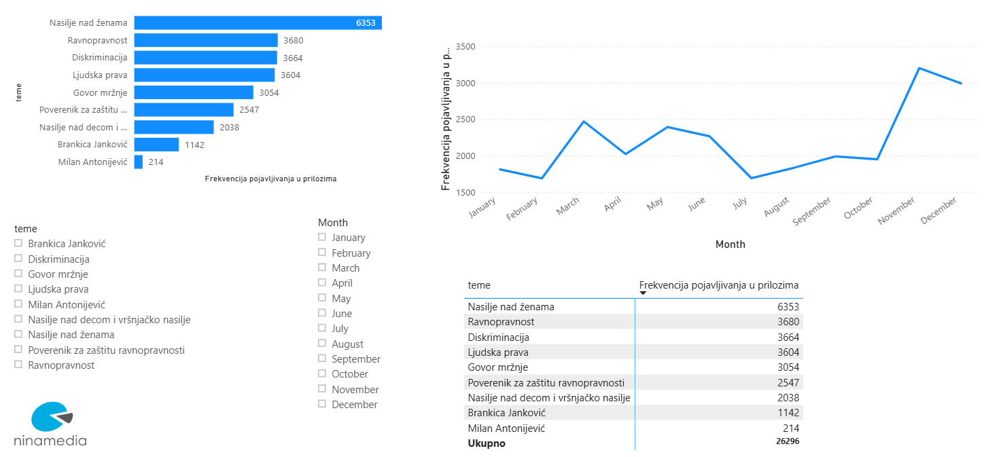
Photo1: Violence against women, Equality, Discrimination, Human rights, Hate speach, Commissioner, Violence against children and…, Brankica Janković, Milan Antonijević

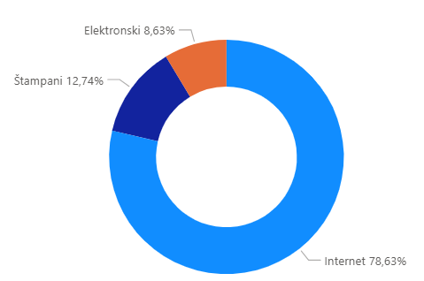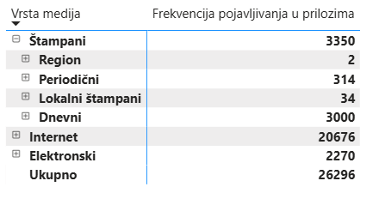

Photo: Electronic 8,63%, Printed 12,74%, Internet 78,63%
Photo: Type of media, Frequency of coverage in reports, Printed, Regional, Periodical, Local, Daily, Internet, Electronic, Total
The topic of violence against women was most represented on the portals of daily newspapers, followed by the daily press, and around 11% of all announcements were broadcast on national and local television stations. Media reporting on cases of violence against women has generally retained a sensationalist character, with narratives that include “victim blaming” still present, to which the Commissioner publicly reacted and pointed out that media and cultural content is flooded with violence against women and their marginalization, as well as that the linguistic matrix that objectifies women reflects patriarchal attitudes and supports harmful stereotypes about their place in society. Violence against women was a media topic in the context of student protests, with a number of media outlets relativizing physical and psychological violence against female students, using sexist comments, belittlement and disclosure of their personal data, nationality, ethnic origin, and private photographs.
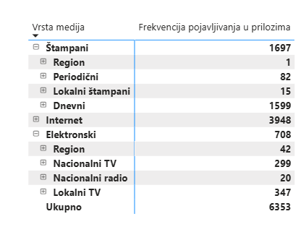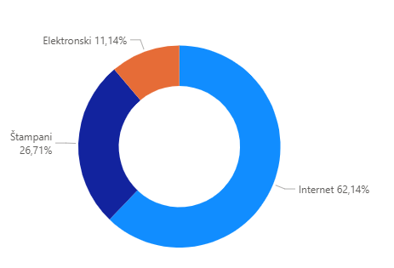
Photo: Electronic 11,14%, Printed 26,71%, Internet 62,14%
Photo: Type of media, Frequency of coverage in reports, Printed, Regional, Periodical, Local, Daily, Internet, Electronic, Total
he media also reported on various activities of the Commissioner aimed at improving the position of women, as well as events dedicated to the importance of greater participation of women leaders in the fields of economy, business, and security. In addition to the recommendation of measures addressed to the mandate holder for forming the Government, Dr. Đuro Macut, concerning balanced representation of women and men in the future Government of the Republic of Serbia, the publication of the Special Report on the Discrimination of Women 2015-2025 attracted the attention of journalists, as well as the Commissioner’s annual conference on the International Day of Tolerance titled “The Position of Women – Big Steps, Small Progress: How Education Can Help Us.” Local media also reported on the implementation of the Commissioner's projects dedicated to improving the position of women in rural areas, as well as educational workshops on gender equality in schools across Serbia.
Given that the first part of the year was turbulent, many of the Commissioner’s activities were postponed and during that period media interest in all topics in the field of discrimination decreased, except for the most extreme ones. In the second half of the year, a series of events organised by the Commissioner attracted media attention, including, in addition to those already mentioned, the presentation of the Collection on Discrimination Based on National Affiliation 2015-2025, and the Special Report on Discrimination against Persons with Disabilities, as well as the international conference on the International Day of Older Persons “My Future – Whose Responsibility?”.
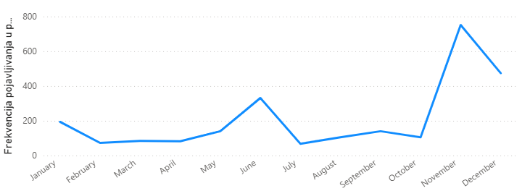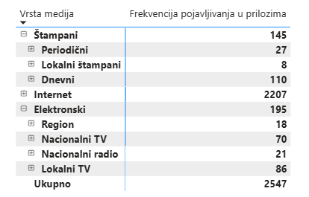

The media play a key role in informing the public and exchanging ideas, and the way they select and present topics directly affects the protection and advancement of human rights. Responsible and professional reporting can help reduce prejudice and strengthening trust in institutions, while the inappropriate use of discriminatory language and neglect of important social issues can deepen intolerance and social distance, which is why the education of journalists and cooperation with the media holds an important place in the work of the Commissioner's institution. An important part of this process is the Annual Media Award for the authors of the best texts and articles on combating discrimination, promoting equality and tolerance, which is jointly awarded by the Commissioner and the OSCE Mission to Serbia. The awards were presented in November for the tenth anniversary, and the winners were announced at the Commissioner's regular annual conference held on the occasion of the International Day for Tolerance. On the occasion of the tenth anniversary of the Media Tolerance Award, a gathering of all previous laureates, over 100 in number, was held in September, and the documentary film “Voices of Equality – Ten Years of the Tolerance Award” was screened, summarizing the award’s decade-long history and the experiences of the awarded journalists. This conference was an opportunity to point out to media representatives that while they deal with the so-called “big topics”, the problems of the “little” man remain in the shadows.

REPORT ON EXECUTION OF THE FINANCIAL PLAN
Under the Law on Budget of the Republic of Serbia for 2025 initial appropriations were established for the Commissioner Programme 1001 – Promotion and Protection of Human and Minority Rights and Freedoms, in the amount of RSD 152,543,000.
During the year, the total amount of expenditure appropriations was increased (through revenues from current donations from foreign states – Source 05, current donations from international organisations – Source 06, and approved funds from the current budget reserve for the payment of employee salaries in December), bringing the total current appropriations to 180,828,153,51 dinars, where, according to funding sources, the structure of these funds consisted of:
SOURCE 01 | 153.194.000,00 | 84,72%
SOURCE 05 | 1.168.248,00 | 0,65%
SOURCE 06 | 21.346.937,10 | 11,81%
SOURCE 15 | 5.118.968,41 | 2,83%
In 2025, the Commissioner was involved in the implementation of three projects funded by donations from international organisations, namely:
- GIZ project – Improving Equality in the Field of Work and Employment – A Joint Initiative for Workplace Equality,
- TEMPUS project – Youth for Equality,
- UN WOMEN Project – Empowering Women in Rural Areas of Serbia to Recognize and Respond to Discrimination and Violence.

EXECUTION OF FINANCIAL RESOURCES
he following was financed from Source 01 – general revenues and budget revenues:
- Programme activity 0012 - Effective Suppression and Protection against Discrimination
The funds were used to finance the regular activities and performance of expert and other tasks of the Commissioner’s Professional Service of relevance for the exercise of its powers, in accordance with the Financial Plan and the Pro-curement Plan. The total execution was RSD 144,425,122,93 or 95.78% of available funds. In the structure of funds spent, expenditures for employees accounted for 87.78%, the use of services and goods for 11.39% (where the majority of costs relate to information services, other expert services, administrative material, expert literature for employees’ regular work and fuel costs) and costs of non-financial assets for 0.83%.
Within Programme Activity 0012, two grants from the Austrian Embassy in Serbia (Source 05) were implemented:
- for the project Youth Panel on Internet Safety, and
- for the realization of the project Empowering Women in Rural Areas through Acquiring New Knowledge and Skills and Increasing Media Visibility.
The total amount of the donation was 1,168,248 dinars, of which 99.99% was spent on implementing the aforementioned project activities
- Project 4003 - МООТ COURT, Trial simulation in the field of protection against discrimination
As in the previous year, this project was financed from the budget of the Republic of Serbia. The objective of this project is to train students for preparation and defence in legal matters in the field of the protection against discrimination. A total of RSD 577,147,00 or 98.32% of available funds was spent on implementation of this project for organisation of students’ competitions and prizes for the best participants.
- Project 4005 – Equally to the Finish Line
The objective of this project is to raise citizens’ awareness of discrimination against persons with disabilities and to present the work of the Commissioner and institutional mechanisms in the fight against discrimination. The total execution for this project was RSD 259,960 or 84.18% of available funds and includes primarily information services.
- Project 4006 – Don’t Judge a Book by Its Covers - Live Library in Serbia
The objective of this project is to fight against negative stereotypes and prejudice and discrimination against social groups and individuals and it constitutes an innovative methodology to promote human rights, equality, the fight against racism and xenophobia. There was no implementation of budget funds within this project.
- Project 4009 – Youth Panel
The objective of this project is to ensure conditions to reduce discrimination against children and the youth. During the course of 2025, lectures/workshops were held for pupils on recognition of discrimination and various forms of violence. RSD 499,200 or 99.84% of available funds was spent for this purpose.
- Project 4013 – A Bridge of Understanding
A prize-winning competition for the best literary works, photographs and visual art works on the topic of intergenerational solidarity was organised as part of this project for primary school pupils. Funds of RSD 311,000 were available for this project in the budget, of which 77.99% was spent. Costs of organisation of events, jury services and prizes for the best pupils’ works were financed.
- Project 4014 – Visibility Advances Equality
In 2025, activities were implemented that include presentation of women and their creative works to the general public in the context of advancement of equality and reduction of the existing discrimination through strengthening of women’s visibility as a creative potential and their empowerment. Funds of RSD 450,000 were available in the budget for this project, of which 99.73% was spent. Costs of consultation services were used for preparation of the concept for the implementation of the project and organisation of events.
Other sources 06 – donations from international organisations, financed the following projects:
- Project 4015 – GIZ – Improving Equality in the Field of Work and Employment - A Joint Initiative for Workplace Equality
The Commissioner and Deutsche Gesellschaft für Internationale Zusammenarbeit (GIZ) GmbH, the Federal Republic of Germany, concluded on 11 June 2024 the agreement on the award of grant in the amount of maximum EUR 63,879,00 for the implementation of activities under the project in the period from 1 July 2024 to 31 May 2025. The project is focused on additional strengthening of cooperation with employers and strengthening of preventative measures with the aim of developing inclusive labour market. Through specially designed educational workshops, employer will improve knowledge on the prevention of and protection against discrimination in the field of labour and employment, learn about examples of successful business practices and prepare themselves for the development and adoption of internal Equality Codes. In 2025, the second, third, and fourth installments of funds were received, totaling EUR 29,116,60, or RSD 3,400,130,70. Project activities also utilized funds from Source 15 (funds carried over from 2024). The total utilization of funds from Source 06 and Source 15 in 2025 was 99.98%
- Project 4016 – TEMPUS – Youth for Equality
The Commissioner and the Tempus Foundation concluded the Contract on the Award of Dedicated Grant for ERASMUS+1 programme, Project – Youth for Equality, worth EUR 60,000, with the duration period of 12 months, from 9 October 2024 to 8 October 2025. From the second tranche of the donation (Source 06), 1,400,285,80 dinars, or 99.78%, was spent, and from the remaining funds carried over from the previous year (Source 15), 4,666,479,80 dinars, or 99.99% of the funds, were utilized.
- Project 4017 – UN WOMEN – Empowering Women in Rural Areas of Serbia to Recognize and Respond to Discrimination and Violence.
The Commissioner and the United Nations Agency for Gender Equality and the Empowerment of Women (UN Women) concluded a Partnership Agreement on the implementation of activities within the project Empowering Women in Rural Areas of Serbia to Recognize and Respond to Discrimination and Violence. The project was fully implemented during 2025, and the total donor value of the project is 16,543,500,00 dinars. A total of 16,458,135,75 dinars, or 99.58% of the funds, were spent. The structure of budget execution for 2025, both by funding sources and by programme, programme activity, and projects, is provided in the annex to this report.

COMPILIANCE WITH DUTIES UNDER LAW ON FREE ACCESS TO INFORMATION OF PUBLIC IMPORTANCE
The Commissioner ensures free access to information by honoring freedom of information requests, publishing the Information Directory and other information on the institution’s official website, reporting to the National Assembly, informing the public by announcements, publications, press conferences and in other relevant manners.
In 2025, the Commissioner received 11 freedom of information requests, all of which were responded to within the statutory deadline.

Table overview of submitted requests by categories
No. | Information requester | Number of submitted requests | Number of adopted/ partially adopted requests | Number of pending requests | Number of dismissed requests | Number of rejected requests
1. | Citizens | 6 | 5 |  |  | 1
2. | Media | 2 | 2
3. | NGOs and other citizens’ associations | 2 | 2
4. | Political parties | /
5. | Public authorities | /
6. | Other | 1 | 1
7. | Total | 11 | 10 |  |  | 1

When providing information, special account is taken of personal data protection, in accordance with the Law on Personal Data Protection. The party in the procedure before the Commissioner has the right to confidentiality of all private data contained in case files and which he/she or other authorised person provides to the Commissioner.
The Commissioner’s Information Directory is available at the official website (www.ravnopravnost.gov.rs). To ensure easier exercise of freedom of information, citizens can download at the Commissioner’s official website forms with examples for submission of freedom of information requests. Requests can be submitted in writing, without using the forms. Requests must clearly state which peace of information is requested and/or to what it specifically relates, i.e. as precise as possible description of the requested information. Requests can, but do not have to, contain reasons for their submission, as well as any other data that facilitate finding of the requested piece of information.
The Law on Free Access to Information of Public Importance specifies fees for making copies of documents containing the requested information, as well as costs of sending, if any. The amount of fees is calculated in accordance with the Regulation on the Amount of Compensation for Necessary Costs. The insight into documents containing the requested information is free of charge. Freedom of information requests relating to the work of the Commissioner or generated in her work can be submitted in writing to the following address: Bulevar kralja Aleksandra 84, 11000 Belgrade, or electronically to the following address: poverenik@ravnopravnost.gov.rs.

ANNEX 1: STATISTICAL OVERVIEW OF COMMISSIONER’S CASES IN 2025

CASES | 2025
Complaints | 939
Recommended measures | 837
Opinions on draft legal documents | 20
Initiatives for amendments to regulations | 16
Criminal charges | 7
Misdemeanor report | 1
Lawsuits | 2*+ 4
Proposals for review of constitutionality | 3
Warnings | 6
Announcements | 35
Confirmations that no discriminatory acting was identified | 2.316
TOTAL number of cases* | 4.151
* Two strategic lawsuits were initiated in 2025. In one of these lawsuits, the Commissioner intervenes as a third party. In addition, four other cases from previous years are still ongoing.
* Announcements are not included in the total number of cases.

Complainants
Natural persons | Number | %
Men | 339 | 42,7
Women | 456 | 57,3
Total | 795 | 100
Other complainants | број | %
Natural persons | 795 | 84,7
Organisation | 74 | 7,9
State authorities | 27 | 2,9
Group of persons | 22 | 2,3
Legal entities | 21 | 2,2
Total number of complainants | 939 | 100

Grounds of discrimination (personal characteristic)
Complaints based on discrimination | No | %
Complaints stating a personal characteristic | 782 | 83,3
Complaints not stating a personal characteristic | 157 | 16,7
Total number of complaints | 939 | 100

Grounds of discrimination (personal characteristic)
Complaints based on discrimination | No | %
Complaints stating one personal characteristic | 655 | 83,8
Complaints stating more personal characteristics | 127 | 16,2
Total number of complaints | 782 | 100

Complaints stating a personal characteristic | No | %
Age | 114 | 12,1
Health status | 112 | 11,9
Income level | 110 | 11,7
Disability | 91 | 9,7
Sex | 89 | 9,5
National affiliation or ethnic origin | 88 | 9,4
Religious and political beliefs | 76 | 8,1
Membership in political, trade union and other organisations | 70 | 7,4
Other personal characteristic | 52 | 5,5
Marital and family status | 43 | 4,6
Property status | 18 | 1,9
Citizenship | 17 | 1,8
Language | 11 | 1,2
Sexual orientation | 11 | 1,2
Gender identity | 10 | 1,1
Previous criminal conviction | 9 | 1,0
Appearance | 7 | 0,7
Race | 5 | 0,5
Ancestors | 3 | 0,3
Genetic characteristics | 2 | 0,2
Skin colour | 1 | 0,1
Birth | 1 | 0,1
Total | 940 | 100
* In 127 complaints, several personal characteristics were stated as the grounds of discrimination
Areas of social relations to which complaints relate
Complaints by discrimination fields | No | %
In employment procedure or at work | 341 | 36,3
Procedure before public authorities (courts, municipalities, ministries, commissions) | 174 | 18,5
Education and vocational training | 160 | 17,0
In providing public services or using facilities and areas | 85 | 9,1
Public sphere/General public | 43 | 4,6
Health care | 32 | 3,4
Public information and the media | 26 | 2,8
Other | 22 | 2,3
Private relations | 18 | 1,9
Housing | 10 | 1,1
Social welfare | 9 | 1,0
Judiciary | 6 | 0,6
Culture, arts, sports | 4 | 0,4
Exercise of collective minority rights | 3 | 0,3
Activity / engagement in trade unions, political parties, NGOs, and other organisations | 2 | 0,2
Property rights and relations | 2 | 0,2
Exercise of religious rights | 2 | 0,2
Total number of complaints | 939 | 100

Fields of discrimination by complainants
Fields of discrimination by complainants | Natural persons |  | CSO | Authorities/ institutions | Group of persons | Legal entities | TOTAL
Fields of discrimination by complainants | M | F |  |  |  |  | No. | %
In employment procedure or at work | 112 | 190 | 12 | 16 | 5 | 6 | 341 | 36,3
Procedure before public authorities (courts, municipalities, ministries, commissions) | 87 | 58 | 18 | 1 | 4 | 6 | 174 | 18,5
Education and vocational training | 31 | 110 | 6 | 3 | 8 | 2 | 160 | 17,0
In providing public services or using facilities and areas | 43 | 33 | 5 | 1 | 1 | 2 | 85 | 9,1
Public sphere/General public | 10 | 19 | 8 | 3 | 1 | 2 | 43 | 4,6
Health care | 13 | 15 | 3 | / | 1 | / | 32 | 3,4
Public information and the media | 10 | 2 | 11 | 1 | / | 2 | 26 | 2,8
Other | 13 | 7 | 1 | / | / | 1 | 22 | 2,3
Private relations | 8 | 8 | 1 | 1 | / | / | 18 | 1,9
Housing | 2 | 5 | 2 | / | 1 | / | 10 | 1,1
Social welfare | 3 | 4 | 2 | / | / | / | 9 | 1,0
Judiciary | 2 | 1 | 2 | 1 | / | / | 6 | 0,6
Culture, arts, sports | 1 | 1 | 1 | 1 | / | / | 4 | 0,4
Exercise of collective minority rights | 1 | / | 1 | / | 1 | / | 3 | 0,3
Activity / engagement in trade unions, political parties, NGOs, and other organisations | 1 | 1 | / | / | / | / | 2 | 0,2
Property rights and relations | 1 | 1 | / | / | / | / | 2 | 0,2
Exercise of religious rights | 1 | / | 1 | / | / | / | 2 | 0,2
Total number of complaints |  |  |  |  |  |  | 939 | 100

In employment procedure or at work
Note: Percentages for stated personal characteristics are calculated based on the number of complainants for complaints where personal characteristics are stated, not on the total number of complaints for the given field.
Complainants in employment procedure or at work | Natural persons |  | CSO | Authorities/ institutions | Group of persons | Legal entities | TOTAL
Complainants in employment procedure or at work | M | F |  |  |  |  | No. | %
Income level | 34 | 68 | 2 | 2 | 4 | / | 110 | 32,0
Membership in political, trade union and other organisations | 12 | 28 | 4 | 1 | / | / | 47 | 13,7
Religious and political beliefs | 14 | 19 | 3 | / | / | / | 38 | 11,1
Sex | 6 | 14 | 1 | 3 | / | / | 27 | 7,9
Health status | 14 | 11 | / | 1 | / | / | 26 | 7,6
Disability | 13 | 8 | 1 | / | / | / | 22 | 6,4
Other personal characteristic | 13 | 6 | 1 | 1 | / | 1 | 22 | 6,4
Marital and family status | 1 | 16 | / | 1 | / | / | 18 | 5,2
National affiliation or ethnic origin | 5 | 5 | 1 | 3 | / | / | 14 | 4,1
Age | 6 | 1 | 1 | / | / | / | 8 | 2,3
Appearance | 3 | 1 | / | / | / | / | 4 | 1,2
Sexual orientation | 1 | / | / | 1 | / | / | 2 | 0,6
Birth | / | 1 | / | / | / | / | 1 | 0,3
Previous criminal conviction | / | 1 | / | / | / | / | 1 | 0,3
Property status | 1 | / | / | / | / | / | 1 | 0,3
Total number of complaints |  |  |  |  |  |  | 343 | 100

Procedure before public authorities (courts, municipalities, ministries, commissions…)
Note: Percentages for stated personal characteristics are calculated based on the number of complainants for complaints where personal characteristics are stated, not on the total number of complaints for the given field.
Complainants in procedure before public authorities (courts, municipalities, ministries, commissions…) | Natural persons |  | CSO | Authorities/ institutions | Legal entities | Group of persons | TOTAL
 | M | F |  |  |  |  | No. | %
National affiliation or ethnic origin | 11 | 3 | 11 | 1 | / | 2 | 28 | 15,6
Sex | 8 | 14 | 1 | / | 1 | / | 24 | 13,3
Disability | 7 | 9 | 3 | / | / | / | 19 | 10,6
Marital and family status | 11 | 8 | / | / | / | / | 19 | 10,6
Health status | 6 | 10 | 1 | / | / | / | 17 | 9,4
Membership in political,  trade union and other organisations | 7 | 2 | 4 | / | / | / | 13 | 7,2
Religious and political beliefs | 5 | 1 | 4 | / | / | 2 | 12 | 6,7
Other personal characteristic | 2 | 6 | 1 | / | / | / | 9 | 5,0
Property status | 2 | 6 | / | / | / | / | 8 | 4,4
Citizenship | 6 | / | / | / | 1 | / | 7 | 3,9
Gender identity | 3 | 2 | / | / | 1 | / | 6 | 3,3
Language | 1 | / | 2 | / | 1 | 2 | 6 | 3,3
Previous criminal conviction | 3 | / | 1 | / | / | / | 4 | 2,2
Age | 2 | 2 | / | / | / | / | 4 | 2,2
Ancestors | / | 2 | / | / | / | / | 2 | 1,1
Race | 2 | / | / | / | / | / | 2 | 1,1
Total number of complaints |  |  |  |  |  |  | 180 | 100

In the field of education and vocational training
Note: Percentages for stated personal characteristics are calculated based on the number of complainants for complaints where personal characteristics are stated, not on the total number of complaints for the given field.
Complainants in the field of education and vocational training | Natural persons |  | CSO | Authorities/ institutions | Group of persons | Legal entities | TOTAL
 | M | F |  |  |  |  | No. | %
Age | 7 | 69 | 3 | / | 3 | / | 82 | 51,3
Health status | 7 | 13 | 1 | 1 | 1 | 1 | 24 | 15,0
Religious and political beliefs | 4 | 9 | / | / | 1 | / | 14 | 8,8
Other personal characteristic | / | 8 | / | 1 | 1 | 1 | 11 | 6,9
Disability | 1 | 7 | / | 1 | / | 1 | 10 | 6,3
National affiliation or ethnic origin | 1 | / | 5 | / | / | / | 6 | 3,8
Membership in political,  trade union and other organisations | / | 4 | / | / | / | / | 4 | 2,5
Marital and family status | 2 | 1 | / | / | 1 | / | 4 | 2,5
Sex | / | 2 | / | / | / | / | 2 | 1,3
Sexual orientation | 1 | / | / | / | / | / | 1 | 0,6
Property status | 1 | / | / | / | / | / | 1 | 0.6
Appearance | / | / | 1 | / | / | / | 1 | 0,6
Total number of complaints |  |  |  |  |  |  | 160 | 100

In providing public services or using facilities and areas
Note: Percentages for stated personal characteristics are calculated based on the number of complainants for complaints where personal characteristics are stated, not on the total number of complaints for the given field.
Complainants in providing public services or using facilities and areas | Natural persons |  | CSO | Authorities/ institutions | Legal entities | Groupof persons | TOTAL
 | M | F |  |  |  |  | No. | %
Disability | 16 | 11 | 1 | / | / | / | 28 | 33,3
Health status | 8 | 7 | 1 | / | / | 1 | 17 | 20,2
Age | 3 | 4 | / | / | / | 1 | 8 | 9,5
Sex | 2 | 4 | 1 | / | / | / | 7 | 8,3
Property status | 4 | 1 | 2 | / | / | / | 7 | 8,3
Citizenship | 3 | 2 | / | / | / | / | 5 | 6
Other personal characteristic | 2 | 1 | / | / | / | / | 3 | 3,6
Language | 3 | / | / | / | / | / | 3 | 3,6
National affiliation or ethnic origin | 1 | / | 2 | / | / | / | 3 | 3,6
Previous criminal conviction | / | / | 1 | / | / | / | 1 | 1,2
Marital and family status | / | 1 | / | / | / | / | 1 | 1,2
Race | 1 | / | / | / | / | / | 1 | 1,2
Total number of complaints |  |  |  |  |  |  | 83 | 100

Complainants in the field of public sphere/general public
Note: Percentages for stated personal characteristics are calculated based on the number of complainants for complaints where personal characteristics are stated, not on the total number of complaints for the given field.

Complainants in the field of public information and the media | Natural persons |  | CSO | Authorities/ institutions | Legal entities | Group of persons | TOTAL
 | M | F |  |  |  |  | No. | %
Sex | 1 | 12 | / | 2 | 1 | / | 16 | 39
National affiliation or ethnic origin | 4 | / | 8 | / | / | / | 12 | 29
Sexual orientation | 2 | 1 | / | / | / | / | 3 | 7,3
Religious and political beliefs | / | 2 | / | / | / | 1 | 3 | 7,3
Membership in political,  trade union and other organisations | / | 2 | / | / | 1 | / | 3 | 7,3
Other personal characteristic | 1 | / | / | / | / | / | 1 | 2,4
Language | / | / | 1 | / | / | / | 1 | 2,4
Citizenship | / | / | / | 1 | / | / | 1 | 2,4
Genetic characteristics | / | 1 | / | / | / | / | 1 | 2,4
Total number of complaints |  |  |  |  |  |  | 41 | 100

Complaiants in the field of health care
Note: Percentages for stated personal characteristics are calculated based on the number of complainants for complaints where personal characteristics are stated, not on the total number of complaints for the given field.
Complainants in the field of health care | Natural persons |  | CSO | Authorities/ institutions | Legal entities | Group of persons | TOTAL
Complainants in the field of health care | M | F |  |  |  |  | No. | %
Health status | 10 | 6 | 3 | / | / | 1 | 20 | 12,5
Disability | / | 4 | / | / | / | / | 4 | 2,5
Other personal characteristic | 1 | 2 | / | / | / | / | 3 | 1,9
National affiliation or ethnic origin | 2 | 1 | / | / | / | / | 3 | 1,9
Age | / | 2 | / | / | / | / | 2 | 1,3
Sex | / | 2 | / | / | / | / | 2 | 1,3
Religious and political beliefs | 1 | / | / | / | / | / | 1 | 0,6
Marital and family status | / | 1 | / | / | / | / | 1 | 0,6
Total number of complaints |  |  |  |  |  |  | 36 | 100

Complainants in the field of public information and the media
Note: Percentages for stated personal characteristics are calculated based on the number of complainants for complaints where personal characteristics are stated, not on the total number of complaints for the given field.
Complainants in the field of public information and the media | Natural persons |  | CSO | Authorities/ institutions | Legal entities | Group of persons | TOTAL
 | M | F |  |  |  |  | No. | %
National affiliation or ethnic origin | 2 | / | 9 | / | / | / | 11 | 36,4
Religious and political beliefs | 2 | 2 | / | / | 1 | / | 5 | 15,2
Sex | 2 | / | 1 | / | / | / | 3 | 9,1
Sexual orientation | 2 | / | / | / | / | / | 2 | 6,1
Disability | 1 | / | 1 | / | / | / | 2 | 6,1
Other personal characteristic | 1 | / | / | / | 1 | / | 2 | 6,1
Race | 2 | / | / | / | / | / | 2 | 6,1
Health status | / | / | 1 | / | / | / | 1 | 3
Age | / |  | / | 1 | / | / | 1 | 3
Appearance | / | / | 1 | / | / | / | 1 | 3
Skin color | 1 | / | / | / | / | / | 1 | 3
Genetic characteristics | / | / | 1 | / | / | / | 1 | 3
Total number of complaints |  |  |  |  |  |  | 32 | 100
A statistical overview was not provided for other fields of social life because the number of filed complaints is below 2.5%.

Complaints filed against
Complaints filed against | Number | %
State authorities | 524 | 55,4
Legal entities | 214 | 22,6
Natural persons | 137 | 14,5
Authorities / Institutions | 48 | 5,1
Groups of persons | 11 | 1,2
Organisation | 11 | 1,2
Total | 945 | 100

Number of complaints by regions
Number of complaints by regions | Number | %
Unknown region | 276 | 29,3
Belgrade region | 241 | 25,7
Southern and Eastern Serbia region | 154 | 16,4
Vojvodina region | 137 | 14,6
Šumadija and Western Serbia region | 124 | 13,2
Kosovo and Metohija region | 7 | 0,7
Total number of complaints by regions | 939 | 100
* The region is unknown when the complaint is filed by e-mail and when the complainant does not indicate the municipality of residence.

Outcomes of proceedings
Outcomes of acting on complaints | 2025
Complaints where opinions were issued | 36
- opinions where violation of rights was identified and recommendations were provided | 30
- opinions where no violation of rights was identified and measures recommended | 4
- opinions where no violation of rights was identified | 2
Criminal charges | 7
Misdemeanor report | 1
Lawsuit | 2* + 4
Proposal for review of constitutionality | 3
Outside the scope of jurisdiction | 88
Incompleteness (shortcomings) | 223
No violation of rights | 146
Court proceedings are being conducted or terminated | 52
Already acted on a case and no new evidence was provided | 134
Due to the passage of time, it is no longer possible to achieve the purpose of the proceedings | 1
Complaints withdrawn/ consequences of acting eliminated | 83
Pending: submitted for a statement and supplement requested | 163
* In 2025, two strategic lawsuits were initiated. In one of these cases, the Commissioner intervenes as a third party. In addition, four other cases from previous years are still ongoing.
Compliance with recommendations
Compliance with recommendations in acting on complaints | No | %
Recommendations complied with | 17 | 81
Recommendations not complied with | 4 | 19
Total | 21 | 100
* In 9 cases the deadline for compliance with recommendations has not expired

Compliance with recommended measures | No | %
Recommendations complied with | 728 | 89.2
Recommendations not complied with | 88 | 10.8
Total | 816 | 100
* In 26 cases the deadline for compliance with recommendations has not expired

Percentage of compliance with the Commissioner’s recommendations | %
Recommendations complied with | 85.1
Recommendations not complied with | 14.9
Percentage of compliance with the Commissioner’s recommendations | 100

ANNEX 2: BUDGET EXECUTION FOR 2025
BUDGET STRUCTURE BY SOURCES OF FINANCING
 | Source of finan- cing | Programme | Programme activity/ project |  | Ec. class |  | DESCRIPTION |  | * Initial appro- priation |  | **Current appro- priation |  | Budget execution |  | % Execution (8:7)
 | 1 | 2 | 3 |  | 4 |  | 5 |  | 6 |  | 7 |  | 8 |  | 9
 | 01 - 06 | 1001 |  |  |  |  | TOTAL BUDGET FOR 2025 |  | 152,543,000 |  | 180,828,154 |  | 173,996,947 |  | 96.22
 | 01 | 1001 |  |  |  |  | TOTAL REVENUES – SOURCE 01 |  | 149,943,000 |  | 153,194,000 |  | 146,452,089 |  | 95.60
 | 01 | 1001 | 0012 |  | I |  | PROGRAMME ACTIVITY |  | 147,537,000 |  | 150,788,000 |  | 144,425,123 |  | 95.78
 | 01 | 1001 | 0012 |  | 411 |  | Salaries, allowances and employee benefits |  | 102,827,000 |  | 107,027,000 |  | 106,237,732 |  | 99.26
 | 01 | 1001 | 0012 |  | 412 |  | Social contributions at the expense of the employer |  | 15,579,000 |  | 16,229,000 |  | 16,097,073 |  | 99.19
 | 01 | 1001 | 0012 |  | 413 |  | Compensations in kind |  | 100,000 |  | 220,000 |  | 208,000 |  | 94.55
 | 01 | 1001 | 0012 |  | 414 |  | Social benefits to employees |  | 1,010,000 |  | 1,990,000 |  | 1,951,294 |  | 98.05
 | 01 | 1001 | 0012 |  | 415 |  | Employee benefits |  | 3,000,000 |  | 2,700,000 |  | 2,290,322 |  | 84.83
 | 01 | 1001 | 0012 |  | 416 |  | Rewards to employees |  | 400,000 |  | 360,000 |  | 0 |  | 0.00
 | 01 | 1001 | 0012 |  | 421 |  | Fixed costs |  | 3,324,000 |  | 3,254,000 |  | 2,724,310 |  | 83.72
 | 01 | 1001 | 0012 |  | 422 |  | Travel expenses |  | 1,560,000 |  | 1,960,000 |  | 1,600,550 |  | 81.66
 | 01 | 1001 | 0012 |  | 423 |  | Contracted services |  | 11,126,000 |  | 8,427,000 |  | 6,164,368 |  | 73.15
 | 01 | 1001 | 0012 |  | 424 |  | Specialised services |  | 427,000 |  | 427,000 |  | 342,514 |  | 80.21
 | 01 | 1001 | 0012 |  | 425 |  | Current repairs and maintenance |  | 1,580,000 |  | 1,460,000 |  | 799,918 |  | 54.79
 | 01 | 1001 | 0012 |  | 426 |  | Material |  | 4,844,000 |  | 4,744,000 |  | 4,208,084 |  | 88.70
 | 01 | 1001 | 0012 |  | 462 |  | Grants to international organisations |  | 200,000 |  | 200,000 |  | 177,104 |  | 88.55
 | 01 | 1001 | 0012 |  | 482 |  | Taxes, mandatory fees, fines, penalties and interest |  | 100,000 |  | 100,000 |  | 24,540 |  | 24.54
 | 01 | 1001 | 0012 |  | 483 |  | Fines and penalties under court decisions |  | 100,000 |  | 420,000 |  | 403,875 |  | 96.16
 | 01 | 1001 | 0012 |  | 512 |  | Machinery and equipment |  | 400,000 |  | 400,000 |  | 331,440 |  | 82.86
 | 01 | 1001 | 0012 |  | 515 |  | Intangible assets |  | 960,000 |  | 870,000 |  | 864,000 |  | 99.31
 | 01 | 1001 | 4003 |  | II |  | PROJECT MOOT COURT  – Trial Simulation |  | 587,000 |  | 587,000 |  | 577,147 |  | 98.32
 | 01 | 1001 | 4003 |  | 423 |  | Contracted services |  | 587,000 |  | 587,000 |  | 577,147 |  | 98.32
 | 01 | 1001 | 4005 |  | III |  | PROJECT  Equally to the Finish Line |  | 308,000 |  | 308,000 |  | 259,260 |  | 84.18
 | 01 | 1001 | 4005 |  | 423 |  | Contracted services |  | 308,000 |  | 308,000 |  | 259,260 |  | 84.18
 | 01 | 1001 | 4006 |  | IV |  | PROJECT  Don’t Judge a Book by Its Covers – Live Library |  | 250,000 |  | 250,000 |  | 0 |  | 0.00
 | 01 | 1001 | 4006 |  | 423 |  | Contracted services |  | 250,000 |  | 250,000 |  | 0 |  | 0.00
 | 01 | 1001 | 4009 |  | V |  | PROJECT  Youth Panel |  | 500,000 |  | 500,000 |  | 499,200 |  | 99.84
 | 01 | 1001 | 4009 |  | 423 |  | Contracted services |  | 500,000 |  | 500,000 |  | 499,200 |  | 99.84
 | 01 | 1001 | 4013 |  | VI |  | PROJECT  A Bridge of Understanding |  | 311,000 |  | 311,000 |  | 242,559 |  | 77.99
 | 01 | 1001 | 4013 |  | 423 |  | Contracted services |  | 311,000 |  | 311,000 |  | 242,559 |  | 77.99
 | 01 | 1001 | 4014 |  | VII |  | PROJECT  Visibility Advances Equality |  | 450,000 |  | 450,000 |  | 448,800 |  | 99.73
 | 01 | 1001 | 4014 |  | 423 |  | Contracted services |  | 450,000 |  | 450,000 |  | 448,800 |  | 99.73
 |  |  |  |  |  |  | Source 05
 | 05 | 1001 | 0012 |  | VIII |  | Donations from the Embassy of Austria in Serbia |  | 0 |  | 1,168,248 |  | 1,168,168 |  | 99.99
 | 05 | 1001 | 0012 |  | 423 |  | Contracted services |  | 0 |  | 1,168,248 |  | 1,168,168 |  | 99.99
 |  |  |  |  |  |  | Source 06
 | 06 | 1001 | 4015-4016 |  | IX-XI |  | DONATIONS FROM INTERNATIONAL ORGANISATIONS – Source 06 |  | 2,600,000 |  | 21,346,937 |  | 21,258,040 |  | 99.58
 | 06 | 1001 | 4015 |  | IX |  | PROJECT GIZ  Workplace Equality |  | 2,600,000 |  | 3,400,131 |  | 3,399,619 |  | 99.98
 |  | 1001 | 4015 |  | 411 |  | Salaries, allowances and employee benefits |  | 0 |  | 341,214 |  | 341,214 |  | 100.00
 |  | 1001 | 4015 |  | 412 |  | Social contributions at the expense of the employer |  | 0 |  | 52,205 |  | 51,694 |  | 99.02
 |  | 1001 | 4015 |  | 422 |  | Travel expenses |  | 190,000 |  | 207,627 |  | 207,626 |  | 100.00
 |  | 1001 | 4015 |  | 423 |  | Contracted services |  | 2,410,000 |  | 2,518,139 |  | 2,518,139 |  | 100.00
 |  | 1001 | 4015 |  | 512 |  | Computer equipment |  | 0 |  | 280,945 |  | 280,945 |  | 100.00
 | 06 | 1001 | 4016 |  | X |  | PROJECT TEMPUS  Youth for Equality |  | 0 |  | 1,403,306 |  | 1,400,286 |  | 99.78
 | 06 | 1001 | 4016 |  | 423 |  | Contracted services |  | 0 |  | 1,403,306 |  | 1,400,286 |  | 99.78
 | 06 | 1001 | 4017 |  | XI |  | UN Women Project: Empowering Women in Rural Areas of Serbia to Recognize and Respond to Discrimination and Violence |  | 0 |  | 16,543,500 |  | 16,458,136 |  | 99.48
 |  | 1001 | 4017 |  | 422 |  | Travel expenses |  | 0 |  | 38,640 |  | 38,619 |  | 99.95
 |  | 1001 | 4017 |  | 423 |  | Contracted services |  | 0 |  | 12,093,260 |  | 12,007,917 |  | 99.29
 |  | 1001 | 4017 |  | 481 |  | Grants |  | 0 |  | 4,411,600 |  | 4,411,600 |  | 100.00
 |  |  |  |  |  |  | SOURCE 15
 | 15 | 1001 | 4015 |  |  |  | PROJECT GIZ  Workplace Equality |  | 0 |  | 452,169 |  | 452,169 |  | 100.00
 |  | 1001 | 4015 |  | 411 |  | Salaries, allowances and employee benefits |  | 0 |  | 168,609 |  | 168,609 |  | 100.00
 |  |  | 4015 |  | 412 |  | Social contributions at the expense of the employer |  | 0 |  | 25,544 |  | 25,544 |  | 100.00
 |  |  | 4015 |  | 423 |  | Contracted services |  | 0 |  | 258,016 |  | 258,016 |  | 100.00
 | 15 | 1001 | 4016 |  | X |  | PROJECT TEMPUS  Youth for Equality |  | 0 |  | 4,666,799 |  | 4,666,480 |  | 99.99
 |  |  | 4016 |  | 423 |  | Contracted services |  | 0 |  | 4,036,783 |  | 4,036,495 |  | 99.99
 |  |  | 4016 |  | 465 |  | Transfers |  | 0 |  | 630,016 |  | 629,985 |  | 99.99
BUDGET EXECUTION FOR 2025
BUDGET STRUCTURE BY PROGRAMMES, PROGRAMME ACTIVITIES AND PROJECTS
Source of financing |  | Programme |  | Programme activity/ Project |  | DESCRIPTION |  | *Initial appropriation |  | **Current appropriation |  | Budget execution |  | % Execution (7:6)
1 |  | 2 |  | 3 |  | 4 |  | 5 |  | 6 |  | 7 |  | 8
01,05,06,15 |  | 1001 |  |  |  | PROGRAMME: Promotion and Protection of Human and Minority Rights and Freedoms |  | 152,543,000 |  | 180,828,154 |  | 173,996,947 |  | 96.22
01 + 05 |  |  |  | 0012 |  | PROGRAMME ACTIVITY: Effective Suppression and Protection against Discrimination |  | 147,537,000 |  | 151,956,248 |  | 145,593,291 |  | 95.81
15 |  |  |  | 4003 |  | PROJECT: MOOT COURT - Trial simulation in the field of anti-discrimination protection |  | 587,000.00 |  | 587,000.00 |  | 577,147.00 |  | 98.32
01 |  |  |  | 4005 |  | PROJECT: EQUALLY TO THE FINISH LINE |  | 308,000 |  | 308,000 |  | 259,260 |  | 84.18
01 |  |  |  | 4006 |  | PROJECT: Don’t Judge a Book by its Covers LIVE LIBRARY |  | 250,000 |  | 250,000 |  | 0 |  | 0.00
01 |  |  |  | 4009 |  | PROJECT: YOUTH PANEL |  | 500,000 |  | 500,000 |  | 499,200 |  | 99.84
01 |  |  |  | 4013 |  | PROJECT: A BRIDGE OF UNDERSTANDING |  | 311,000 |  | 311,000 |  | 242,559 |  | 77.99
01 |  |  |  | 4014 |  | PROJECT: VISIBILITY ADVANCES EQUALITY |  | 450,000 |  | 450,000 |  | 448,800 |  | 99.73
06 + 15 |  |  |  | 4015 |  | PROJECT: GIZ Workplace Equality |  | 2,600,000 |  | 3,852,300 |  | 3,851,788 |  | 99.98
06 + 15 |  |  |  | 4016 |  | PROJECT: TEMPUS Youth for Equality |  | 0 |  | 6,070,106 |  | 6,066,766 |  | 99.78
06 |  |  |  | 4017 |  | PROJECT: UN WOMEN Empowering Women in Rural Areas of Serbia to Recognize and Respond to Discrimination and Violence |  | 0 |  | 16,543,500 |  | 16,458,136 |  | 99.78

ANNEX 3: REFERENCES
International sources
- Blueprint to Close the Women’s Health Gap: How to Improve Lives and Economies for All, WEF, 2025, available at: https://reports.weforum.org/docs/WEF_Blueprint_to_Close_the_Women%E2%80%99s_Health_Gap_2025.pdf
- Combating cyber violence against women and girls: Developing an EU measurement framework, European Institute for Gender Equality (EIGE), Feb. 7th 25, available at: https://eige.europa.eu/sites/default/files/documents/combating-cyber-violence-against-women-and-girls-developing-an-eu-measurement-framework.pdf
- Commission simplifies rules on sustainability and EU investments, European Commission, 2025, available at: https://ec.europa.eu/commission/presscorner/api/files/document/print/en/ip_25_614/IP_25_614_EN.pdf
- COMMISSION STAFF WORKING DOCUMENT Serbia, EQUINET, 2024, available at: https://enlargement.ec.europa.eu/document/download/43922ef8-fb98-4d49-b757-2c579bb17d70_en?filename=SWD_2024_241_1_EN_autre_document_travail_service_part1_v3.pdf
- She figures 2024, Policy report, European Commission, Directorate-General for Research and Innovation, February 2025, available at: https://data.europa.eu/doi/10.2777/592260
- The Future of Jobs Report 2025, WEF, 2025, available at: https://reports.weforum.org/docs/WEF_Future_of_Jobs_Report_2025.pdf
- OLUNTEERING, UNPAID CARE WORK AND GENDER IN LOWER-INCOME COUNTRIES, ILO, 31 January 2025, available at: https://www.ilo.org/sites/default/files/2025-01/57956-UNV-ILO-Publication-FINAL-WEB-2.pdf
- World Employment and Social Outlook Trends 2025, ILO, 16 January 2025, available at: https://www.ilo.org/sites/default/files/2025-01/WESO25_Trends_EN_WEB5.pdf
- New Growth Plan for the Western Balkans, EQUINET, 2024, available at: https://enlargement.ec.europa.eu/document/download/d05ac01c-7838-4e47-b5cc-03d7add95945_en?filename=NewGrowthPlan-WB_SRB_29.10.pdf
- Joint Report on the European Protection Order, European Union Agency for Criminal Justice Cooperation, 2025, available at: https://op.europa.eu/en/publication-detail/-/publication/35751661-f596-11ef-b7db-01aa75ed71a1/languageen?WT.mc_id=Selectedpublications&WT.ria_c=41957&WT.ria_f=6415&WT.ria_ev=search&WT.URL=https%3A%2F%2Fop.europa.eu%2Fen%2Fweb%2Fgeneral-publications%2Fjust-published
- Collabouration A key to unlock the challenges of rare diseases research, European Commission Directorate-General for Research and Innovation, 2025, available at: https://op.europa.eu/en/publication-detail/-/publication/c85cfbb5f58f11efb7db01aa75ed71a1/languageen?WT.mc_id=Selectedpublications&WT.ria_c=41957&WT.ria_f=6415&WT.ria_ev=search&WT.URL=https%3A%2F%2Fop.europa.eu%2Fen%2Fweb%2Fgeneral-publications%2Fjus
- Prospects for 2025 What others are saying, General Secretariat of the Council (Council of the European Union), 2025, available at: https://op.europa.eu/en/publication-detail/-/publication/9eead356-f590-11ef-b7db-01aa75ed71a1/languageen?WT.mc_id=Selectedpublications&WT.ria_c=41957&WT.ria_f=6415&WT.ria_ev=search&WT.URL=https%3A%2F%2Fop.europa.eu%2Fen%2Fweb%2Fgeneral-publications%2Fjus
- Diversity and inclusion strategy 2030,General Secretariat of the Council (Council of the European Union), 2025, available at: https://op.europa.eu/en/publication-detail/-/publication/e0c207cc-f591-11ef-b7db-01aa75ed71a1/languageen?WT.mc_id=Selectedpublications&WT.ria_c=41957&WT.ria_f=6415&WT.ria_ev=search&WT.URL=https%3A%2F%2Fop.europa.eu%2Fen%2Fweb%2Fgeneral-publications%2Fjus
- The Framework Convention on Artificial Intelligence, Council of Europe, 2025, available at: http://rm.coe.int/ai-convention-brochure/1680afaeba
- Women’s Rights in Review 30 Years after Beijing, UN WOMEN, 2025, available at: https://www.unwomen.org/sites/default/files/2025-03/womens-rights-in-review-30-years-after-beijing-en.pdf
- World Report 2025; Srbija/Kosovo, Human Rights Watch, 2025, available at: https://www.hrw.org/sr/world-report/2025/country-chapters/serbia/kosovo
- The Gendered Impact of AI: Mapping the Problem, Exploring Solutions, EQUINET, 2024, available at: https://equineteurope.org/wp-content/uploads/2024/09/Output-of-the-joint-meeting-of-the-Gender-Equality-and-AI-WGs_final-version.docx
- World Happiness Report 2025, University of Oxford: Wellbeing Research Centre, 2025, available at: https://happiness-report.s3.us-east-1.amazonaws.com/2025/WHR+25.pdf
- The World Happiness Report dashboard powered by Gallup, Gallup, 2025, available at: https://data.worldhappiness.report/country/SRB
- UN General Assembly Reports on Social Development Preparations for and observance of the 30th anniversary of the International Year of the Family, United Nations Department of Economic and Social Affairs Social Inclusion, 2025, available at: https://docs.un.org/en/A/80/61
- UN ECOSOC Reports on Social Development 2025 Modalities for the fifth review and appraisal of the implementation of the Madrid International Plan of Action on Ageing, 2002 (E/CN.5/2025/5) - 2025 Report, United Nations Department of Economic and Social Affairs Social Inclusion, 2025, available at: http://undocs.org/E/CN.5/2025/5
- Reports to the Human Rights Council A/HRC/57/47: Indigenous persons with disabilities - Report of the Special Rapporteur on the rights of Indigenous Peoples, UN HUMAN RIGHTS Office of the High Commissioner, 2025, available at: https://www.ohchr.org/en/documents/thematic-reports/ahrc5747-indigenous-persons-disabilities-report-special-rapporteur
- EQUINET CALENDAR 2025, EQUINET, 2025, available at: https://equineteurope.org/wp-content/uploads/2025/01/Calendar-2025_web_1.pdf
- Equinet Work Plan 2025, EQUINET, 2025, available at: https://equineteurope.org/wp-content/uploads/2023/10/Equinet-Work-Plan-2025.pdf
- United Nations Statistical Yearbook 2024, Statistics Division of the Department of Economic and Social Affairs, 2025, available at: https://unstats.un.org/UNSDWebsite/Publications/StatisticalYearbook/syb67.pdf
- Global Report on Trafficking in Persons 2024, UNODC, 2024, available at: https://reliefweb.int/attachments/b4bcf6be-bfa2-417f-b825-55632b39e813/GLOTIP2024_BOOK.pdf
- Monitoring cases of gender-based violence – Toolkit, UN Office of the High Commissioner for Human Rights, 26 Mar 2025, available at: https://reliefweb.int/attachments/3874e9ae-d83b-4058-b4fa-68cef716bde3/tool-1-keyterminology-digital-21-march.pdf
- EDF position paper on gender stereotypes against women with disabilities, European Disability Forum, 2025, available at: https://www.edf-feph.org/content/uploads/2025/02/EDF-position-paper-on-Gender-Stereotypes-against-women-with-disabilities8.docx
- COMMUNICATION FROM THE COMMISSION TO THE EUROPEAN PARLIAMENT, THE COUNCIL, THE EUROPEAN ECONOMIC AND SOCIAL COMMITTEE AND THE COMMITTEE OF THE REGIONS A Roadmap for Women's Rights, European Commission, Brussels, 2025, available at: https://commission.europa.eu/document/download/0c3fe55d-9e4f-4377-9d14-93d03398b434_en?filename=Gender%20Equality%20Report%20Chapeau%20Communication.pdf
- COMMISSION STAFF WORKING DOCUMENT 2025 Report on gender equality in the EU, European Commission, Brussels, 2025, available at: https://commission.europa.eu/document/download/055fdbab-5786-425e-a072-652bf53d8fe4_en?filename=Gender%20Equality%20Report.pdf
- ANNUAL REVIEW OF THE HUMAN RIGHTS SITUATION OF LGBTI PEOPLE IN EUROPE AND CENTRAL ASIA 2025, ILGA EUROPE, 2025, available at: https://www.ilga-europe.org/files/uploads/2025/02/ILGA-Europe-Annual-Review-2025.pdf
- Cities for All Ages, OECD Centre for Entrepreneurship, 2025, available at: https://www.oecd.org/content/dam/oecd/en/publications/reports/2025/03/cities-for-all-ages_27894d77/f0c8fefa-en.pdf
- State of Social Protection Report 2025: The 2-Billion-Person Challenge, WORLD BANK, 2025, available at: https://openknowledge.worldbank.org/bitstreams/3a191516-270b-40c9-acdf-79e3f382c708/download
- Serbia Data Dashboards, WORLD BANK, 2025, available at: https://datacatalogfiles.worldbank.org/ddh-published/0037942/DR0087109/ASPIRE%20performance%20indicators.zip
- 2024 Results Report, The United Nations in Serbia, 2025, available at: https://serbia.un.org/en/download/183221/293250
- First Report by Tonino Picula on Serbia to the Members of the European Parliament, Rapporteur: Tonino Picula 4.15.2025, available at: https://www.europarl.europa.eu/doceo/document/A-10-2025-0072_HR.docx
- 2025 Rule of Law Report Country Chapter on the rule of law situation in Serbia, European Commission, Strasbourg, 8th July,.2025, available at: https://commission.europa.eu/document/download/298f86d5-723b-4d3e-90b4-98ea24d9c885_en?filename=2025%20Rule%20of%20Law%20Report%20-%20Country%20Chapter%20Serbia_0.pdf
- Understanding Artificial Intelligence: Concepts, Limitations, and Risks, EQUINET, 2025, available at: https://equineteurope.org/wp-content/uploads/2025/04/Explainer-1_Understanding-Artificial-Intelligence.-Concepts-Limitations-and-Risks.pdf
- Explaining ‘By-Design’ Approaches: Principles and Implementation, EQUINET, 2025, available at: https://equineteurope.org/wp-content/uploads/2025/04/Explainer-2_Explaining-By-Design-Approaches.-Principles-and-Implementation.pdf
- Technical Standards: Opportunities for Equality Bodies and Civil Society Organisations, EQUINET, 2025, available at: https://equineteurope.org/wp-content/uploads/2025/04/Explainer-4_Technical-Standards.-Opportunities-for-Equality-Bodies-and-Civil-Society-Organisations.pdf
- Competition and labour - A Trade Union Reading of EU Competition Policies, ETUC, 2025, available at: https://www.etuc.org/sites/default/files/publication/file/2025-03/Study%20on%20Competition%20Law_Final_EN.pdf
- ILOSTAT, ILO, 2025, available at: https://ilostat.ilo.org/data/country-profiles/?ref_area=SRB
- The 2025 Human Development Report A matter of choice People and possibilities in the age of AI, UNDP, 2025, available at: https://hdr.undp.org/system/files/documents/global-report-document/hdr2025reporten.pdf
- Digital Transformation and Artificial Intelligence: Ethical and Responsible Use in Media, OSCE, 2025, available at: https://www.osce.org/files/f/documents/f/5/590435.pdf
- Sex-based violence against women and girls: new frontiers and emerging issues, Human Rights Council,16 June–11 July 2025, available at: https://www.ohchr.org/sites/default/files/documents/hrbodies/hrcouncil/sessions-regular/session59/advance-version/a-hrc-59-47-aev.pdf
- Use of digital technologies to achieve universal birth registration, Report of the United Nations High Commissioner for Human Rights, 25.apr.25, available at: https://undocs.org/en/A/HRC/59/61
- Right to Social Security, United Nations and International Labour Organisation (ILO), 2025, available at: https://www.ohchr.org/sites/default/files/2025-02/OHCHR-ILO-Fact-Sheet-39-Right-to-Social-Security.pdf
- UN Human Rights Appeal 2025, OHCHR, 2025, available at: https://www.ohchr.org/sites/default/files/documents/publications/annualappeal/United-Nations-Human-Rights-Appeal-2025.pdf
- THE STATE OF THE WORLDS HUMAN RIGHTS, Amnesty International, 2025, available at: https://www.amnesty.org/en/wp-content/uploads/2025/04/WEBPOL1085152025ENGLISH.pdf
- UNICEF Commitments for the Global Disability Summit (GDS) 2025, UNICEF, 2025, available at: https://www.unicef.org/media/169146/file/UNICEF-Commitments-for-Global-Disability-Summit-2025.pdf
- A Global Research Agenda for Children with Disabilities, UNICEF, 2025, available at: https://www.unicef.org/innocenti/media/10886/file/UNICEF-Innocenti-Disabilities-Global-Research-Agenda-Report-2025.pdf
- The UN Human Rights Report 2024, OHCHR, 2025, available at: https://www.ohchr.org/sites/default/files/documents/publications/ohchr-reports/ohchr-report-2024.pdf
- CEDAW/C/LUX/CO/8: Concluding observations on the eighth periodic report of Luxembourg - Committee on the Elimination of Discrimination against Women Committee on the Elimination of Discrimination against Women, 2025, available at: https://docs.un.org/en/CEDAW/C/LUX/CO/8
- Poster: Women political leaders 2025, UN WOMEN, 2025, available at: https://www.unwomen.org/sites/default/files/2025-06/poster-women-political-leaders-2025-en.pdf
- Glossary of health data, statistics and public health indicators, WHO, 2025, available at: https://iris.who.int/bitstream/handle/10665/380225/9789240105485-eng.pdf?sequence=1
- World health statistics 2025 Monitoring health for the SDGs, Sustainable Development Goals, WHO, 2025, available at: https://iris.who.int/bitstream/handle/10665/381418/9789240110496-eng.pdf?sequence=1
- World Report 2025 Events of 2024, Human Rights Watch, 2025, available at: https://www.hrw.org/sites/default/files/media_2025/01/World%20Report%202025.pdf
- Global Wage Report 2024–25 Executive summary, ILO, 2025, available at: https://www.ilo.org/sites/default/files/2025-02/GWR-2024_Layout_E_RGB_Web.pdf
- Economic factors for wage setting, ILO, 2025, available at: https://www.ilo.org/sites/default/files/2025-05/Economic%20factors%20for%20wage%20setting%20report.pdf
- Statistical Yearbook Statistics Division, Department of Economic and Social Affairs of the United Nations, 2024, available at: https://unstats.un.org/UNSDWebsite/Publications/StatisticalYearbook/syb67.pdf
- World Migration Report 2024, IOM UN MIGRATION, 2024, available at: https://publications.iom.int/system/files/pdf/pub2023-047-l-world-migration-report-2024_13.pdf
- Rare diseases: a global health priority for equity and inclusion, WHO, 2025, available at: https://apps.who.int/gb/ebwha/pdf_files/EB156/B156_(15)-en.pdf
- Global Gender Gap Report 2025, WEF, 2025, available at: https://reports.weforum.org/docs/WEF_GGGR_2025.pdf
- The real fertility crisis The pursuit of reproductive agency in a changing world, UNFPA, 2025, available at: https://www.unfpa.org/sites/default/files/pub-pdf/EN_State%20of%20World%20Population%20report%202025.pdf
- GENDER REPORT Women lead for learning, UNESCO, 2025, available at: https://unesdoc.unesco.org/ark:/48223/pf0000393701/PDF/393701eng.pdf.multi.nameddest=Gender%20Report_2025_Full_EN.indd%3A.84500%3A6310
- The Global Disability Inclusion Report: Accelerating disability inclusion in a diverse and changing world, UNICEF, ILO, OHCHR, UNGDF, UN Women, WHO, IDA and others, 2025, available at: https://www.globaldisabilitysummit.org/wp-content/uploads/2025/03/GIP03351-UNICEF-GDIR-Full-report_Proof-4.pdf
- STATISTICAL SNAPSHOT- Asylum-seekers and migrants - presence/Jun 2025 Serbia, UNHCR, 2025,available at: https://www.unhcr.org/rs/wp-content/uploads/sites/40/2025/07/JUNE-Stat-Snapshot.pdf
- GLOBAL TRENDS FORCED DISPLACEMENT IN 2024, UNHCR, 2025, available at: https://www.unhcr.org/global-trends-report-2024
- Statistical Bulletin Serbia 2025, EUDA, 2025, available at: https://www.euda.europa.eu/geographical-scope/serbia_en
- State of the Global Workplace, GALLUP, 2025, available at: https://www.equoranda.com/wp-content/uploads/2025/05/state-of-the-global-workplace-2025-download-1.pdf
- Serbia 2024 Human Rights Report, U.S. DEPARTMENT OF STATE, 2025, available at: https://www.state.gov/wp-content/uploads/2025/08/624521_SERBIA-2024-HUMAN-RIGHTS-REPORT.pdf
- Communication from the Commission ‘State of Digital Decade 2025: Keep building the EU’s sovereignty and digital future’ (main report), European Commission, 2025, available at: https://ec.europa.eu/newsroom/dae/redirection/document/116741
- Staff working document Digital Decade in 2025 progress and outlook Accompanying the document State of the Digital Decade 2025, European Commission, 2025, available at: https://ec.europa.eu/newsroom/dae/redirection/document/116896
- Overcoming age-based discrimination against older persons Resolution 2592 (2025)1, CO - Parliamentary Assembly, 2025, available at: https://pace.coe.int/pdf/1c03b17db383d13f7f97c5f8fe07688594b22f5db24470e0f189257621ab339f/res.%202592.pdf
- Overcoming age-based discrimination against older persons Reply to Recommendation1: Recommendation 2291 (2025) Committee of Ministers - Doc. 16181, 02 June 2025, COE - Committee of Ministers, 2025, available at: https://pace.coe.int/pdf/fe83d11fce47dbb849802237ba105c0f44826aa9e98680eb39d099b6a28c2570/doc.%2016181.pdf
- Online Policy Roundtable Report The missing piece in striving for equality in Europe: the case of age discrimination, AGE Platform Europe, the European Network of National Human Rights Institutions (ENNHRI), and Equinet, 6 February 2025, available at: https://equineteurope.org/wpcontent/uploads/2025/06/FINAL_Report_AGE_ENNHRI_Equinet-roundtable-on-age-discrimination.docx
- Annual Review OF Serbia 2025, ILGA EUROPE, 2025, available at: https://www.ilga-europe.org/files/uploads/2025/02/Annual-Review-2025-Serbia.pdf
- Rainbow map Serbia, ILGA EUROPE, 2025, available at: https://rainbowmap.ilga-europe.org/countries/serbia/
- Intersection between older persons’ right to social protection and their right to work, Report of the Independent Expert on the enjoyment of all human rights by older persons, Claudia Mahler, Human Rights Council Sixtieth session, 2025, available at: https://www.age-platform.eu/new-un-report-on-older-persons-rights-to-social-protection-and-work/
- EU ENLARGEMENT PACKAGE 2025 INPUT FOR THE WESTERN BALKANS, The Kvinna till Kvinna Foundation, 2025, available at: https://kvinnatillkvinna.org/wp-content/uploads/2025/09/The-Kvinna-till-Kvinna-Foundation-EU-enlargement-package-2025-Western-Balkans.pdf
- Being Intersex in the EU, FRA, 2025, available at: https://fra.europa.eu/en/publication/print/pdf/node/46435
- THE UNHEARD 12 MILLION The unstoppable voices of Roma and Traveller Women, Michael O’Flaherty, Commissioner for Human Rights, Council of Europe, October 2025, available at: https://rm.coe.int/book-on-roma-and-travellers-the-unheard-12-million-the-unstoppable-voi/488028aa54
- ANNUAL REPORT ON ECRI´S ACTIVITIES covering the period from 1 January to 31 December 2024, ECRI, 28 May 2025, available at: https://rm.coe.int/annual-report-on-ecri-s-activities-covering-the-period-from-1-january-/1680b5bcd9
- AIDS, CRISIS AND THE POWER TO TRANSFORME UNAIDS GLOBAL AIDS UPDATE 2025, UNAIDS, 10 July 2025, available at: https://www.unaids.org/sites/default/files/2025-07/2025-global-aids-update-JC3153_en.pdf
- Migration and Interreligious: Balkans for Dialogue Intercultural Region Inclusive, KAICID, 2025, available at: https://www.kaiciid.org/sites/default/files/2025-05/udp001_migrationwesternbalkans.pdf
- 14th GENERAL REPORT, GRETA, June 2025, available at: https://rm.coe.int/14th-general-report-of-greta-prems-067125-gbr-2578-14th-general-report/1680b638e3
- 2025 Trafficking in Persons Report, U.S. DEPARTMENT OF STATE, 2025, available at: https://www.state.gov/reports/2025-trafficking-in-persons-report/serbia/
- ENVIRONMENTAL CHALLENGES AND NATIONAL MINORITIES, Council of Europe, 2025, available at: https://rm.coe.int/factsheet-on-environmental-challenges-and-national-minorities-en-final/1680b67d86
- COUNCIL OF EUROPE STRATEGY ON THE ENVIRONMENT United around our Values for People and the Planet, Council of Europe, 2025, available at: https://rm.coe.int/council-of-europe-strategy-on-the-environement-2025/1680b5d582
- Artificial Intelligence for Monitoring the Application of EU Law, European Parliament’s Policy Department for Justice, Civil Liberties and Institutional Affairs at the request of the Committee on Legal Affairs (JURI), 2025, available at: https://www.europarl.europa.eu/RegData/etudes/STUD/2025/777915/IUST_STU(2025)777915_EN.pdf
- Analysis of the results of the European Parliament’s public consultation on Women’s health, European Parliament’s public consultation on women’s health in the EU, 2025, available at: https://www.europarl.europa.eu/RegData/etudes/STUD/2025/778578/ECTI_STU(2025)778578_EN.pdf
- Berlin Process Youth Forum 2025 Youth Recommendations, Regional Youth Cooperation Office, 2025, штампано издање.
- The effect of gender pay and pension gaps and new ways of working on women’s mental health, European Parliament Policy Department for Citizens, Equality and Culture Directorate-General for Citizens’ Rights, Justice and Institutional Affairs, 2025, available at: https://www.europarl.europa.eu/RegData/etudes/STUD/2025/777652/IUST_STU(2025)777652_EN.pdf
- Anti - government protests in Serbia, European Parliament, 2025, available at: https://www.europarl.europa.eu/RegData/etudes/ATAG/2025/775906/EPRS_ATA(2025)775906_EN.pdf
- ЈOINT MOTION FOR A RESOLUTION, European Parliament, 2025, available at: https://www.europarl.europa.eu/doceo/document/RC-10-2025-0459_EN.pdf
- Resolution on the polarization and increased repression in Serbia, one year after the Novi Sad tragedy, European Parliament, 2025, available at: https://oeil.secure.europarl.europa.eu/oeil/en/procedure-document-summary/pdf?id=1856429
- Eurostat regional yearbook 2025 edition, European Union, 2025, available at: https://op.europa.eu/en/publication-detail/-/publication/68ee3485-9cf4-11f0-97c8-01aa75ed71a1
- STATE OF THE UNION 2025 – LETTER OF INTENT, Ursula von der Leyen, Brussels, 10 September 2025, available at: https://commission.europa.eu/document/download/16ad9a9c-6c79-45cc-ae28-f72de0a321a2_en?filename=State-of-the-Union-2025-President-von-der-Leyen-letter-of-intent.pdf
- Global Economic Prospects, WORLD BANK, 2025, available at: https://openknowledge.worldbank.org/server/api/core/bitstreams/0e685254-776a-40cf-b0ac-f329dd182e9b/content
- Serbia Report 2025, European Commission, 2025, available at: https://enlargement.ec.europa.eu/document/download/6e68ce26-b95b-48e1-921a-c60c12da8f00_en?filename=serbia-report-2025.pdf
- The White Book 2025, Foreign Investors Council (ФИЦ), 2025, available at: https://fic.org.rs/wp-content/uploads/2025/11/e-WB25.pdf
- State of the World’s Children 2025: Ending Child Poverty – Our shared imperative, UNICEF Innocenti, Florence, 2025, available at: SOWC-2025-full-report-EN.pdf
- Violence in Schools and Student Well-being in Serbia: Summary of Research Findings, Council of Europe, 2025, printed edition
- Resolution A/HRC/58/L.24/Rev.1, UN General Assembly, 28. March 2025, available at: https://www.hrw.org/sites/default/files/media_2025/03/Older%20Persons%27%20Rights%20-%20HRC58.pdf
- Proposal for a horizontal equal treatment directive – Complementary impact assessment STUDY, European Parliamentary Research Service, November 2025, available at: https://www.europarl.europa.eu/RegData/etudes/STUD/2025/774698/EPRS_STU(2025)774698_EN.pdf
- The AGE Barometer 2025 - Older workers and the future of work: Navigating digitalisation, the green transition, and labour shortages, AGE Platform Europe, available at: https://www.age-platform.eu/content/uploads/2025/11/AGE-Barometer-2025.pdf
- Delivering impact for zero violence: UN Women’s progress to end violence against women and girls 2022- 2025, UN Women, 2025, available at: https://www.unwomen.org/sites/default/files/2025-12/delivering-impact-for-zero-violence-en.pdf
- Progress on the Sustainable Development Goals: The gender snapshot 2025, UN Women, 2025, available at: https://www.unwomen.org/sites/default/files/2025-09/progress-on-the-sustainable-development-goals-the-gender-snapshot-2025-en.pdf

National Sources
- Women in Prison in Serbia: International Standards, National Legislation, and Quality of Life, Institute for Criminological and Sociological Research, 2025 available at: https://www.iksi.ac.rs/izdanja/zene_u_zatvoru_u_srbiji.pdf
- Children’s participation in decision-making in the Republic of Serbia, University of Belgrade – Faculty of Political Science, January 2025, available at: http://katalog.fpn.bg.ac.rs/sites/default/files/2025-02/CPDM%20Serbia.pdf
- Digital Compass for Parents – Digital Literacy, UNICEF Serbia, 2025, available at: https://www.unicef.org/serbia/media/27476/file/Digitalna%20pism%D0%B5nost_FINAL.pdf.pdf
- Attitudes of Serbian Citizens on Protests and University Blockades, CRTA, 2025, available at: https://crta.rs/wp-content/uploads/2025/02/Crta-Istrazivanje-javnog-mnjenja-februar-2025.pdf
- Golden and Other Cages: Gender-Based and Domestic Violence Against Queer Women, Da se zna!, 2025, available at: https://dasezna.lgbt/wp-content/uploads/2025/02/ZLATNI-I-OSTALI-KAVEZI_compressed.pdf
- Trapped in Violence, IDEAS, 2025, available at: http://ideje.rs/wpcontent/uploads/2025/02/Zarobljene_u_nasilju_web.pdf
- Monitoring Report 1/25 – Public Gathering of Students in Blockade “UNDER OUR (AUTO) KOMANDA”, JUKOM, 2025, available at: https://yucom.org.rs/wp-content/uploads/2025/02/Monitoring_Izvestaj_Studentske-blokade-na-Autokomandi_27-01-2025.pdf
- Monitoring Report 2/25 – Spontaneous Gathering of Students in Blockade: Attack on Students in Novi Sad, JUKOM, 2025, available at: https://yucom.org.rs/wp-content/uploads/2025/02/Monitoring_Izvestaj_Studentske-blokade-Bulevar-Oslobodjenja-Novi-Sad.pdf
- Monitoring Report 3/25 – Student Gathering in the University Blockade in Kragujevac: “See You on Sretenje”, JUKOM, 2025, available at: https://yucom.org.rs/wp-content/uploads/2025/02/Monitoring_Izvestaj-3-25_Sretnimo-se-na-Sretenje_15022025.pdf
- Analysis of Psychosocial Support Services for Victims of Gender-Based and Domestic Violence, FemPlatz / Gender Equality Institute, Novi Sad, 2024, available at: https://femplatz.org/library/publications/2025-02_Analiza_usluga_psihosocijalne_podrske.pdf
- Comparative Analysis of the Alignment of Existing Youth Policies with the Needs of Young People from Single-Parent Families in North Macedonia, Serbia, and Bosnia and Herzegovina, Info Center, 2025, available at: https://nvoinfocentar.mk/wp-content/uploads/2025/01/SRB-Youth-Policies-for-Single-Parents-and-One-parent-Families-in-the-Western-Balkans.pdf
- Main Issues of Labour Legislation in Serbia, Prof. Bojan Urdarević | Assistant Jovana Misailović, 2025, available at: http://www.centaronline.org/userfiles/files/publikacije/FCD-Glavni-problemi-radnog-zakonodavstva-u-Srbiji.pdf
- Media Monitoring – Media Report: TV, Print & Online Portals January – December 2024, CRTA, 2025, available at: https://crta.rs/wp-content/uploads/2025/03/2024-Annual-report_SRB.pdf
- Improving the Economic Status of Women and Women’s Entrepreneurship at the Local Level, Ana and Vlade Divac Foundation, within the “Sustainable Development for All” Platform, 2025, available at: https://sdgs4all.rs/documents/unapredjenje-ekonomskog-polozaja-zena-i-zenskog-preduzetnistva-na-lokalnom-nivou/
- Violence Against Older Women – The Last Taboo, Gerontological Society of Serbia, 2025, available at: https://gds.org.rs/wp-content/uploads/2025/03/nasilje-nad-zenama-1.pdf
- Annual Report on Operations 2024, SOS Children’s Villages Serbia, 2025, available at: https://sos-decijasela.rs/wp-content/uploads/2025/04/Godisnji-izvestaj-2024_SOS-Decija-sela-Srbija.pdf
- Report on the State of Labour Rights in the Republic of Serbia in 2024, Center for Democracy Foundation, April 2025, available at: http://www.centaronline.org/userfiles/files/publikacije/FCD-Izvestaj-o-stanju-radnih-prava-u-Republici-Srbiji-2024.pdf
- YOUTH IN THE MEDIA MIRROR 2024, National Youth Council of Serbia (KOMS), 2025, available at: https://koms.rs/wp-content/uploads/2025/04/Mladi_u_medijskom_ogledalu_2024.pdf
- Acting Head in Every Fourth Public Prosecutor’s Office in Serbia, prEUgovor, 2025, available at: https://preugovor.org/Infografici/1917/Vrsilac-funkcije-na-celu-svakog-cetvrtog-javnog.shtml
- Citizens Intend to Engage More Actively in the Fight Against Corruption in Serbia, prEUgovor, 2025, available at: https://preugovor.org/Infografici/1914/Gradjani-nameravaju-da-se-aktivnije-angazuju.shtml
- Corruption as the Most Important Social Issue for Citizens of Serbia, prEUgovor, 2025, available at: https://preugovor.org/Infografici/1911/Korupcija-kao-najvazniji-drustveni-problem-za.shtml
- Freedom of Assembly in Serbia: Attacks on Participants in Protests and Blockades, prEUgovor, 2025, available at: https://preugovor.org/Infografici/1899/SLOBODA-OKUPLJANJA-U-SRBIJI-Napadi-na-ucesnike.shtml
- INTERNATIONAL DAY OF FAMILIES, Statistical Office of the Republic of Serbia, 2025, available at: https://publikacije.stat.gov.rs/G2025/Pdf/G202527006.pdf
- Monthly Statistical Bulletin, Republic of Serbia, Statistical Office of the Republic of Serbia, 2025, available at: https://www.stat.gov.rs/publikacije/publication/?p=17317&tip=3
- (Mis)Use of the Experiences of Victims of Human Trafficking in Advocacy Processes, ASTRA, 2025, available at: https://drive.google.com/file/d/1VZHzbp9srNBGrFW75j68GoCRNDRrsLwx/view?usp=sharing
- Textile Industry: Country Profile, Serbia 2, Center for Politics of Emancipation, 2025, available at: https://cpe.org.rs/wp-content/uploads/2025/03/CCC-ProfilZemljeSrbija-CPE-2024.pdf
- Urban Miners – Analysis of the Impact of Policies and Practices on the Labour Status of Individual Collectors of Secondary Raw Materials in Serbia, with Recommendations for Legalization and Improving Efficiency, Osman Balić and Dragan Todorović, YUROM Center, 2025, available at: https://npao.ni.ac.rs/files/584/KNJIGA_O_SAKUPLJA%C4%8CIMA_SA_KORICAMAweb_93a33.pdf
- A System Against the Poor – Annual Report on the State of Economic and Social Rights for 2024, A11 Initiative, 2025, available at: https://www.a11initiative.org/wp-content/uploads/2025/05/SISTEM-PROTIV-SIROMASNIH_Godisnji-izvestaj-2025.pdf
- The Illusion of Choice: Who (Really) Chooses and Who Pays the Price? Analysis of Gender Inequality, Sexual Exploitation, and Legal Challenges in Contemporary Society, ATINA, 2025, available at: http://www.atina.org.rs/sites/default/files/Prostitucija%20Udruzenje%20Atina.pdf
- Gender Stereotypes and Prejudices Hindering the Development of Women’s Scientific and Entrepreneurial Potential in the Academic Sector, Prof. Dr. Sanja Podunavac-Kuzmanović, Prof. Dr. Jovana Grahovac, Dr. Ivana Danilov – Association of Women Scientists of Serbia “SRNA” and others, 2024, available at: https://drive.google.com/file/d/1Adj0Cw8n7k73vuFx2P-6gN5PNGY0fcWb/view?usp=drivesdk
- Gender and Region: Resistance, Strategies, and Impacts, Feminist Cultural Center BeFem, 2025, available at: https://www.befem.org/wp-content/uploads/2025/03/Adriana-Zaharijevic-Rod-i-region.pdf
- Public Opinion Survey: Attitudes of Citizens of Serbia Toward the Work of the Police, TMG Insights (representative of the international Kantar network), 2024, printed edition.
- Attitudes of Citizens of Serbia Toward Migrants and Refugees from the Middle East and Africa, IOM in partnership with the Commissariat for Refugees and Migration of the Republic of Serbia and UNHCR, 2025, available at: https://serbia.iom.int/sites/g/files/tmzbdl1126/files/documents/RESOURCES/stavovi-gradjana-prema-migrantima-i-izbeglicama_final.pdf
- ATTITUDES OF CITIZENS OF SERBIA, CRTA, 2025, available at: https://crta.rs/wp-content/uploads/2025/04/Javnomnjensko-istrazivanje-Crta-april-2025-1.pdf
- GREEN AGENDA, Public Opinion Survey Report, CeSID, 2025, available at: https://www.undp.org/sites/g/files/zskgke326/files/2025-05/prezentacija_glavni_nalazi-srb.pdf
- Efficiency of Real-Time Fund Management for Supporting Social and Family Law Protection Programms Implemented by Associations, State Audit Institution, 2025, available at: https://www.dri.rs/storage/newaudits/2025-3-sv%20%20svrsishodnost%20upravljanja%20sredstvima%20u%20realnom%20vremenu%20socijalna%20i%20porodicno%20pravna%20zastita.pdf
- Public Opinion and the European Union: Attitudes in Times of Crisis, CeSID, 2025, available at: http://www.cesid.rs/wp-content/uploads/2025/06/SMART_CeSID_IZVESTAJ-1.pdf
- Situation Analysis of the Rights and Status of Children and Adolescents in Serbia, UNICEF, 2025, available at: https://www.unicef.org/serbia/media/27781/file/SitAn_2024_sr_web.pdf.pdf
- Civil Society Alternative Report to the Committee on the Rights of the Child Serbia, Child Rights Centre Serbiа, 2025, available at: https://cpd.org.rs/wp-content/uploads/2025/04/Coalition-Alternative-Report-to-the-Committee-on-the-Rights-of-the-Child-.pdf
- Contribution to the Serbia 2025 Annual Report, Network of Organisations for Children of Serbia (MODS), 2025, available at: https://zadecu.org/wp-content/uploads/2025/04/Contribution-to-the-Serbia-2025-Annual-Report_MODS.pdf
- Children’s Report on the Rights of the Child, Child Rights Centre, 2025, available at: https://cpd.org.rs/wp-content/uploads/2025/04/Decji-izvestaj-Komitet-za-prava-deteta.pdf
- Excerpt from the Analysis of Institutional Action Regarding Freedom of Assembly and Freedom of Expression (2019–2024): Incitement to Violent Change of the Constitutional Order (Article 309 of the Criminal Code), YUCOM, 2025, available at: https://yucom.org.rs/wp-content/uploads/2025/07/Pozivanje-na-nasilnu-promenu-ustavnog-poretka-1.pdf
- Second Report of the Protector of Citizens – National Rapporteur on Trafficking in Human Beings for 2024, Republic of Serbia, Protector of Citizens, 2025, printed edition
- Labour Rights of Vulnerable Foreigners in Serbia and Bosnia and Herzegovina: A Comparative Perspective, FOSTER, 2025, available at: https://idcserbia.org/publikacija-radna-prava-ranjivih-stranaca-u-srbiji-i-bosni-i-hercegovini-uporedna-perspektiva/radna-prava-ranjive-kategorije-stranaca-u-srbiji-i-bih_uporedna-perspektiva-2/
- Rights of Seasonal and Informally Engaged Workers in Serbia: Exploitation, Insecure Conditions, and Legal Uncertainty, A11 Initiative, 2025, available at: https://www.a11initiative.org/wp-content/uploads/2025/05/Prava-sezonskih-i.-radnika-u-Srbiji.pdf
- Key Findings of the European School Survey Project on Alcohol and Other Drugs (ESPAD) for 2024, 2025, available at: https://www.euda.europa.eu/sites/default/files/pdf/32516_sr.pdf?931907
- The Status and Rights of Children Whose Mothers Are Victims of Femicide, Autonomous Women’s Center, 2024, available at: https://www.womenngo.org.rs/images/publikacijedp/2024/Polozaj_i_prava_dece_cije_su_majke_zrtve_femicida.pdf
- FEMICICE IN SERBIA IN 2024, Autonomous Women’s Center, available at: https://www.womenngo.org.rs/images/femicid/Izvestaj_o_femicidu_2024.pdf
- Thirteenth Report on the Independent Monitoring of the Implementation of the Law on the Prevention of Domestic Violence in Serbia for the Period January-December 2024, AWC, 2025, available at: https://www.womenngo.org.rs/images/resurscentar/13_IZVESTAJ_primena_Zakona_o_sprecavanju_nasilja_u_porodici_2024.pdf
- Infographic – Implementation of the Law on the Prevention of Domestic Violence – 2024, Autonomous Women’s Center 2025, available at: https://www.womenngo.org.rs/images/resurscentar/Cinjenice_primena_Zakona_o_sprecavanju_NUP_2024.pdf
- Report on the Work of Social Protection Institutions in Protecting Children from Child Marriages for 2024, Republic Institute for Social Protection, 2025, available at: https://www.zavodsz.gov.rs/media/2936/6-izve%C5%A1taj-o-radu-2024-de%C4%8Diji-brakovi-rev-1032025-final-sk.pdf
- Report on the Work of Social Protection Institutions in Protecting Children from Child Labour Exploitation for 2024, Republic Institute for Social Protection, 2025, available at: https://www.zavodsz.gov.rs/media/2949/9-izve%C5%A1taj-dr-2024-final.pdf
- Employment and the Position of Foreign Workers in Serbia, Friedrich-Ebert-Stiftung (FES), 2025, available at: https://library.fes.de/pdf-files/bueros/belgrad/22260.pdf
- Alcohol and Drug Use Among First- and Second-Year Secondary School Students in Serbia – Key Results of the ESPAD* Survey for 2024, Institute of Public Health of Serbia “Dr Milan Jovanović Batut,” 2025, available at: https://www.batut.org.rs/download/aktuelno/OsnovniRezultatiDM2024.pdf
- Alternative Report on the Position and Needs of Youth in the Republic of Serbia, KOMS, 2025, available at: https://koms.rs/wp-content/uploads/2025/08/Alternativni-izvestaj-2025.pdf
- Passport to Your Rights, COE, available at: https://rm.coe.int/-/48800ec65f
- Position in the Labour Market, Need for Support in Employment and Work–Parenting Reconciliation for Parents of Children with Developmental Difficulties, EVO RUKA, 2025, available at: https://evoruka.org/wp-content/uploads/2025/06/Istrazivanje-Polozaj-na-trzistu-rada-potreba-za-podrdjkom-u-oblasti-zaposljavanja-i-uskladjivanja-rada-i-roditeljstva-za-roditelje-dece-sa-razvojnim-teskocama-FINALL.pdf
- Report on the Audit of the Legality and Efficiency of Operations: Legality and Effectiveness of Measures Taken by the Joint-Stock Company for the Management of Public Railway Infrastructure “Railway Infrastructure of Serbia,” Belgrade, Regarding the Employment of Persons with Disabilities, State Audit Institution, 2025, available at: https://www.dri.rs/izvestaj/14510
- Transphobia and Homophobia in Serbia | 2024, DA SE ZNA!, 2025, available at: https://dasezna.lgbt/wp-content/uploads/2025/09/Izvestaj-srpski-jezik-digitalno-1.pdf
- Statistical Calendar of the Republic of Serbia, 2025, Statistical Office of the Republic of Serbia, 2025, available at: https://publikacije.stat.gov.rs/G2025/Pdf/G202517018.pdf
- Sustainable Development Goals Portal, Statistical Office of the Republic of Serbia, 2025, available at: https://sdg.indikatori.rs
- Open Data Portal of the Sustainable Development Goals, Statistical Office of the Republic of Serbia, 2025, available at: https://opendata.stat.gov.rs/odatasdgun/
- DevInfo Database, Republic of Serbia, 2025, Statistical Office of the Republic of Serbia, 2025, available at: http://devinfo.stat.gov.rs/republika_srbija
- Human Rights in Serbia 2024: Law, Practice, and International Human Rights Standards, Belgrade Centre for Human Rights, 2025, available at: https://www.bgcentar.org.rs/wp-content/uploads/2025/05/Ljudska-prava-u-Srbiji-2024-NBS_web.pdf
- The State of Democracy in Serbia 2024, Centre for Contemporary Politics, European Western Balkans, 2025, available at: https://centarsavremenepolitike.rs/wp-content/uploads/2020/07/Stanje-demokratije-2024-LR.pdf
- White Book of Youth Policy, KOMS, 2025, available at: https://koms.rs/wp-content/uploads/2025/09/BELA-KNJIGA.pdf
- Domestic Violence Hidden Behind the Concept of “Parental Alienation”: Research on Judicial Practice in Custody and Visitation Cases, Autonomous Women’s Center, 2024, available at: https://www.womenngo.org.rs/images/publikacije-dp/2024/Nasilje_u_porodici_skriveno_iza_koncepta-otudjenje_od_roditelja-Istrazivanje_sudske_prakse.pdf
- POLICY PAPER Key Lessons Learned and Successful Practices from BCHR’s Implementation of the Project “Support to (Potential) Victims of Migrant Smuggling and Human Trafficking in Serbia”, Belgrade Centre for Human Rights, 2025, available at: https://www.bgcentar.org.rs/wp-content/uploads/2025/06/BCHR-Policy-Paper_EU4FAST_2025.pdf
- Respect, Protection, and Fulfillment of the Human Rights of Persons in Need of International Protection in the Republic of Serbia: Annual Report for 2024, IDEAS, 2025, available at: https://ideje.rs/wp-content/uploads/2025/07/Godisni-izvestaj_3.jul-ver2.pdf
- Towards Sustainable Social Inclusion: Handbook for the Implementation of Social Inclusion Measures at the Level of Social Work Centers, IDEAS, 2025, available at: https://ideje.rs/wp-content/uploads/2025/10/KA-ODRZIVOJ-SOCIJALNOJ-UKLJUCENOSTI_web.pdf
- Partnership for Social Inclusion: A Guide for the Implementation of Work Activation Measures for Cash Social Assistance Beneficiaries at the Local Level, IDEAS, 2025, Printed Edition
- Regular Annual Report of the Commissioner for the Protection of Citizens for 2024, Republic of Serbia, Commissioner for the Protection of Citizens, 2025, Printed Edition
- Analysis of the Work of Professional Teams for the Protection of Children from Abuse and Neglect in Healthcare Institutions of the Republic of Serbia in 2023, Institute of Public Health of Serbia “Dr Milan Jovanović Batut,” 2024, available at: https://www.batut.org.rs/download/izvestaji/Analiza%20zastite%20dece%20od%20zlostavljanja%202023.pdf
- Grey Book 17, NALED,2025, available at: https://naled.rs/htdocs/Files/17658/SK-web.pdf
- Quality of the Regulatory Environment in Serbia 2024/25, NALED, 2025, available at: https://naled.rs/htdocs/Files/17868/RIS_izvestaj_2024_2025_final_clear.pdf
- Trend Analysis 2024, AKTIV, 2025, available at: https://ngoaktiv.org/wp-content/uploads/2025/04/Analiza-Trendova-2024-1.pdf
- NGO PRAXIS’ CONTRIBUTION TO SERBIA 2025 ANNUAL REPORT, PRAXIS, 2025, available at: https://www.praxis.org.rs/images/praxis_downloads/Praxis_Contribution_EC_2025_Annual_Report.pdf
- Compassion Fatigue: Secondary Traumatization of Employees in Long-Term Care Institutions and Family Caregivers, Red Cross of Serbia,2025, available at: https://www.redcross.org.rs/media/10351/zamor-saosecanja2305.pdf
- Annual Work Report for 2024, Roma Center for Women and Children Daje, 2025, available at: http://romadaje.org/wp-content/uploads/2025/01/godisnji-izvestaj-za-2024.pdf
- Report on the Work of the Labour Inspectorate for 2024, Republic of Serbia, Ministry of Labour, Employment, Veteran and Social Affairs, Labour Inspectorate, 2025, Printed Edition
- Does the “Media Spotlight” Break the Darkness of Human Trafficking? Quantitative–Qualitative Analysis of Media Content on Human Trafficking, ASTRA,2024, available at: https://drive.google.com/file/d/1iDTnVjImwlIfeSSkTMGb4tR9NPL8lkqR/view
- Analysis of Judicial Practice for 2024 Regarding Criminal Offenses Committed Against Minors for Adoption, ASTRA, 2025, available at: https://drive.google.com/file/d/1MvcO0RzF82PTO3DlBUMik_B3v5JCH5bW/view
- National Report on Inclusive Education in the Republic of Serbia for the Period 2022–2024, Ministry of Education of the Republic of Serbia,2025, available at: https://prosveta.gov.rs/wp-content/uploads/2025/09/Nacionalni-izvestaj-o-inkluzivnom-obrazovanju-u-Republici-Srbiji-2022-2024.pdf
- Final Report on the Implementation of the Strategy for Improving the Status of Persons with Disabilities in the Republic of Serbia for the Period 2020-2024, Republic of Serbia, Ministry of Labour, Employment, Veteran and Social Affairs – Labour Inspectorate, available at: https://www.minrzs.gov.rs/sr/dokumenti/izvestaji/sektor-za-zastitu-osoba-sa-invaliditetom/finalni-izvestaj-o-sprovodjenju-strategije-unapredjenja-polozaja-osoba-sa-invaliditetom-u-republici-srbiji-za-period-od-2020-do-2024-godine
- Three-Year Report on the DI Strategy 2022-2024, Republic of Serbia, Ministry of Labour, Employment, Veteran and Social Affairs – Labour Inspectorate, 2025, available at: https://www.minrzs.gov.rs/sr/dokumenti/izvestaji/sektor-za-socijalnu-zastitu
- Social Protection, Discrimination, and Automation – What Can Possibly Go Wrong? Initiative A 11,2025, available at: https://www.a11initiative.org/wp-content/uploads/2025/10/Socijalna-zastita-diskriminacija-i-automatizacija-Sta-sve-moze-da-podje-po-zlu.pdf
- Alarm Report on the Progress of Serbia in Cluster 1, 2025, prEUgovor,2025, available at: https://preugovor.org/upload/document/preugovor_202505_alarm_en.pdf
- The Right of Persons with Disabilities to Parenthood: The Need to Introduce Parenting Assistance into the Social Protection System of Serbia, Reaktis, 2025, Printed Edition
- Passivization of Albanian Addresses in the Preševo Valley as a Discriminatory Practice, Youth Initiative for Human Rights (YIHR Serbia), 2023, Printed Edition
- State of Denial: Lies About Crimes Under the Flag, Youth Initiative for Human Rights (YIHR Serbia), 2025, Printed Edition
- State of Denial: Lessons in Patriotism from War Criminals, Youth Initiative for Human Rights (YIHR Serbia), 2025, Printed Edition
- State of Denial: Time of Silent Pride, Youth Initiative for Human Rights (YIHR Serbia), 2025, Printed Edition
- National Mechanism for the Prevention of Torture: Report for 2024, Commissioner for the Protection of Citizens, 2025, Printed Edition
- Guidelines for the Development and Improvement of the Home Assistance Service for Children with Developmental Disabilities, Association of Social Protection Professionals of Serbia, 2025, available at: https://www.zavodsz.gov.rs/media/3038/smernice-puk-web.pdf
- Content of Professional Work of Guardianship Authorities in Proceedings for Maintaining a Child’s Personal Relations with a Parent, Relatives, and Other Persons with Special Bonds under Controlled Conditions, Republic Institute for Social Protection, 2025, available at: https://www.zavodsz.gov.rs/media/3041/stru%C4%8Dno-metodlo%C5%A1ko-uputstvo-za-kontrolisano-vi%C4%91enje.pdf
- Youth at a Crossroads: Shift to the Right and the European Dilemma, Friedrich-Ebert-Stiftung (FES), 2025, available at: https://emins.org/wp-content/uploads/2025/12/Mladi-na-prekretnici.pdf
- Children in the Social Protection System, Republic Institute for Social Protection, 2025, available at: https://www.zavodsz.gov.rs/media/3013/deca-u-sistemu-sz-u-2024-godini.pdf
- Adults in the Social Protection System in 2024, Republic Institute for Social Protection, 2025, available at: https://www.zavodsz.gov.rs/media/3014/punoletni-u-sistemu-socijalne-za%C5%A1tite-2024.pdf
- Report on Progress in Achieving the Sustainable Development Goals by 2030 in the Republic of Serbia, Working Group for Monitoring the Sustainable Development Goals, Statistical Office of the Republic of Serbia, 2025, available at: https://sdg.indikatori.rs/sr-cyrl/documents/
- Ensuring Social Security through the Social Pension Scheme, Women at a Crossroads, 2025, available at: https://www.zenenaprekretnici.org/wp-content/uploads/2025/11/Finalne.F.Bojic_.pdf
- Summary – Ensuring Social Security through the Social Pension Scheme, Women at a Crossroads, 2025, available at: https://www.zenenaprekretnici.org/wpcontent/uploads/2025/11/Saz%CC%8Cetak.F.Bojic-1.pdf
- Gender Gap in Poverty, Pension Accessibility, and the Labour Market, Women at a Crossroads, 2025, available at: https://www.zenenaprekretnici.org/wp-content/uploads/2025/11/Finalno.M.Vladisavljevic-1.pdf
- Simulation of the Introduction of Social Pensions in Serbia, Women at a Crossroads, 2025, Printed Edition
- Summary - Simulation of the Introduction of Social Pensions in Serbia, Women at a Crossroads, 2025, Printed Edition
- Book of Recommendations 2025 of the National Convention on the European Union, NCEU, 2025, available at: https://eukonvent.org/wp-content/uploads/2025/11/Knjiga-preporuka-2025.pdf.
- Labour Force Survey, Q3, Statistical Office of the Republic of Serbia, 2025, available at: https://publikacije.stat.gov.rs/G2025/Html/G20251321.html#
- Regular Annual Report on the Monitoring of the UN Convention on the Rights of Persons with Disabilities for 2025, Commissioner for the Protection of Citizens, 2025, available at: https://www.ombudsman.rs/attachments/article/8349/Redovni%20godisnji%20izvestaj%20Nezavisnog%20mehanizma%20za%20pracenje%20UN%20Konvencije%20o%20pravima%20osoba%20sa%20invaliditetom.pdf
- Guide to Reasonable Workplace Adjustments, NCEU, 2025, available at: https://www.uips.rs/images/docs/Vodic_za_razumno_prilagodjavanje_radnog_mesta.pdf
- SAFETY COMPASS: Expert Analysis on Youth Safety and Violence Against Youth, KOMS, 2025, available at: https://koms.rs/wp-content/uploads/2025/12/BEZBEDNOSNI-KOMPAS-2025.pdf
- Child Marriage and Adolescent Pregnancy in Serbia: Responses and Challenges, UNICEF, 2025, available at: https://www.unicef.org/serbia/media/29371/file/De%C4%8Diji%20brak%20i%20adolescentne%20trudno%C4%87e%20u%20Srbiji%20%E2%80%93%20odgovor%20i%20izazovi_web.pdf.pdf

ECRI Report on Serbia, ECRI, 2024, available at: https://rm.coe.int/fourth-ecri-report-on-serbia-translation-in-serbian-/1680b06415
Official Gazette of the Republic of Serbia, No. 12/2022
“Official Gazette of the RS”, Nos. 22/09 and 52/21
In accordance with the Law on the Foundations of the Education System and the Law on Student Standard, a person entering employment in educational institutions and student standard institutions must meet the requirements prescribed by law, including the requirement that no discriminatory conduct has been established against that person in accordance with the law. Fulfilment of this requirement may also be verified during employment and, in addition to employees, this requirement must also be proven by the director of an educational institution, the founder of the institution, and members of the governing body. Fulfilment of this requirement may also be verified during employment and, in addition to employees, this requirement must also be proven by the director of an educational institution, the founder of the institution, and members of the governing body. At the request of a person or an educational institution, the Commissioner, after considering each individual request and examining the records kept by the institution, issues the relevant certificate.
The World Health Organization removed homosexuality from the list of diseases as early as 1990, and the Serbian Medical Society did the same in 2008.
“Official Gazette of the RS”, Nos. 21/15, 92/20, 123/22 and 13/25.
“Official Gazette of the RS”, Nos. 25/19 and 92/23.
„Official Gazette”, no. 09/07, 99/11, 18/13, 103/15, 40/15, 10/23 и 92/23
Available at: http://ravnopravnost.gov.rs/posebni-izvestaji/
Available at:http://ravnopravnost.gov.rs/posebni-izvestaji/
Collection of Opinions, Initiatives, Warnings and Court Proceedings Concerning Discrimination on the Grounds of Sexual Orientation and Gender Identity, available at: https://ravnopravnost.gov.rs/zbornik-misljenja-inicijativa-upozorenja-sudskih-postupaka-zbog-diskriminacije-po-osnovu-seksualne-orijentacije-i-rodnog-identiteta/
Peer Education Programme on Recognising and Responding to Discrimination, available at: https://ravnopravnost.gov.rs/wp-content/uploads/2025/09/Program-vrsnjacke-edukacije-latinica.pdf
Easy-to-Read Guide to the Commissioner for the Protection of Equality, available at: https://ravnopravnost.gov.rs/wp-content/uploads/2025/11/Brosura-na-lakom-jeziku-1.pdf
Manual for Teaching Topics Related to Protection against Discrimination and the Promotion of Equality, available at: https://ravnopravnost.gov.rs/wp-content/uploads/2025/11/11112025.pdf
Collection of Selected Opinions, Recommendations, Initiatives, Warnings, and Court Proceedings Concerning Discrimination Based on National Affiliation or Ethnic Origin, available at: https://ravnopravnost.gov.rs/zbornik-odabranih-misljenja-preporuka-inicijativa-up030renja-i-sudskih-postupaka-zbog-diskriminaci-je-ha-osnovu-nacionalne-pripadnosti-ili-etnickog-porekla/
Including trainings conducted in 2016, 2017, 2018, 2019, 2021, 2022, 2023, and 2024, the total number of police officers who participated in the training programme amounts to 903.
https://eur-lex.europa.eu/eli/dir/2023/970/oj
Directive (EU) 2024/1500 of the European Parliament and of the Council of 14 May 2024 on standards for equality bodies in the field of equal treatment and equal opportunities between women and men in matters of employment and occupation, and amending Directives 2006/54/EC and 2010/41/EU, PE/92/2023/REV/1, OJ L, 2024/1500, 29.5.2024, http://data.europa.eu/eli/dir/2024/1500/oj
Council Directive (EU) 2024/1499 of 7 May 2024 on standards for equality bodies in the field of equal treatment between persons irrespective of their racial or ethnic origin, equal treatment in matters of employment and occupation between persons irrespective of their religion or belief, disability, age or sexual orientation, equal treatment between women and men in matters of social security and in the access to and supply of goods and services, and amending Directives 2000/43/EC and 2004/113/EC, ST/10788/2023/REV/1, OJ L, 2024/1499, 29.5.2024, http://data.europa.eu/eli/dir/2024/1499/oj
https://digital-strategy.ec.europa.eu/en/policies/regulatory-framework-ai
https://equineteurope.org/publications/technical-standards-opportunities-for-equality-bodies-and-civil-society-organisations/
https://equineteurope.org/publications/understanding-artificial-intelligence-concepts-limitations-and-risks/
https://equineteurope.org/publications/explaining-by-design-approaches-principles-and-implementation/
chrome-extension://efaidnbmnnnibpcajpcglclefindmkaj/https://rm.coe.int/1680505d5b
https://www.coe.int/en/web/european-commission-against-racism-and-intolerance/recommendation-no.15
Diversity, Еquity, and Inclusion – различитост, равноправност и инклузија
https://equineteurope.org/wp-content/uploads/2025/10/Equinet-Conference-Highlights-25-Years-of-Equality.pdf
https://equineteurope.org/publications/43258/
Serbia 2025 Report, European Commission, Brussels, 2025, available at: https://www.mei.gov.rs/upload/documents/eu_dokumenta/2025/serbia_2025_report_sr.pdf
Proposal for a horizontal equal treatment directive – Complementary impact assessment STUDY, ЕU, 2025, available here: https://www.europarl.europa.eu/RegData/etudes/STUD/2025/774698/EPRS_STU(2025)774698_EN.pdf
Technical Standards: Opportunities for Equality Bodies and Civil Society Organisations, ЕQUINET, 2025, available here: https://equineteurope.org/wp-content/uploads/2025/04/Explainer-4_Technical-Standards.-Opportunities-for-Equality-Bodies-and-Civil-Society-Organisations.pdf
Understanding Artificial Intelligence: Concepts, Limitations, and Risks, ЕQUINET 2025, available here: https://equineteurope.org/wp-content/uploads/2025/04/Explainer-1_Understanding-Artificial-Intelligence.-Concepts-Limitations-and-Risks.pdf
Available here: https://commission.europa.eu/document/download/0c3fe55d-9e4f-4377-9d14-93d03398b434_en?filename=Gender%20Equality%20Report%20Chapeau%20Communication.pdf
Women’s Rights in Review 30 Years After Beijing, United Nations Entity for Gender Equality and the Empowerment of Women (UN Women), 2025, доступно на: https://www.unwomen.org/sites/default/files/2025-03/womens-rights-in-review-30-years-after-beijing-en.pdf
Modalities for the fifth review and appraisal of the implementation of the Madrid International Plan of Action on Ageing, 2002, UN ECOSOC, Report of the Secretary-General, 2025, available here: http://undocs.org/E/CN.5/2025/5
World Employment and Social Outlook Trends 2025, ILO, 2025, available here: https://www.ilo.org/sites/default/files/2025-01/WESO25_Trends_EN_WEB5.pdf
THE STATE OF THE WORLDS HUMAN RIGHTS, Amnesty International, 2025, available here: https://www.amnesty.org/en/wp-content/uploads/2025/04/WEBPOL1085152025ENGLISH.pdf
Annual Report 2025, European Court of Human Rights, 2025, available here: https://www.echr.coe.int/documents/d/echr/annual-report-2025-eng
Case Panayotopoulos and Others v. Greece, complaint no. 44758/20 from 21. 1. 2025, More available here: https://hudoc.echr.coe.int/#{"tabview":["document"],"itemid":["001-240187"]} ; case Bazhenov and Others v. Russia, complaint no. 8825/22 and 19130/22 from 4. 2. 2025. More available here: https://hudoc.echr.coe.int/#{"tabview":["document"],"itemid":["001-241571"]} ; case Salay v. Slovakia, complaint 29359/22 from 27. 2. 2025. More available here: https://hudoc.echr.coe.int/#{"tabview" :["document"],"itemid":["001-241985"]}; case I.C. v. the Republic of Moldova, complaint no. 36436/22 from 27. 2. 2025. More available here: https://hudoc.echr.coe.int/#{"itemid":["001-241986"]}; case L. and Others v. France, complaints no. 46949/21, 24989/22 and 39759/22, from 24. 4. 2025. More available here: https://hudoc.echr.coe.int/#{"tabview":["document"],"itemid":["001-242789"]}; case Derrek and Others v. Russia, complaint no. 31712/21 from 29. 4. 2025. More available here: https://hudoc.echr.coe.int/#{"tabview":["document"],"itemid":["001-242861"]}; case N.T. v. Cyprus, complaint no. 28150/22 from 3. 7. 2025. More available here: https://hudoc.echr.coe.int/#{"tabview":["document"],"itemid":["001-243885"]}; case Bednarek and Others v. Poland, complaint бр. 58207/14 from 10. 7. 2025. More available here: https://hudoc.echr.coe.int/#{"itemid":["001-243999"]}; case Ilareva and Others v. Bulgaria, complaint no. 24729/17, dated 9. 12. 2025. More available here: https://hudoc.echr.coe.int/#{"tabview":["document"],"itemid" :["001-244721"]} and case Ortega v. Spain, complaint no. 36325/22 from 4. 12. 2025.
Report on the Implementation of the Strategy for Deinstitutionalization and the Development of Social Protection Services in the Community 2022/2026 for the period 2022–2024, Ministry of Labour, Employment, Veterans, and Social Affairs, 2025, available at: https://www.minrzs.gov.rs/sr/dokumenti/izvestaji/sektor-za-socijalnu-zastitu
Report on the Implementation of the Strategy for Deinstitutionalization and the Development of Social Protection Services in the Community 2022/2026 for the period 2022–2024, Ministry of Labour, Employment, Veterans, and Social Affairs, 2025, available at: https://www.minrzs.gov.rs/sr/dokumenti/izvestaji/sektor-za-socijalnu-zastitu
Adults in the Social Protection System in 2024, Republic Institute for Social Protection, 2025, available at: https://www.zavodsz.gov.rs/media/3014/punoletni-u-sistemu-socijalne-za%C5%A1tite-2024.pdf
Compassion Fatigue – Secondary Traumatization of Employees in Long-Term Care Institutions and Family Caregivers, Milutin Vračević, Nataša Todorović, Nataša Milić, Dejana Stanisavljević, Red Cross of Serbia, 2025, available at: https://www.redcross.org.rs/media/10351/zamor-saosecanja2305.pdf
Towards Sustainable Social Inclusion, Centre for Research and Social Development IDEAS, 2025, available at: http://ideje.rs/wp-content/uploads/2025/10/KA-ODRZIVOJ-SOCIJALNOJ-UKLJUCENOSTI_web.pdf
Social Protection, Discrimination and Automation: What Can Go Wrong? It Has Gone Wrong, A 11 Initiative, Belgrade, 2025, available at: https://www.a11initiative.org/wp-content/uploads/2025/10/Socijalna-zastita-diskriminacija-i-automatizacija-Sta-sve-moze-da-podje-po-zlu.pdf
Human Rights in Serbia 2024, Belgrade Centre for Human Rights, 2025, available at: https://www.bgcentar.org.rs/wp-content/uploads/2025/05/Ljudska-prava-u-Srbiji-2024-NBS_web.pdf
Ibid, p. 28.
“Book of Recommendations 2025 of the National Convention on the European Union”, 2025, available at: https://eukonvent.org/wp-content/uploads/2025/11/Knjiga-preporuka-2025.pdf
Employment and the Position of Foreign Workers in Serbia, Friedrich-Ebert-Stiftung, 2025, available at: https://library.fes.de/pdf-files/bueros/belgrad/22260.pdf
Ibid. p. 10.
Labour Rights of Vulnerable Foreigners in Serbia and Bosnia and Herzegovina: A Comparative Perspective, Foster, 2025, available at: https://idcserbia.org/publikacija-radna-prava-ranjivih-stranaca-u-srbiji-i-bosni-i-hercegovini-uporedna-perspektiva/radna-prava-ranjive-kategorije-stranaca-u-srbiji-i-bih_uporedna-perspektiva-2/
Ibid, p. 58.
Audit Report on the Regularity and Efficiency of Operations: “Regularity and Effectiveness of Measures Taken by the Joint Stock Company ‘Railway Infrastructure of Serbia‘“, Belgrade, Regarding the Employment of Persons with Disabilities, State Audit Institution, 2025, available at: https://www.dri.rs/izvestaj/14510
Report on the Work of the Labour Inspectorate for 2024, Republic of Serbia, Ministry of Labour, Employment, Veteran and Social Affairs, Labour Inspectorate, 2025, available at:: https://www.minrzs.gov.rs/sr/dokumenti/ostalo/izvestaji-o-radu/plan-inspekcijskog-nadzora
Report on Progress in Achieving the Sustainable Development Goals by 2030 in the Republic of Serbia, Statistical Office of the Republic of Serbia, 2025, available at: https://sdg.indikatori.rs/media/hp2kvyhg/decenija_cor_u_republici_srbiji_2015-2025_cir.pdf
Results report 2024, United Nations Serbia, 2025, available at: https://serbia.un.org/en/download/183221/293250
https://www.coe.int/sr/web/belgrade/enhancing-the-human-rights-protection-for-detained-and-sentenced-persons-in-serbia
ECRI Report on Serbia, ECRI, 2024, available at: https://rm.coe.int/fourth-ecri-report-on-serbia-translation-in-serbian-/1680b06415
Official Gazette of the Republic of Serbia”, No. 12/2022
Serbia 2025 Report, European Commission, Brussels, 2025, available at: https://www.mei.gov.rs/upload/documents/eu_dokumenta/2025/serbia_2025_report_sr.pdf
Estimated population, Statistical Office of the Republic of Serbia, 2025, available at: https://www.stat.gov.rs/vesti/statisticalrelease/?p=17030&a=18&s=1801?s=1801
Labour Force Survey of the labour force, Statistical Office of the Republic of Serbia, available at: https://www.stat.gov.rs/sr- cyrl/vesti/statisticalrelease/?p=17213&a=24&s=2400
Children in the Social Welfare System 2023, Republic Institute for Social Welfare, Belgrade, 2025, available at: https://www.zavodsz.gov.rs/media/3013/deca-u-sistemu-sz-u-2024-godini.pdf
Situation Analysis of the Rights and Status of Children and Adolescents in Serbia, UNICEF, 2025, available at: https://www.unicef.org/serbia/media/27781/file/SitAn_2024_sr_web.pdf.pdf
National Report on Inclusive Education in the Republic of Serbia 2022–2024, Ministry of Education, 2025, available at: https://prosveta.gov.rs/wp-content/uploads/2025/09/Nacionalni-izvestaj-o-inkluzivnom-obrazovanju-u-Republici-Srbiji-2022-2024 .pdf
“Official Gazette of the City of Niš”, No. 67/2025
Children in the Social Welfare System 2023, Republic Institute for Social Protection, Belgrade, 2025, available at: https://www.zavodsz.gov.rs/media/3013/deca-u-sistemu-sz-u-2024-godini.pdf
Analysis of the Work of Professional Teams for the Protection of Children from Abuse and Neglect in Health Institutions of the Republic of Serbia in 2023, Institute of Public Health of Serbia “Dr Milan Jovanović Batut”, available at: https://www.batut.org.rs/download/izvestaji/Analiza%20zastite%20dece%20od%20zlostavljanja%202023.pdf
Alternative Civil Society Report to the Committee on the Rights of the Child, Child Rights Centre, 2025, available at: https://cpd.org.rs/wp-content/uploads/2025/11/Alternativni-izvestaj-sa-aneksima.pdf
Violence in Schools and Student Well-being in Serbia, Council of Europe, 2025, available at: https://prosveta.gov.rs/wp-content/uploads/2025/11/SAZETAK-Nasilje-u-skolama-i-dobrobit-ucenika-u-Srbiji.pdf
Alternative Report on the Position and Needs of Young People in the Republic of Serbia 2025, Umbrella Organisation of Youth of Serbia, 2025, available at: https://koms.rs/wp-content/uploads/2025/08/Alternativni-izvestaj-2025.pdf
Study on the Position and Needs of Young People in the Republic of Serbia, Ministry of Tourism and Youth, 2025, available at: https://mto.gov.rs/extfile/sr/13258/Istrazivanja.pdf
A/HRC/58/L.24/Rev.1,UN General Assembly, 28 March 2025, available at: https://www.hrw.org/sites/default/files/media_2025/03/Older%20Persons%27%20Rights%20-%20HRC58.pdf
Overcoming age-based discrimination against older persons, Resolution 2592, Parliamentary Assembly of the Council of Europe (PACE), 2025, available at: https://pace.coe.int/en/news/9769/pace-calls-for-action-to-combat-age-based-discrimination-against-older-persons
Proposal for a horizontal equal treatment directive – Complementary impact assessment STUDY, European Parliamentary Research Service, November 2025, available at: https://www.europarl.europa.eu/RegData/etudes/STUD/2025/774698/EPRS_STU(2025)774698_EN.pdf
Intersection between older persons’ right to social protection and their right to work, Report of the Independent Expert on the enjoyment of all human rights by older persons Claudia Mahler, Human Rights Council, 2025, available on the website: https://docs.un.org/en/A/HRC/60/24
The AGE Barometer 2025 - Older workers and the future of work: Navigating digitalisation, the green transition, and labour shortages, AGE Platform Europe, available at: https://www.age-platform.eu/content/uploads/2025/11/AGE-Barometer-2025.pdf
More at: https://www.age-platform.eu/age-against-the-machine-what-red-cross-of-serbia-learned-about-challenging-ageism-through-art/
More at: https://ravnopravnost.gov.rs/saopstenje-za-javnost-12/
“Official Gazette of the Republic of Serbia”, Nos. 13/18 and 83/21
Special Report on Discrimination against Persons with Disabilities, Commissioner for the Protection of Equality, 2025, available at: https://ravnopravnost.gov.rs/wp-content/uploads/2025/06/FINAL-Poseban-izvestaj-OSI-UNFPA-250619-2.pdf
Available at: https://www.srbija.gov.rs/vest/936319/javni-poziv-za-ucesce-u-izradi-prvog-nacrta-zakona-roditelj-negovatelj.php
Compassion Fatigue, secondary traumatization of employees in long-term care institutions and family caregivers, Red Cross of Serbia, Belgrade, 2025, available at: https://www.redcross.org.rs/sr/resursi/%C5%A1tampane-publikacije/zamor-saose%C4%87anja-sekundarna-traumatizacija-zaposlenih-u-us tanovama-dugotrajne-nege-i-porodi%C4%8Dnih-negovatelja/
Available at: https://www.batut.org.rs/index.php?content=2964
Available at: https://norbs.rs/registar-obolelih-od-retkih-bolesti/
Report on the State and Prospects for the Development of Labour Legislation de lege ferenda for the Exercise and Protection of Labour Rights of Persons Living with Rare Diseases in the Republic of Serbia, NORBS, 2025, available at: https://norbs.rs/wp-content/uploads/2025/06/Izvestaj-o-stanju-i-perspektivama_prelom-2.pdf
Alzheimer’s disease EU-IN Horizon Scanning Report, European Medicines Agency, 2024, available at: https://www.ema.europa.eu/en/documents/report/alzheimers-disease-eu-horizon-scanning-report_en.pdf
European Journal of Public Health, Volume 30, Issue Supplement_5, September 2020, S Baros , A Bozinovic-Knezevic, available at: https://academic.oup.com/eurpub/article/30/Supplement_5/ckaa165.734/5913666
Available at: https://www.healthcareanticorruption.org/saopstenja/SRAMAN%20JUBILEJ%20KORUPCIJE%20U%20ZDRAVSTVU%20SRBI JE.9.decembar2025.pdf
05 No.: 110-1211/2025 of 13 February 2025; "Official Gazette of the RS", Nos. 44/2001, 15/2002 – other regulation, 30/2002, 32/2002 – correction, 69/2002, 78/2002, 61/2003, 121/2003, 130/2003, 67/2004, 120/2004, 5/2005, 26/2005, 81/2005, 105/2005, 109/2005, 27/2006, 32/2006, 58/2006, 82/2006, 106/2006, 10/2007, 40/2007, 60/2007, 91/2007, 106/2007, 7/2008, 9/2008, 24/2008, 26/2008, 31/2008, 44/2008, 54/2008, 108/2008, 113/2008, 79/2009, 25/2010, 91/2010, 20/2011, 65/2011, 100/2011, 11/2012, 124/2012, 8/2013, 4/2014, 58/2014, 113/2017 – other law, 19/2021, 48/2021, 73/2023, 83/2023, 119/2023, 101/2024, 5/2025, 12/2025, 13/2025, 17/2025, 83/2025, 87/2025, 93/2025, 120/2025.
Implemented in 2024
Serbia 2025 Report, European Commission, Brussels, 2025, available at: https://www.mei.gov.rs/upload/documents/eu_dokumenta/2025/serbia_2025_report_sr.pdf
ttps://www.uips.rs/images/docs/Vodic_za_razumno_prilagodjavanje_radnog_mesta.pdf
Global Report on Disability Inclusion, International Disability Alliance (IDA), available at: https://www.globaldisabilitysummit.org/wp-content/uploads/2025/03/GIP03351-UNICEF-GDIR-Full-report_Proof-4.pdf
More at: https://ravnopravnost.gov.rs/rs/513-25-diskriminacija-po-osnovu-invaliditeta/
More at: https://ravnopravnost.gov.rs/1158-24-inicijativa-javnobeleznickoj-komori-srbije/
Guidelines for the development and improvement of the home assistance service for children with developmental disorders, Association of Professional Social Protection Practitioners, available at: https://www.zavodsz.gov.rs/media/3038/smernice-puk-web.pdf
More at: https://ravnopravnost.gov.rs/375-24-misljenje-povodom-prituzbe-protiv-predskolske-ustanove/
Ex post analysis of the effects of the Strategy for Improving the Position of Persons with Disabilities in the Republic of Serbia for the period from 2020 to 2024, Ministry of Labour, Employment, Veteran and Social Affairs, available at: https://www.minrzs.gov.rs/sr/dokumenti/izvestaji/sektor-za-zastitu-osoba-sa-invaliditetom/finalni-izvestaj-o-sprovodjenju-strategij e-unapredjenja-polozaja-osoba-sa-invaliditetom-u-republici-srbiji-za-period-od-2020-do-2024-godine
Gender Equality in 2025: Gains, Gaps and the USD 342 trillion choice, United Nations Entity for Gender Equality and the Empowerment of Women, available at: https://www.unwomen.org/en/articles/explainer/gender-equality-in-2025-gains-gaps-and-the-342t-choice
Global Gender Gap Report, World Economic Forum, available at: https://www.weforum.org/publications/global-gender-gap-report-2025/
Women and Men in the Republic of Serbia, Statistical Office of the Republic of Serbia, 2024, available at: https://www.stat.gov.rs/sr-cyrl/publikacije/publication/?p=15601
Invisible Withdrawal – The Impact of Violence against Women in Politics on Women’s Political Participation in Serbia, Westminster Foundation for Democracy, available at: https://www.wfd.org/sites/default/files/2025-11/Invisible%20Retreat%20SUMMARY_F_SER%20.pdf
Beijing Declaration and Platform for Action
Women in Politics: 2025, Inter-Parliamentary Union (IPU) and UN Women, 2025, available at: chrome-extension://efaidnbmnnnibpcajpcglclefindmkaj/https://www.unwomen.org/sites/default/files/2025-03/women-in-politics-2025-en.pdf
Available at: https://www.osce.org/files/f/documents/1/3/563505.pdf
“Official Gazette of the RS", No. 81/2025 and 97/2025
More at: https://ravnopravnost.gov.rs/923-25-prituzba-protiv-skole-zbog-kriterijuma-za-pohadjanje-celodnevne-nastave/
Available at: https://normlex.ilo.org/dyn/nrmlx_en/f?p=NORMLEXPUB:12100:0::NO::P12100_INSTRUMENT_ID:312535
Right to Social Security, International Labour Organization and Office of the High Commissioner for Human Rights, Fact Sheet No. 39, New York and Geneva, published in 2025, available at https://www.ilo.org/sites/default/files/2025-02/OHCHR-ILO%20Fact%20Sheet%20Right%20to%20Social%20Security%20web.p df
Report on the State of Human Rights in the Republic of Serbia in 2024, Foundation Center for Democracy, project “Labour Rights and Decent Work in Socio-Economic Reforms in Serbia – Black on White”, with the support of the Olof Palme International Center, Prof. Bojan Urdarević | Assistant Jovana Misailović, Belgrade, published in 2025, available at: http://www.centaronline.org/userfiles/files/publikacije/FCD-Izvestaj-o-stanju-radnih-prava-u-Republici-Srbiji-2024.pdf
Key Problems of Labour Legislation in Serbia, Foundation Center for Democracy, project “Labour Rights and Decent Work in Socio-Economic Reforms in Serbia – Black on White”, with the support of the Olof Palme International Center, Prof. Bojan Urdarević | Assistant Jovana Misailović, Belgrade, published in 2025, available at: http://www.centaronline.org/userfiles/files/publikacije/FCD-Glavni-problemi-radnog-zakonodavstva-u-Srbiji.pdf
https://ravnopravnost.gov.rs/389-24-objedinjena-inicijativa-ministarstvu-pravde-za-izmenu-krivicnog-zakonika/ https://ravnopravnost.gov.rs/696-24-misljenje-na-nacrt-zakona-o-izmenama-i-dopunama-krivicnog-zakonika/ https://ravnopravnost.gov.rs/rs/390-24-inicijativa-za-izmenu-zakona-o-izvrsenju-krivicnih-sankcija/ and https://ravnopravnost.gov.rs/480-24-inicijativa-za-izmene-i-dopune-clana-181-zakona-o-izvrsenju-krivicnih-sankcija/
Scientific monograph: Dragan Stojanović, Conflict and Balance: How Couples in Serbia Balance Between Work, Family and Social Expectations, Dosije Studio, 2025.
“Official Gazette of the Republic of Serbia”, No. 51/25
Available at: https://ravnopravnost.gov.rs/posebni-izvestaji/
Development Finance for Gender Equality 2025, OECD, available at: https://one.oecd.org/document/DCD/DAC/GEN(2025)1/en/pdf
Global Gender Gap Report, World Economic Forum, available at: https://www.weforum.org/publications/global-gender-gap-report-2025/
Available at: https://ideje.rs/wp-content/uploads/2025/02/Zarobljene_u_nasilju_web.pdf
Available at: https://www.unicef.org/serbia/media/29371/file/De%C4%8Diji%20brak%20i%20adolescentne%20trudno%C4%87e%20u%20Sr biji%20%E2%80%93%20odgovor%20i%20izazovi_web.pdf.pdf
Available at: https://europa.rs/ponizavanje-zena-na-drustvenim-mrezama-najcesci-oblik-digitalnog-nasilja/
Available at: https://ravnopravnost.gov.rs/unapredjenje-polozaja-zena-i-devojcica-u-ruralnim-oblastima/
“Official Gazette of the Republic of Serbia”, No. 23/22
More at: https://ravnopravnost.gov.rs/1038-25-misljenje-u-postupku/
More at: https://ravnopravnost.gov.rs/47-25-diskriminacija-na-osnovu-nacionalne-pripadnosti/
Survey: Perception of the Roma Community about Discrimination, Commissioner for the Protection of Equality 2024. https://ravnopravnost.gov.rs/percepromzajodiskr/
https://ravnopravnost.gov.rs/svetski-dan-roma-4/
https://ravnopravnost.gov.rs/442-25-preporuka-mera-opstini-ada/;https://ravnopravnost.gov.rs/441-25-preporuka-mera-opstini-b acka-topola/;https://ravnopravnost.gov.rs/443-25-preporuka-mera-opstini-kanjiza/;https://ravnopravnost.gov.rs/444-25-preporuk a-mera-opstini-mali-idjos/;https://ravnopravnost.gov.rs/446-25-preporuka-mera-opstini-senta/;https://ravnopravnost.gov.rs/445-2 5-preporuka-mera-opstini-novi-knezevac/;https://ravnopravnost.gov.rs/440-25-preporuka-mera-gradu-subotica/
More at: https://ravnopravnost.gov.rs/90-2025-postupak-po-prituzbi-zbog-diskriminacije-clanova-kud-na-osnovu-nacionalne-pripadnosti/; https://ravnopravnost.gov.rs/91-2025-misljenje-u-postupku-po-prituzbi-sah-kluba-protiv-jls/
More at: https://ravnopravnost.gov.rs/naucni-skup-jednakost-kroz-afirmativnu-akciju-odrzan-u-sanu/
For more information, see: https://ravnopravnost.gov.rs/upozorenje-za-javnost-15
The Opinion is available at the following link: https://ravnopravnost.gov.rs/628-24-postupak-povodom-diskriminacije-po-osnovu-clanstva-u-sindikalnoj-organizaciji/
For more information, see: https://ravnopravnost.gov.rs/upozorenje-za-javnost-16/
For more information, see: https://ravnopravnost.gov.rs/1137-25-preporuka-mera-muzeju-vojvodine/
Rainbow map, ILGA-Europe, available at: https://rainbowmap.ilga-europe.org/countries/serbia/
Serbia 2025 Report, European Commission, Brussels, 2025, available at: https://www.mei.gov.rs/upload/documents/eu_dokumenta/2025/serbia_2025_report_sr.pdf
Transphobia and homophobia in Serbia, Da se zna, 2025, available at: https://dasezna.lgbt/wp-content/uploads/2025/09/Izvestaj-srpski-jezik-digitalno-1.pdf
Rulebook on the Manner of Issuance and the Form of the Certificate of a Competent Healthcare Institution on Gender Reassignment (“Official Gazette of the Republic of Serbia”, No. 103 of 26 December 2018)
Available at: https://ravnopravnost.gov.rs/zbornik-misljenja-inicijativa-upozorenja-sudskih-postupaka-zbog-diskriminacije-po-osnovu-seksualne-orijentacije-i-rodnog-identiteta/
World Migration Report 2024, available at: https://worldmigrationreport.iom.int/msite/wmr-2024-interactive/
Support to (Potential) Victims of Migrant Smuggling and Human Trafficking in Serbia, Belgrade Centre for Human Rights, 2025, available at: https://www.bgcentar.org.rs/wp-content/uploads/2025/06/BCHR-Policy-Paper_EU4FAST_2025.pdf
Regulation on the Ratification of the Convention Relating to the Status of Refugees with the Final Act of the United Nations Conference of Plenipotentiaries on the Status of Refugees (“Official Gazette of the FPRY – International Treaties and Other Agreements,” No. 7/60)
Attitudes of Citizens of Serbia toward Migrants and Refugees from the Middle East and Africa, IOM, UNHCR, Commissariat for Refugees and Migration, 2025, available at: https://serbia.iom.int/sites/g/files/tmzbdl1126/files/documents/RESOURCES/stavovi-gradjana-prema-migrantima-i-izbeglicama_final.pdf
The Rights of Seasonal and Informally Employed Workers in Serbia: exploitation, precarious conditions and legal uncertainties, A-11, available at: https://www.a11initiative.org/wp-content/uploads/2025/05/Prava-sezonskih-i.-radnika-u-Srbiji.pdf
The Second Report of the Ombudsman – National Rapporteur on Human Trafficking for 2024, available: https://www.ombudsman.rs/index.php/2011-12-25-10-17-15/n-ci-n-lni-izv-s-il-c-u-bl-s-i-rg-vin-ljudi/8259-2024
United States Department of State Report 2025 Trafficking in Persons Report: Serbia, avalable at: https://www.state.gov/reports/2025-trafficking-in-persons-report/serbia/
Report on the results of the implementation of the programme to combat human trafficking for the period 2024-2029 with the Action Plan for its implementation for the period 2024-2026, available at: https://efaidnbmnnnibpcajpcglclefindmkaj/https://www.mup.gov.rs/wps/wcm/connect/9caa44dc-e8f2-42ef-a715-5abad0296356/Izvestaj+AP+za+2024.+godinu+-+25.02.2025-lat.pdf?MOD=AJPERES&CVID=pAffgB9
Fore more information, see: https://ravnopravnost.gov.rs/578-24-preporuka-mera-bankama-povodom-pristupa-finansijskim-uslugama-izbeglicama-i-traziocima-azila/
Announcement of the Statistical Office of the Republic – Poverty and Social Inequality 2023, published on October 15, 2024, available at: https://publikacije.stat.gov.rs/G2024/HtmlL/G20241285.html
Report on Citizens’ Perceptions of Discrimination in Serbia, 2023, Commissioner for the Protection of Equality, available at: https://ravnopravnost.gov.rs/izvestaj-o-percepciji-gradjana-i-gradjanki-o-diskriminaciji-u-srbiji/
A11 – Initiative for Economic and Social Rights, Social Protection, Discrimination, and Automation: What Could Possibly Go Wrong? It Did, 2025, available at: https://www.a11initiative.org/wp-content/uploads/2025/10/Socijalna-zastita-diskriminacija-i-automatizacija-Sta-sve-moze-da-podje-po-zlu.pdf
For more information, see: https://ravnopravnost.gov.rs/659-24-diskriminacija-na-osnovu-nacionalne-pripadnosti/
For more information, see: https://ravnopravnost.gov.rs/91-2025-misljenje-u-postupku-po-prituzbi-sah-kluba-protiv-jls/
The General-Purpose AI Code of Practice (GPAI), European Commission, 2025, available at: https://digital-strategy.ec.europa.eu/en/policies/contents-code-gpai
Voices of Resistance to Digital Violence – Annual Report on the Monitoring of Digital Rights Violations in Serbia for 2025, SHARE Foundation, 2025, available at: https://sharefoundation.info/wp-content/uploads/2025/12/Glasovi_otpora_digitalnom_nasilju_2025.pdf
Combating Cyber Violence Against Women and Girls: Developing an EU Measurement Framework, European Institute for Gender Equality, 2025, available at: https://eige.europa.eu/sites/default/files/documents/combating-cyber-violence-against-women-and-girls-developing-an-eu-measurement-framework.pdf
Advancing Digital Rights in Serbia, BIRN, 2025, available at: https://birnsrbija.rs/wp-content/uploads/2025/10/Digital_SRB.pdf
Official Gazette of the Republic of Serbia, No. 94/2024

